Final Project Design and Plan

**Team name:** ABC

**Team members:** John Doe – Developer, Alex Smith – Tester

**Link to project Github repo**: create your own following this template: <https://github.com/drphamwit/FinalProjectRepoTemplate>

# Introduction (10 pts)

Briefly describe what your project is all about.

E.g., This project aims to build a simple chat room using Socket Programming.

# Features (10 pts)

List all features of your application in the priority order.

E.g., Chat Room application

1. User can join the chat room

2. User can enter their name

3. User can chat with other users in the chat room

4. Everyone is notified when a user joins or leaves the chat room

5. …

# Design (70 pts)

## System Architecture (20 pts)

Provide an overview of system architecture and then the details of each component.

E.g., Client-Server architecture of a Chat Room application

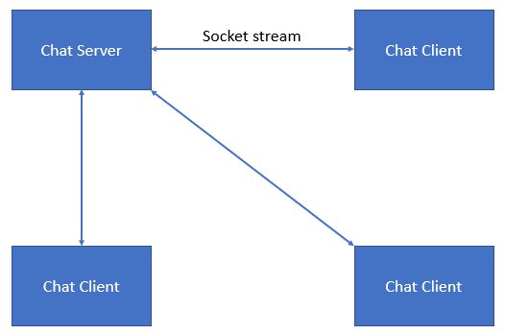

Figure 1. Chat Room client-server architecture

### Details:

E.g., details of chat room client-server architecture

**Chat Server:**

Multithread chat server that can handle multiple clients at the same time. Chat server is responsible for the followings:

* Manage multiple concurrent client connections
* Manage chat room
  + Joining/leaving the chat room
  + Broadcasting messages to all connected clients

**Chat Client:**

Multithreaded chat client that is responsible for the followings:

* Manage connection with chat server
* Provide interface to accept user’s text messages
* Send/receive messages to/from chat room

## Class Diagram (20 pts)

Provide class diagram of each component in the system architecture.

E.g., Class diagram for Chat Server

**UML**

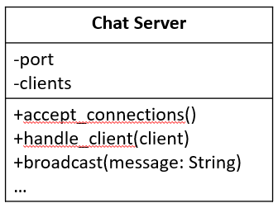

**Fields**

* + port: server port
  + clients: connected client connection sockets

**Methods**

* + accept_connection(): accepts a client connection
  + handle_client(client): handles sending/receiving messages from client socket
  + …

## GUI (10 pts)

Provide a sketch of the GUI (if any) and explain all the elements on the GUI.

Note: GUI doesn’t need to be polish. You can sketch it on paper, whiteboard and take pictures of it and paste it here. Make sure to highlight all elements on the GUI and explain what they are.

E.g., Chat Client

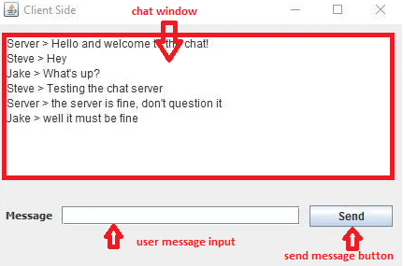

## Workflow (20 pts)

List all the use cases and illustrate each with a workflow.

E.g.,

Use case 1: User can join the chat room

**Flowchart**

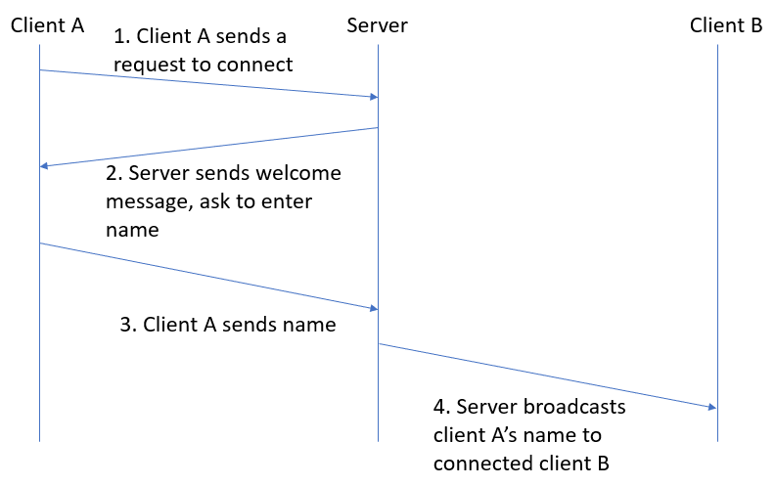

Figure 2. User joins chat room flow

# Tools (5 pts)

## Hardware

E.g.,

- Raspberry PI

- Temperature sensors

- …

## Software

E.g.,

- Python socket lib

- Yahoo Finance APIs

- …

# Weekly Plan (5 pts)

List all weekly deliverables

E.g.,

Week 1 (Oct 18 – Oct 25)

* Create team Github repo
* Submit design doc and plan
* Send first progress updates email

Week 2 (Oct 25 – Nov 1)

…