IHARQ Cumulative Layer 10
Reproducibility and Presentation Package Through P01
IHARQ-CUMULATIVE-LAYER10-THROUGH-P01-R1
PASS — FINALIZED AND FROZEN
Read-only rendering / presentation / reproduction authority. Evidence Map, Layer 0, Phase Analysis, Protocol, and execution evidence remain upstream authorities.

Executive Summary
P00 Layer 10 R2 is preserved. P01 Layer 10 adds governed views, cards, source-bound figures, exact tables, provenance and reproduction routes driven by the finalized cumulative Evidence Map. No scientific source value, finding, reviewed claim wording, Protocol rule, or Evidence Map relation was changed.
Surface | State
P00 Layer 10 | PRESERVED — 14 views / 14 cards / 14 exports
P01 Layer 10 | COMPLETE — 20 views / 12 cards / 11 figures / 14 tables
A4 | Substrate readiness only; effectiveness not evaluated in P01
A14 | ABSENT / PROHIBITED
Negative evidence | VISIBLE
Next step | Final P01 whole-stack synchronization / closure / P02 authorization review

1. Authority and Read-Only Contract
Conceptual chain: Layer 0 reviewed claim → Evidence Map → Layer 10 rendering. Layer 10 may render, format, cross-reference, package and export; it may not recompute, retune, reclassify, strengthen, or rewrite evidence.

2. P00 Preservation
P00-BASIC-LAYER10-PACKAGE-R2 is embedded under preserved_p00_layer10/. 60 predecessor release-manifest file hashes were verified with zero failures. Existing P00 warning parity, negative visibility and read-only semantics are preserved.

3. P01 Source Inventory
dataset | subjects | source_files | source_events | accepted_events | source_hz | license
PhysioNetMI | 109 | 327 | 9509 | 4918 | 128, 160 | ODC-By-1.0
BNCI2014_001 | 9 | 18 | 5184 | 2592 | 250 | CC BY-ND 4.0
Lee2019_MI | 54 | 108 | 5400 | 5400 | 1000 | GPL-3.0 (maintained source card)

4. Subject-Grouped Split
dataset | subjects | train_subjects | cal_subjects | val_subjects | test_subjects | train_windows | cal_windows | val_windows | test_windows
PhysioNetMI | 109 | 65 | 22 | 11 | 11 | 2949 | 979 | 495 | 495
BNCI2014_001 | 9 | 5 | 2 | 1 | 1 | 1440 | 576 | 288 | 288
Lee2019_MI | 54 | 32 | 11 | 5 | 6 | 3200 | 1100 | 500 | 600
Mandatory warning: leakage conclusion is bounded to the implemented registered checks.

5. Frozen Preprocessing Contract
Order | Step | Contract
1 | Source-unit validation | Preserve provider units/metadata; reject unresolved unit ambiguity
2 | EEG selection | EEG-only branch; no non-EEG channels in official core
3 | Demeaning | Continuous-run demeaning before event window extraction
4 | Average reference | Continuous-run average reference
5 | Joint resampling | Signal and events jointly resampled to 160 Hz with polyphase resampling; Kaiser β=5.0
6 | Band-pass filtering | 8–32 Hz, 4th-order Butterworth SOS, zero-phase; odd padding; padlen 27
7 | Storage dtype | float32
8 | Official windowing | cue +0.5 to +3.5 s, 480 samples; reject out-of-bounds; no clipping

6. Core and Quality Closure
Official core: cue +0.5→+3.5 s, 480 samples @160 Hz; 12,910 accepted events → 12,910 valid official core windows; 0 invalid windows; 172 persisted HDF5 subject shards.
Quality: 489 recording/run summaries; 20 soft/provider flags; 0 hard-invalid summaries. Soft/provider flag ≠ corruption.

Figure — P00→P01 progression
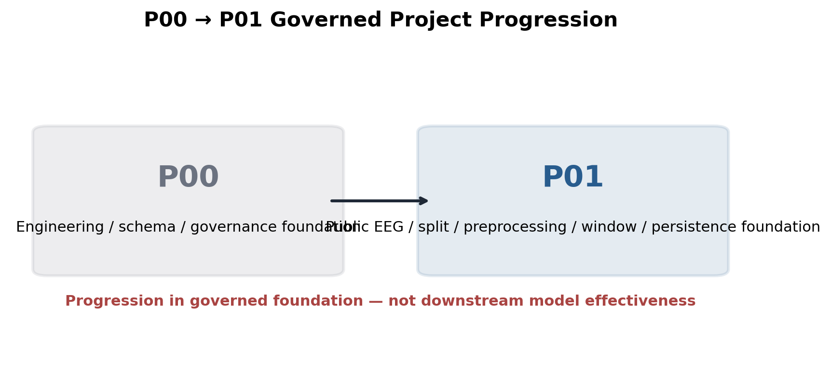
Governed warning: PUBLIC_EEG_ONLY; NON_CLINICAL; no model-effectiveness inference

Figure — Source → accepted event → core window flow
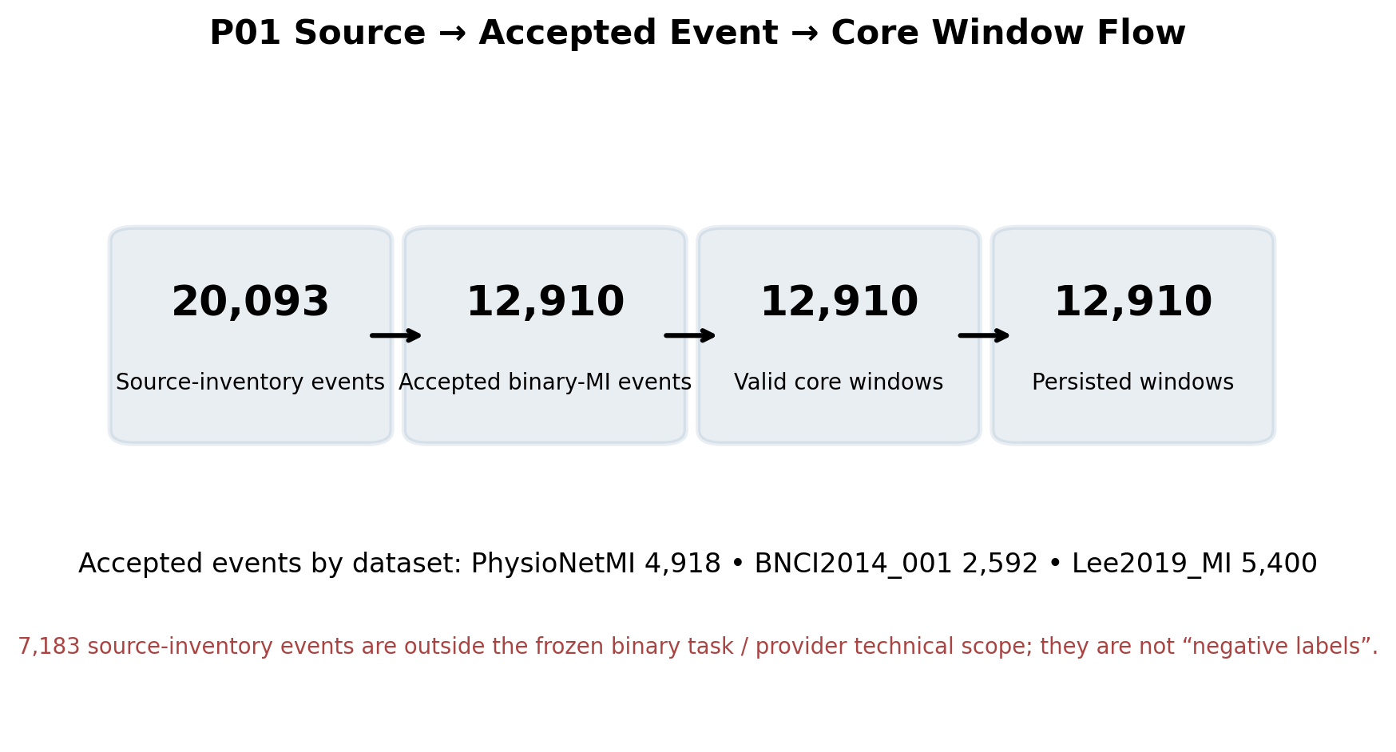
Governed warning: Denominator/accounting only; not model performance

Figure — Subject split allocation
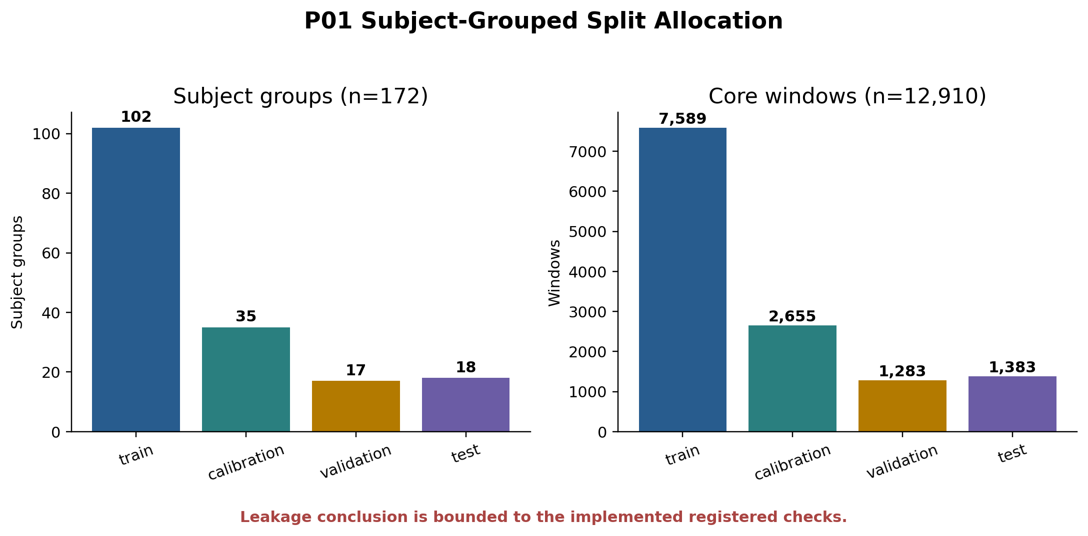
Governed warning: IMPLEMENTED_CHECKS_ONLY

Figure — Preprocessing chain
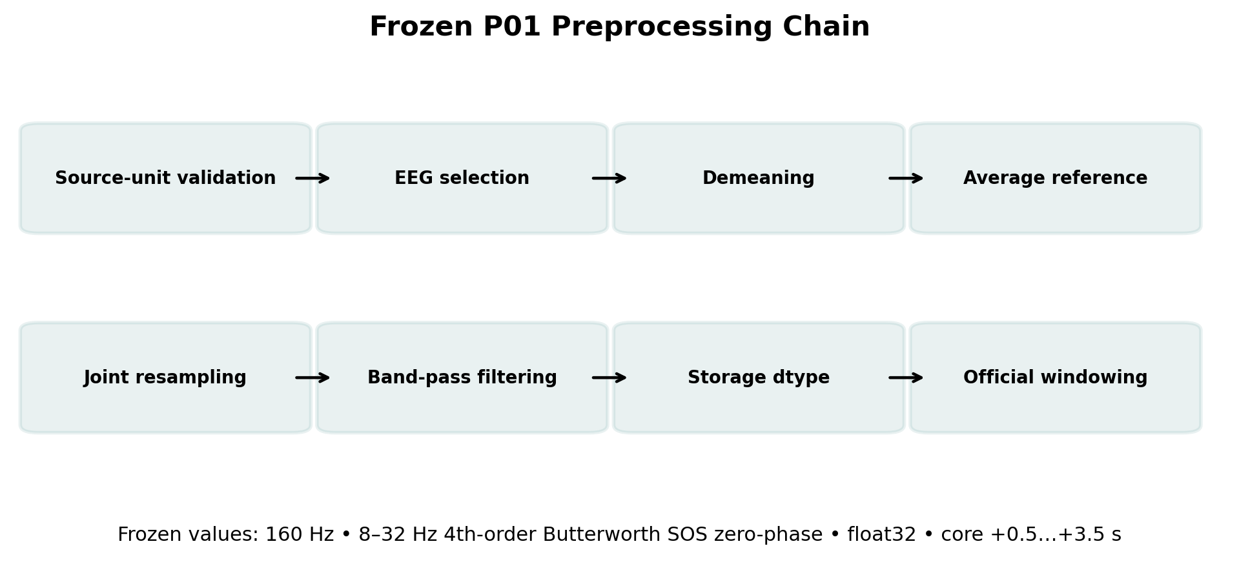
Governed warning: Implementation contract only; no preprocessing-effectiveness inference

Figure — Official core window
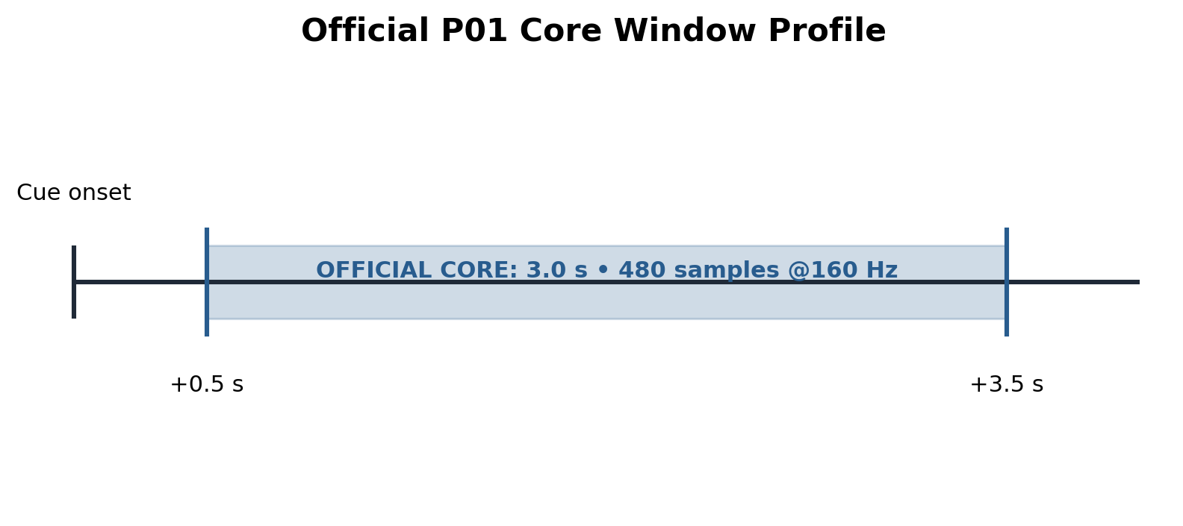
Governed warning: NO_MODEL_EFFECT_INFERENCE

Figure — Core denominator conservation
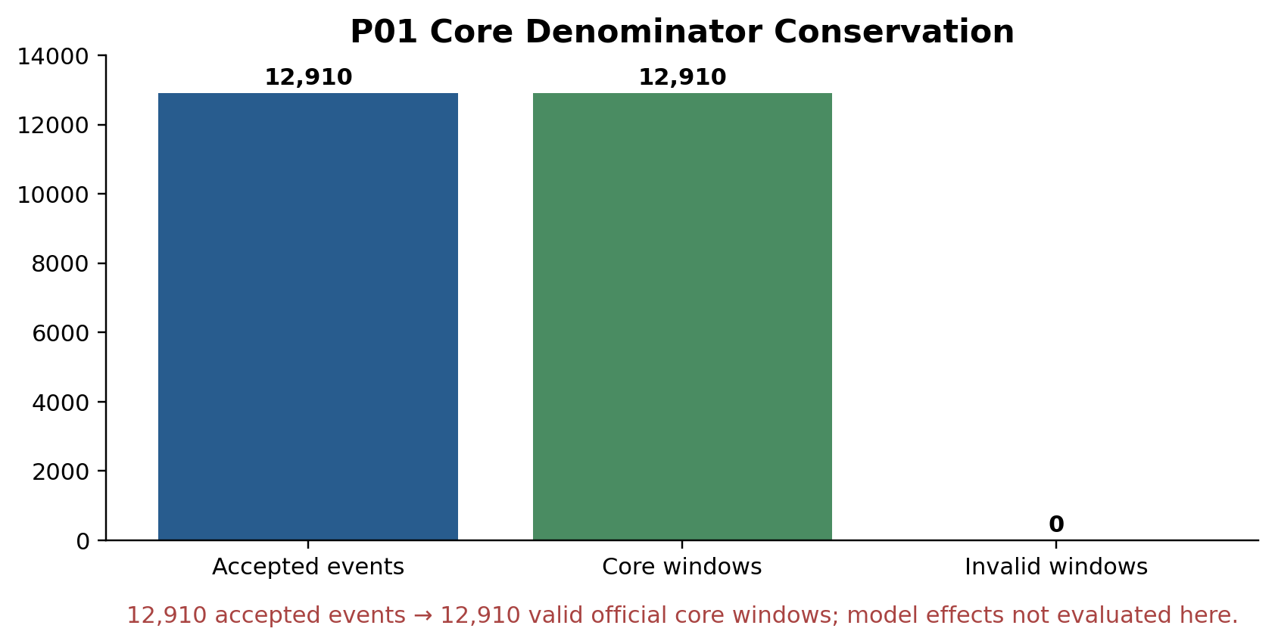
Governed warning: NO_MODEL_EFFECT_INFERENCE; external access constraints apply

Figure — Core vs A4 timing
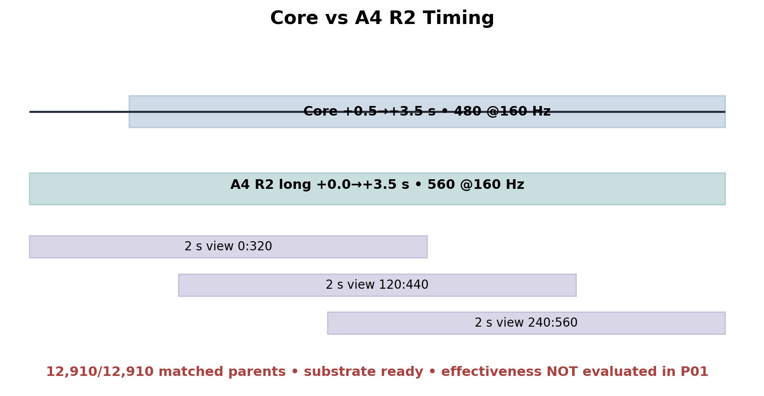
Governed warning: A4 readiness only; effectiveness not evaluated in P01

Figure — A4 R1 failure → R2 design
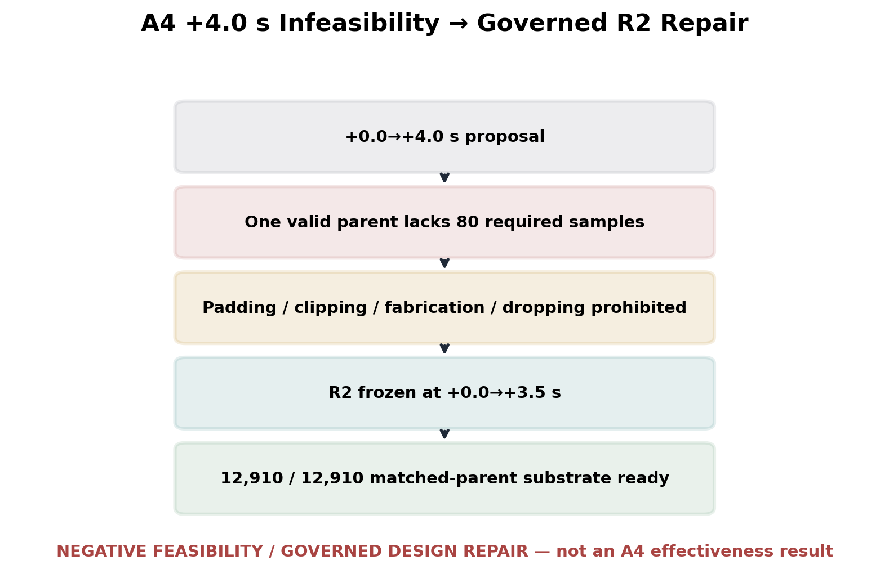
Governed warning: Retrospective feasibility origin; no effect claim

Figure — Stage/repair chronology
Governed warning: Execution history; historical failures are not current positive evidence

Figure — Evidence ceiling
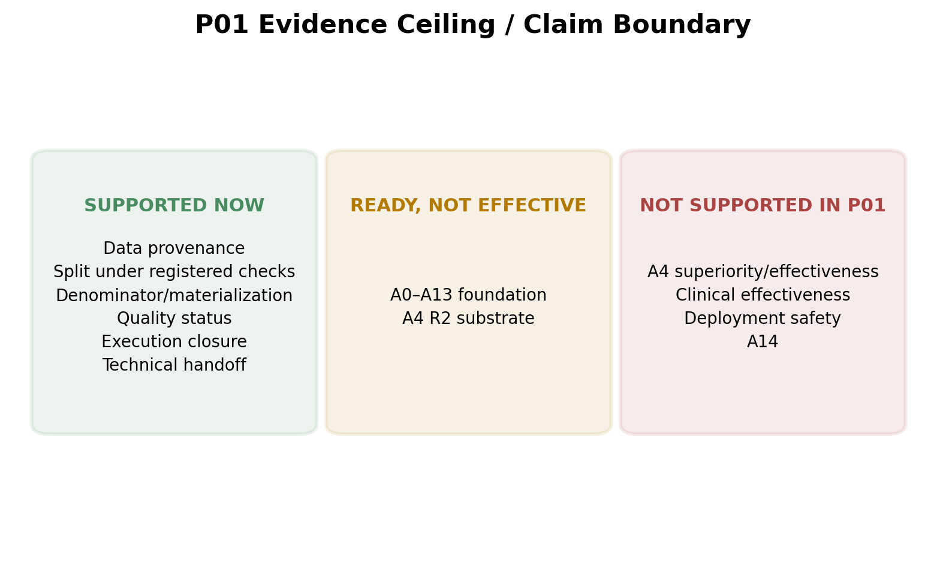
Governed warning: PUBLIC_EEG_ONLY; NON_CLINICAL; NO_DEPLOYMENT_CLAIM; NO_ABLATION_EFFECTIVENESS_IN_P01

Figure — P01→P02 handoff graph
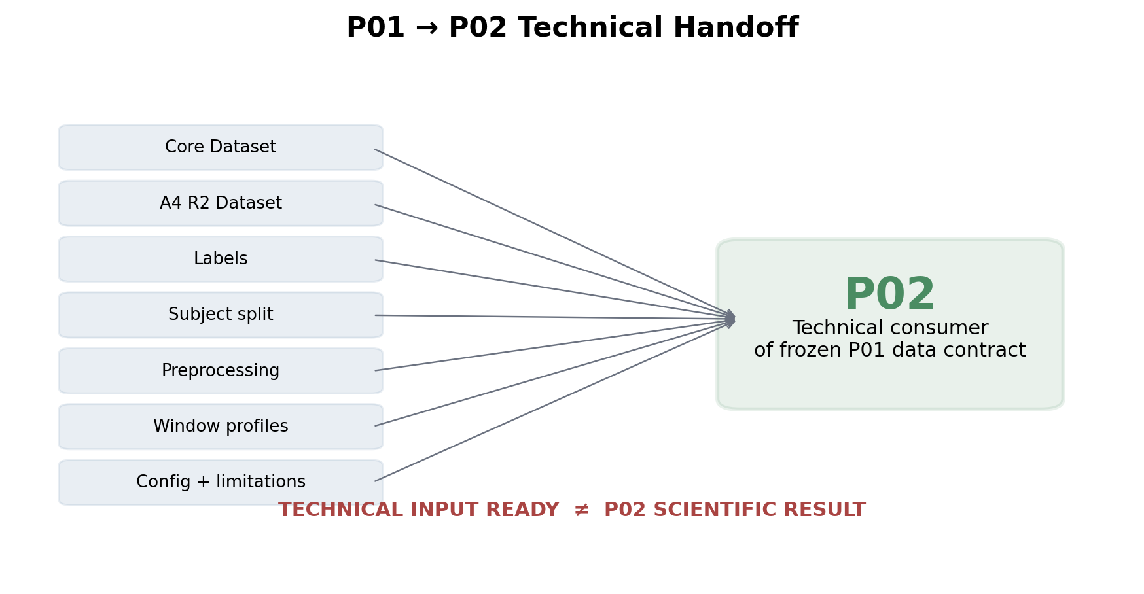
Governed warning: DOCUMENTARY_CLOSURE_SEQUENCE_REMAINS; no prediction of P02 success

7. A0–A13 and A14
ID | Identity | P01 state | Executed
A0 | Raw Decoder / Accept-All Raw Decoder Reference | FOUNDATION_READY | NO
A1 | Calibrated Decoder / Calibration Visibility | FOUNDATION_READY | NO
A2 | Simple Registered Threshold / Confidence-Threshold Baseline | FOUNDATION_READY | NO
A3 | Uncertainty and Selective Prediction | FOUNDATION_READY | NO
A4 | Longer-Window, Multi-Window Voting/Averaging and Ordinary Ensemble Controls | FOUNDATION_READY | NO
A5 | IHARQ-lite / Rule-Based Evidence Verification | FOUNDATION_READY | NO
A6 | IHARQ + Evidence-Quality Estimator | FOUNDATION_READY | NO
A7 | IHARQ + RegimeRisk Temporal Trust | FOUNDATION_READY | NO
A8 | Learning-to-defer / Deferral Comparison | FOUNDATION_READY | NO
A9 | Supervised Adaptive-IHARQ / Adaptive Readiness Policy | FOUNDATION_READY | NO
A10 | Contextual Bandit / Simulation-Bounded Immediate-Reward Adaptation | FOUNDATION_READY | NO
A11 | Reinforcement-Learning Policy / Simulation-Bounded Sequential Policy Learning | FOUNDATION_READY | NO
A12 | StressForge Stress Tests / Controlled Stress Robustness | FOUNDATION_READY | NO
A13 | Layer 9 Simulation-Only Embodiment Demo | FOUNDATION_READY | NO
A14 = ABSENT / PROHIBITED. READY ≠ EFFECTIVE.

8. P01 Reviewed Claim Cards

P01-CLM-001/v1 — APPROVED_WITH_QUALIFICATIONS
Within the frozen P01 binary motor-imagery branch, Phase 1 established a checksum-bound, provenance-traceable foundation over the three activated public EEG datasets.
Limitations: PUBLIC_EEG_ONLY, NON_CLINICAL, BINARY_MI_BRANCH_SCOPE
Warning: PUBLIC_EEG_ONLY; NON_CLINICAL; BINARY_MI_BRANCH_SCOPE

P01-CLM-002/v1 — APPROVED_WITH_QUALIFICATIONS
The frozen P01 split assigned 172 subject groups wholly and disjointly across train, calibration, validation, and test roles and passed the implemented registered leakage/disjointness checks; this does not prove that every conceivable leakage mechanism is impossible.
Limitations: IMPLEMENTED_CHECKS_ONLY
Warning: IMPLEMENTED_CHECKS_ONLY

P01-CLM-003/v1 — APPROVED
Under the frozen official core-window policy, all 12,910 accepted events yielded 12,910 valid core windows, with 0/12,910 invalid official core windows.
Limitations: NO_MODEL_EFFECT_INFERENCE
Warning: NO_MODEL_EFFECT_INFERENCE

P01-CLM-004/v1 — APPROVED_WITH_QUALIFICATIONS
The official P01 core numerical artifact was persisted as 172 lossless HDF5 subject shards covering 12,910 windows and was verified under its Kaggle provider-version/logical-revision/manifest-hash identity contract.
Limitations: PRIVATE_KAGGLE_EXTERNAL_ARTIFACT_ACCESS, SOURCE_LICENSE_REDISTRIBUTION_CONSTRAINTS
Warning: PRIVATE_KAGGLE_EXTERNAL_ARTIFACT_ACCESS; SOURCE_LICENSE_REDISTRIBUTION_CONSTRAINTS

P01-CLM-005/v1 — APPROVED_WITH_QUALIFICATIONS
P01 applied the ANNOTATE_NOT_REPAIR quality policy across 489 quality summaries: 20 soft/provider flags were retained, 0/489 summaries were hard-invalid, and 0/12,910 official core windows were invalid under the registered criteria.
Limitations: SOFT_FLAG_NOT_EQUIVALENT_TO_CORRUPTION
Warning: SOFT_FLAG_NOT_EQUIVALENT_TO_CORRUPTION

P01-CLM-006/v1 — APPROVED_WITH_QUALIFICATIONS
P01 established Layer-1 foundation readiness for each official A0-A13 identity; none of these ablation-effectiveness experiments was executed in P01, and A14 remained absent/prohibited.
Limitations: NO_ABLATION_EFFECTIVENESS_IN_P01
Warning: NO_ABLATION_EFFECTIVENESS_IN_P01

P01-CLM-007/v1 — APPROVED_WITH_QUALIFICATIONS
P01 established a fully matched A4 R2 Layer-1 data substrate for future governed evaluation: 12,910/12,910 parent events are represented without padding, clipping, fabricated samples, or parent-event loss. A4 R2 arose after the +4.0 s feasibility failure and was not evaluated for decoder effectiveness in P01.
Limitations: A4_R2_RETROSPECTIVE_FEASIBILITY_ORIGIN_NOT_CONFIRMATORY_IN_P01, A4_EFFECTIVENESS_NOT_EXECUTED
Warning: A4_R2_RETROSPECTIVE_FEASIBILITY_ORIGIN_NOT_CONFIRMATORY_IN_P01; A4_EFFECTIVENESS_NOT_EXECUTED

P01-CLM-008/v1 — APPROVED
The accepted P01 execution completed 27/27 registered stages, 16/16 deterministic P01 gates, and 50/50 regression tests with 0 unresolved blockers; final execution-bundle integrity checks also closed.
Limitations: NO_EFFECTIVENESS_INFERENCE
Warning: NO_EFFECTIVENESS_INFERENCE

P01-CLM-009/v1 — APPROVED_WITH_QUALIFICATIONS
The accepted P01 run used Python 3.12.13 under a documented compatibility amendment and the governed adaptive-disk policy P01-L1-KAGGLE-ADAPTIVE-DISK-R1; the accepted records show no change to the frozen datasets, labels, subject split, core preprocessing, core window policy, or 12,910-event denominator attributable to these runtime/resource amendments.
Limitations: ACTUAL_RUNTIME_PYTHON_3_12_13_WITH_COMPATIBILITY_AMENDMENT, ADAPTIVE_DISK_RESOURCE_AMENDMENT
Warning: ACTUAL_RUNTIME_PYTHON_3_12_13_WITH_COMPATIBILITY_AMENDMENT; ADAPTIVE_DISK_RESOURCE_AMENDMENT

P01-CLM-010/v1 — APPROVED_WITH_QUALIFICATIONS
P01 freezes a technical Layer-1 data contract that P02 may consume using the recorded dataset, label-map, split, preprocessing, core-window, and external-artifact identities; silent relabeling, rewindowing, split mutation, denominator substitution, or test-visibility leakage is prohibited. This is technical readiness, not evidence of P02 scientific success.
Limitations: DOCUMENTARY_CLOSURE_SEQUENCE_REMAINS
Warning: DOCUMENTARY_CLOSURE_SEQUENCE_REMAINS

P01-CLM-011/v1 — DEFERRED
P01 did not evaluate whether A4 R2 improves decoder performance relative to the core window; that effectiveness question remains deferred to a future governed matched downstream experiment.
Limitations: A4_EFFECTIVENESS_NOT_EXECUTED, A4_R2_RETROSPECTIVE_FEASIBILITY_ORIGIN_NOT_CONFIRMATORY_IN_P01
Warning: A4_EFFECTIVENESS_NOT_EXECUTED; A4_R2_RETROSPECTIVE_FEASIBILITY_ORIGIN_NOT_CONFIRMATORY_IN_P01

P01-CLM-012/v1 — REJECTED
P01 is a public, non-clinical data-foundation and execution-validation phase; it does not establish clinical effectiveness, patient benefit, deployment safety, or medical-device readiness.
Limitations: PUBLIC_EEG_ONLY, NON_CLINICAL, NO_DEPLOYMENT_CLAIM
Warning: PUBLIC_EEG_ONLY; NON_CLINICAL; NO_DEPLOYMENT_CLAIM

9. Governed Tables
Table ID | Title | Rows | Export
L10-P01-TBL-001 | Source dataset inventory | 3 | tables/exports/L10-P01-TBL-001.csv
L10-P01-TBL-002 | Event/window denominator | 4 | tables/exports/L10-P01-TBL-002.csv
L10-P01-TBL-003 | Subject split allocation | 3 | tables/exports/L10-P01-TBL-003.csv
L10-P01-TBL-004 | Preprocessing contract | 8 | tables/exports/L10-P01-TBL-004.csv
L10-P01-TBL-005 | Quality outcomes | 1 | tables/exports/L10-P01-TBL-005.csv
L10-P01-TBL-006 | A0–A13 readiness | 14 | tables/exports/L10-P01-TBL-006.csv
L10-P01-TBL-007 | A4 profile | 1 | tables/exports/L10-P01-TBL-007.csv
L10-P01-TBL-008 | External artifacts | 2 | tables/exports/L10-P01-TBL-008.csv
L10-P01-TBL-009 | Execution closure | 5 | tables/exports/L10-P01-TBL-009.csv
L10-P01-TBL-010 | Repair/rerun history | 8 | tables/exports/L10-P01-TBL-010.csv
L10-P01-TBL-011 | Reviewed claims | 12 | tables/exports/L10-P01-TBL-011.csv
L10-P01-TBL-012 | Limitation register | 20 | tables/exports/L10-P01-TBL-012.csv
L10-P01-TBL-013 | Negative/deferred/rejected claims | 2 | tables/exports/L10-P01-TBL-013.csv
L10-P01-TBL-014 | P02 handoff | 7 | tables/exports/L10-P01-TBL-014.csv

10. External Artifact Retrieval

P01-L1-DERIVED-WINDOWS-d03f0a7c869dd95a-20260806222242-68a91473
Field | Value
Provider | Kaggle
Dataset | csthv999z/iharq-p01-l1-derived-windows-d03f0a7c869d-20260806222242-68a91473
Provider revision | 2
Logical revision | 1
Manifest SHA-256 | dc21f418e9a1add62adb346f627d5d729735a5f1ecaa1d771f6fa5cfede627e1
Size bytes | 1,166,652,764
Format | LOSSLESS_HDF5_SUBJECT_SHARDS
Access | PRIVATE Kaggle Dataset access + source-license compliance

P01-L1-A4-DERIVED-WINDOWS-4cd080393345e8aa-20260807143013-663eab13
Field | Value
Provider | Kaggle
Dataset | csthv999z/iharq-p01-l1-a4-d03f0a7c-9a7c6108
Provider revision | 1
Logical revision | 2
Manifest SHA-256 | 29124d59907610b1545e0a2b5d1811a4d4a2bf1df64cad49aa880f4721c47305
Size bytes | 1,357,362,334
Format | LOSSLESS_HDF5_MATCHED_3P5S_SUBJECT_SHARDS_WITH_REGISTERED_VIRTUAL_MULTIWINDOW_VIEWS
Access | PRIVATE Kaggle Dataset access + source-license compliance

11. Repair / Negative Evidence
Revision | Episode | Class | Scientific consequence
R45 | Dependency-ID-normalized core adoption | integration/canonicalization | Core bytes unchanged
R46 | Missing runtime import correction | implementation | Scientific freeze unchanged
R47 | Governed decimal/canonicalization repair | canonicalization | Scientific freeze unchanged
R48 | A4 interface/persistence hardening | integration | No core change
R49 | A4 R1→R2 feasibility correction | scientific design for future control | A4 future profile only; official core unchanged
R50 | Stage-07 revision-guard correction | implementation | No scientific change
R51–R53 | Stage-18 integration/shim repair | integration | No scientific change
R54 | Stage-26 secret-redaction/repackaging recovery | security/packaging | No scientific change
Deferred A4 effectiveness and rejected clinical/deployment effectiveness remain visible as negative governance state; neither is rendered as a positive result.

12. Reproduction / P02 Handoff
The package exposes claim-to-source routes, external retrieval instructions, source manifests and exact table/figure exports. The P02 handoff is technical readiness only: TECHNICAL INPUT READY ≠ P02 SCIENTIFIC RESULT.

13. Final Validation
Check | Result
P00 preservation | PASS
Evidence Map coverage | PASS
Reviewed wording parity | PASS
Source-value reproduction | PASS
Warning/limitation parity | PASS
Negative visibility | PASS
A0–A13/A14/A4 boundaries | PASS
Read-only audit | PASS
Execution bundle CRC/checksums | PASS
Secrets/placeholders | PASS
Freeze-critical blockers | 0
CUMULATIVE_LAYER10_THROUGH_P01: PASS — FINALIZED AND FROZEN
NEXT GOVERNED STEP: FINAL PHASE-1 WHOLE-STACK SYNCHRONIZATION, CUMULATIVE PROJECT-STATE UPDATE, HANDOFF, AND FORMAL PHASE-1 CLOSURE / PHASE-2 AUTHORIZATION REVIEW.

14. Thesis-Defense / Limitation / Provenance Views
Thesis-defense summary. By the end of P01, the project had established a governed public-EEG data/split/preprocessing/window/persistence foundation with 12,910 valid core windows, exact subject-group split identity, quality/accounting closure, A0–A13 foundation readiness, A4 R2 substrate readiness, accepted execution closure, and a technically ready P01→P02 handoff. It had not established A4 superiority, clinical effectiveness, deployment safety, or A14.

Major limitation cards
PUBLIC_EEG_ONLY / NON_CLINICAL / NO_DEPLOYMENT_CLAIM: P01 is a public-data foundation; clinical and deployment effectiveness are outside the evidence ceiling.
IMPLEMENTED_CHECKS_ONLY: Split/leakage statements remain bounded to the implemented registered checks.
SOFT_FLAG_NOT_EQUIVALENT_TO_CORRUPTION: 20 soft/provider flags are not equivalent to corrupt recordings; 0 hard-invalid summaries is not artifact-free EEG.
A4_EFFECTIVENESS_NOT_EXECUTED: A4 R2 is a matched data substrate; no P01 decoder-effectiveness comparison exists.
PRIVATE_KAGGLE_EXTERNAL_ARTIFACT_ACCESS: Core/A4 numerical bytes require governed private access and source-license compliance.

Representative provenance chains
P01-CLM-003/v1 → P01-FIND-003 → P01-AC-003-DENOMINATOR → P01 stages 07–15 → WindowRecords / derived_windows_dataset.json
P01-CLM-007/v1 → P01-FIND-009 / P01-FIND-010 → P01-AC-008-A4 → A4 Stage 14/15 + R49 lineage → a4_window_family_dataset.json / R2 freeze
P01-CLM-008/v1 → P01-FIND-012 → P01-AC-010-GATES-REPAIRS → stages 00–26 → stage_results.json / gate_decision.json / checksums.sha256
CUMULATIVE_LAYER10_THROUGH_P01: PASS — FINALIZED AND FROZEN
NEXT: FINAL PHASE-1 WHOLE-STACK SYNCHRONIZATION, CUMULATIVE PROJECT-STATE UPDATE, HANDOFF, AND FORMAL PHASE-1 CLOSURE / PHASE-2 AUTHORIZATION REVIEW.

