Journal: Ecological Applications
Manuscript Type: Article

Title: Shifts and expansion in a spatially-structured fish stock spanning international borders in the Northwest Atlantic
Authors:
Nancy L Shackell*
Fisheries and Oceans Canada, Bedford Institute of Oceanography, Dartmouth, NS, Canada
*Contact and Corresponding Author: Nancy.Shackell@dfo-mpo.gc.ca
ORCID https://orcid.org/0000-0001-5128-948X
Kiyomi J Ferguson
Fisheries and Oceans Canada, Bedford Institute of Oceanography, Dartmouth, NS, Canada
Kiyomi.Ferguson@dfo-mpo.gc.ca
ORCID https://orcid.org/0009-0003-4544-2742
Andrew J. Allyn
Gulf of Maine Research Institute, Portland, ME, USA
ORCID https://orcid.org/0000-0002-1584-0198
Cornelia E. den Heyer
Fisheries and Oceans Canada, Bedford Institute of Oceanography, Dartmouth, NS, Canada
ORCID https://orcid.org/0000-0002-1933-5885
Jamie C. Tam
Fisheries and Oceans Canada, Bedford Institute of Oceanography, Dartmouth, NS, Canada
ORCID https://orcid.org/0009-0006-3462-8981

David M Keith
Fisheries and Oceans Canada, Bedford Institute of Oceanography, Dartmouth, NS, Canada
ORCID https://orcid.org/0000-0003-3564-2030

Katherine E. Mills
Gulf of Maine Research Institute, Portland, ME, USA
ORCID https://orcid.org/0000-0001-6078-7747

James T. Thorson
Habitat and Ecological Processes Research, Alaska Fisheries Science Center, Seattle, Washington, USA
ORCID https://orcid.org/0000-0001-7415-1010

Open Research Statement: Code and protocols used in this study are available at https://github.com/kifre1/Hali_Shift_withNF. Data used within this paper are within the public domain except for Newfoundland data, which is available upon request. No primary data were collected by the authors. All analyses were performed using R statistical programming language and code is available upon request.

Key words: species distribution modeling, distribution shifts, transboundary, fisheries, Atlantic halibut, integrated modelling

ABSTRACT
Marine commercial fish species can shift their geographic distributions as environmental conditions change. Distribution shifts of commercial species across borders pose a challenge because individual jurisdictions often conduct stock assessments using only data from within their own borders. This can lead to fisheries managers reacting to local trends in abundance that do not represent stock-wide status. Atlantic halibut (Hippoglossus hippoglossus) spans across Eastern Canada, extends into the United States of America (USA), across a French territory and into the High Seas. Here we focus on the USA-Canadian border and use Atlantic halibut as a case study to develop a Distribution Shifts Assessment framework. On the Canadian side, the halibut fishery is sustainably certified, whereas in the USA, the same population is designated as “overfished”. We used a spatio-temporal modeling framework to integrate USA and Canadian fisheries-independent surveys to examine a suite of distribution shift indicators at both regional and smaller (focal area) scales, before and during a period of enhanced warming (1990-2005 and 2006-2023, respectively). Abundance increased in both the USA and Canada over the full time series. The proportion of halibut abundance on the Canadian side ranged from 89-96%, averaging 94% over the time series. As abundance increased during the 2006-2023 period, the centre of gravity (COG) shifted at a rate of 4 km/year north (95% CI:3-4.3 km), and 12 km/year east (95% CI: 10-15 km) in Canada. In the USA in the same period, the COG shifted southwest at 3 km/year south (95% CI: 1.5-4 km) and 1 km/year west (95% CI: 0.5-2 km) As the population increased between 2006 and 2023, the leading edge of the range expanded northward and predominantly eastward ~271km, while the trailing edge shifted northward and predominantly eastward 70 km, consistent with the shelf topography and overall northern expansion. Our results are consistent with the expansion of available thermal habitat and an increase in the growing season for Atlantic halibut throughout the region. A “Distribution Shifts Assessment” framework is presented as a possible roadmap to operationalize distribution shift indicators for fisheries management and other fisheries-focused decision-support frameworks.

INTRODUCTION
Global warming has already had a profound impact on the geographic distribution of a wide range of plants and animals, most notably in rapidly warming areas, as species move to more suitable habitat (Chen et al. 2011; Parmesan 2006; Pecl et al. 2017). The knowledge, detection, and monitoring of changes in species distributions driven by ecological and environmental drivers are an integral component of natural resource management, particularly in an era of climate change. This is especially true in the ocean, where marine ectotherm distributional shifts are more closely aligned with their thermal tolerance limits than their terrestrial counterparts (Sunday et al. 2012). Marine species distribution shifts are indeed occurring more rapidly (Lenoir et al. 2020; Poloczanska et al. 2013) and an impact on fisheries has been detected through the average preferred temperature of commercial species, which has increased globally (Cheung et al. 2013). Incorporating the impacts of climate change into fisheries management has become a global imperative, and in North America, has been highlighted in changes to Canada’s Fisheries Act (Bill C-68, 2019), and the implementation of the United States’ Magnuson-Stevens Act (Procedure for Addressing Climate Change in NMFS Essential Fish Habitat Consultations). Efforts by both Canada and the United States (USA) include commitments to an ecosystem approach to fisheries management (Ecosystem approach to fisheries management (EAFM); Northeast Ecosystem and Socioeconomic Profile Workshop Report ) which supports sustainable fisheries and adaptive management.

Shifts in species distributions pose a challenge to the management of commercial fisheries, partly because of how catch quotas are spatially allocated. Typically, fishery removal quotas are assigned to a specific area or management unit, in which harvesters are allowed to catch a portion of a stock, often based on the historical distribution across a region. If the historical proportions of fish among management units start to change, then the process of spatial allocation of quota becomes complicated. While distribution shifts can be a challenge within a nation’s Exclusive Economic Zone (EEZ, the ocean from a coastal nation’s shoreline out to 200 nm that is under that nation’s jurisdiction, see Figure 1), challenges intensify when the distribution of commercially harvested fish shift across international borders or between EEZs with differing and independent management and governance structures. Globally, 67% of 938 commercial marine stocks are transboundary resources (Palacios-Abrantes, Reygondeau, et al. 2020). Further, 23% of global transboundary stocks are projected to shift across EEZ borders as early as 2030 (Palacios-Abrantes et al. 2022).

The potential for economic disruption and conflict between jurisdictions driven by species distribution shifts has led to recommendations for focused research on both governance structure and the science needed to support adaptation (Palacios-Abrantes et al. 2022; Pinsky, Selden, et al. 2020; Sumaila et al. 2020; Vogel et al. 2023; Woods et al. 2021; Pinsky et al. 2018). In the northern hemisphere, several independent nations conduct their own research surveys to identify, count, and locate demersal marine species (Maureaud et al. 2021). Commercial stock assessments are typically conducted from these separate surveys for each EEZ and nation. As such, shifts in distribution across national boundaries could be interpreted incorrectly (e.g., a collapse in one jurisdiction is another jurisdiction’s emerging fishery). This siloed approach has started to change with increased accessibility to integrated survey databases (Maureaud et al. 2024; Thorson 2019). Alongside increased data availability, integrated spatio-temporal models have been developed to combine multiple surveys and account for their differences (e.g.“catchability”) while allowing for a broader, larger geographic perspective (Thorson 2019). Such integrated models have been used to understand large-scale ecological phenomena, such as a region-wide decline of a coastal shark (Davidson et al. 2025), the large-scale population structure of a commercial species (Lindegren et al. 2025), and distribution shifts across international borders (O’Leary et al. 2022).

Formerly, broad expectations of global warming were that plants and animals would shift latitudinally towards cooler, more suitable habitats (Parmesan 2006). Over time, those expectations have been refined (Comte et al. 2020). Across all taxa, 59% of observed range shifts met expectations based on a physiological response to increasing temperatures (Comte et al. 2020; Lawlor et al. 2024). Substantial distribution shifts were expected throughout the Northwest Atlantic based on anticipated warming (Morley et al. 2018), and while there is evidence of marine species’ distribution shifts within USA and Canadian waters, they are not always in the direction anticipated in response to warming, showing that drivers other than temperature can heavily influence species distribution (Fredston et al. 2021; Gordó-Vilaseca et al. 2023; Kleisner et al. 2016; Lawlor et al. 2024; Mills et al. 2024; Pinsky, Selden, et al. 2020). A varied response to warming serves to highlight the importance of drawing on ecological knowledge of a species in order to apply the most appropriate approaches to determine distribution shifts.

Here, we use Atlantic halibut (Hippoglossus hippoglossus) as a case study to integrate fisheries-independent surveys that sample juveniles from both the USA and Canada within a spatio-temporal modeling framework. We then use the model output to examine a suite of distribution shift indicators (Link et al. 2021). While Atlantic halibut are distributed across Canadian, USA, French territorial, and international waters, this study focuses on the area surrounding the nautical border between Canada and the USA known as the Hague Line (Figure 1). Canadian surveys show that Atlantic halibut abundance has rebounded from an overfished status; biomass and landings have increased over the last 20 years and the fishery was certified as sustainable by the Marine Stewardship Council in 2013 (Johnson et al. 2024; Trzcinski and Bowen 2016). Meanwhile, assessments in USA waters show that halibut abundance remains low (NOAA.NEFSC, 2024); halibut has been designated as overfished since 2012 and is managed under a rebuilding plan. An integrated modelling approach will enable us to focus on a large-scale research question and provide advice for evidence-based management across the Hague Line. Finally, we generalize our approach by developing a Distribution Shifts Assessment framework that can, leverage data from multiple jurisdictions and be applied to other stocks facing similar management challenges. The goal of the framework is to present a possible roadmap to operationalize distribution shift indicators for fisheries management and other fisheries-focused decision-support frameworks.

MATERIALS AND METHODS

Data and Study Area

Biological data
Six bottom trawl research vessel (RV) survey data sets were used in this analysis (see Appendix S1: Table S1). The Northeast Fisheries Science Center (NEFSC) is a division of NOAA’s National Marine Fisheries Service, which conducts spring and fall RV surveys covering an area from Cape Hatteras to the southern part of the Scotian Shelf (Figure 1). Fisheries and Oceans Canada (DFO) Newfoundland conducts spring and fall RV surveys, which span from the Laurentian Channel and up the coast of Labrador. The DFO Maritimes Region conducts spring and summer RV surveys, covering the Scotian Shelf, the Bay of Fundy, and Georges Bank, up to the Laurentian Channel and has the highest proportion of sets with Atlantic halibut presence compared to the other surveys (Appendix S1: Table S1). All surveys use a stratified random sampling design, and there is some spatial overlap between the NOAA NEFSC and DFO Maritimes surveys (Appendix S2: Figure S1). Annually, there is fairly consistent coverage across the survey domain, and the northern range of the Newfoundland surveys (NAFO regions 2GHJ), where coverage is more sporadic, was excluded from the analysis (Appendix S2: Figure S2).
While the surveys collectively range from Cape Hatteras in the USA to the tip of Labrador, Canada, our study area represents the intersection between the footprints of the seasonal NOAA NEFSC, DFO Maritimes, and DFO Newfoundland RV surveys, and the historical Atlantic halibut distribution. Over the last decade, multiple research studies have supported the working theory that Atlantic halibut are spatially structured and exhibit diverse of movement patterns. Juveniles, sampled by the RV survey, occur in persistent focal areas across its range (Boudreau et al. 2017). Adult landings are proportional to the size of juvenile habitat (French et al. 2018). Adults can migrate hundreds of kilometers to the slope to spawn in winter and then return to their original areas, exhibiting summer site fidelity, but some stay resident at the summer site year-round, while a minority of halibut emigrate to other regions (Gatti et al. 2020; Ransier et al. 2024; Shackell et al. 2022).
Atlantic halibut are genetically uniform across the USA and Canadian continental shelf, but there are subtle genetic differences from the Gulf of St. Lawrence (GSL) population (Kess et al., 2021). In Canada, Atlantic halibut is managed as two separate stocks: the Scotian Shelf and Southern Grand Banks (SS-SGB), and the GSL (Figure 1). The GSL was excluded from this case study, along with NAFO region 3Pn, because GSL fish are frequently present in this area, and its inclusion could interfere with the detection and interpretation of patterns related to the SS-SGB stock. We also excluded observations at the extreme southern and northern edges that extend beyond the observed range of Atlantic halibut (Shackell et al., 2016; French et al., 2018), (see Appendix S1: Table S1), as well as NAFO region 3M (due do sparse data).
Surveys were originally designed to monitor groundfish abundance, focusing on commercial species. The Atlantic halibut caught in the trawl surveys are predominantly juveniles, as the larger halibut can out-swim the trawls; the trawl gear has a domed shape and selectivity which peaks around 45 cm (S. Johnson et al. 2024). While the RV surveys catch predominantly juvenile halibut (~50cm, 1kg), those of 125cm (~20kg) or more have been caught, which creates high variability in the weight per tow. Disparate RV survey data were combined into a data frame that included details for each unique survey tow (i.e.. survey, location, tow, swept area, date) and the associated biomass and abundance of Atlantic halibut (generating zeros where applicable) within the timeframe of 1990 to 2023.

Environmental and Historical Data
We gathered and processed depth, annual/seasonal average sea surface temperature, and annual/seasonal average bottom temperature data from the Bedford Institute of Oceanography North Atlantic model (BNAM). With a 1/12° resolution, BNAM is an eddy-resolving North Atlantic Ocean model that was created based on the Nucleus for European Modelling of the Ocean (NEMO) framework to support ocean monitoring (Brickman et al. 2021; Z. Wang et al. 2018). This makes it suitable for this study area, which is often under-resolved by global ocean climate models (Brickman et al. 2021). Seasonal averages of the BNAM environmental data were calculated annually by grouping monthly values as follows: spring (March-May), summer (June-August), and fall (September-November). RV survey tows were then matched to the BNAM covariate data based on the season and year of collection. To assign environmental values to each tow location, this temporal matching was followed by spatial alignment, using bilinear interpolation to average values from the four nearest BNAM grid cells, implemented with the “extract” function from the R raster package (Hijmans 2025).

Species Distribution Model Fitting
We fitted Atlantic halibut species distribution models (SDMs) using the vector autoregressive spatio-temporal (VAST) modeling approach, implemented with the R VAST package (Thorson 2019) (Appendix S1: Section S1) . Similar to other mixed effects SDMs, a VAST SDM can be described as an “environment-only” SDM enhanced with additional components to account for unexplained temporal, spatial, and spatio-temporal variability in the true underlying abundance as well as sampling differences among observations unrelated to variability in abundance (i.e., catchability covariates) (Thorson 2019). We fitted numerical abundance caught per tow, as this is the standard practice in Atlantic halibut stock assessments (Johnson et al., 2024), with a zero-inflated Poisson distribution (which involves modelling two linear predictors), and a barrier effect (preventing influence from crossing natural boundaries). The first linear predictor has a logit-link and models the proportion of zeros in excess of what is expected from the second linear predictor, which represents the intensity of a log-linked Poisson distribution. We fitted four alternative VAST models, which all shared this two-stage structure. All four models used the same approach to account for systematic differences among surveys by including survey (i.e., NEFSC, DFO Maritimes, DFO Newfoundland) as a fixed effect within the catchability component of the model and an offset based on a standard area-swept (km²) for each survey. All models also included season as a fixed effect with three levels (spring, summer, fall), representing differences in expected log-density between seasons across space and years.
We first fitted a base (null) intercept-only model with an AR1 autoregressive structure on annual intercepts for both linear predictors. As the autoregressive parameter (Rho₁) approached the upper bound of 1.0, we adjusted the first linear predictor to a random walk process. We used this same intercept autoregressive structure on all subsequent models. Next, we fitted an Environmental Covariates Only model (“Env”), which incorporated the environmental covariates (depth, and seasonal average surface and bottom temperatures) as dome-shaped (quadratic) effects using the bs function in the splines R package (Wang and Yan 2021) with degree equal to two. We then fitted an Environmental Covariates + Spatial model (“Env + Sp”), which included a random effect for persistent spatial variability in encounter probability and positive catch rates. Finally, we fitted a fully specified Environmental Covariates + Spatial + Spatio-Temporal model (“Env + Sp + SpT”), which added an additional spatio-temporal random effect to account for variability in encounter probability and positive catch rates at each time step. With this full model, we also tried to include an AR1 autoregressive structure on the spatio-temporal components for each linear predictor, though adjusted to a random walk for the first linear predictor following parameter estimation issues. Additional VAST modeling details can be found in Appendix S1: Section 1, and Appendix S1: Table S2.
We fitted models to data from 1990-2019, and held out observations from 2019-2023 to validate model predictive skill. After fitting each model, we completed general diagnostic checks to confirm model convergence and identify any underlying issues. Convergence checks of residual diagnostics did not show signs of concern with the zero-inflated Poisson distribution selection (Appendix S2: Figure S3). Moreover, parameter estimate summaries indicated all models converged, with final gradients < 0.001 (Parameter estimates: Appendix S1: Table S2). We then evaluated fitted models by calculating the marginal Akaike Information Criterion (AIC) to evaluate the model’s parsimony (i.e., expected out-of-sample predictive performance). Next, we compared each model’s prediction skill to the held out 2019-2023 observations. We calculated the area under the receiver-operator curve (AUC) using the AUC function in the MLmetrics R package (Yan, 2024) as a measure of presence/absence classification ability, and we quantified prediction accuracy using root mean squared error (RMSE) and mean absolute error (MAE) with the accuracy function in the MLmetrics R package (Yan, 2024).

Shift Indicators
Animal distributions respond to a variety of ecosystem conditions, and it is important to fisheries management to distinguish between changes in productivity and those in distribution driven by climate change (Link et al. 2021). To quantify and understand Atlantic halibut distribution and abundance changes, we selected the best-fitting and predictive SDM (Env + Sp + SpT), and then used it with the BNAM gridded environmental data to make continuous year-season predictions across the study domain from 1990-2023. Since spring had the best survey coverage, with sampling in all three regions (Appendix S1: Table S1), we isolated yearly spring model estimates for our shift indicator analysis.
Following Link et al., (2021)’s proposed business rules, we used the model predictions to estimate a suite of six indicators of shift and expansion to identify, assess, and categorize the nature of spatial or temporal changes in abundance across the study region: Abundance, Centre of Gravity (COG), Depth-Weighted Abundance (DWA), Area Occupied (AO), Leading and Trailing Range Edge, and Distance to Border (i.e., distance from COG to the international border at the Hague line). COG was estimated using centroid formulas that calculate the average latitude and longitude, weighted by abundance. DWA was estimated as the average depth, weighted by abundance. AO was estimated using an index representing the area containing 90% of the abundance. Leading and Trailing Range Edges were estimated based on the geographical minimum (5%) and maximum (95%) of modelled abundance. Distance to Border was estimated using geospatial tools (e.g., Haversine formula) to compute the shortest path from the COG to the nearest point on the international border (the Hague line), implementing a rule to ensure that this path did not cross land.
We calculated each indicator as a time series within two distinct warming periods, at a regional scale (USA and Canada), and then within focal areas (Appendix S1: Table S3). Warming waters have already led to changes in species productivity in the Gulf of Maine region (Pershing et al. 2015) and temperatures are projected to continue to rise (Brickman et al. 2021). Across the study domain, an increase in the frequency of naturally occurring warm water influxes resulted in an enhanced warming trend that started around 2005-2007 (Brickman et al. 2018; Friedland et al. 2024) leading to a thermal regime shift by 2012 in the Gulf of Maine region (Friedland et al. 2024). The increase in Atlantic halibut abundance in Canada (starting around 2005), has been associated with an increase in available thermal habitat across the region (Czich et al. 2023). In this analysis, we evaluated and compared temporal trends in abundance and shift indicators using a linear model in two periods: before (1990-2005) and during (2006-2023) enhanced warming. We assumed a Gaussian error distribution and extracted the slopes and confidence intervals to compare rates between the two periods.
To capture the population structure and to support fine-scale analyses of this broadly distributed species, we further divided the study area into focal areas designed to represent the spatial stock structure of Atlantic halibut. The use of focal areas enabled the application of the shift indicators to a spatially-structured population. Twelve focal areas were identified within the study region based on five sources of evidence relating to Atlantic halibut stock structure and distributions (Figure 2a) (Boudreau et al. 2017; Kersula and Seitz 2019; Liu et al. 2019; Ransier et al. 2024; Seitz et al. 2016; Shackell et al. 2022). To ensure that the size of the focal areas was not too restrictive, we conducted several iterations using different sized polygons. For the first iteration, we created polygons around identified focal areas , andthen estimated the 0.05, 0.5, and 0.95 abundance quantiles for each year within each. If the 0.05 or 0.95 quantile indices were at a maximum and/or showed no variation over the time series, we increased the polygon size for the next iteration until there was at least some variation in the 0.05 and 0.95 quantiles. Descriptions of the focal areas are found in Appendix S1: Table S3.

RESULTS

Species Distribution Model Evaluation

The three fitted Atlantic halibut SDMs (Env, Env + Sp, and Env + Sp + SpT) each estimated similar spatial and temporal trends in Atlantic halibut abundance. Overall, there appeared to be relevant spatial and spatio-temporal patterns in the data that could not be explained solely by the environmental covariates, contributing to a progressive increase in model performance with the addition of spatial and then spatio-temporal random effects . The fully specified Env + Sp + SpT model had the best fit and therefore was used for the development of the subsequent portion of this analysis (Table 1). It offered the best balance between model fit and complexity (lowest marginal AIC), and was the best predictive model with the highest area under the curve (AUC), indicating a strong ability to distinguish between positive and negative outcomes, and the lowest root mean squared error (RMSE) and mean absolute error (MAE) (Table Model Results: Null and Fitted Model Diagnostics). Each season showed similar spatial and temporal estimates, patterns, and trends, further supporting the isolation of spring estimates for the calculation of shift indicators (Appendix S2: Figure S4) .

Regional and Focal Area Abundance Trends
Abundance increased in all focal areas (Figure 2a) and in both the USA and Canada during the 2006-2023 period (Figure 2b,c). Throughout the time period, Atlantic halibut in Canadian waters have accounted for 94% of their total abundance in the study area. At the regional level, the rate of change in abundance was significantly positive in Canada during the 2006-2023 period but not in the USA, where the increase had levelled off around 2012 (Appendix S2: Figure S5). Abundance increased during the 2006-2023 period across the study area, especially in the northeast, where the greatest increase in temperature also occurred (Figure 3). This is reflected in the rates of change among focal areas where the rates of change in abundance were significantly positive and higher across the northeastern part of the range, as well as in the most southerly focal area (Appendix S2: Figure S5).

Centre of Gravity and Depth-Weighted Abundance
The net direction of movement of the annual COG was northeast in Canada over the full time period, it shifted in both periods of 1990-2005 and 2006-2023 at a rate of 3 and 12 km per year respectively (Figure 4a, Appendix S1: Table S4). The net direction of movement of the annual COG was north in the USA over the full time period, it shifted in both periods at a rate of 5 and 2 km per year, respectively (Figure 4a, Appendix S1: Table S4). The shift in Canadian waters is consistent with the topography of the region, which lies on a northeast axis, while the shift north in the USA suggests a shift towards the coast.
We examined patterns at the level of focal areas in consideration of Atlantic halibut spatial structure (Boudreau et al., 2017). We had created the focal areas to be similar in size and large enough to potentially detect distribution shifts (see methods), but acknowledge their size may still limit shift detection, so here we focus on overall net direction. Our expectation, given warming and/or a population increase, is that the COG of focal areas would shift northeastward across most areas. The movement patterns of COG varied among focal areas and time periods; this variability did not conform to our original expectations (Figure 4b); Appendix S2: Figure S6). The COG of Nantucket Shoals, Bay of Fundy, Browns Bank, and Gully shifted slightly north or northeast, while Cape Breton shifted in a southerly direction, and Grand Banks shifted northwest (Appendix S2: Figure S6; Appendix S2: Figure S7). Across all focal areas, the net distance of COG shifts ranged from 7 to 29 km (Appendix S1: Table S4), nonetheless, we focused on the net directional patterns as net distance may be limited by the spatial extent of the focal area polygons.
In some cases of demersal fish species, a response to warming can include a shift to deeper waters (Dulvy et al. 2008; Freitas et al. 2021). We examined the DWA at the regional level, and observed no significant changes in depth in either region (Appendix S2: Figure S8). However, at the scale of focal areas, the DWA has shallowed in all focal areas west of Sable Island Bank (Appendix S2: Figure S9).

Leading and Trailing Range Edge and Area Occupied
In 1990-2005, the Leading Range Edge shifted 43 km north and 51 km west,a total distance of ~66 km. From 2006-2023, the Leading Range Edge shifted 62 km north and ~264 km east, resulting in a total shift of 271 km northeast. From 1990-2005, the Trailing Range Edge shifted 18 km north and 4 km east for a total shift of ~20 km. From 2006-2023, the Trailing Range Edge shifted 12 km north and 69 km east, resulting in a total shift of ~70 km northeast (Figure 5a). The results indicate a predominately eastwardly expansion on the Leading Range Edge along the northeast axis of the continental shelf.
During 1990-2005, the AO was stable in Canada and decreased in the USA (Figure 5b). During 2006-2023, the AO increased over time for each region, Canada and the USA (Figure 5b). The relationship between AO and total abundance was not significant in either of the regions during the 1990-2005 period (Figure 5c). During 2006-2023, the relationship between AO and total abundance was significantly positive in Canada, indicating a spatial expansion as abundance increased (Figure 5c). The relationship between AO and total abundance was significantly negative in the USA, during the 2006-2023 period (Figure 5c), when abundance was higher (Figure 2c) suggesting that density or number per unit area is decreasing within the USA.

Distance to International Border
The distances from the COG to the jurisdictional border (Hague line) have not changed appreciably during either period in both regions, nor in any of the focal areas (Figure 6 a, b). Georges Bank spans the Hague Line, and the 5th and 95th quantiles of focal areas adjacent to the international border (especially Eastern Gulf of Maine and Bay of Fundy), reflect a potential for mixing across the border (Figure 6b).

Summary: Interpreting the suite of shift indicators
Following Link et al., (2021), we interpreted the suite of shift indicators by comparing their rates of change, largely focusing on the 2006-2023 period. Firstly, abundance increased in Canada and in the USA since the early 2000s, but then levelled off in the USA (Figure 2c) while it continued to increase in Canada at a rate of 4.4%. number/year (95% CI: 3.1-5.6%) from 2006-2023 (Figure 7a). During the 2006-2023 period in Canada, the COG shifted northeast in Canada at a rate of 4 km/year north (95% CI:3-4.3 km), and 12 km/year east (95% CI: 10-15 km) (Figure 7b). During the same period in the USA, the COG shifted southwest at 3 km/year south (95% CI: 1.5-4 km) and 1 km/year west (95% CI: 0.5-2 km) (Figure 7b). From 2006-2023, AO in both Canada and the USA increased at a rate of 2.8% km/year (95% CI: 1.7-3.8%) and 2.4% km/year respectively (95% CI: 1.2-3.7%) (Figure 7c). From 2006-2023, AO increased by 0.58% for every 1% increase in abundance in Canada (Figure 7d). In contrast, over the same period, AO decreased by 0.44% for every 1% increase in abundance in the USA (Figure 7d).

From 2006-2023, the Leading Range Edge shifted 3.4 km north per year (95% CI: 2.92 to 8.29 km) and 14.68 km east per year (95% CI: 3.66 to 25.7 km). The Trailing Range Edge shifted at a much slower rate of 0.67 km north per year (95% CI: 0.33 to 1.67 km) and 3.82 km east per year (95% CI: 0.05 to 7.58 km) (Figure 7e). There was no evidence of deepening. From 2006-2023, mean depth changes by 1.63 m shallower per year (95% CI: 3.77 to 0.5 m) in Canada and by 1.63 m shallower per year (95% CI: 3.77 to 0.5 m) in the USA (Figure 7f). From 2006-2023, in Canada, the distance from the population centroid to the Hague Line (Distance to Border)increased at a rate of 17.3 km/year (95% CI: 12.68 to 21.92 km) and by 0.53 km/year (95% CI: 0.09 to 1.15 km) in the USA (Figure 7g). In conclusion, juvenile Atlantic halibut have increased in abundance, occupying more area, and expanded northeast during the warmer 2006-2023 period, relative to 1990-2005.

DISCUSSION
Here we provide evidence of a range expansion in a spatially-structured stock that has been rapidly growing after recovering from overfishing (Trzcinski and Bowen 2016; Johnson et al., 2024), and has also benefitted from the increase in water temperatures (Czich et al. 2023). Overall, the population is expanding in a northeasterly direction, but there is no evidence of consistent directional shifts within focal areas. The northeast shift and expansion are consistent with the shelf’s topography, which also follows a northeast axis, and with the concomitant increase in both abundance and area occupied. Interpreting the suite of indicators together in a comprehensive large-scale assessment is important because they collectively tell the story of shifts and range expansion (Link et al., 2021).

Transboundary science advice to inform fishery management
The ability to track spatial indicators is possible because of the long-term monitoring in both Canada and the USA (Shackell et al. 2016) and can be used to inform bilateral conversations and stock management in support of the effective management of this transboundary species. Consider, in this study, the proximity of the southerly focal areas to the international border. Observations of electronically tagged fish suggest residency within the Gulf of Maine (Kersula and Seitz 2019; Seitz et al. 2016) but that mixing can occur during seasonal spawning migrations to the slope (Liu et al. 2019). Conventional tagging showed that 28% fish tagged in the Eastern Gulf of Maine have been caught in adjacent waters on the Canadian side (Kanwit 2007). The indicator of Distance to Border over time represents a useful and simple indicator to monitor shifts towards or away from the shared border. As well, marine species range edges typically maintain their thermal niche, although there are exceptions (Fredston et al. 2021). Often, the colder edge will move faster, that is, range expansion can occur before range contraction (Fredston-Hermann et al. 2020). Consistent with the axis of the study domain, as well as the expectations outlined by Fredston-Hermann et al., (2020), we detected a northeast shift in the Leading Range Edge during the warmer 2006-2023 period which is suggestive of a response to temperature change.
The assessment and fishery management of Atlantic halibut does not have a formalized transboundary process, but there is growing interest in Atlantic halibut on both sides of the border due to its high economic value and the recognition that there is a propensity to cross the Hague line (Shackell et al., 2022). Examples of the successful provision of transboundary science advice exist between Canada and the USA with regards to Pacific halibut and Pacific hake (IPHC 2021; Johnson et al. 2025; Webster et al. 2020). In each case, species abundance data from both the USA and Canada are incorporated into assessment models, and this science advice is provided to relevant management bodies on either side of the border. By incorporating spatially resolved environmental data to indicate how and where the species is moving within and between international borders, we provide a collaboratively produced (USA and Canada) SDM that provides insights that are not possible using traditional stock assessment methods. This work can be used as additional information to support and confirm traditional model outputs (e.g. multimodel inference), or incorporated directly into the stock assessment (McDonald et al. 2021). This advancement builds on both countries' efforts to improve ecosystem approaches to fisheries management and adopt tools that allow for adaptive management. Considering the increase in modelling capacity, efforts towards international cooperation on climate adaptation, and the projected continued warming in this region, there is a need for an organized distribution shifts assessment framework.

Distribution Shifts Assessment Framework
Globally, our ability to assess distribution shifts is improving, but is still hampered by a lack of sharing of monitoring data collected by neighboring jurisdictions, and a clear methodology to test whether or not the shift is due to climate change (Maureaud et al. 2021; 2024; Taheri et al. 2021). In contrast, integrated spatio-temporal modelling approaches continue to develop, as does our understanding of their application to both habitat and stock assessment (Grüss et al. 2025).
Here, we have provided a distribution shift assessment that uses the output from a spatio-temporal model to estimate distribution shift indicators, which are then interpreted as an ensemble (Link et al. 2021). However, to fully operationalize this use of spatio-temporal SDMs and species distribution indicators, a framework that works synergistically with existing Ecosystem Approaches to Fisheries Management is required (Figure 8). The first step in the process would be to identify the species that are most vulnerable (or favored) under climate change (Boyce et al. 2022) using regional information when available (Boyce et al. 2024), and to further prioritize species based on fishery or conservation needs. The second step uses available data to develop an SDM to estimate shift indicators for each prioritized species. The third step relies on an appropriate data management platform to present the outputs for multiple stocks or species. Step 4 and 5 are as yet undeveloped but recognize that there are species-specific climate indicators available (e.g. Boyce et al., 2022) that can help identify thresholds for distribution shift indicators for use in risk assessments to help decide whether to expand or contract a fishery in a given area. The development of a species-specific risk assessment framework with management objectives and thresholds, involves collaboration with scientists, managers, rightsholders, and stakeholders. This study primarily focuses on the initial two steps, but is cognizant of the operational linkages of spatio-temporal SDMs for fisheries management and other fisheries-focused decision-support frameworks (DePiper et al. 2017; Levin et al. 2009)

Managing harvested marine stocks will increasingly require proper accounting for changes in stock distribution. A flexible and accessible distribution shifts assessment framework based on an integrated spatio-temporal model will facilitate the development of more effective science advice for stocks that are found in multiple jurisdictions or management areas. The application of such a framework will highlight the need for collaborations among jurisdictions within existing regulatory settings. It can also be used to identify climate adaptation strategies that may be relevant at regional and stock scales, including: spatially re-allocating quota, limiting or enhancing fisheries, and opening or closing fishing areas (e.g. (Free et al. 2025; Woods et al. 2021). Such an approach can support the sustainable management of harvested marine species and reduce economic impacts of climate-driven changes:challenges that are being faced globally (Palacios-Abrantes, Sumaila, et al. 2020; Pinsky, Rogers, et al. 2020; Vogel et al. 2023).

ACKNOWLEDGEMENTS
We thank the many individuals who have been involved with long-term research vessel monitoring surveys in both Canada and the USA, who have made so many research projects possible. We also thank internal reviewers, Christine Stortini, Danni Harper and Nathan Hebert for their critiques, as well as the FISHGLOB https://fishglob.sites.ucsc.edu/ consortium for constant feedback. Funding to support research collaboration between USA and Canadian colleagues was provided by NOAA and DFO. Funding for KEM and AJA was provided by NOAA Fisheries Office of Science and Technology through the Cooperative Institute for the North Atlantic Region via grant #NA19OAR4320074 and a Grants and Contribution Agreement from the Government of Canada.

CONFLICT OF INTEREST STATEMENT
The authors declare no conflict of interest.

REFERENCES

Boudreau, Stephanie A., Nancy L. Shackell, Stuart Carson, and Cornelia E. den Heyer. 2017. “Connectivity, Persistence, and Loss of High Abundance Areas of a Recovering Marine Fish Population in the Northwest Atlantic Ocean.” Ecology and Evolution 7 (22): 9739–49. https://doi.org/10.1002/ece3.3495.
Boyce, Daniel G., Derek P. Tittensor, Susanna Fuller, et al. 2024. “Operationalizing Climate Risk in a Global Warming Hotspot.” Npj Ocean Sustainability 3 (1): 33. https://www.nature.com/articles/s44183-024-00067-5.
Boyce, Daniel G., Derek P. Tittensor, Cristina Garilao, et al. 2022. “A Climate Risk Index for Marine Life.” Nature Climate Change 12 (9): 854–62. https://www.nature.com/articles/s41558-022-01437-y.
Brickman, D., D. Hebert, and Z. Wang. 2018. “Mechanism for the Recent Ocean Warming Events on the Scotian Shelf of Eastern Canada.” Continental Shelf Research 156: 11–22.
Brickman, Dave, Michael A. Alexander, Andrew Pershing, James D. Scott, and Zeliang Wang. 2021. “Projections of Physical Conditions in the Gulf of Maine in 2050.” Elementa: Science of the Anthropocene 9 (1): 00055. https://doi.org/10.1525/elementa.2020.20.00055.
Chen, I.-Ching, Jane K. Hill, Ralf Ohlemüller, David B. Roy, and Chris D. Thomas. 2011. “Rapid Range Shifts of Species Associated with High Levels of Climate Warming.” Science 333 (6045): 1024–26. https://doi.org/doi:10.1126/science.1206432.
Cheung, William W. L., Reg Watson, and Daniel Pauly. 2013. “Signature of Ocean Warming in Global Fisheries Catch.” Nature 497 (7449): 365–68. https://doi.org/10.1038/nature12156.
Comte, L., G. Grenouillet, R. Bertrand, et al. 2020. “BioShifts: A Global Geodatabase of Climate-Induced Species Redistribution over Land and Sea. Figshare.” Dataset.
Czich, Andrew N., R.R.E. Stanley, T.S. Avery, C.E. den Heyer, and N.L. Shackell. 2023. “Recent and Projected Climate Change–Induced Expansion of Atlantic Halibut in the Northwest Atlantic.” FACETS 8 (January): 1–14. https://doi.org/10.1139/facets-2021-0202.
Davidson, Lindsay N. K., Philina A. English, Jacquelynne R. King, et al. 2025. Rapid Widespread Declines of an Abundant Coastal Shark. March 11. https://ecoevorxiv.org/repository/view/8666/.
DePiper, Geret S., Sarah K. Gaichas, Sean M. Lucey, et al. 2017. “Operationalizing Integrated Ecosystem Assessments within a Multidisciplinary Team: Lessons Learned from a Worked Example.” ICES Journal of Marine Science 74 (8): 2076–86. https://doi.org/10.1093/icesjms/fsx038.
Dulvy, Nicholas K., Stuart I. Rogers, Simon Jennings, Vanessa Stelzenmüller, Stephen R. Dye, and Hein R. Skjoldal. 2008. “Climate Change and Deepening of the North Sea Fish Assemblage: A Biotic Indicator of Warming Seas.” Journal of Applied Ecology 45 (4): 1029–39. https://doi.org/10.1111/j.1365-2664.2008.01488.x.
Fredston, Alexa, Malin Pinsky, Rebecca L. Selden, et al. 2021. “Range Edges of North American Marine Species Are Tracking Temperature over Decades.” Global Change Biology 27 (13): 3145–56.
Fredston-Hermann, Alexa, Rebecca Selden, Malin Pinsky, Steven D. Gaines, and Benjamin S. Halpern. 2020. “Cold Range Edges of Marine Fishes Track Climate Change Better than Warm Edges.” Global Change Biology 26 (5): 2908–22. https://doi.org/10.1111/gcb.15035.
Free, Christopher M., Zoë J. Kitchel, Matthew Seeley, and Allison Shields. 2025. “Quota Allocation Policies in U.S. Federal Fisheries Management and Implications for Climate Resilience.” Fish and Fisheries, June 27, faf.70000. https://doi.org/10.1111/faf.70000.
Freitas, Carla, David Villegas-Ríos, Even Moland, and Esben Moland Olsen. 2021. “Sea Temperature Effects on Depth Use and Habitat Selection in a Marine Fish Community.” Journal of Animal Ecology 90 (7): 1787–800. https://doi.org/10.1111/1365-2656.13497.
French, Kiyomi J., Nancy L. Shackell, and Cornelia E. den Heyer. 2018. “Strong Relationship between Commercial Catch of Adult Atlantic Halibut (Hippoglossus Hippoglossus) and Availability of Suitable Habitat for Juveniles in the Northwest Atlantic Ocean.” Fishery Bulletin 116 (2): 111–31.
Friedland, Kevin D., Hubert du Pontavice, Jaime Palter, et al. 2024. “Regime Change in Northwest Atlantic Sea Surface Temperatures Revealed Using a Quantile Approach.” Regional Studies in Marine Science 71 (April): 103398. https://doi.org/10.1016/j.rsma.2024.103398.
Gatti, Paul, Dominique Robert, Jonathan A. D. Fisher, Rachel C. Marshall, and Arnault Le Bris. 2020. “Stock-Scale Electronic Tracking of Atlantic Halibut Reveals Summer Site Fidelity and Winter Mixing on Common Spawning Grounds.” ICES Journal of Marine Science, ahead of print. https://doi.org/10.1093/icesjms/fsaa162.
Gordó-Vilaseca, Cesc, Laurene Pecuchet, Marta Coll, Henning Reiss, Alexander Jüterbock, and Mark John Costello. 2023. “Over 20% of Marine Fishes Shifting in the North and Barents Seas, but Not in the Norwegian Sea.” PeerJ 11 (August): e15801. https://doi.org/10.7717/peerj.15801.
Grüss, Arnaud, Richard L. O’Driscoll, James T. Thorson, Jeremy R. McKenzie, Sira L. Ballara, and Anthony R. Charsley. 2025. “Impacts of Different Types of Data Integration on the Predictions of Spatio-Temporal Models: A Fishery Application and Simulation Experiment.” Fisheries Research 284 (April): 107321. https://doi.org/10.1016/j.fishres.2025.107321.
Hijmans, R. 2025. Raster: Geographic Data Analysis and Modeling. R package. R Package Version 3.6-32. https://github.com/rspatial/raster.
IPHC. 2021. IPHC Management Strategy Evaluation for Pacific Halibut (Hippoglossus Stenolepis). IPHC-2021-AM097-11.
Johnson, Kelli, Andrew Edwards, Aaron Berger, Chris Grandin, and Chantel Wetzel. 2025. Status of the Pacific Hake (Whiting) Stock in U.S. and Canadian Waters in 2025. https://repository.library.noaa.gov/view/noaa/67186.
Johnson, S., B. Hubley, C.E. denHeyer, and L. Li. 2024. “Framework Assessment of Atlantic Halibut on the Scotian Shelf and Southern Grand Banks (NAFO Divisions 3NOPs4VWX5Zc).” DFO Can. Sci. Advis. Sec. Res. Doc. 2024/13 (February): iv + 58 p. https://www.dfo-mpo.gc.ca/csas-sccs/Publications/ResDocs-DocRech/2024/2024_013-eng.html.
Kanwit, J. Kohl. 2007. “Tagging Results from the 2000–2004 Federal Experimental Fishery for Atlantic Halibut (Hippoglossus Hippoglossus) in the Eastern Gulf of Maine.” Journal of Northwest Atlantic Fishery Science 38: 37–42.
Kersula, M., and A. Seitz. 2019. “Diverse Migratory Behaviors of Atlantic Halibut (Hippoglossus Hippoglossus, L.) Based on the 2000–2017 Maine Halibut Tagging Program.” Journal of Northwest Atlantic Fishery Science 50: 13–24. https://doi.org/10.2960/J.v50.m719.
Kleisner, K. M., M. J. Fogarty, S. McGee, et al. 2016. “The Effects of Sub-Regional Climate Velocity on the Distribution and Spatial Extent of Marine Species Assemblages.” PLOS ONE 11 (2): e0149220. https://doi.org/10.1371/journal.pone.0149220.
Lawlor, Jake A., Lise Comte, Gaël Grenouillet, et al. 2024. “Mechanisms, Detection and Impacts of Species Redistributions under Climate Change.” Nature Reviews Earth & Environment 5 (5): 351–68. https://doi.org/10.1038/s43017-024-00527-z.
Lenoir, Jonathan, Romain Bertrand, Lise Comte, et al. 2020. “Species Better Track Climate Warming in the Oceans than on Land.” Nature Ecology & Evolution 4 (8): 1044–59. https://doi.org/10.1038/s41559-020-1198-2.
Levin, Phillip S., Michael J. Fogarty, Steven A. Murawski, and David Fluharty. 2009. “Integrated Ecosystem Assessments: Developing the Scientific Basis for Ecosystem-Based Management of the Ocean.” PLOS Biology 7 (1): e1000014. https://doi.org/10.1371/journal.pbio.1000014.
Lindegren, Martin, Magnús Thorlacius, James T Thorson, et al. 2025. “Population Structure of Greenland Halibut across the North Atlantic Inferred from Large-Scale Monitoring and Spatial Modelling.” ICES Journal of Marine Science 82 (5): fsaf068. https://doi.org/10.1093/icesjms/fsaf068.
Link, J. S., M. A. Karp, P. Lynch, W. E. Morrison, and J. Peterson. 2021. “Proposed Business Rules to Incorporate Climate-Induced Changes in Fisheries Management.” ICES Journal of Marine Science 78 (10): 3562–80.
Liu, Chang, Crista Bank, Michael Kersula, et al. 2019. “Movements of Atlantic Halibut in the Gulf of Maine Based on Geolocation.” ICES Journal of Marine Science 76 (7): 2020–32.
Maureaud, A. A., R. Frelat, L. Pecuchet, et al. 2021. “Are We Ready to Track Climate-Driven Shifts in Marine Species across International Boundaries? - A Global Survey of Scientific Bottom Trawl Data.” Global Change Biology 27 (2): 220–36; https://doi.org/10.1111/GCB.15404. https://doi.org/10.1111/gcb.15404.
Maureaud, Aurore A., Juliano Palacios-Abrantes, Zoë Kitchel, et al. 2024. “FISHGLOB_data: An Integrated Dataset of Fish Biodiversity Sampled with Scientific Bottom-Trawl Surveys.” Scientific Data 11 (1): 24.
McDonald, Raphaël R, David M Keith, Jessica A Sameoto, Jeffrey A Hutchings, and Joanna M Flemming. 2021. “Explicit Incorporation of Spatial Variability in a Biomass Dynamics Assessment Model.” ICES Journal of Marine Science 78 (9): 3265–80. https://doi.org/10.1093/icesjms/fsab192.
Mills, Katherine E, Adam Kemberling, Lisa A Kerr, et al. 2024. “Multispecies Population-Scale Emergence of Climate Change Signals in an Ocean Warming Hotspot.” ICES Journal of Marine Science 81 (2): 375–89. https://doi.org/10.1093/icesjms/fsad208.
Morley, James W., Rebecca L. Selden, Robert J. Latour, Thomas L. Frölicher, Richard J. Seagraves, and Malin L. Pinsky. 2018. “Projecting Shifts in Thermal Habitat for 686 Species on the North American Continental Shelf.” PLOS ONE 13 (5): e0196127. https://doi.org/10.1371/journal.pone.0196127.
NOAA.NEFSC,. 2024. Atlantic Halibut: 2024 Management Track Assessment Report. Stock SMART data records. U.S. Department of Commerce, NOAA, NMFS, Northeast Fisheries Science Center. http://apps-st.fisheries.noaa.gov/stocksmart.
O’Leary, Cecilia A, Lukas B DeFilippo, James T Thorson, et al. 2022. “Understanding Transboundary Stocks’ Availability by Combining Multiple Fisheries-Independent Surveys and Oceanographic Conditions in Spatiotemporal Models.” ICES Journal of Marine Science 79 (4): 1063–74. https://doi.org/10.1093/icesjms/fsac046.
Palacios-Abrantes, J., T. L. Frolicher, G. Reygondeau, et al. 2022. “Timing and Magnitude of Climate-Driven Range Shifts in Transboundary Fish Stocks Challenge Their Management.” Glob Chang Biol 28 (7): 2312–26. https://doi.org/10.1111/gcb.16058.
Palacios-Abrantes, J., G. Reygondeau, C. C. C. Wabnitz, and W. W. L. Cheung. 2020. “The Transboundary Nature of the World’s Exploited Marine Species.” Sci Rep 10 (1): 17668. https://doi.org/10.1038/s41598-020-74644-2.
Palacios-Abrantes, Juliano, U. Rashid Sumaila, and William W. L. Cheung. 2020. “Challenges to Transboundary Fisheries Management in North America under Climate Change.” Ecology and Society 25 (4). https://doi.org/10.5751/ES-11743-250441.
Parmesan, Camille. 2006. “Ecological and Evolutionary Responses to Recent Climate Change.” Annual Review of Ecology, Evolution, and Systematics 37 (Volume 37, 2006): 637–69. https://doi.org/10.1146/annurev.ecolsys.37.091305.110100.
Pecl, Gretta T., Miguel B. Araújo, Johann D. Bell, et al. 2017. “Biodiversity Redistribution under Climate Change: Impacts on Ecosystems and Human Well-Being.” Science 355 (6332): eaai9214.
Pershing, Andrew J., Michael A. Alexander, Christina M. Hernandez, et al. 2015. “Slow Adaptation in the Face of Rapid Warming Leads to Collapse of the Gulf of Maine Cod Fishery.” Science 350 (6262): 809–12. https://doi.org/10.1126/science.aac9819.
Pinsky, M. L., G. Reygondeau, R. Caddell, J. Palacios-Abrantes, J. Spijkers, and W. W. L. Cheung. 2018. “Preparing Ocean Governance for Species on the Move.” Science 360 (6394): 1189–91. https://doi.org/10.1126/science.aat2360.
Pinsky, M. L., L. A. Rogers, J. W. Morley, and T. L. Frölicher. 2020. “Ocean Planning for Species on the Move Provides Substantial Benefits and Requires Few Trade-Offs.” Science Advances 6 (50): eabb8428. https://doi.org/10.1126/sciadv.abb8428.
Pinsky, Malin L., Rebecca L. Selden, and Zoë J. Kitchel. 2020. “Climate-Driven Shifts in Marine Species Ranges: Scaling from Organisms to Communities.” Annual Review of Marine Science 12 (Volume 12, 2020): 153–79. https://doi.org/10.1146/annurev-marine-010419-010916.
Poloczanska, Elvira S., Christopher J. Brown, William J. Sydeman, et al. 2013. “Global Imprint of Climate Change on Marine Life.” Nature Climate Change 3 (10): 919–25. https://doi.org/10.1038/nclimate1958.
Ransier, Krista T., Paul Gatti, Arnault Le Bris, et al. 2024. “Electronic Tags Reveal High Migratory Diversity within the Largest Atlantic Halibut (Hippoglossus Hippoglossus) Stock.” Canadian Journal of Fisheries and Aquatic Sciences 81 (7): 828–46. https://doi.org/10.1139/cjfas-2023-0282.
Seitz, A C, M D Evans, M B Courtney, and J K Kanwit. 2016. “Continental Shelf Residency by Adult Atlantic Halibut Electronic Tagged in the Gulf of Maine.” Journal of Northwest Atlantic Fishery Science 48 (November): 33–40. https://doi.org/10.2960/J.v48.m713.
Shackell, N. L., K. T. Frank, J. A. Nye, and C. E. den Heyer. 2016. “A Transboundary Dilemma: Dichotomous Designations of Atlantic Halibut Status in the Northwest Atlantic.” ICES Journal of Marine Science 73 (7): 1798–805. https://doi.org/10.1093/icesjms/fsw042.
Shackell, Nancy L., Jonathan A. D. Fisher, Cornelia E. Den Heyer, et al. 2022. “Spatial Ecology of Atlantic Halibut across the Northwest Atlantic: A Recovering Species in an Era of Climate Change.” Reviews in Fisheries Science & Aquaculture 30 (3): 281–305. https://doi.org/10.1080/23308249.2021.1948502.
Sumaila, U. Rashid, Juliano Palacios-Abrantes, and William W. L. Cheung. 2020. “Climate Change, Shifting Threat Points, and the Management of Transboundary Fish Stocks.” Ecology and Society 25 (4). https://doi.org/10.5751/ES-11660-250440.
Sunday, Jennifer M., Amanda E. Bates, and Nicholas K. Dulvy. 2012. “Thermal Tolerance and the Global Redistribution of Animals.” Nature Climate Change 2 (9): 686–90. https://doi.org/10.1038/nclimate1539.
Taheri, Shirin, Babak Naimi, Carsten Rahbek, and Miguel B. Araújo. 2021. “Improvements in Reports of Species Redistribution under Climate Change Are Required.” Science Advances 7 (15): eabe1110. https://doi.org/10.1126/sciadv.abe1110.
Thorson, James T. 2019. “Guidance for Decisions Using the Vector Autoregressive Spatio-Temporal (VAST) Package in Stock, Ecosystem, Habitat and Climate Assessments.” Fisheries Research 210: 143–61.
Trzcinski, M. Kurtis, and W. Don Bowen. 2016. “The Recovery of Atlantic Halibut: A Large, Long-Lived, and Exploited Marine Predator.” ICES Journal of Marine Science 73 (4): 1104–14.
Vogel, Jacqueline M., Catherine Longo, Jessica Spijkers, et al. 2023. “Drivers of Conflict and Resilience in Shifting Transboundary Fisheries.” Marine Policy 155: 105740. https://www.sciencedirect.com/science/article/pii/S0308597X23002737.
Wang, Wenjie, and Jun Yan. 2021. “Shape-Restricted Regression Splines with R Package Splines2.” Journal of Data Science 19 (3): 498–517. https://doi.org/10.6339/21-JDS1020.
Wang, Zeilang, Y. Lu, B.J.W. Greenan, D Brickman, and B. DeTracey. 2018. “BNAM: An Eddyresolving North Atlantic Ocean Model to Support Ocean Monitoring.” Can. Tech. Rep. Hydrogr. Ocean. Sci. 327: vii + 18p.
Webster, Raymond A., Eric Soderlund, Claude L. Dykstra, and Ian J. Stewart. 2020. “Monitoring Change in a Dynamic Environment: Spatio-Temporal Modelling of Calibrated Data from Different Types of Fisheries Surveys of Pacific Halibut.” Canadian Journal of Fisheries and Aquatic Sciences, no. ja.
Woods, P. J., J. I. Macdonald, H. Bárðarson, et al. 2021. “A Review of Adaptation Options in Fisheries Management to Support Resilience and Transition under Socio-Ecological Change.” ICES Journal of Marine Science 79 (2): 463–79. https://doi.org/10.1093/icesjms/fsab146.
Yan, Yachen. 2024. Yanyachen/MLmetrics. R. Released October 20. https://github.com/yanyachen/MLmetrics.

Table 1: Model fit and predictive performance for four alternative species distribution models.
Model | Marginal AIC | Delta AIC | AUC | RMSE | MAE | n. Fixed Effects
Env + Spy + SpT | 24346.60 | 0 | 0.88 | 0.56 | 0.15 | 32
Env + Sp | 24793.84 | 447.24 | 0.87 | 0.63 | 0.17 | 29
Env | 29035.90 | 4689.3 | 0.79 | 0.69 | 0.21 | 25
Null (Intercept Only) | 31481.99 | 7135.39 | 0.69 | 0.70 | 0.21 | 5

Figure Captions
Figure 1: Northwest Atlantic Ocean. The study region (dashed black line) for this analysis represents the range of Atlantic halibut (Hippoglossus hippoglossus) in the USA (NOAA NEFSC) and Canadian (DFO Maritimes and Newfoundland) research vessel (RV) surveys. Atlantic halibut in the northwest Atlantic are managed in three Stock Assessment Regions (SAR): the Gulf of Maine and Georges Banks (GM-GB, blue), the Scotian Shelf and Southern Grand Banks (SS-SGB, red), and the Gulf of Saint Lawrence (GSL, yellow). Inset map shows the distribution of RV survey abundance counts (1990-2023) across the Hague line (dashed navy), which represents the border between USA and Canadian waters. The Exclusive Economic Zone (EEZ, solid navy) demarcates waters where coastal states hold sovereign rights over natural resources. Depth contours are at every 100m up to 500m and then every 500m up to 5000m.

Figure 2: Focal Areas and estimated abundance trends. (a) Focal Areas: EGOM refers to the Eastern Gulf of Maine, Bay of Fundy (BOF), Cape Breton (CapeBreton), Halibut Channel (HaliChan), Cape Cod (CapeCod), Browns Bank (Browns), Gully (Gully), Grand Banks (GrandBanks),Nantucket Shoals (Nantucket), Georges Bank (Georges), Sable Island Bank (Sable), Tail of the Grand Banks (GBTail), (b) Annual modelled abundance (millions) and confidence intervals of Atlantic halibut (Hippoglossus hippoglossus), with y-axis on log scale, in all focal areas, and in (c) Canada and USA regions. The dashed vertical line is at 2005, dividing the time series into 1990-2005 and 2006-2023. Canada accounted for 94% of the total abundance in both periods.

Figure 3: Spatial estimates of Atlantic halibut abundance, and bottom temperature. Estimated spatial abundance of Atlantic halibut (Hippoglossus hippoglossus) and bottom temperature (1990-2005) and the difference gained/lost in the 2006-2023 period. (a) Mean estimated abundance for 1990-2005, here, abundance estimates were square-root transformed and interpolated using bivariate linear interpolation (Akima, 2025) for mapping purposes. (b) Gain or loss in abundance: Absolute difference in the mean estimated abundance for 2006-2023 less the abundance for 1990- 2005, with gain scaled in red and loss scaled in blue. (c) Mean annual bottom temperature 1990-2005 (Bedford Institute of Oceanography North Atlantic model (BNAM)). (d) Warming or Cooling signal: Absolute difference in mean annual bottom temperature in the 2006-2023 period less the 1990- 2005 period, with warming scaled in red, and cooling scaled in blue.

Figure 4. Annual Centre of Gravity (COG) of Atlantic halibut (Hippoglossus hippoglossus) from 1990-2023. COG representing the average latitude and longitude, weighted by modeled abundance estimates in: (a) Canada and the USA, and (b) each focal area. Color gradient represents the annual COG (year). The arrow start represents the geographical position at the start of the time series, and the arrow head represents the direction and end of the time series. Arrows are slightly offset for display.

Figure 5. Shift indicators: Leading and Trailing Range Edge, Area Occupied and relation with Abundance. (a) Mapped Leading and Trailing Range Edge of distribution of modeled Atlantic halibut (Hippoglossus hippoglossus) abundance estimates from 1990-2023.. Expansion would occur in the northeast or southwest directions consistent with the topography of the study domain. The terminal year, 2023, is displayed as a larger dot. (b) Area Occupied (AO) in Canada and the USA from 1990-2023, and (c) relationship between AO and total annual abundance during 1990-2005 and during 2006-2023 in both regions

Figure 6. Distance to International Border (Hague line). The international border is represented by the dashed line at 0, negative values represent westward, while positive values represent eastward movement. Values are the 5th, mean, and 95th quantile of the density of Atlantic halibut distribution during 1990-2005 (blue) and 2006-2023 (red), for (a) Canada and USA and (b) Focal areas, arranged roughly north to south: Tail of the Grand Banks (GBTail), Grand Banks (GrandBanks), Halibut Channel (HaliChan), Cape Breton (CapeBreton), Gully (Gully), Sable Island Bank (Sable), Browns Bank (Browns), Bay of Fundy (BOF), Georges Bank (Georges), Eastern Gulf of Maine (EGOM), Cape Cod (CapeCod), Nantucket (Nantucket Shoals).

Figure 7. Regional Summary of Shift Indicator Slopes. Values are the slope and confidence interval (CI) of Atlantic halibut (hippoglossos hoppoglossos) abundance over time within two periods, 1990-2005 (blue) and 2006-2023 (red), for Canada (left) and USA (right). All slopes are centered between positive and negative values in original units (0 represented with a dashed line). (a) Abundance. (b) Centre of Gravity (COG) for both latitudinal (North) and longitudinal (East) shifts: positive slopes represent Northward and Eastward, and negative slopes represent Southward and Westward movement. (c)Area Occupied (AO). (d) AO versus Abundance, (e)Leading and Trailing Range Edge for both latitudinal (N) and longitudinal (E) shifts: positive slopes represent Northward and Eastward, and negative slopes represent Southward and Westward movement. (f) Depth-Weighted Abundance: positive slopes represent deepening and negative slopes represent shallowing. (g) Distance to Border: positive slopes represent movement away and negative slopes represent movement towards the international border (Hague line).

Figure 8: Proposed Distribution Shifts Assessment Framework (DSAF). DSAF utilizes Ecosystem Approach principles in support of climate informed fisheries management. This study focused on steps 1 and 2 highlighted in green. See text for details.

FIGURES
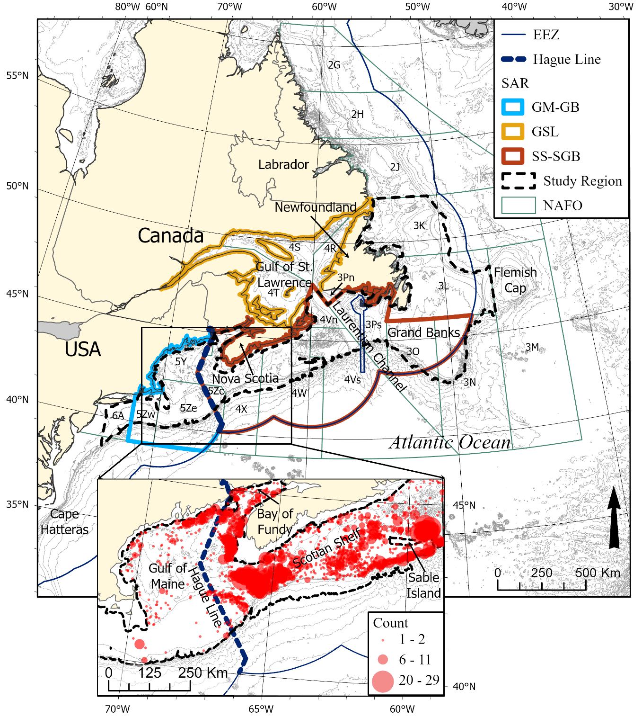
Figure 1

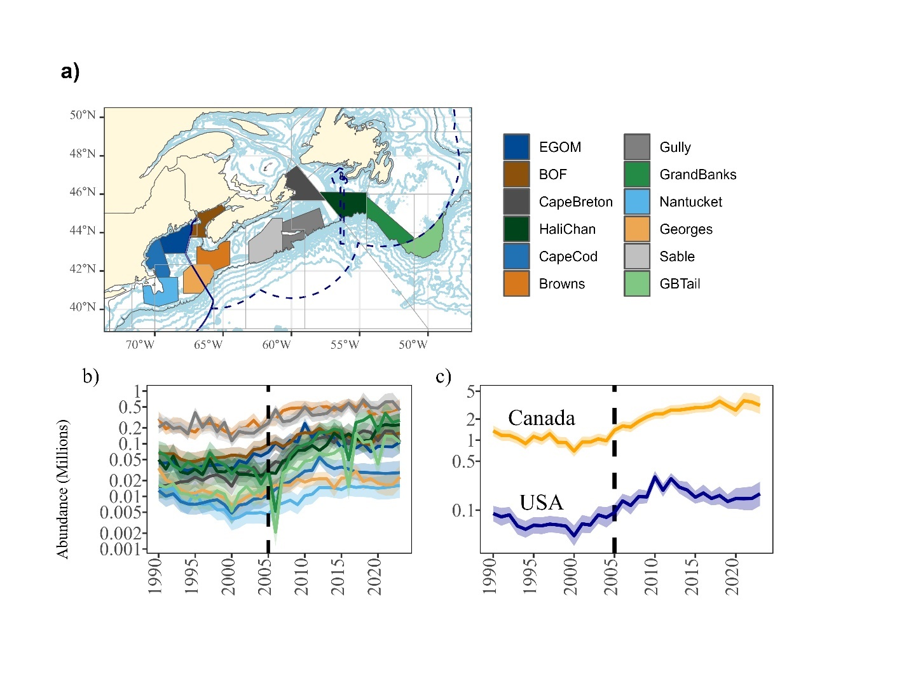
Figure 2

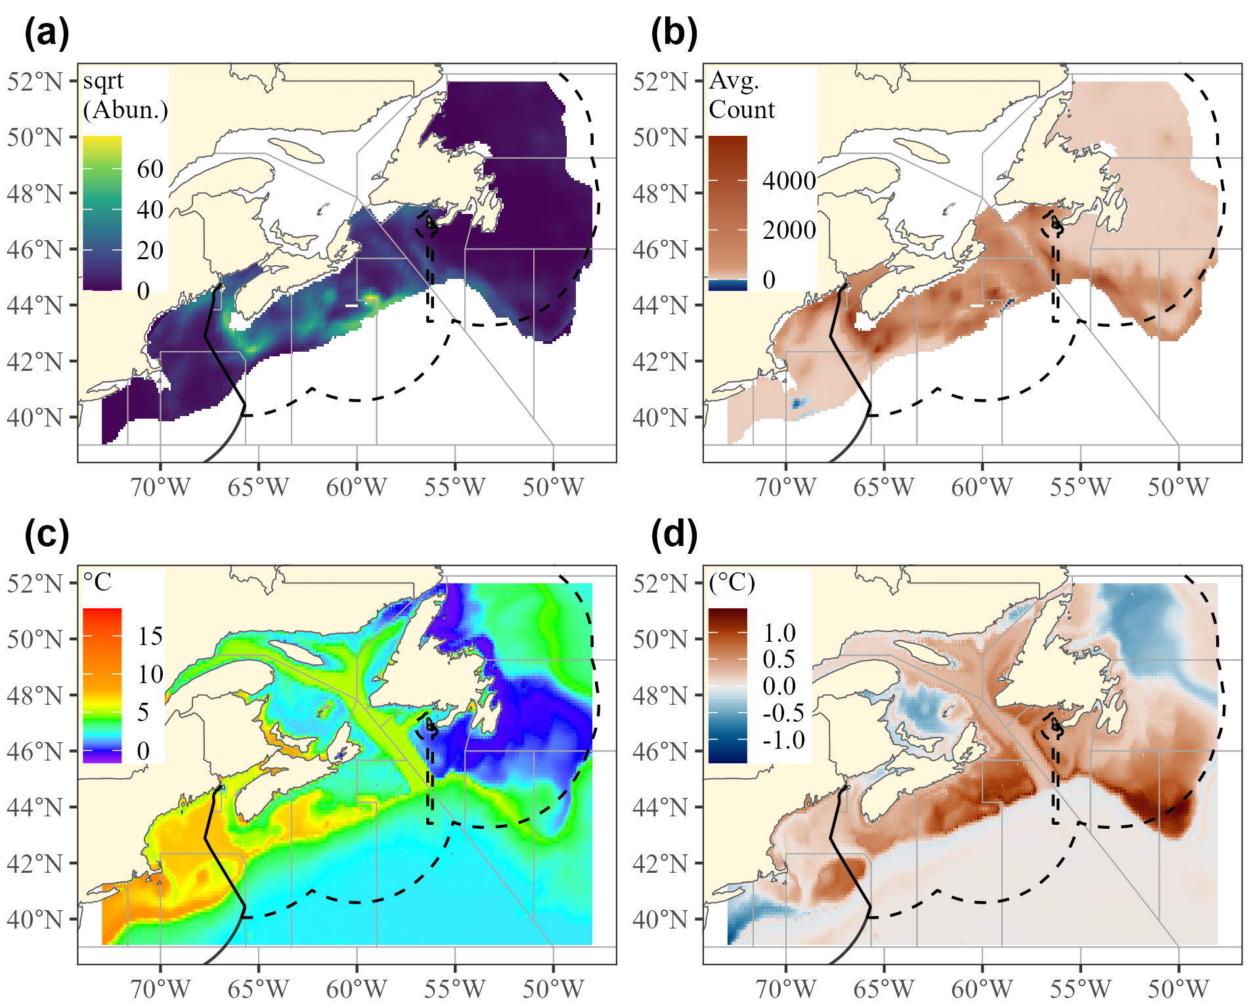
Figure 3

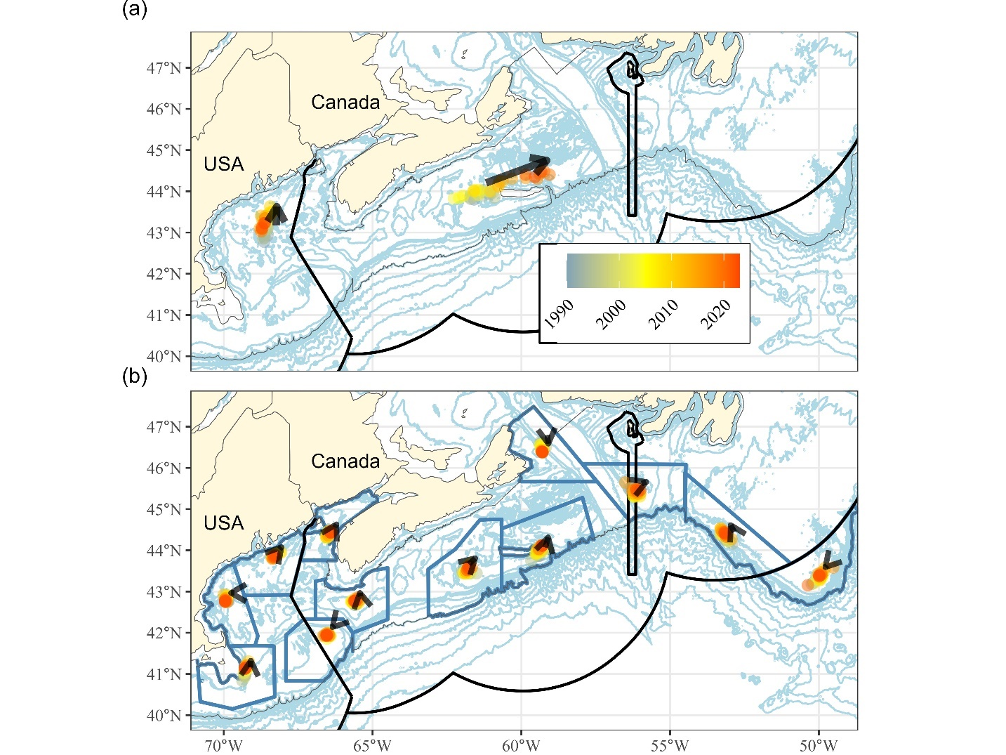
Figure 4

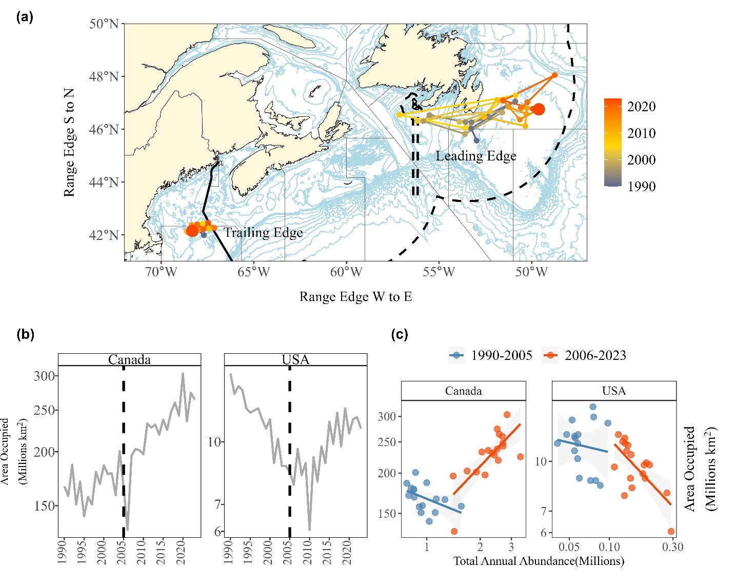
Figure 5

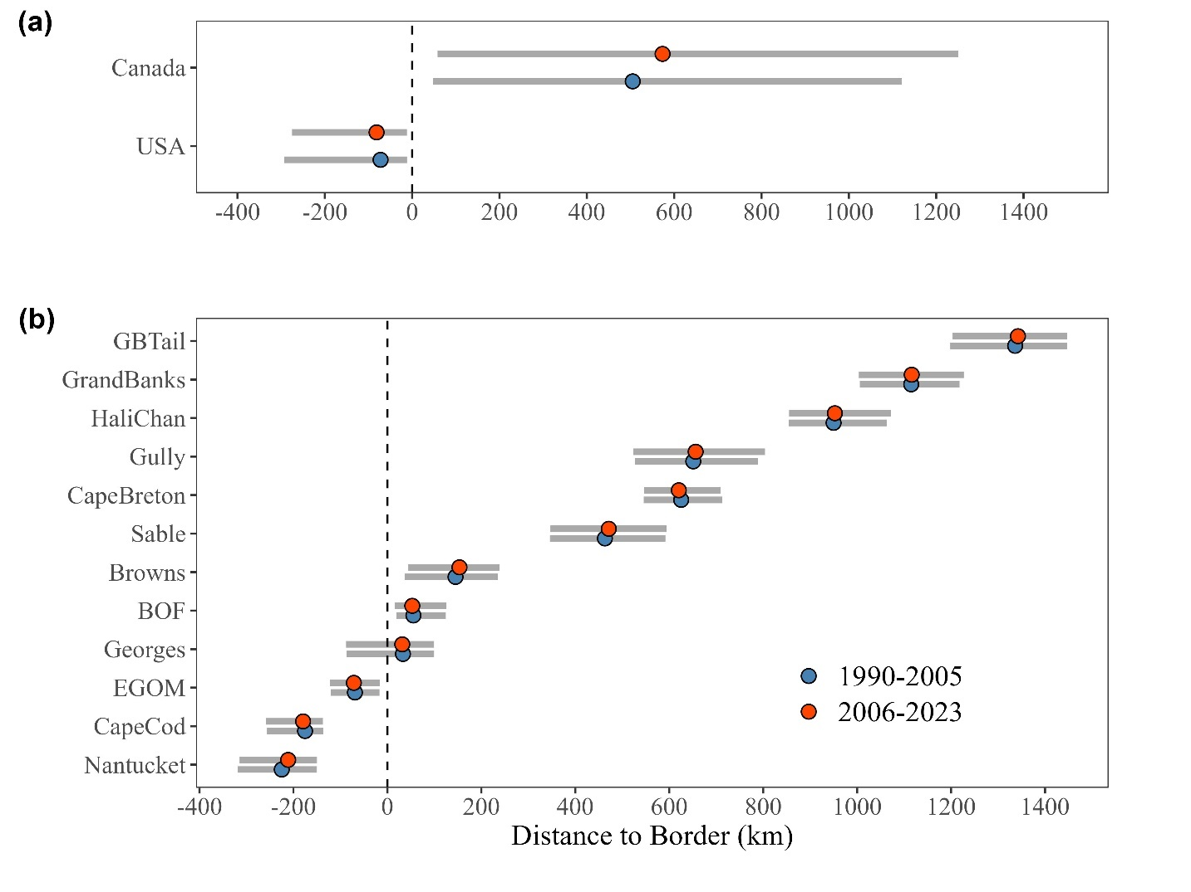
Figure 6

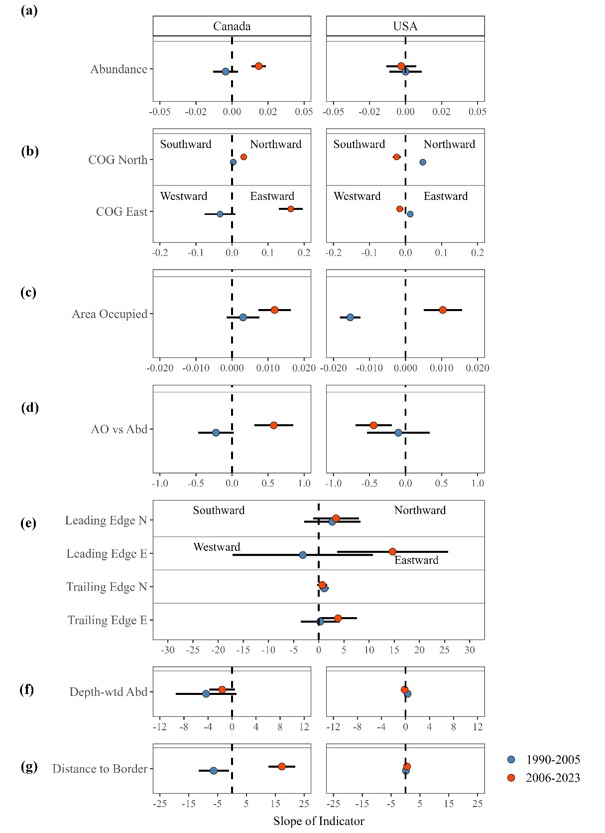
Figure 7

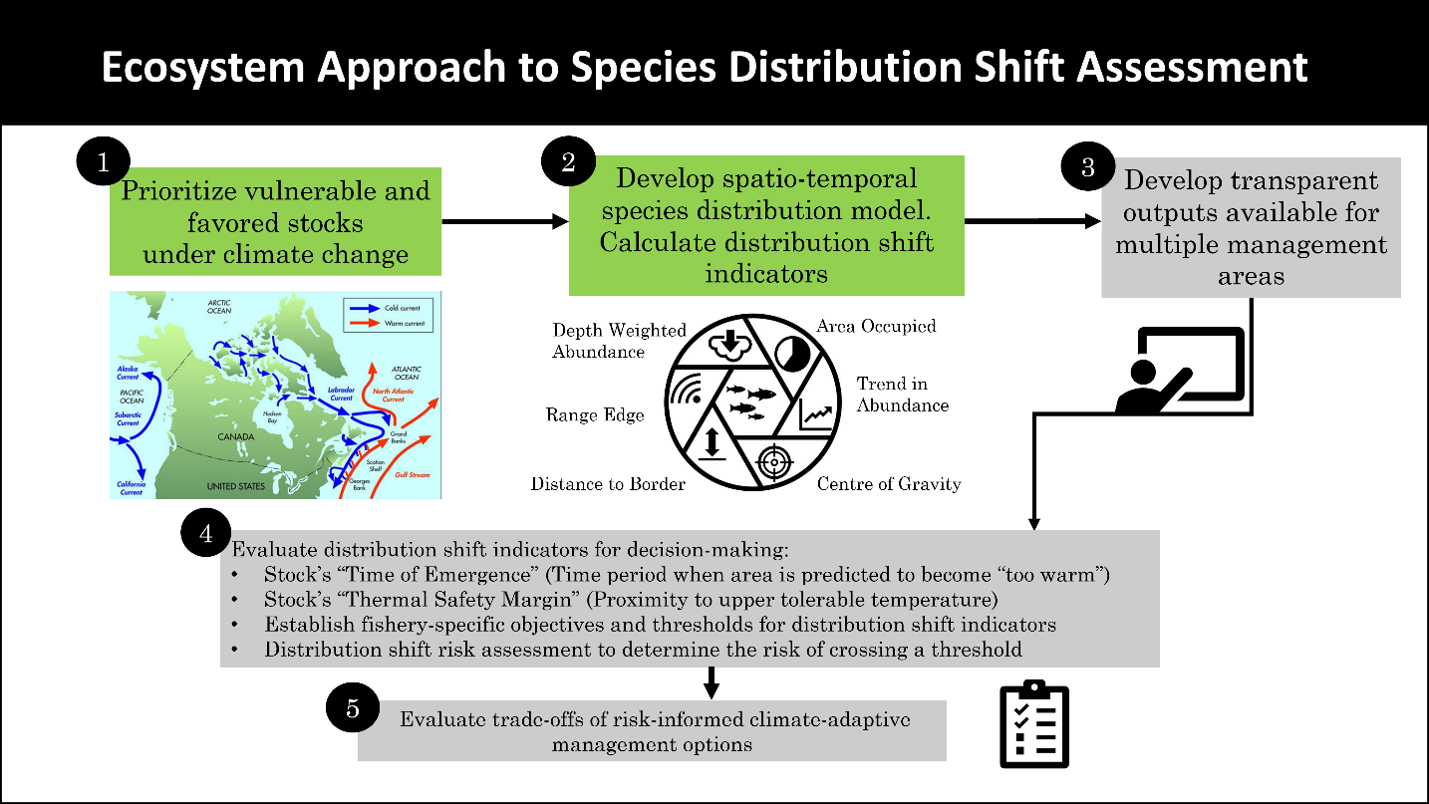
Figure 8

Includes a null (intercept only) model, a model with environmental covariates (“Env”), a model with environmental covariates and spatial random effect (“Env + Sp”), and a fully specified model with environmental covariates, spatial, and spatio-temporal random effects (“Env + Sp + SpT”). Marginal and delta Akaike Information Criterion (AIC) were used to evaluate the model’s parsimony, and predictive performance statistics (area under the receiver-operator curve (AUC), root mean squared error (RMSE), and mean absolute error (MAE) were all calculated by comparing model predictions to held-out observations between 2019-2023.

