Problem 2
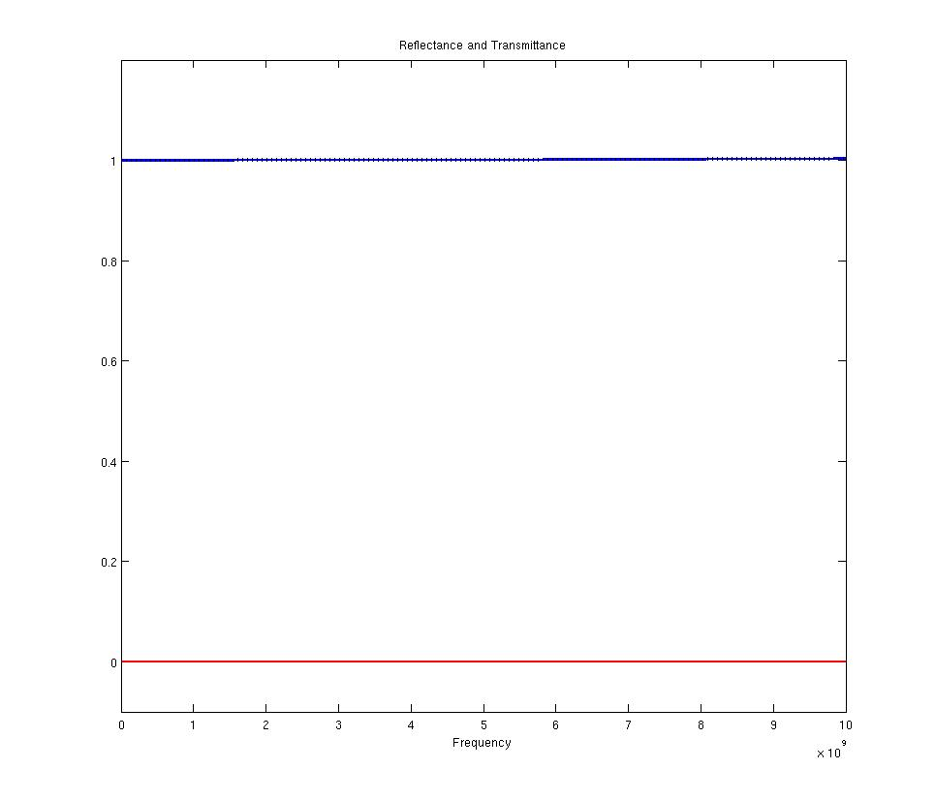

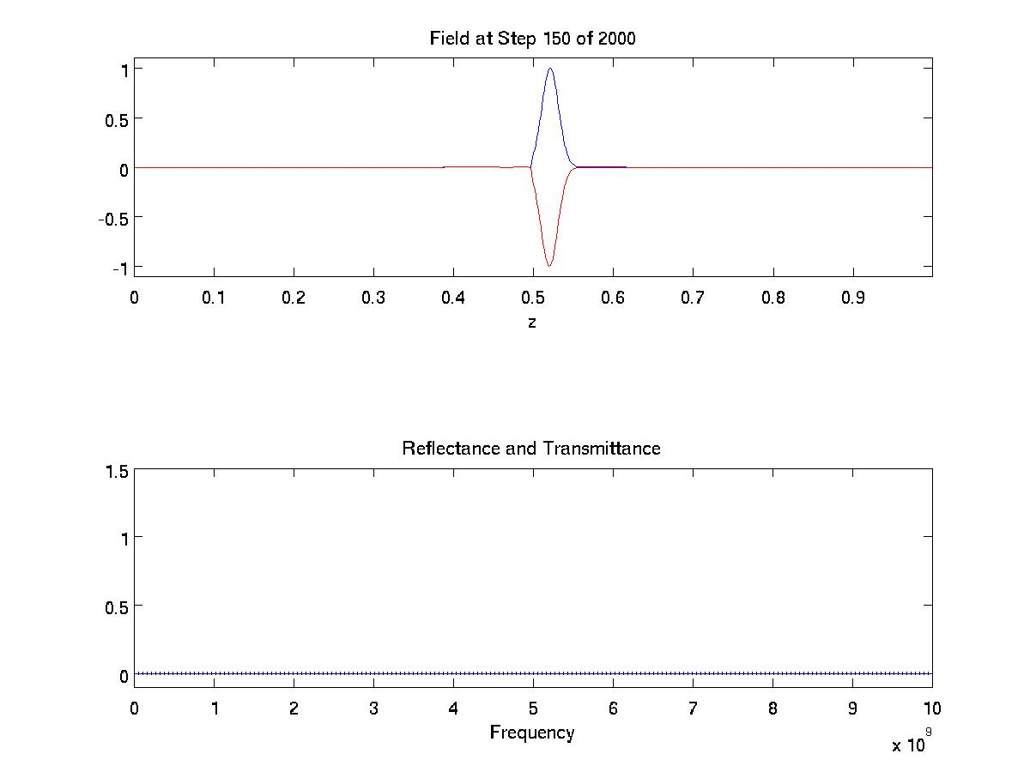

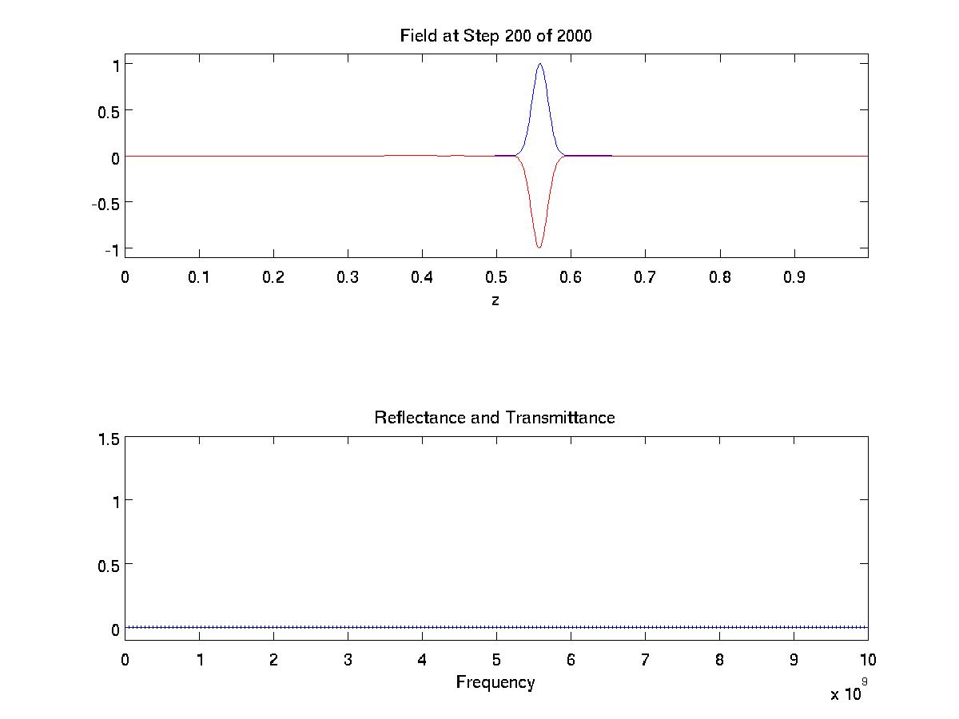
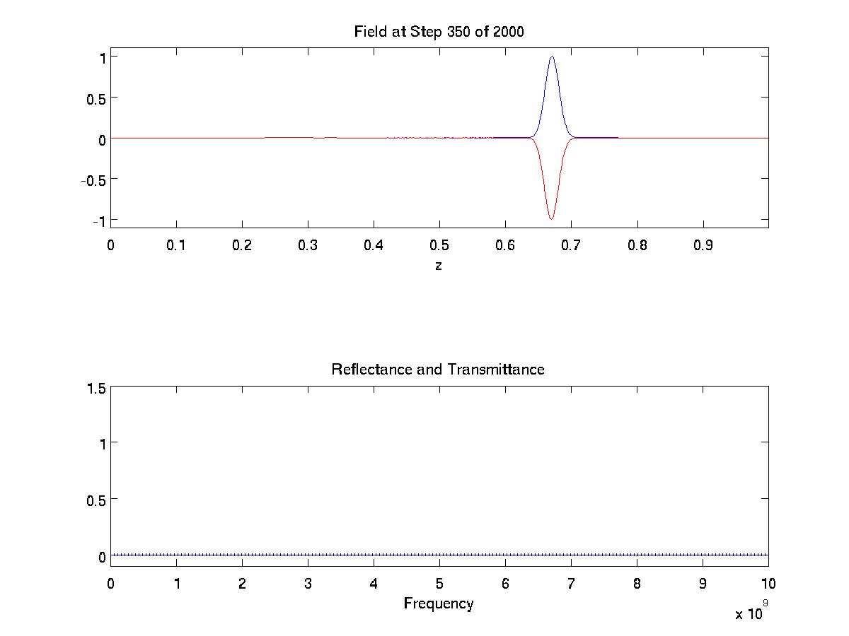
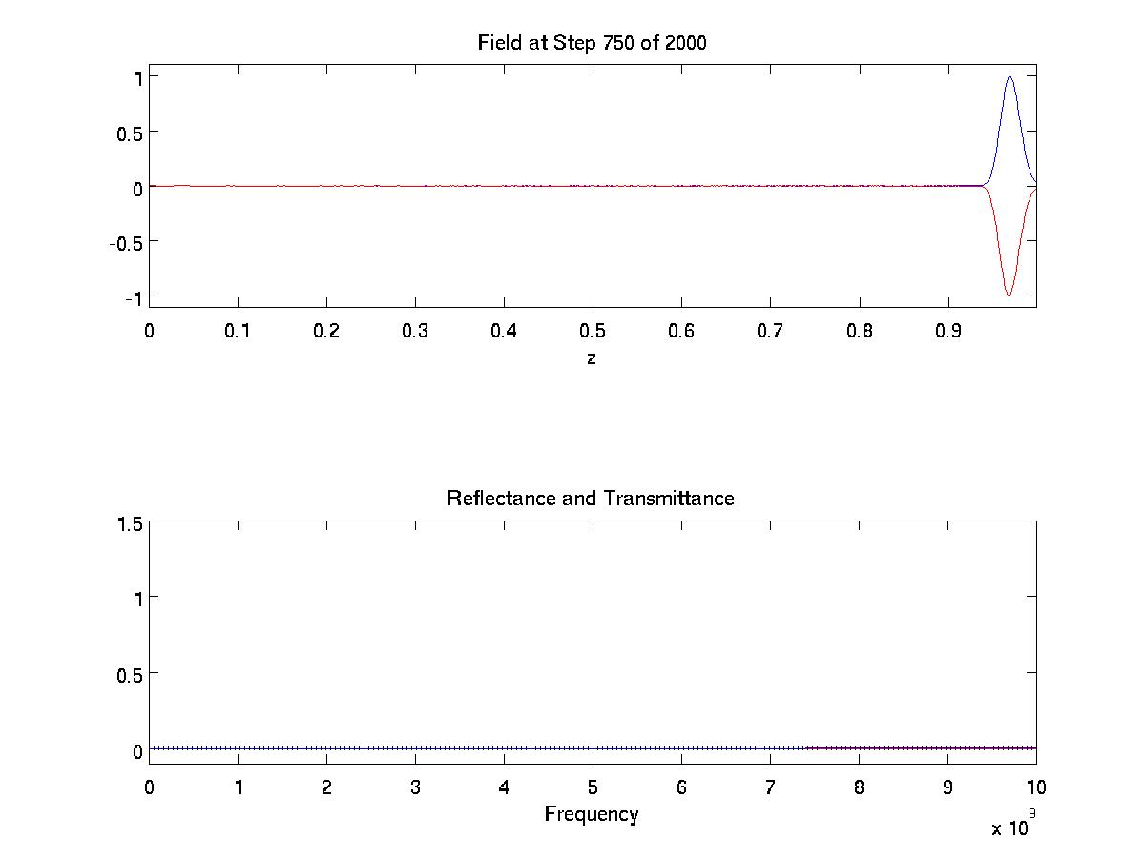
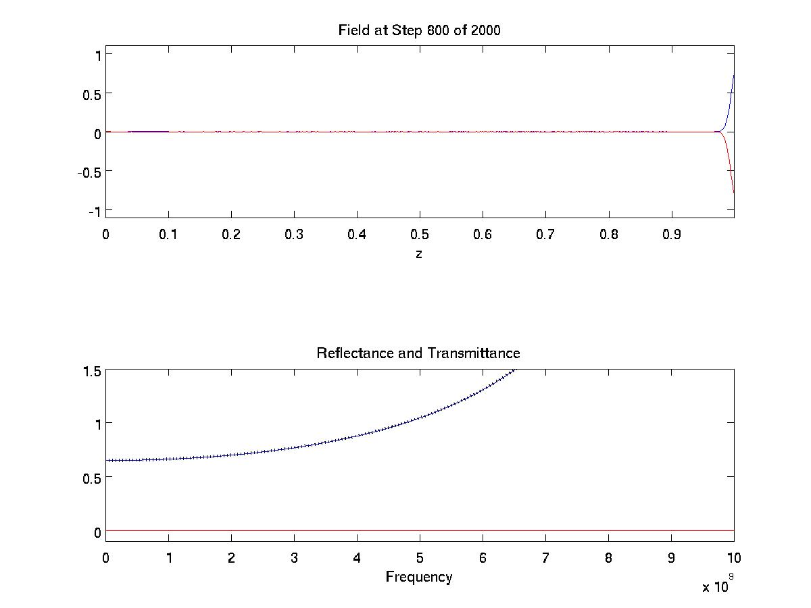
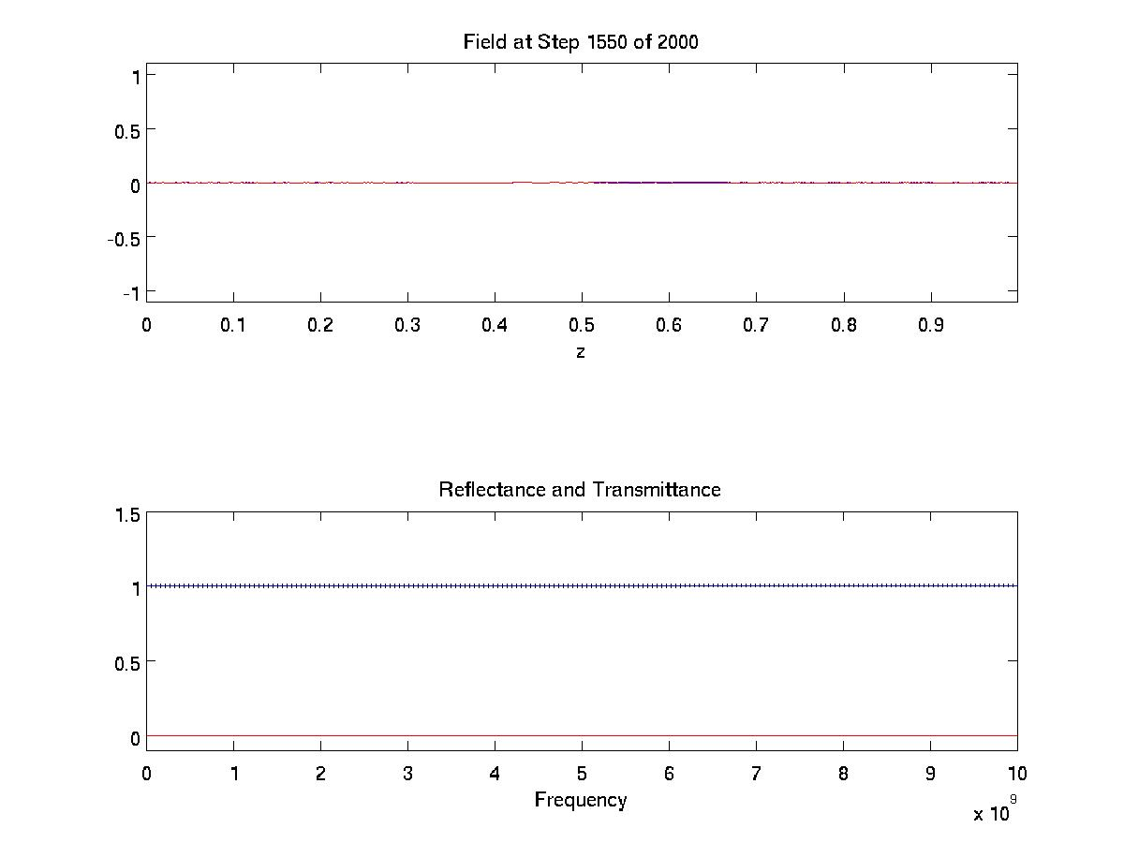
Appendix – P2 Code

%FDTD1D

%%%%%%%%%%%%%%%%%%%%%%%%%%%%%%%%%%%%%%%%%
% Pre-Program Work
%%%%%%%%%%%%%%%%%%%%%%%%%%%%%%%%%%%%%%%%%

% Initialize MATLAB
close all; clc;
clear all;

%Constants
c0 = 299792458; %m/s
e0 = 8.854187817*10^-12; %F/m
u0 = 1.256637061*10^-6; %H/m

%%%%%%%%%%%%%%%%%%%%%%%%%%%%%%%%%%%%%%%%%
% Initialization
%%%%%%%%%%%%%%%%%%%%%%%%%%%%%%%%%%%%%%%%%

%Simulated Environment Settings
STEPS = 2000;
Nz = 180;
dz = 0.02;
f_max = 10e9; % 10Ghz

%Compute Grid Resolution
N_lambda = 20;
lambda_min = c0 / (f_max);
d_wl = lambda_min/N_lambda;
N_d = 4;
d_d = 1/4; % since we are only working with freespace we will set d to 1;
dz = min(d_wl, d_d);
Nz = ceil(1/dz);
dz = 1/Nz;

%Grid Axis
za=[0:Nz-1]*dz;

%Compute Time Steps
dt = dz/(2*c0); %secs
ta = [0:STEPS-1]*dt; % Time Axis;

% Source Parameters
nzc = round (Nz/2); %Position of Sources
NFREQ = f_max / 10e6; %Frequencies every 100Mhz upto 10Ghz
FREQ = linspace(0, f_max, NFREQ); %FREQ List
tau = 0.5/f_max; % tau parameter
t0 = 6*tau; % Delay/Pulse Position

%%%%%%%%%%%%%%%%%%%%%%%%%%%%%%%%%%%%%%%%%
% Model
%%%%%%%%%%%%%%%%%%%%%%%%%%%%%%%%%%%%%%%%%

%Material Vectors
ER = ones([1 Nz]);
UR = ones([1 Nz]);

%%%%%%%%%%%%%%%%%%%%%%%%%%%%%%%%%%%%%%%%%
% Source
%%%%%%%%%%%%%%%%%%%%%%%%%%%%%%%%%%%%%%%%%
s = dz/(2*c0) + dt/2; % Delay between E and H
Esrc = exp(-((ta-t0)/tau).^2); % E Source
A = -sqrt(ER(nzc)/UR(nzc)); % H Amplitude
Hsrc = A*exp(-((ta-t0+s)/tau).^2); % H Source

%%%%%%%%%%%%%%%%%%%%%%%%%%%%%%%%%%%%%%%%%%%%%%%%
%FDTD Initialization
%%%%%%%%%%%%%%%%%%%%%%%%%%%%%%%%%%%%%%%%%%%%%%%%

% Compute Update Coefficients
mER = (c0*dt/dz)./ER;
mHR = (c0*dt/dz)./UR;

% Initialize Feilds
Ey = zeros([1 Nz]);
Hx = zeros([1 Nz]);

%PAB Parameters
h1 = 0; h2 = 0; h3 = 0;
e1 = 0; e2 = 0; e3 = 0;

%Power Measurements
REF = zeros(1, NFREQ);
TRN = zeros(1, NFREQ);
SRC = zeros(1, NFREQ);
K = exp(-1i*2*pi*dt*FREQ);

%%%%%%%%%%%%%%%%%%%%%%%%%%%%%%%%%%%%%%%%%%%%%%%%
% Execute Simulation
%%%%%%%%%%%%%%%%%%%%%%%%%%%%%%%%%%%%%%%%%%%%%%%%

for t = 1:STEPS

% Calculate H
for nz = 1:Nz-1
Hx(nz) = Hx(nz) + mHR(nz)*(Ey(nz+1)-Ey(nz));
end

Hx(Nz) = Hx(Nz) + mHR(Nz)*(e3 - Ey(Nz));

%H Sources
Hx(nzc-1) = Hx(nzc-1) - mHR(nzc-1)*Esrc(t);

h3 = h2; h2 = h1; h1 = Hx(1); % Boundary Params;

% Calculate E
Ey(1) = Ey(1) + mER(1)*(Hx(1) - h3);
for nz = 2:Nz
Ey(nz) = Ey(nz) + mER(nz)*(Hx(nz)-Hx(nz-1));
end

%Inject Source
Ey(nzc) = Ey(nzc) - mER(nzc)*Hsrc(t);

e3=e2; e2=e1; e1=Ey(Nz); % Boundary Params;

%Update Fourier Transforms
for nf = 1: NFREQ
REF(nf) = REF(nf) + (K(nf)^t)*Ey(1)*dt;
TRN(nf) = TRN(nf) + (K(nf)^t)*Ey(Nz)*dt;
SRC(nf) = SRC(nf) + (K(nf)^t)*Esrc(t)*dt;
end

if(mod(t,10) == 0)
h = subplot(11,1,1:4);
plot(za, Ey, '-b'); hold on;
plot(za, Hx, '-r'); hold off;
axis([za(1) za(Nz) -1.1 1.1]);
xlabel('z');
title(['Field at Step ' num2str(t) ' of ' num2str(STEPS)]);

R = abs(REF./SRC).^2;
T = abs(TRN./SRC).^2;

subplot(11,1,8:11)
plot(FREQ, R, '-r'); hold on;
plot(FREQ, T, '-b');
plot(FREQ, R+T, ':k', 'LineWidth', 2); hold off;
axis([FREQ(1) FREQ(NFREQ) -0.1 1.5]);
xlabel('Frequency');
title('Reflectance and Transmittance');
end

drawnow();

%if(mod(t,50) == 0)
% saveas(h, ['images/' num2str(t) '.jpg'], 'jpg');
%end
end

%%%%%%%%%%%%%%%%%%%%%%%%%%%%%%%%%%%%%%%%%%%%%%%%
% Compute Values
%%%%%%%%%%%%%%%%%%%%%%%%%%%%%%%%%%%%%%%%%%%%%%%%

REF = abs(REF./SRC).^2;
TRN = abs(TRN./SRC).^2;
CON = REF+TRN;

%%%%%%%%%%%%%%%%%%%%%%%%%%%%%%%%%%%%%%%%%%%%%%%%
% Plot Fields
%%%%%%%%%%%%%%%%%%%%%%%%%%%%%%%%%%%%%%%%%%%%%%%%
fig = figure;
SetFigure(fig, 'HW#5-P2', [500 274 965 826]);

plot(FREQ, REF, '-r', 'LineWidth', 2); hold on;
plot(FREQ, TRN, '-b', 'LineWidth', 2);
plot(FREQ, CON, ':k', 'LineWidth', 3); hold off;
axis([FREQ(1) FREQ(NFREQ) -0.1 1.2]);
xlabel('Frequency');
title('Reflectance and Transmittance');

