P1 – Calculate PML Parameters
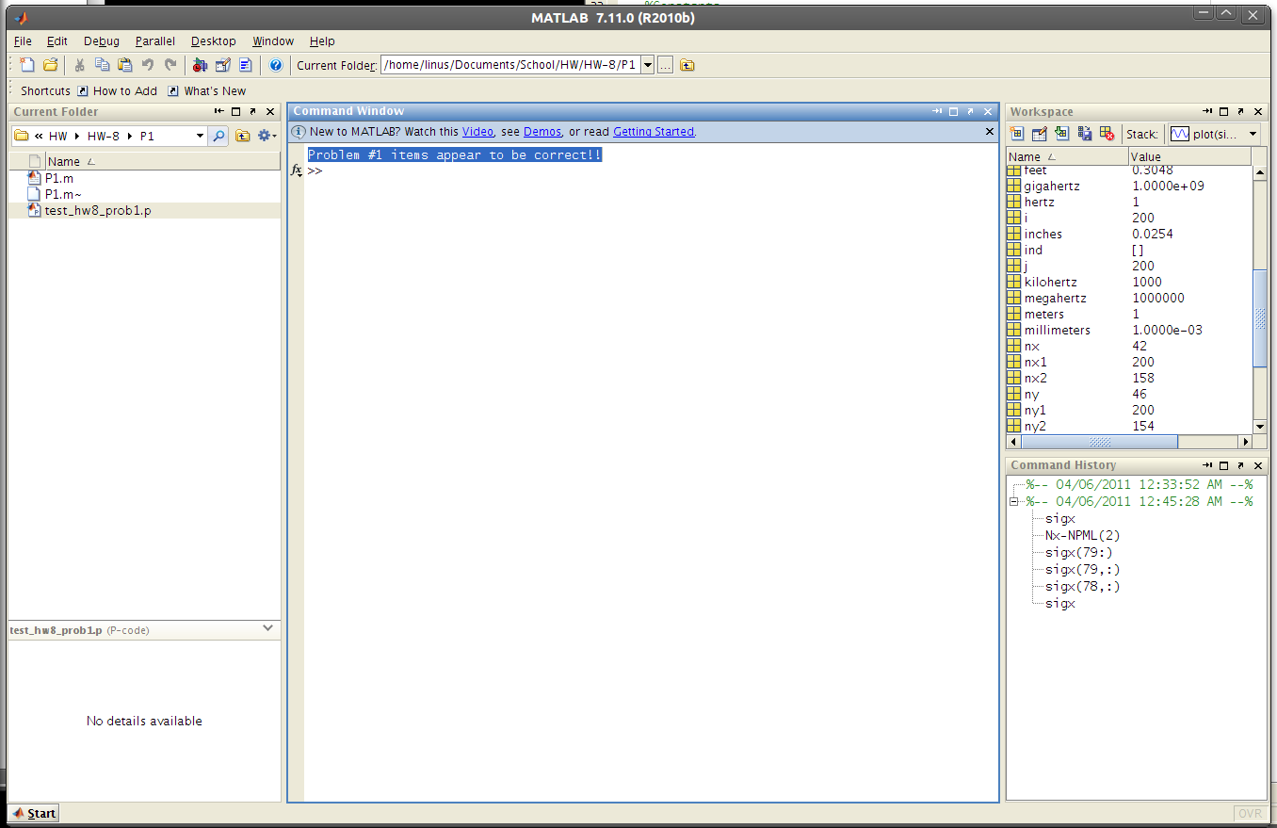

%%%%%%%%%%%%%%%%%%%%%%%%%%%%%%%%%%%%%%%%%
% Pre-Program Work
%%%%%%%%%%%%%%%%%%%%%%%%%%%%%%%%%%%%%%%%%

% Initialize MATLAB
close all; clc;
clear all;

% UNITS
meters = 1;
decimeters = 1e-1 * meters;
centimeters = 1e-2 * meters;
millimeters = 1e-3 * meters;
inches = 2.54 * centimeters;
feet = 12 * inches;
seconds = 1;
hertz = 1/seconds;
kilohertz = 1e3 * hertz;
megahertz = 1e6 * hertz;
gigahertz = 1e9 * hertz;

%Constants
c0 = 299792458; %m/s
e0 = 8.854187817*10^-12; %F/m
u0 = 1.256637061*10^-6; %H/m

%%%%%%%%%%%%%%%%%%%%%%%%%%%%%%%%%%%%%%%%%
% Initialization of Parameters
%%%%%%%%%%%%%%%%%%%%%%%%%%%%%%%%%%%%%%%%%

Nx = 100;
Ny = 100;
NPML = [20 21 22 23];
dx = 0.1;
dy = 0.1;
dt = 1.6e-10;
tau = 3.3e-9;
STEPS = 500;

% Compute 2x Grid
Nx2 = 2*Nx;
Ny2 = 2*Ny;

%%%%%%%%%%%%%%%%%%%%%%%%%%%%%%%%%%%%%%%%%
% Calculate PML Parameters
%%%%%%%%%%%%%%%%%%%%%%%%%%%%%%%%%%%%%%%%%

% Compute sigx
sigx = zeros(Nx2, Ny2);
for nx=1:2*NPML(1)
i = 2*NPML(1) - nx + 1;
sigx(i, :) = (0.5*e0/dt)*(nx/2/NPML(1))^3;
end
for nx=1:2*NPML(2)
i = Nx2 - 2*NPML(2) + nx;
sigx(i, :) = (0.5*e0/dt)*(nx/2/NPML(2))^3;
end

% Compute sigy
sigy = zeros(Nx2, Ny2);
for ny=1:2*NPML(3)
j = 2*NPML(3) - ny + 1;
sigy(:,j) = (0.5*e0/dt)*(ny/2/NPML(3))^3;
end
for ny=1:2*NPML(4)
j = Ny2 - 2*NPML(4) + ny;
sigy(:,j) = (0.5*e0/dt)*(ny/2/NPML(4))^3;
end

test_hw8_prob1

