P2 – Compute Update Coefficients

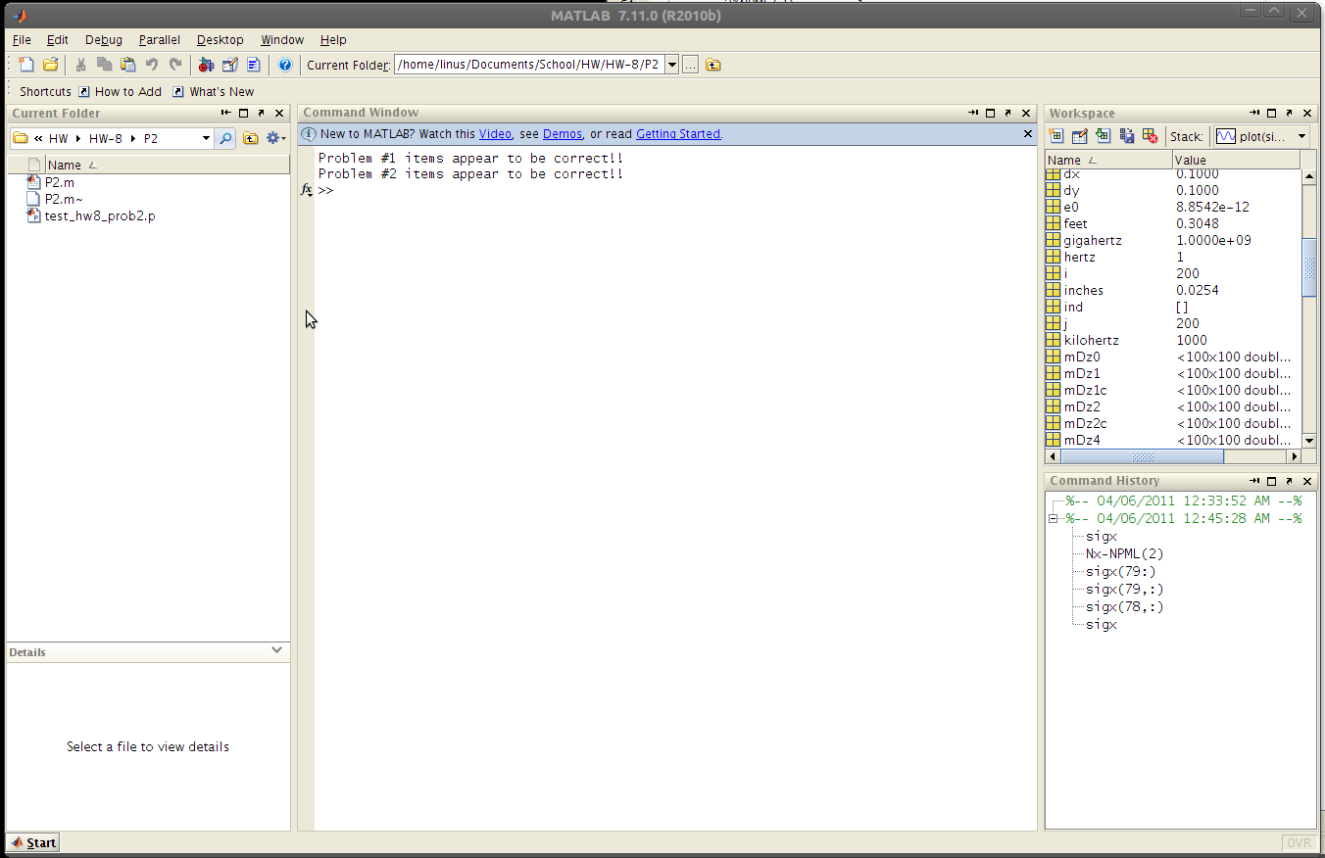

%%%%%%%%%%%%%%%%%%%%%%%%%%%%%%%%%%%%%%%%%%%%%%%%
%FDTD Initialization
%%%%%%%%%%%%%%%%%%%%%%%%%%%%%%%%%%%%%%%%%%%%%%%%

% Material Properties
URxx = ones(Nx,Ny);
URyy = ones(Nx,Ny);
ERzz = ones(Nx,Ny);

% Update Coefficients
sigHx = sigx(1:2:Nx2, 2:2:Ny2);
sigHy = sigy(1:2:Nx2, 2:2:Ny2);

mHx0 = 1/dt + (sigHy/(2*e0));
mHx1 = (1/dt - (sigHy/(2*e0)))./mHx0;
mHx2 = -(c0./URxx)./mHx0;
mHx3 = -((c0*dt/e0)*(sigHx./URxx))./mHx0;

sigHx = sigx(2:2:Nx2, 1:2:Ny2);
sigHy = sigy(2:2:Nx2, 1:2:Ny2);
mHy0 = (1/dt)+(sigHx/(2*e0));
mHy1 = (1/dt - (sigHx/(2*e0)))./mHy0;
mHy2 = -(c0./URyy)./mHy0;
mHy3 = -((c0*dt/e0)*sigHy./URyy)./mHy0;

sigDx = sigx(1:2:Nx2, 1:2:Ny2);
sigDy = sigy(1:2:Nx2, 1:2:Ny2);
mDz0 = (1/dt) + ((sigDx + sigDy)/(2*e0)) + (sigDx.*sigDy)*dt/(4*e0^2);
mDz1 = ((1/dt) - ((sigDx + sigDy)/(2*e0)) - (sigDx.*sigDy)*dt/(4*e0^2)) ./mDz0;
mDz2 = c0./mDz0;
mDz4 = - (dt/e0^2)*sigDx.*sigDy./mDz0;

mEz1 = 1./ERzz;

test_hw8_prob2

