Josh Eads

CIS 234A

Spring 2015

Assignment 1: Project Introduction

1. **Select Stories**
   * STORY – Foundation – N-Item Sort – Admin Set-Up
   * STORY – Foundation – N-Item Sort – User Taking Test
   * STORY – Progress Meter
   * STORY – Cumulative Statistics
2. **Clarifying Questions** (questions coincide with number 1 above, a-d)
   * STORY – Foundation – N-Item Sort – Admin Set-Up
     1. Do you want to save tests, so they can be reused?
     2. Or is every test new, such that nobody’s taken it before?
   * STORY – Foundation – N-Item Sort – User Taking Test
     1. How many questions/items are going to be compared (ballpark)?
     2. Will the user be shown their results from the test?
3. User Interface Sketches
   * STORY – Foundation – N-Item Sort – Admin Set-Up

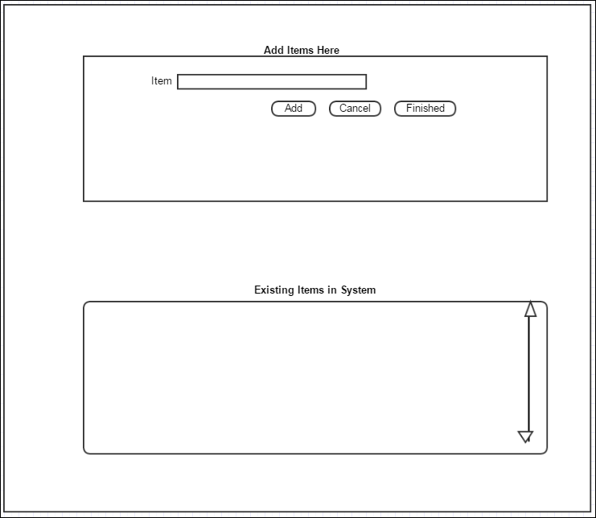

* 1. STORY – Foundation – N-Item Sort – User Taking Test

Test Taking Page:

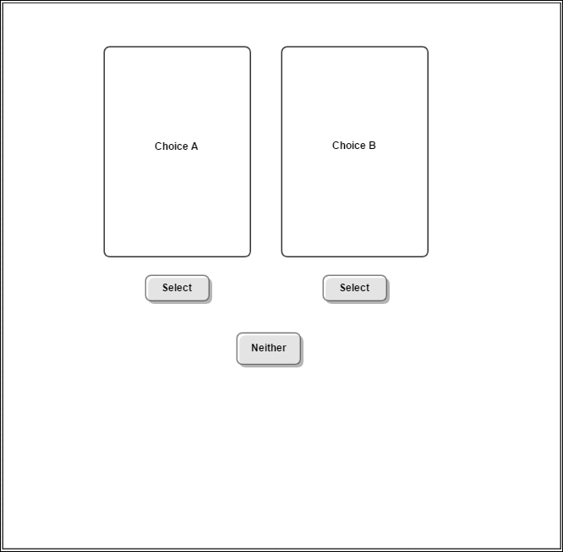

“You’re Finished”:

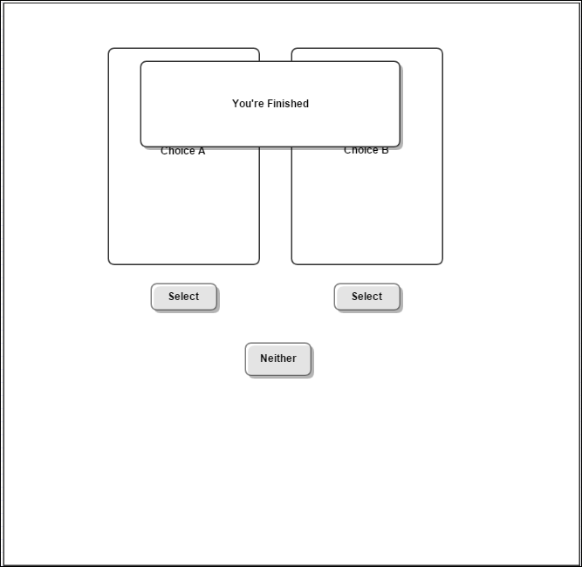

1. STORY – Progress Meter

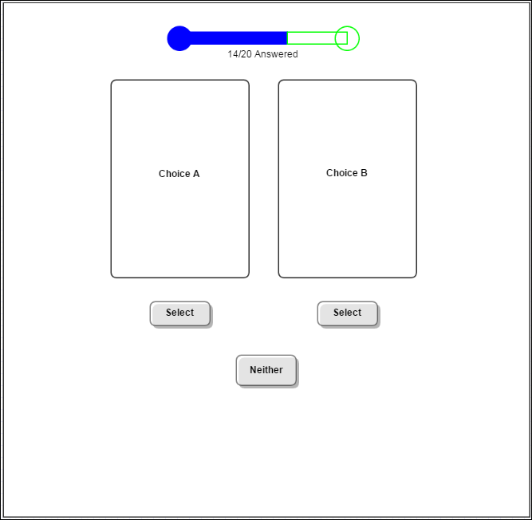

1. STORY – Cumulative Statistics

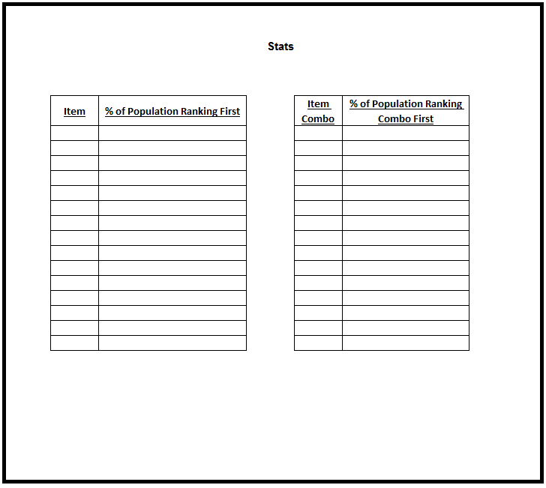

1. **Implementation Notes**
   * **Twitter Bootsrap for HTML/CSS styling**
   * **IntelliJ for IDE (Java)**
   * **GitHub for version control**
   * **MS SQL Server for database, and host on PCC’s servers**
   * **Develop algorithm to account for all pairs needing to be compared to each other.**
   * **Trello for project management/collaboration**
   * **java.awt.\***