**Assignment 1: Project Introduction**

See my comments below in red – Cara

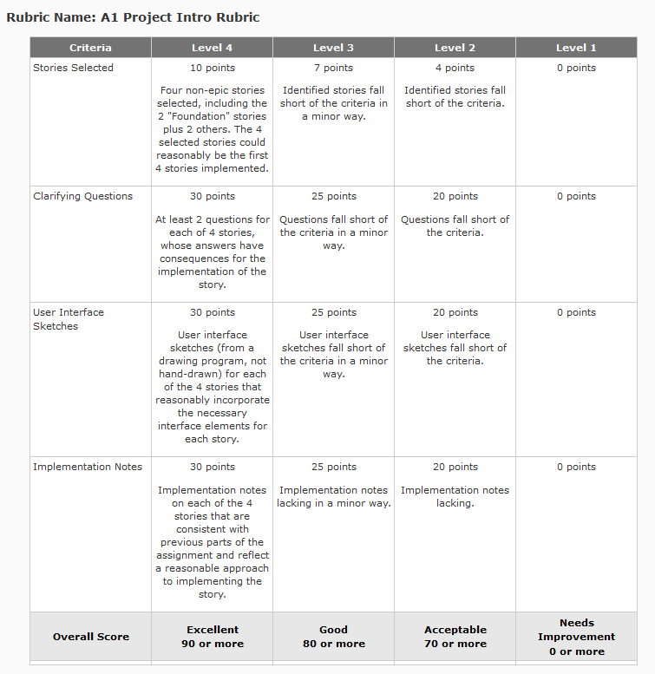

**##### STORY – Foundation – N-item Sort – Admin Set-up #####**

AS A Business

I WANT to define a system whereby people can directly compare N items in groups of 2 and store their responses

SO THAT I can analyze their responses and calculate a bias-free ranking

GIVEN an administrator setting up the test

AND no items currently exist in the system (e.g., stored in the database)

WHEN the administrator goes to define the N items

THEN the administrator is presented with the ability to enter any number of items, where an item is a word or phrase (text data)

AND there is a way for the administrator to indicate when he/she is finished entering items (such as a “Finish” button)

AND there is a way to cancel the task (such as a “Cancel” button)

GIVEN an administrator setting up the test

AND some items already exist in the system (e.g., stored in the database)

WHEN the administrator goes to define the N items

THEN the administrator is presented with a non-editable list of existing items in the system

GIVEN an administrator entering items to define a test

AND fewer than 2 items have been entered

WHEN the administrator begins entering items

THEN the “Finish” action is disabled

GIVEN an administrator entering items to define a test

AND at least 2 items have been entered

WHEN the administrator enters the 2nd item

THEN the “Finish” action is enabled

**My Questions:**

1. **Will there be more than one administrator account?**
2. **Will there be only one test defined in the system at any given time?**
3. **Will a previous test have the ability to be saved in a database to be used again or simply for historical purposes?**
4. **Will the administrator have the ability to delete/edit recently added item(s) to the database, but prior to the ‘FINISH’ button being clicked? (e.g. error in spelling , grammar, punctuation)**
5. **Will the administrator have the ability to delete/edit existing items in the database?**
6. **Will the Admin Setup page contain instructions or will instructions be a separate document outside of the application? Good to think about documentation**

**IMPLEMENTATION NOTES:**

**- Admin Username AND Password credentials will be configured in the database manually.**

**- Login page has an input box for the Username, an input box for the Password, a button to Login, AND a link to the Registration page for first time users. A registration page seems to contradict your previous point that admin credentials will be configured in the database manually.**

**- Unsuccessful username AND password entries will respond with  
 “Invalid Username and Password, please try again.”**

**- Once the administrator has logged in successfully THEN the Admin Setup page is shown.**

**- The ‘FINISH’ button on the Admin Setup page is initially disabled.**

**- Any existing items in the database are shown AND initially de-selected.**

**- The Admin has the ability to select the existing item(s) to be used as part of the test.**

**- The Admin can add a new word or phrase (text data) to the existing database.**

**- Once the Admin has selected two or more existing items to be used in the test THEN the ‘FINISH’ button is enabled.**

**-Once the ‘FINISH’ button is clicked THEN the Admin will see a Test Setup Success page.**

**-The Admin Setup page ‘CANCEL’ button will log out the Admin AND return them to the login screen.**

**- The Test Setup Success Page will have a button for the Admin to logout and end the session.**

**These are good criteria for fleshing out how the application will behave, but they don’t really address the implementation.**

**##### STORY – Foundation – N-item Sort – User Taking Test #####**

AS A User

I WANT to take a test that directly compares N items in groups of 2 and stores my responses

SO THAT I can understand my preferences

GIVEN some number of items configured (e.g. words)

WHEN the user goes to the test

THEN the user is assigned a unique test-session ID

GIVEN a user taking the test, with a unique test-session ID

WHEN the user begins the test

THEN the user is presented with two items (e.g. words) to choose from

AND can select one, the other, or “I can’t decide”

AND their choice is stored somewhere (e.g. written to a database)

AND that choice is stored as one “win” for the item they chose and one “loss” for the item they didn’t choose, or a “tie” for both items if the user chose “I can’t decide”

GIVEN a user taking the test

AND they have provided answers to every combination of A and B items

WHEN the user would be shown a pair of items

THEN instead they see something else (e.g. a “you’re finished!” message, or the results - TBD)

**My Questions:**

1. **During the test will the user know what choice number they are on and how many choices the test they are taking contains?**
2. **During the test will the user be able to go back and change an answer to a question once their choice has been made (e.g. change selection, error click)?**
3. **Will the instructions for the test be in a view prior to the test, in the same view as the test or will the instructions be on a separate document that the user has during the test?**
4. **Will the results be just their results for this test, or their results incorporated with everyone else who has taken the same test? Buttons for both types of test results?**
5. **Can a user save their progress during a test to finish later if they are unable to finish the test for some reason (e.g. family emergency, gets sick, internet crashes)? Good question, this may elicit a new story that is needed.**

**IMPLEMENTATION NOTES:**

* **Login page has an input box for the Username, an input box for the Password, a button to Login, AND a link to the Registration page for first time users.**
* **- Unsuccessful username AND password entries will respond with  
   “Invalid Username and Password, please try again.”**
* **The Registration page has input for First Name, Last name, E-Mail, Username, and Password.**
* **The Registration Page has a submit button that creates the first time user account THEN shows the Successful Registration page.**
* **The Registration page has a button to cancel registration AND return the user to the login page.**
* **The Successful Registration page has a button to take the user to the login page.**
* **Once the user has successfully been able to login, the User Welcome page is shown with instructions on how to take the test with a button to continue to the beginning of the test.**
* **The User Test page will ask the user ‘which do you prefer?’ with the ability to select one of the two choices, with a third option ‘I can’t decide’ for each of the individual questions in the test.**
* **The User Test page will show which question they are currently on (x) along with how many questions there are for the test (y) e.g. ‘Question x of y’**
* **The User Test page will show the Unique Test Session ID on the page during the test**
* **After the last question on the test has been answered, the user will be shown a Test Completion Success page and be shown a button to see the results.**
* **The Test Results page will have items from the test displayed showing the wins, losses, ties sorted by their will-loss-tie ranking record AND a button to log out.**

**##### STORY – User Tracking #####**

AS A Business

I WANT the ability to associate test results with a particular user

SO THAT I can find them again

GIVEN a user taking a test

WHEN the test is started

THEN the user is prompted for their personal info (e.g. email)

AND this info is saved somewhere (e.g., to a database)

**My Questions:**

1. **Will the results be shown by Username or Username? Username or Username?**
2. **Will each user register personal info and create a login for each test they take?**
3. **Will a user take a test more than once?**
4. **Will a user take more than one test?**
5. **Can the user information be captured before the test is started?**

**IMPLEMENTATION NOTES:**

* **There will be a database of users and a database of test results.**
* **The user’s database will contain the Username, First Name, Last Name, E-mail, Username, and Password.**
* **The user’s database primary key will be the Username.**
* **The test results database will contain the Unique Test Session ID, Username, word or phrase (text data), Wins, Losses, and Ties.**
* **The test results database primary key will be the Unique Test Session ID.**
* **The test results database foreign key will be the user database_Username.**
* **The login page will have a link to a registration page for first time users**
* **The registration page will save the users personal info and create a username and password.**
* **Once the user successfully logs in, the test will be shown**
* **Once the test is shown the unique test session ID is created and associated to the username.**

**##### STORY – Basic Result Reporting #####**

AS A Business

I WANT the ability to view the ranked items for a given user

SO THAT I can use that information for business decisions

(e.g. talk about it with client)

GIVEN a user who has finished the ranking process

WHEN I pull up their ranking results

THEN I can see the items in ranking order, where the order is calculated based on 1 point for a win, 0 points for a tie and -1 point for a loss

AND I can see the win-loss-tie record for each item

**My Questions:**

1. **Will the results be available to the user after the test or only to the Admin for the Admin to discuss with the User at a later time?**
2. **Will the results page have a button to create a printable results page for physical distribution?**
3. **Will the results be for all the tests the user has taken? Or for just the last test the user has taken? Or both?**

**IMPLEMENTATION NOTES:**

* **The Test Results database will have a primary key of Unique Test Session ID**
* **The Test Results database will have a foreign key of the Username from the Users database**
* **The Results page will show the Unique Test Session ID along with the Username, each item from the test with each items win, loss, ties, and Total Points.**

**Nice job with the screens**

**Login Page**

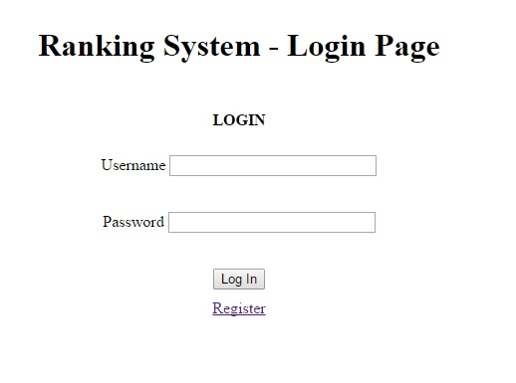

**Registration Page**

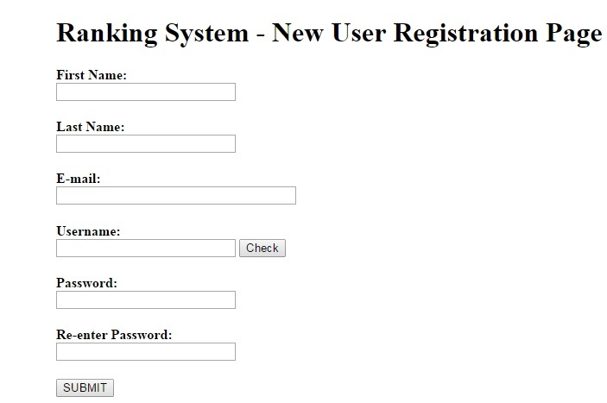

**Successful Registration Page**

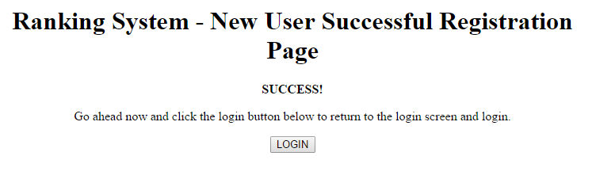

**Admin Setup Page**

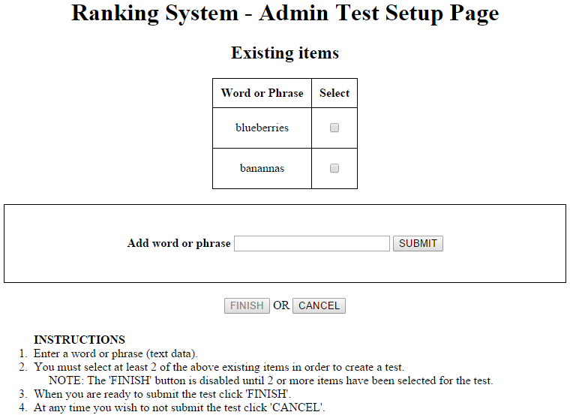

**Test Setup Success Page**

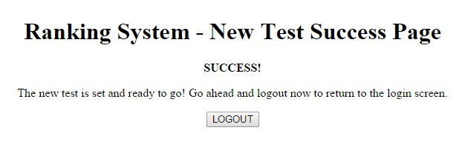

**User Welcome Page**

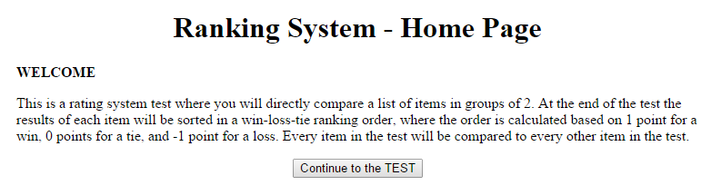

**User Test Page**

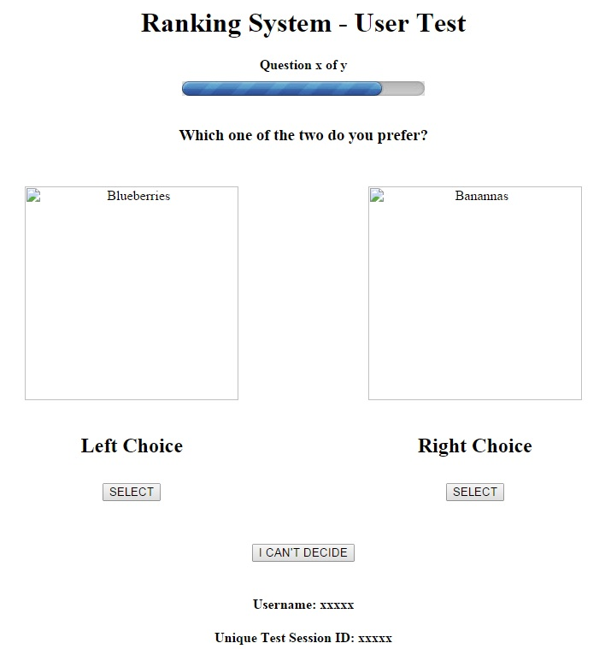

**Test Completion Success page**

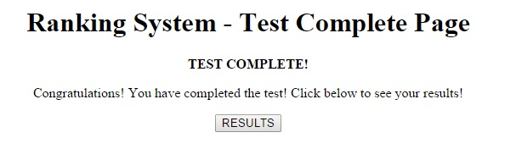

**Test Results Page**

