ĐẶC TẢ MÀN HÌNH G10-G13 (VERSION 1)

## Mockup:

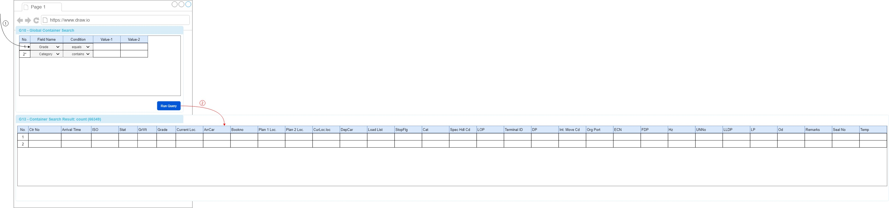

Hình : Đặc tả màn hình G10-G13 ver1.0

## Đặc tả:

* Trên Gridview G10-Global Container Search bao gồm các columns:

### Component input:

#### Value-1

##### Desc: giá trị thứ nhất.

##### Component type: input text.

##### Validation:

#### Value-2

##### Desc: Giá trị thứ hai.

##### Component type: input text.

##### Validation:

### Component output:

#### No (G10)

##### Desc: Số tự tăng.

##### Component type: label.

##### Validation:

#### Field Name

##### Desc: Tên trường cần thực hiện so sánh.

##### Component type: dropdown-list.

##### Validation:

#### Condition

##### Desc: Phép toán so sánh.

##### Component type: dropdown-list.

##### Validation:

#### No (G13)

##### Desc: Số tự tăng.

##### Component type: label.

##### Validation:

#### Ctr No

##### Desc:

##### Component type: label

##### Validation:

#### Arrival Time

##### Desc:.

##### Component type: label

##### Validation:

#### ISO

##### Desc:.

##### Component type: label

##### Validation:

#### Stat

##### Desc:.

##### Component type: label

##### Validation:

#### GrWt

##### Desc:.

##### Component type: label

##### Validation:

#### Grade

##### Desc: Số tự tăng.

##### Component type: label.

##### Validation:

#### Current Loc.

##### Desc:

##### Component type: label

##### Validation:

#### ArrCar

##### Desc:.

##### Component type: label

##### Validation:

#### Book No

##### Desc:.

##### Component type: label

##### Validation:

#### Plan 1 Loc.

##### Desc:.

##### Component type: label

##### Validation:

#### Plan 2 Loc.

##### Desc:.

##### Component type: label

##### Validation:

#### CurLoc.loc

##### Desc: Số tự tăng.

##### Component type: label.

##### Validation:

#### DepCar

##### Desc:

##### Component type: label

##### Validation:

#### Load List

##### Desc:.

##### Component type: label

##### Validation:

#### StopFlg

##### Desc:.

##### Component type: label

##### Validation:

#### Cat

##### Desc:.

##### Component type: label

##### Validation:

#### Spec Hdl Cd

##### Desc:.

##### Component type: label

##### Validation:

#### LOP

##### Desc: Số tự tăng.

##### Component type: label.

##### Validation:

#### Terminal ID

##### Desc:

##### Component type: label

##### Validation:

#### DP

##### Desc:.

##### Component type: label

##### Validation:

#### Int. Move Cd

##### Desc:.

##### Component type: label

##### Validation:

#### Org Port

##### Desc:.

##### Component type: label

##### Validation:

#### ECN

##### Desc:.

##### Component type: label

##### Validation:

#### FDP

##### Desc: Số tự tăng.

##### Component type: label.

##### Validation:

#### Hz

##### Desc:

##### Component type: label

##### Validation:

#### UNNo

##### Desc:.

##### Component type: label

##### Validation:

#### LLDP

##### Desc:.

##### Component type: label

##### Validation:

#### LP

##### Desc:.

##### Component type: label

##### Validation:

#### Od

##### Desc:.

##### Component type: label

##### Validation:

#### Remarks

##### Desc: Số tự tăng.

##### Component type: label.

##### Validation:

#### Seal No

##### Desc:

##### Component type: label

##### Validation:

#### Temp

##### Desc:.

##### Component type: label

##### Validation:

## Flowchart & Diagrams

1. GET api/v2/sites/{siteId}/global-item-searchs/fields

* Desc:
* Input:

|  |  |
| --- | --- |
| **Paramatter** | **Desc** |
| siteId | * Mã site, Vd: CTL, HP,... Dùng để load file svg tương ứng. |

* Output:

|  |  |
| --- | --- |
| **Data** | **Desc** |
| {  "FieldName": "<field_name>",  "Desc": "<desc>",  "Validates":  {  "RequireType": "<require_type>",  "Message": "<msg>"  }  } |  |

1. POST api/v2/sites/{siteId}/global-item-searchs

* Desc:
* Input:

|  |  |
| --- | --- |
| **Paramatter** | **Desc** |
| siteId | Mã site, Vd: CTL, HP,... Dùng để load file svg tương ứng. |

* Output:

|  |  |
| --- | --- |
| **Data** | **Desc** |
| {  "CtrNo": "<ctr_no>",  "ArrivalTime": "<arrival_time>",  "Iso": "<iso>",  ….  } | "<ctr_no>": |