ĐẶC TẢ MÀN HÌNH ApiEndpoints (VERSION 1)

## Mockup:

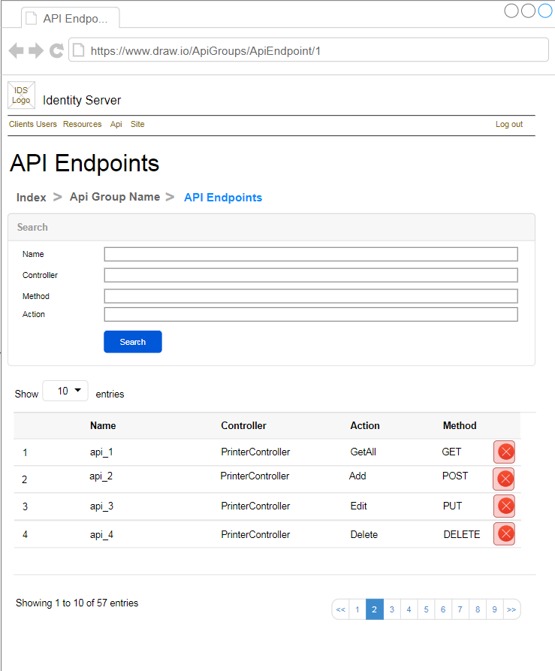

Hình 1: Đặc tả màn hình Update ver1.0

## Đặc tả:

### Button Search

#### Component input:

##### Id

###### Desc: Api Group Id.

###### Component type: hidden.

###### Validation: **REQUIRED**

##### Name

###### Desc: Name.

###### Component type: input text.

###### Validation: **REQUIRED**

##### Controller

###### Desc: Controller.

###### Component type: input text.

###### Validation: **REQUIRED**

##### Method

###### Desc: Method.

###### Component type: input text.

###### Validation: **REQUIRED**

##### Action

###### Desc: Action.

###### Component type: input text.

###### Validation: **REQUIRED**

##### Description

###### Desc: Description

###### Component type: input text

###### Validation:

#### Component output:

##### No

###### Desc: Giá trị tự tăng.

###### Component type: label.

###### Validation:

##### Name

###### Desc: Name

###### Component type: label.

###### Validation:

##### Controller

###### Desc: Controller.

###### Component type: label.

###### Validation:

##### Action

###### Desc: Action.

###### Component type: label.

###### Validation:

##### Method

###### Desc: Method.

###### Component type: label.

###### Validation:

##### Buttons

###### Desc: Delete để xóa Api Endpoint này khỏi Api Group tương ứng.

###### Component type: button.

###### Validation:

### Button Delete Api Endpoint

#### Component input:

##### Id

###### Desc: Api Endpoint Id.

###### Component type: hidden.

###### Validation: **REQUIRED**

#### Component output:

##### View Index

###### Desc: Nếu API trả về thành công, trở về view Index, đồng thời hiển thị alert success.

###### Component type: View.

###### Validation:

## Flowchart & Diagrams

1. POST api/v1/apiGroup/deleteApiEndpoint

* Desc: Xóa Api Endpoint khỏi Api Group
* Input:

|  |  |
| --- | --- |
| **Paramatter** | **Desc** |
| apiGroupId | (int) Api Group Id |
| apiEndpointId | (int) Api Endpoint Id |

* Output:

|  |  |
| --- | --- |
| **Data** | **Desc** |
| {  IsError: <is_error>,  MessageCode: <message_code>,  MessageError: <message_error>,  Data: <data>  } | <is_error>: (bool) Có lỗi hay không  <message_code>: (string) Danh sách mã lỗi (nếu có)  <message_error>: (string) Mô tả lỗi (nếu có)  <data>: NULL |

1. GET api/v1/apiGroup/getApiEndpoints

* Desc: Lấy danh sách Api Endpoints thuộc 1 Api Group
* Input:

|  |  |
| --- | --- |
| **Data** | **Desc** |
| {  ApiGroupId: <api_group_id>,  Page: <page>,  PageSize: <page_size>  } | <api_group_id >: (int) Api Group Id  <page>: (int) page  <page_size>: (int) page size |

* Output:

|  |  |
| --- | --- |
| **Data** | **Desc** |
| {  IsError: <is_error>,  MessageCode: <message_code>,  MessageError: <message_error>,  Data:{  PageSize: <page_size>,  TotalCount: <total_count>,  ApiEndpoints:[  {  Id: <id>,  Name: <name>,  Controller: <controller>,  Action: <action>,  Method: <method>  }]  }  } | <is_error>: (bool) Có lỗi hay không  <message_code>: (string) Danh sách mã lỗi (nếu có)  <message_error>: (string) Mô tả lỗi (nếu có)  <page_size>: (int)  <total_count>: (int)  <id>: (int)  <name>: (string)  <controller>: (string)  <action>: (string)  <method>: (string) |