ĐẶC TẢ MÀN HÌNH Clone Client (VERSION 1)

## Mockup:

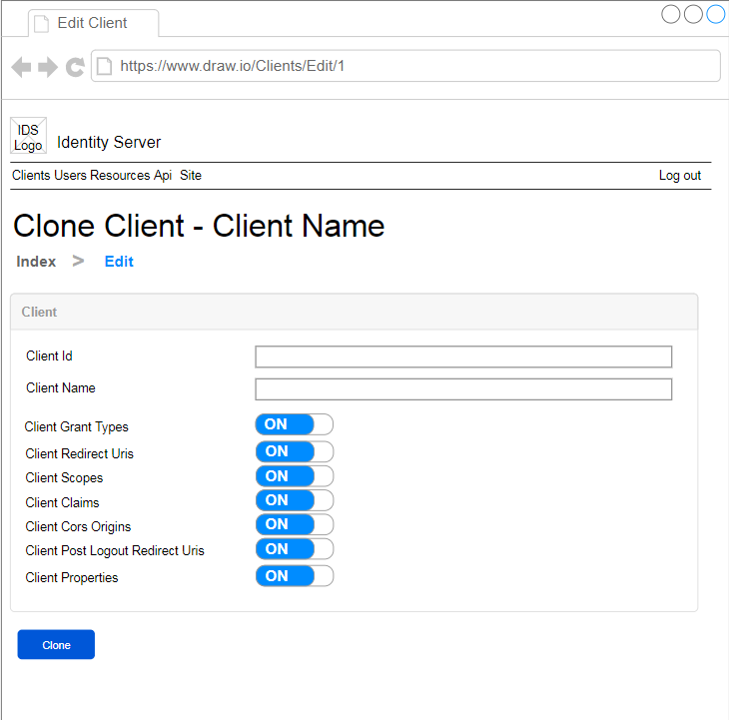

Hình 1: Đặc tả màn hình Clone Client ver1.0

## Đặc tả:

### Button Clone Client

#### Component input:

##### Id

###### Desc: Id của client muốn clone.

###### Component type: hidden.

###### Validation: **REQUIRED**

##### ClientId

###### Desc: Client Id muốn tạo.

###### Component type: input text.

###### Validation: **REQUIRED**

##### ClientName

###### Desc: Name của client muốn tạo.

##### CloneClientCorsOrigins

###### Desc: Clone Client Cors Origins

###### Component type: radio button.

###### Validation: **REQUIRED**

##### CloneClientRedirectUris

###### Desc: Clone Client Redirect Uris

###### Component type: radio button.

###### Validation: **REQUIRED**

##### CloneClientGrantTypes

###### Desc: Clone Client Grant Types

###### Component type: radio button.

###### Validation: **REQUIRED**

##### CloneClientScopes

###### Desc: Clone Client Scopes

###### Component type: radio button.

###### Validation: **REQUIRED**

##### CloneClientClaims

###### Desc: Clone Client Claims

###### Component type: radio button.

###### Validation: **REQUIRED**

##### CloneClientPostLogoutRedirectUris

###### Desc: Clone Client Post Logout Redirect Uris

###### Component type: radio button.

###### Validation: **REQUIRED**

##### CloneClientProperties

###### Desc: Clone Client Properties

###### Component type: radio button.

###### Validation: **REQUIRED**

#### Component output:

##### View

###### Desc: Sau khi gọi API trả về thành công thì trở về màn hình index, đồng thời hiển thị alert thông báo success, ngược lại hiển thị alert thông báo error

###### Component type: View.

###### Validation:

## Flowchart & Diagrams

1. POST api/v1/client/clone

* Desc: Cập nhật thông tin client
* Input:

|  |  |
| --- | --- |
| **Data** | **Desc** |
| {  Id: <id>,  ClientId: <client_id>,  ClientName: <client_name>,  CloneClientCorsOrigins: <clone_client_cors_origins>,  CloneClientRedirectUris: <clone_client_redirect_uris>,  CloneClientGrantTypes: <clone_client_grant_types>,  CloneClientScopes: <clone_client_scopes>,  CloneClientClaims: <clone_client_claims>,  CloneClientPostLogoutRedirectUris: <clone_client_post_logout_redict_uris>,  CloneClientProperties: <clone_client_properties>  } | <id>: (int) Id,  <client_id>: (string),  <client_name>: (string),  <clone_client_cors_origins >: (bool),  <clone_client_redirect_uris >: (bool),  <clone_client_grant_types >: (bool),  <clone_client_scopes >: (bool),  <clone_client_claims >: (bool),  <clone_client_post_logout_redirect_uris >: (bool),  <clone_client_properties >: (bool), |

* Output:

|  |  |
| --- | --- |
| **Data** | **Desc** |
| {  IsError: <is_error>,  MessageCode: <message_code>,  MessageError: <message_error>,  Data: {  Id: <id>  }  } | <is_error>: (bool) Có lỗi hay không  <message_code>: (string) Danh sách mã lỗi (nếu có)  <message_error>: (string) Mô tả lỗi (nếu có)  <id>: (int) Id của client clone thành công |