ĐẶC TẢ MÀN HÌNH Update (VERSION 1)

## Mockup:

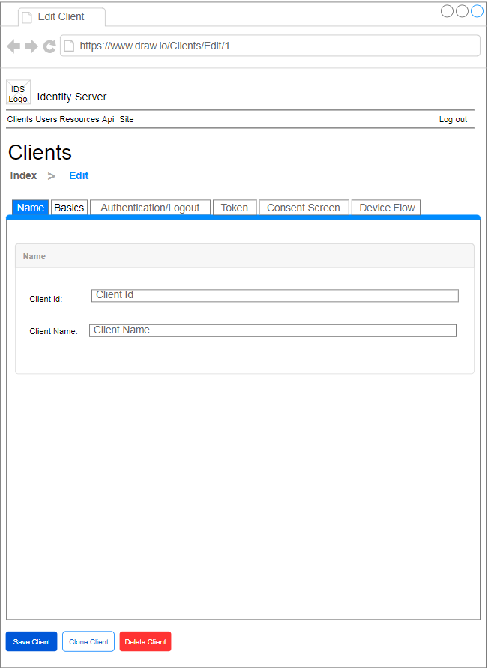

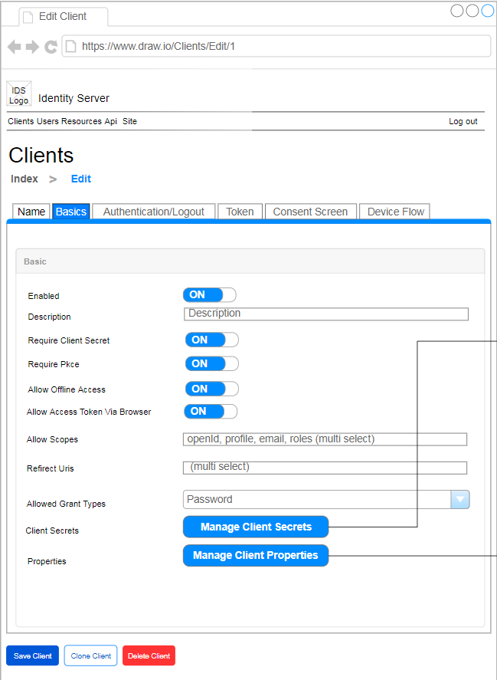

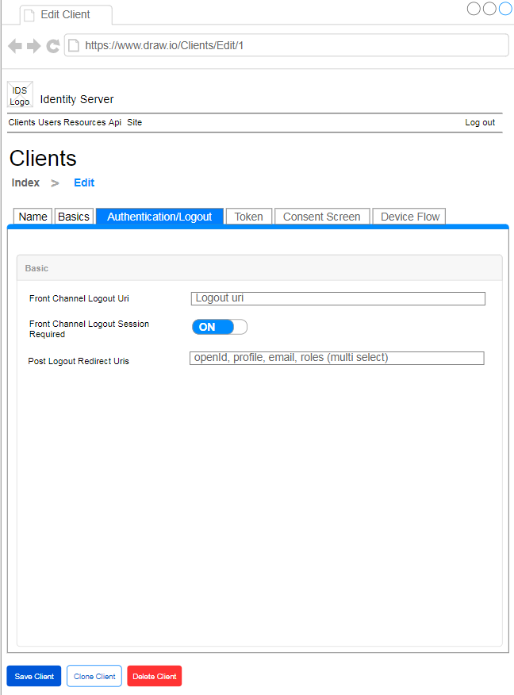

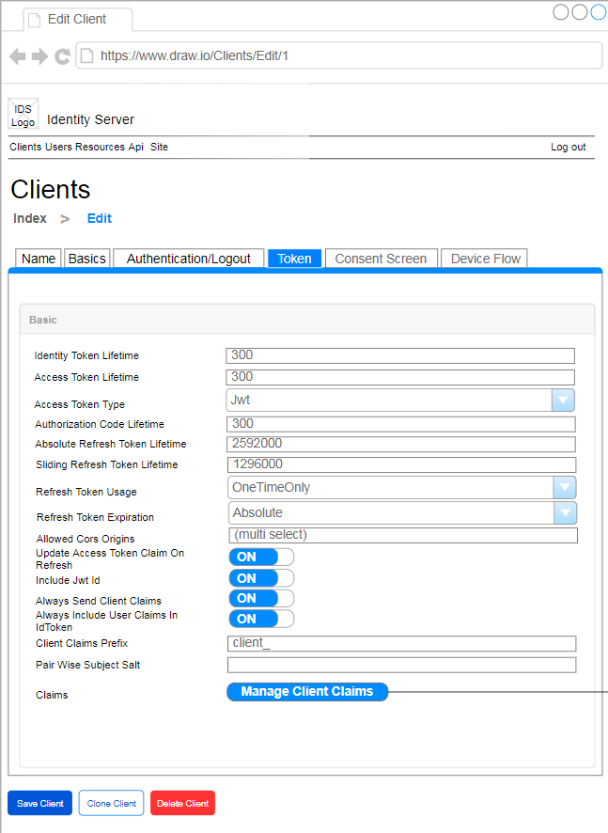

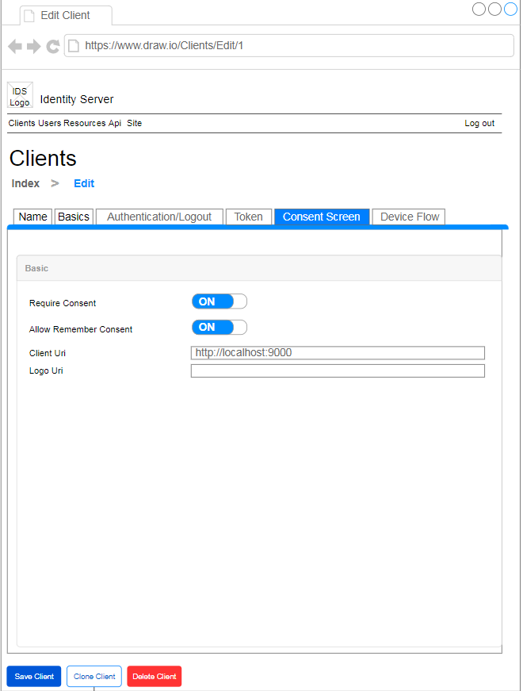

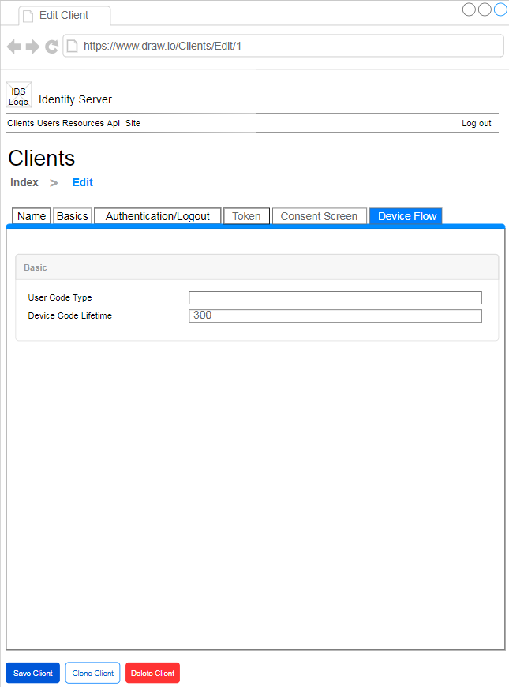

Hình 1: Đặc tả màn hình Update ver1.0

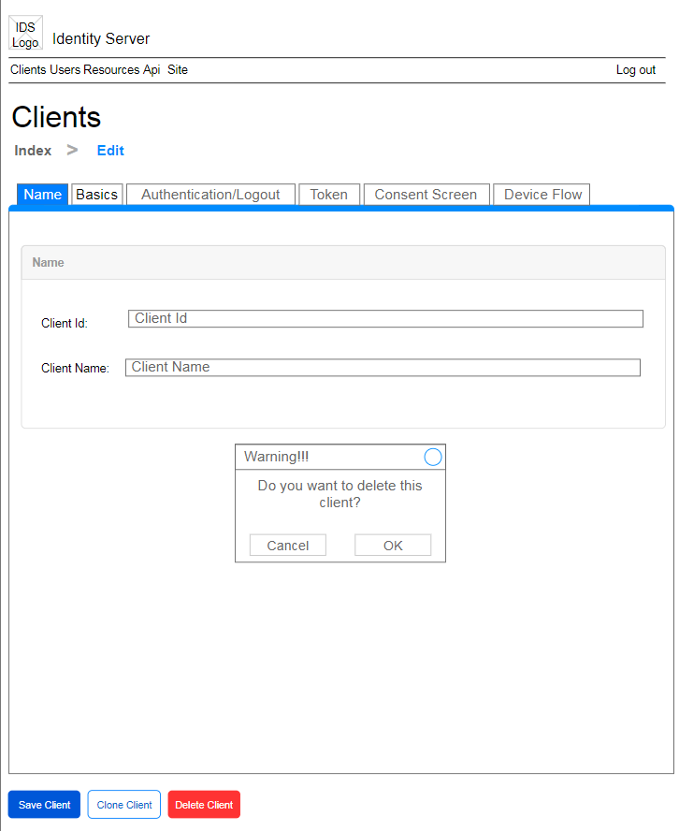

Hình 2: Đặc tả màn hình Delete Client ver1.0

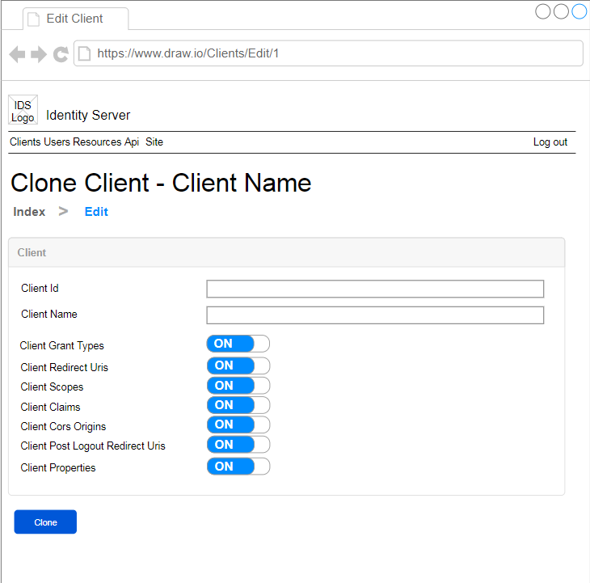

Hình 3: Đặc tả màn hình Clone Client ver1.0

## Đặc tả:

### Button Save Client

#### Component input:

##### Id

###### Desc: Id.

###### Component type: hidden.

###### Validation: **REQUIRED**

##### ClientId

###### Desc: ClientId.

###### Component type: input text.

###### Validation: **REQUIRED**

##### Client Name

###### Desc: Client Name.

###### Component type: input text.

###### Validation: **REQUIRED**

##### Enable

###### Desc: Trạng thái client

###### Component type: radio button.

###### Validation: **REQUIRED**

##### Description

###### Desc: Mô tả client

###### Component type: textarea text

###### Validation:

##### RequireClientSecret

###### Desc: Require Client Secret

###### Component type: radio button.

###### Validation: **REQUIRED**

##### RequirePkce

###### Desc: Require Pkce

###### Component type: radio button.

###### Validation: **REQUIRED**

##### AllowOfflineAccess

###### Desc: Allow Offline Access

###### Component type: radio button.

###### Validation: **REQUIRED**

##### AllowAccessTokensViaBrowser

###### Desc: Allow Access Tokens Via Browser

###### Component type: radio button.

###### Validation: **REQUIRED**

##### AllowScopeItems

###### Desc: Allow Scopes Items

###### Component type: multiselect string.

###### Validation:

##### RedirectUrisItems

###### Desc: Redirect Uris Items

###### Component type: multiselect string.

###### Validation:

##### AllowGrantTypes

###### Desc: Allow Grant Types

###### Component type: multiselect string.

###### Validation:

##### FrontChannel Logout Uri

###### Desc: Front Channel Logout Uri.

###### Component type: input text.

###### Validation:

##### FrontChannelLogoutSessionRequired

###### Desc: Front Channel Logout Session Required

###### Component type: radio button.

###### Validation: **REQUIRED**

##### BackChannel Logout Uri

###### Desc: Back Channel Logout Uri.

###### Component type: input text.

###### Validation:

##### BackChannelLogoutSessionRequired

###### Desc: Back Channel Logout Session Required

###### Component type: radio button.

###### Validation: **REQUIRED**

##### PostLogoutRedirectUrisItems

###### Desc: Post Logout Redirect Uris Items

###### Component type: tags string.

###### Validation:

##### UserSsoLifetime

###### Desc: User Sso Lifetime.

###### Component type: input text.

###### Validation:

##### IdentityTokenLifetime

###### Desc: Identity Token Lifetime.

###### Component type: input text.

###### Validation: **REQUIRED**

##### AccessTokenLifetime

###### Desc: Access Token Lifetime.

###### Component type: input text.

###### Validation: **REQUIRED**

##### AccessTokenType

###### Desc: Access Token Type.

###### Component type: combobox int.

###### Validation: **REQUIRED**

##### AuthorizationCodeLifetime

###### Desc: Authorization Code Lifetime.

###### Component type: input text.

###### Validation: **REQUIRED**

##### AbsoluteRefreshTokenLifetime

###### Desc: Absolute Refresh Token Lifetime.

###### Component type: input text.

###### Validation: **REQUIRED**

##### SlidingRefreshTokenLifetime

###### Desc: Sliding Refresh Token Lifetime.

###### Component type: input text.

###### Validation: **REQUIRED**

##### RefreshTokenUsage

###### Desc: Refresh Token Usage.

###### Component type: combobox int.

###### Validation: **REQUIRED**

##### RefreshTokenExpiration

###### Desc: Refresh Token Expiration.

###### Component type: combobox int.

###### Validation: **REQUIRED**

##### AllowedCorsOriginsItems

###### Desc: Allowed Cors Origins Items

###### Component type: tags string.

###### Validation:

##### UpdateAccessTokenClaimsOnRefresh

###### Desc: Update Access Token Claims On Refresh

###### Component type: radio button.

###### Validation: **REQUIRED**

##### IncludeJwtId

###### Desc: Include Jwt Id

###### Component type: radio button.

###### Validation: **REQUIRED**

##### AlwaysSendClientClaims

###### Desc: Always Send Client Claims

###### Component type: radio button.

###### Validation: **REQUIRED**

##### AlwaysIncludeUserClaimsInIdToken

###### Desc: Always Include User Claims In Id Token

###### Component type: radio button.

###### Validation: **REQUIRED**

##### ClientClaimsPrefix

###### Desc: Client Claims Prefix.

###### Component type: input text.

###### Validation:

##### PairWiseSubjectSalt

###### Desc: Pair Wise Subkect Salt.

###### Component type: input text.

###### Validation:

##### RequireConsent

###### Desc: Require Consent

###### Component type: radio button.

###### Validation: **REQUIRED**

##### AllowRememberConsent

###### Desc: Allow Remember Consent

###### Component type: radio button.

###### Validation: **REQUIRED**

##### ClientUri

###### Desc: Client Uri.

###### Component type: input text.

###### Validation:

##### LogoUri

###### Desc: Logo Uri.

###### Component type: input text.

###### Validation:

##### UserCodeType

###### Desc: User Code Type.

###### Component type: input text.

###### Validation:

##### DeviceCodeLifetime

###### Desc: DeviceCodeLifetime.

###### Component type: input text.

###### Validation: **REQUIRED**

#### Component output:

##### View Index

###### Desc: Nếu API trả về thành công, trở về view Index, đồng thời hiển thị alert success.

###### Component type: View.

###### Validation:

### Button Delete Client

#### Component input:

##### Id

###### Desc: Id.

###### Component type: button.

###### Validation:

#### Component output:

##### Modal

###### Desc: Hiển thị modal cho người dùng xác nhận chắc chắn xóa hay không. Nếu Ok thì gọi API, nếu cancel thì đóng modal. Sau khi gọi API trả về thành công thì trở về màn hình index, đồng thời hiển thị alert thông báo success, ngược lại hiển thị alert thông báo error

###### Component type: Modal.

###### Validation:

### Button Clone Client

#### Component input:

##### Id

###### Desc: Id của client muốn clone.

###### Component type: hidden.

###### Validation: **REQUIRED**

#### Component output:

##### View

###### Desc: Chuyển đến View Clone Client

###### Component type: View.

###### Validation:

### Button Manage Client Secrets

#### Component input:

##### Id

###### Desc: Id của client.

###### Component type: hidden.

###### Validation: **REQUIRED**

#### Component output:

##### View ClientSecret

###### Desc: Chuyển đến view ClientSecret

###### Component type: View.

###### Validation:

### Button Manage Client Properties

#### Component input:

##### Id

###### Desc: Id của client.

###### Component type: hidden.

###### Validation: **REQUIRED**

#### Component output:

##### View ClientProperties

###### Desc: Chuyển đến view ClientProperties

###### Component type: View.

###### Validation:

### Button Manage Client Claims

#### Component input:

##### Id

###### Desc: Id của client.

###### Component type: hidden.

###### Validation: **REQUIRED**

#### Component output:

##### View ClientClaims

###### Desc: Chuyển đến view ClientClaims

###### Component type: View.

###### Validation:

## Flowchart & Diagrams

1. POST api/v1/client/update

* Desc: Cập nhật thông tin client
* Input:

|  |  |
| --- | --- |
| **Data** | **Desc** |
| {  Id: <id>,  ClientId: <client_id>,  ClientName: <client_name>,  Enable: <enable>,  Description: <description>,  RequireClientSecret: <require_client_secret>,  RequicePkce: <require_pkce>,  AllowOfflineAccess: <allow_offline_access>,  AllowAccessTokenViaBrowser: <allow_access_token_via_browser>,  AllowScopeItems: <allow_scope_items>,  RedirectUrisItems: <redirect_uris_items>,  AllowGrantTypes: <allow_grant_types>,  FrontChannelLogoutUri: <front_channel_logout_uri>,  FrontChannelLogoutSessionRequired: <front_channel_logout_session_required>,  BackChannelLogoutUri: <back_channel_logout_uri>,  BackChannelLogoutSessionRequired: <back_channel_logout_session_required>,  PostLogoutRedirectUrisItems: <post_logout_redirect_uris_items>,  UserSsoLifetime: <user_sso_lifetime>,  IdentityTokenLifetime: <identity_token_lifetime>,  AccessTokenLifetime: <access_token_lifetime>,  AccessTokenType: <access_token_type>,  AuthorizationCodeLifetime: <authrization_code_lifetime>,  AbsoluteRefreshTokenLifetime: <absolute_refresh_token_lifetime>,  SlidingRefreshTokenLifetime: <sliding_refresh_token_lifetime>,  RefreshTokenUsage: <refresh_token_usage>,  RefreshTokenExpiration: <refresh_token_expiration>,  AllowedCorsOriginsItems: <allowed_cors_origins_items>,  UpdateAccessTokenClaimsOnRefresh: <update_access_token_claims_on_refresh>,  IncludeJwtId: <include_jwt_id>,  AlwaysSendClientClaims: <always_send_client_claims>,  AlwaysIncludeUserClaimsInIdToken: <always_include_user_claims_in_id_token>,  ClientClaimsPrefix: <client_claims_prefix>,  PairWiseSubjectSalt: <pair_wise_subject_salt>,  RequireConsent: <require_consent>,  AllowRememberConsent: <allow_remember_consent>,  ClientUri: <client_uri>,  LogoUri: <logo_uri>,  UserCodeType: <user_code_type>,  DeviceCodeLifetime: <device_code_lifetime>  } | <id>: (int) Id  <client_id>: (string) ClientId  <client_name>: (string) Client Name  <enable>: (bool)  <description>: (string)  <require_client_secret>: (bool)  <requice_pkce>: (bool)  <allow_offline_access>: (bool)  <allow_access_token_via_browser>: (bool)  <allow_scopes_items>: (string)  <redirect_uris_items>: (string)  <allow_grant_types>: (string)  <font_channel_logout_uri>: (string)  <front_channel_logout_session_required>: (bool)  <back_channel_logout_uri>: (string)  <back_channel_logout_session_required>: (string)  <post_logout_redirect_uris_items>: (string)  <user_sso_lifetime>: (int)  <identity_token_lifetime>: (int)  <access_token_lifetime>: (int)  <access_token_type>: (int)  <authorization_code_lifetime>: (int)  <absolute_refresh_token_lifetime>: (int)  <sliding_refresh_token_lifetime>: (int)  <refresh_token_usage>: (int)  <refresh_token_expiration>: (int)  <allowed_cors_origins_items>: (string)  <update_access_token_claims_on_refresh>: (bool)  <include_jwt_id>: (bool)  <always_send_client_claims>: (bool)  <always_include_user_claims_in_id_token>: (bool)  <client_claims_prefix>: (string)  <pair_wise_subject_salt>: (string)  <require_consent>: (bool)  <allow_remember_consent>: (bool)  <client_uri>: (string)  <logo_uri>: (string)  <user_code_type>: (string)  <device_code_lifetime>: (int) |

* Output:

|  |  |
| --- | --- |
| **Data** | **Desc** |
| {  IsError: <is_error>,  MessageCode: <message_code>,  MessageError: <message_error>,  Data: <data>  } | <is_error>: (bool) Có lỗi hay không  <message_code>: (string) Danh sách mã lỗi (nếu có)  <message_error>: (string) Mô tả lỗi (nếu có)  <data>: NULL |

1. POST api/v1/client/delete

* Desc: Cập nhật thông tin client
* Input:

|  |  |
| --- | --- |
| **Data** | **Desc** |
| {  Id: <id>  } | <id>: (int) Id |

* Output:

|  |  |
| --- | --- |
| **Data** | **Desc** |
| {  IsError: <is_error>,  MessageCode: <message_code>,  MessageError: <message_error>,  Data: {  Id: <id>  }  } | <is_error>: (bool) Có lỗi hay không  <message_code>: (string) Danh sách mã lỗi (nếu có)  <message_error>: (string) Mô tả lỗi (nếu có)  <id>: (int) Id của client bị xóa |

1. GET api/v1/client/getById/{id}

* Desc: Tìm kiếm client theo id
* Input:

|  |  |
| --- | --- |
| **Data** | **Desc** |
| {  Id: <id>  } | <id>: (int) Id của client |

* Output:

|  |  |
| --- | --- |
| **Data** | **Desc** |
| {  IsError: <is_error>,  MessageCode: <message_code>,  MessageError: <message_error>,  Data:{  AbsoluteRefreshTokenLifetime: <absolute_refresh_token_lifetime>,  AccessTokenLifetime: <access_token_lifetime>,  ConsentLifetime: <consent_lifetime>,  AccessTokenType: <access_token_type>,  AllowAccessTokensViaBrowser: <allow_access_tokens_via_browser>,  AllowOfflineAccess: <allow_offline_access>,  AllowPlainTextPkce: <allow_plain_text_pkce>,  AllowRememberConsent: <allow_remember_consent>,  AlwaysIncludeUserClaimsInIdToken: <always_include_user_claims_in_id_token>,  AlwaysSendClientClaims: <always_send_client_claims>,  AuthorizationCodeLifetime: <authorization_code_lifetime>,  FrontChannelLogoutUri: <front_channel_logout_uri>,  FrontChannelLogoutSessionRequired: <front_channel_logout_session_required>,  BackChannelLogoutUri: <back_channel_logout_uri>,  BackChannelLogoutSessionRequired: <back_channel_logout_session_required>,  ClientId: <client_id>,  ClientName: <client_name>,  ClientUri: <client_uri>,  Description: <description>,  Enabled: <enabled>,  EnableLocalLogin: <enable_local_login>,  Id: <id>,  IdentityTokenLifetime: <identity_token_lifetime>,  IncludeJwtId: <include_jwt_id>,  LogoUri: <logo_uri>,  ClientClaimsPrefix: <client_claims_prefix>,  PairWiseSubjectSalt: <pair_wise_subject_salt>,  ProtocolType: <protocol_type>,  RefreshTokenExpiration: <refresh_token_expiration>,  RefreshTokenUsage: <refresh_token_usage>,  SlidingRefreshTokenLifetime: <sliding_refresh_token_lifetime>,  RequireClientSecret: <require_client_secret>,  RequireConsent: <require_consent>,  RequirePkce: <require_pkce>,  UpdateAccessTokenClaimsOnRefresh: <update_access_token_claims_on_refresh>,  PostLogoutRedirectUris:[ <string_1>,<string_2>,…],  IdentityProviderRestrictions:[ <string_1>,<string_2>,…],  RedirectUris:[ <string_1>,<string_2>,…],  AllowedCorsOrigins:[ <string_1>,<string_2>,…],  AllowedGrantTypes:[ <string_1>,<string_2>,…],  AllowedScopes:[ <string_1>,<string_2>,…],  Updated: <updated>,  LastAccessed: <last_accessed>,  UserSsoLifetime: <user_sso_lifetime>,  UserCodeType: <user_code_type>,  DeviceCodeLifetime: <device_code_lifetime>  }  } | <is_error>: (bool) Có lỗi hay không  <message_code>: (string) Danh sách mã lỗi (nếu có)  <message_error>: (string) Mô tả lỗi (nếu có)  <absolute_refresh_token_lifetime>: (int),  <access_token_lifetime>: (int),  <consent_lifetime>: (int?),  <access_token_type>: (int),  <allow_access_tokens_via_browser>: (bool),  <allow_offline_access>: (bool),  <allow_plain_text_pkce>: (bool),  <allow_remember_consent>: (bool),  <always_include_user_claims_in_id_token>: (bool),  <always_send_client_claims>: (bool),  <authorization_code_lifetime>: (int),  <front_channel_logout_uri>: (string),  <front_channel_logout_session_required>: (bool),  <back_channel_logout_uri>: (string),  <back_channel_logout_session_required>: (bool),  <client_id>: (string),  <client_name>: (string),  <client_uri>: (string),  <description>: (string),  <enabled>: (bool),  <enable_local_login>: (bool),  <id>: (int),  <identity_token_lifetime>: (int),  <include_jwt_id>: (bool),  <logo_uri>: (string),  <client_claims_prefix>: (string),  <pair_wise_subject_salt>: (string),  <protocol_type>: (string),  <refresh_token_expiration>: (int),  <refresh_token_usage>: (int),  <sliding_refresh_token_lifetime>: (int),  <require_client_secret>: (bool),  <require_consent>: (bool),  <require_pkce>: (bool),  <update_access_token_claims_on_refresh>: (bool),  <post_logout_redirect_uris>: (List<string>),  <identity_provider_restrictions>: (List<string>),  <redirect_uris>: (List<string>),  <allowed_cors_origins>: (List<string>),  <allowed_grant_types>: (List<string>),  <allowed_scopes>: (List<string>),  <updated>: (DateTime?),  <last_accessed>: (DateTime?),  <user_sso_lifetime>: (int?),  <user_code_type>: (string),  <device_code_lifetime>: (int) |