ĐẶC TẢ MÀN HÌNH Add (VERSION 1)

## Mockup:

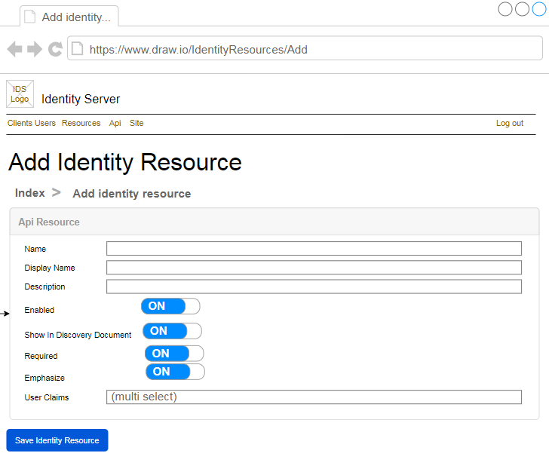

Hình : Đặc tả màn hình Add ver1.0

## Đặc tả:

### Button Save Api Resource

#### Component input:

##### Name

###### Desc: Name.

###### Component type: input text.

###### Validation: **REQUIRED**

##### Display Name

###### Desc: Display Name.

###### Component type: input text.

###### Validation:

##### Description

###### Desc: Description

###### Component type: input text

###### Validation:

##### Enabled

###### Desc: Enable Api Resource

###### Component type: radio button

###### Validation: **REQUIRED**

##### ShowInDiscoveryDocument

###### Desc: Show In Discovery Document

###### Component type: radio button

###### Validation: **REQUIRED**

##### Required

###### Desc: Required

###### Component type: radio button

###### Validation: **REQUIRED**

##### Emphasize

###### Desc: Emphasize

###### Component type: radio button

###### Validation: **REQUIRED**

##### User Claims

###### Desc: User Claims

###### Component type: combobox multiselect

###### Validation:

#### Component output:

##### View Index

###### Desc: Nếu API trả về thành công, trở về view Index, đồng thời hiển thị alert success.

###### Component type: View.

###### Validation:

## Flowchart & Diagrams

1. POST api/v1/identityResource/add

* Desc: Thêm mới Identity Resource
* Input:

|  |  |
| --- | --- |
| **Paramatter** | **Desc** |
| name | (string) Name |
| displayName | (string) Display Name |
| description | (string) Description |
| enabled | (bool) Enabled |
| showInDiscoveryDocument | (bool) Show In Discovery Document |
| required | (bool) Required |
| Emphasize | (bool) Emphasize |
| userClaims | (string) User Claims |

* Output:

|  |  |
| --- | --- |
| **Data** | **Desc** |
| {  IsError: <is_error>,  MessageCode: <message_code>,  MessageError: <message_error>,  Data: <data>  } | <is_error>: (bool) Có lỗi hay không  <message_code>: (string) Danh sách mã lỗi (nếu có)  <message_error>: (string) Mô tả lỗi (nếu có)  <data>: NULL |

1. GET api/v1/identityResource/userClaims

* Desc: Lấy danh sách User Claims
* Input:
* Output:

|  |  |
| --- | --- |
| **Data** | **Desc** |
| {  IsError: <is_error>,  MessageCode: <message_code>,  MessageError: <message_error>,  Data:{  UserClaims:[  {  Value: <value>,  DisplayText: <display_text>  },…]  }  } | <is_error>: (bool) Có lỗi hay không  <message_code>: (string) Danh sách mã lỗi (nếu có)  <message_error>: (string) Mô tả lỗi (nếu có)  <value>: (string) Giá trị user claim  <display_text>: (string) Text hiển thị trên combobox |