ĐẶC TẢ MÀN HÌNH Users (VERSION 1)

## Mockup:

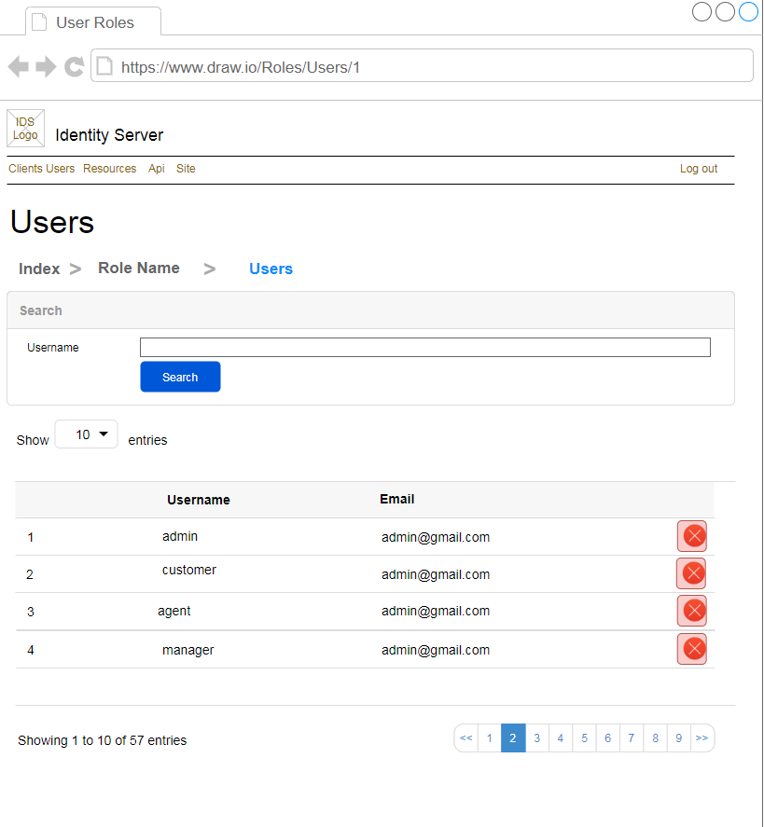

Hình 1: Đặc tả màn hình Users ver1.0

## Đặc tả:

### Button Search

#### Component input:

##### Id

###### Desc: Role Group Id.

###### Component type: hidden.

###### Validation: **REQUIRED**

##### Username

###### Desc: Username.

###### Component type: input text.

###### Validation:

#### Component output:

##### No

###### Desc: Giá trị tự tăng.

###### Component type: label.

###### Validation:

##### Username

###### Desc: Username

###### Component type: label.

###### Validation:

##### Email

###### Desc: Email

###### Component type: label.

###### Validation:

##### Buttons

###### Desc: Delete để xóa User này khỏi Role Group tương ứng.

###### Component type: button.

###### Validation:

### Button Delete User

#### Component input:

##### UserId

###### Desc: User Id.

###### Component type: hidden.

###### Validation: **REQUIRED**

##### RoleGroupId

###### Desc: Role Group Id.

###### Component type: hidden.

###### Validation: **REQUIRED**

#### Component output:

##### View Index

###### Desc: Nếu API trả về thành công, trở về view Index, đồng thời hiển thị alert success.

###### Component type: View.

###### Validation:

## Flowchart & Diagrams

1. POST api/v1/roleGroup/deleteUser

* Desc: Xóa User khỏi Role Group
* Input:

|  |  |
| --- | --- |
| **Paramatter** | **Desc** |
| userId | (int) User Id |
| roleGroupId | (int) Role Group Id |

* Output:

|  |  |
| --- | --- |
| **Data** | **Desc** |
| {  IsError: <is_error>,  MessageCode: <message_code>,  MessageError: <message_error>,  Data: <data>  } | <is_error>: (bool) Có lỗi hay không  <message_code>: (string) Danh sách mã lỗi (nếu có)  <message_error>: (string) Mô tả lỗi (nếu có)  <data>: NULL |

1. GET api/v1/roleGroup/getUsers?roleGroupId={roleGroupId}&username={username}&page={page}&pageSize={pageSize}

* Desc: Lấy danh sách Users thuộc 1 Role Group
* Input:

|  |  |
| --- | --- |
| **Data** | **Desc** |
| {  RoleGroupId: <api_group_id>,  Username: <username>,  Page: <page>,  PageSize: <page_size>  } | <role_group_id >: (int) Role Group Id  <username >: (string)  <page>: (int) page  <page_size>: (int) page size |

* Output:

|  |  |
| --- | --- |
| **Data** | **Desc** |
| {  IsError: <is_error>,  MessageCode: <message_code>,  MessageError: <message_error>,  Data:{  PageSize: <page_size>,  TotalCount: <total_count>,  ApiGroups:[  {  Id: <id>,  Username: <username>,  Email: <email>  }]  }  } | <is_error>: (bool) Có lỗi hay không  <message_code>: (string) Danh sách mã lỗi (nếu có)  <message_error>: (string) Mô tả lỗi (nếu có)  <page_size>: (int)  <total_count>: (int)  <id>: (int)  <username>: (string)  <email>: (string) |