ĐẶC TẢ MÀN HÌNH Y10; Y20; Y30 (VERSION 1)

# Màn hình Y10:

## Mockup:

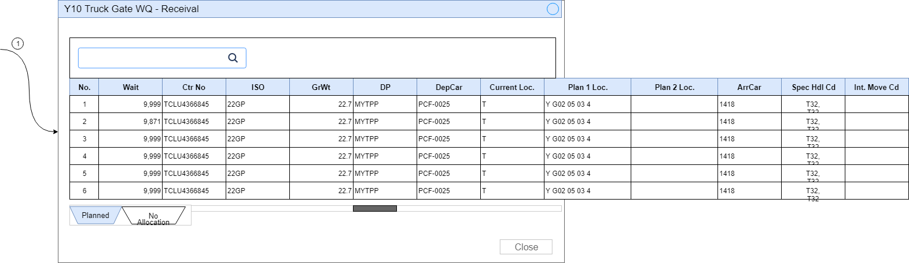

Hình 1: Đặc tả màn hình G10-G13 ver1.0

## Đặc tả:

* Trên Gridview Y10-Truck Gate WQ-Receival bao gồm các columns:

### Component input:

#### Search box

##### Desc: Search thông tin trên lưới.

##### Component type: input text.

##### Validation: θ

### Component output:

#### No

##### Desc: Số tự tăng.

##### Component type: label.

##### Validation:

#### Wait

##### Desc:

##### Component type: label

##### Validation:

#### Ctr No

##### Desc:

##### Component type: label

##### Validation:

#### ISO

##### Desc:

##### Component type: label

##### Validation:

#### GrWt

##### Desc:

##### Component type: label

##### Validation:

#### DP

##### Desc: Số tự tăng.

##### Component type: label.

##### Validation:

#### DepCar

##### Desc:

##### Component type: label.

##### Validation:

#### Current Loc.

##### Desc:

##### Component type: label

##### Validation:

#### Plan 1 Loc.

##### Desc:

##### Component type: label

##### Validation:

#### Plan 2 Loc.

##### Desc:

##### Component type: label

##### Validation:

#### ArrCar

##### Desc:

##### Component type: label

##### Validation:

#### Spec Hdl Cd

##### Desc:

##### Component type: label

##### Validation:

#### Int. Move Cd

##### Desc:

##### Component type: label.

##### Validation:

## Flowchart & Diagrams

1. GET api/v2/sites/{siteId}/truck-gate-wqs/{locTypeId}/receivals

* Desc:
* Input:

|  |  |
| --- | --- |
| **Paramatter** | **Desc** |
| siteId | * Mã site, Vd: CTL, HP,... |
| locTypeId | * Loại location: 1: Planned/ 2: no-allocation |

* Output:

|  |  |
| --- | --- |
| **Data** | **Desc** |
| {  "Wait": "<wait>",  "CtrNo": "<ctr_no>",  "ISO":"<iso>",  "GrWt":"<grwt>",  "DP":"<dp>",  "DepCar":"<depcar>",  "CurrentLoc":"<current_loc>",  "Plan1Loc":"<plan_1_loc>",  "Plan2Loc":"<plan_2_loc>",  "ArrCar":"<arr_car>",  "SpecHdlCd":"<spec_hdl_cd>",  "IntMoveCd":"<int_move_cd>",  } |  |

# Màn hình Y20:

## Mockup:

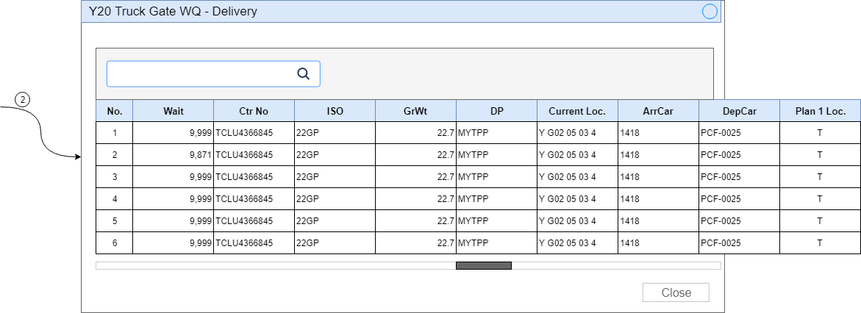

Hình 1: Đặc tả màn hình G10-G13 ver1.0

## Đặc tả:

* Trên Gridview Y20-Truck Gate WQ-Delivery bao gồm các columns:

### Component input:

#### Search box

##### Desc: Search thông tin trên lưới.

##### Component type: input text.

##### Validation: θ

### Component output:

#### No

##### Desc: Số tự tăng.

##### Component type: label.

##### Validation:

#### Wait

##### Desc:

##### Component type: label

##### Validation:

#### Ctr No

##### Desc:

##### Component type: label

##### Validation:

#### ISO

##### Desc:

##### Component type: label

##### Validation:

#### GrWt

##### Desc:

##### Component type: label

##### Validation:

#### DP

##### Desc: Số tự tăng.

##### Component type: label.

##### Validation:

#### Current Loc.

##### Desc:

##### Component type: label

##### Validation:

#### ArrCar

##### Desc:

##### Component type: label

##### Validation:

#### DepCar

##### Desc:

##### Component type: label.

##### Validation:

#### Plan 1 Loc.

##### Desc:

##### Component type: label

##### Validation:

## Flowchart & Diagrams

1. GET api/v2/sites/{siteId}/truck-gate-wqs/deliveries

* Desc:
* Input:

|  |  |
| --- | --- |
| **Paramatter** | **Desc** |
| siteId | * Mã site, Vd: CTL, HP,... |

* Output:

|  |  |
| --- | --- |
| **Data** | **Desc** |
| {  "Wait": "<wait>",  "CtrNo": "<ctr_no>",  "ISO":"<iso>",  "GrWt":"<grwt>",  "DP":"<dp>",  "CurrentLoc":"<current_loc>",  "ArrCar":"<arr_car>",  "DepCar":"<depcar>",  "Plan1Loc":"<plan_1_loc>",  } |  |

# Màn hình Y30:

## Mockup:

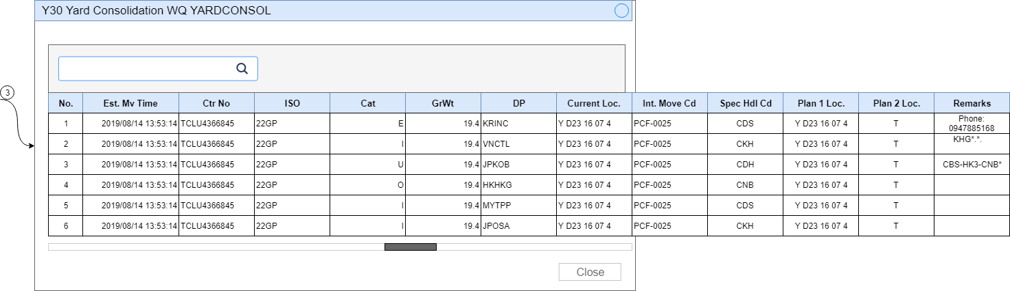

Hình 1: Đặc tả màn hình G10-G13 ver1.0

## Đặc tả:

* Trên Gridview Y30-Yard consolidation WQ YARDCONSOL bao gồm các columns:

### Component input:

#### Search box

##### Desc: Search thông tin trên lưới.

##### Component type: input text.

##### Validation: θ

### Component output:

#### No

##### Desc: Số tự tăng.

##### Component type: label.

##### Validation:

#### Est. Mv Time

##### Desc:

##### Component type: label

##### Validation:

#### Ctr No

##### Desc:

##### Component type: label

##### Validation:

#### ISO

##### Desc:

##### Component type: label

##### Validation:

#### Cat

##### Desc:

##### Component type: label

##### Validation:

#### GrWt

##### Desc:

##### Component type: label

##### Validation:

#### DP

##### Desc: Số tự tăng.

##### Component type: label.

##### Validation:

#### Current Loc.

##### Desc:

##### Component type: label

##### Validation:

#### Int. Move Cd

##### Desc:

##### Component type: label

##### Validation:

#### Spec Hdl

##### Desc:

##### Component type: label.

##### Validation:

#### Plan 1 Loc.

##### Desc:

##### Component type: label

##### Validation:

#### Plan 2 Loc.

##### Desc:

##### Component type: label

##### Validation:

#### Remarks

##### Desc:

##### Component type: label

##### Validation:

## Flowchart & Diagrams

1. GET api/v2/sites/{siteId}/yard-consolidation-wqs

* Desc:
* Input:

|  |  |
| --- | --- |
| **Paramatter** | **Desc** |
| siteId | * Mã site, Vd: CTL, HP,... |

* Output:

|  |  |
| --- | --- |
| **Data** | **Desc** |
| {  "EstMvTime": "<est_mv_time>",  "CtrNo": "<ctr_no>",  "ISO":"<iso>",  "Cat":"<cat>",  "GrWt":"<grwt>",  "DP":"<dp>",  "CurrentLoc":"<current_loc>",  "IntMoveCd":"<int_move_cd>",  "SpecHdlCd":"<spec_hdl_cd>",  "Plan1Loc":"<plan_1_loc>",  "Plan2Loc":"<plan_2_loc>",  "Remarks":"<remarks>",  } |  |