File Browser Requirements:

* Allows browsing of all files and folders available.
* Browsing begins at the root folder which includes subdivisions corresponding to connected drives and network resources.

Select: will mark or unmark the selected file/folder then move selection to next file/folder

Return: returns to the main (root) folder

Content will be the parent folder for the file browser.

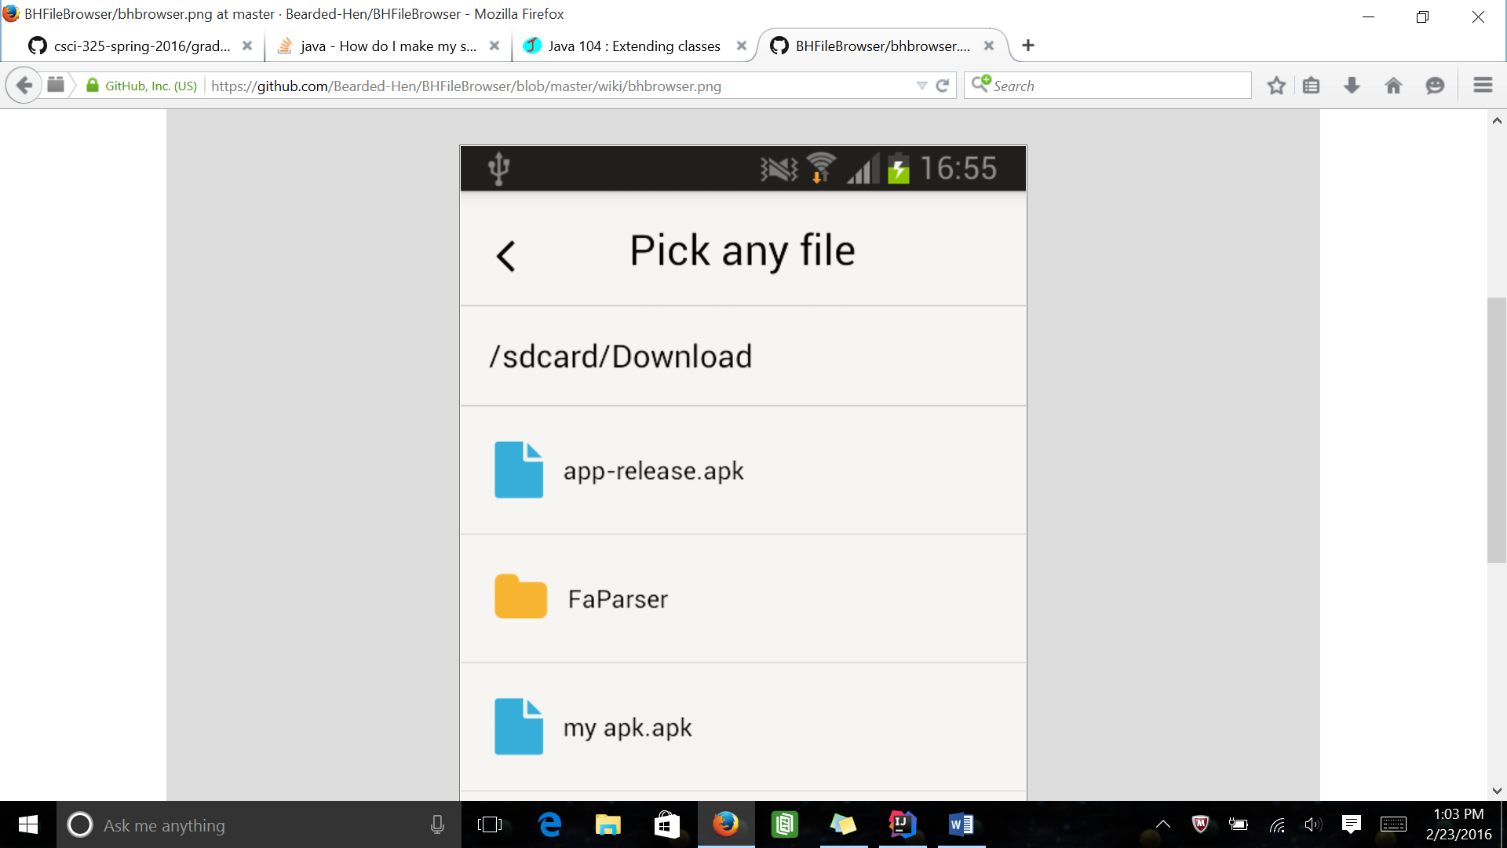

In order to create file browser we must:

* Determine proper state of external storage
* Use file filters
* We will use the file class in order to receive the file browser needed