**Android Implementation Photos and Explanation**

Main Activity/Start Screen

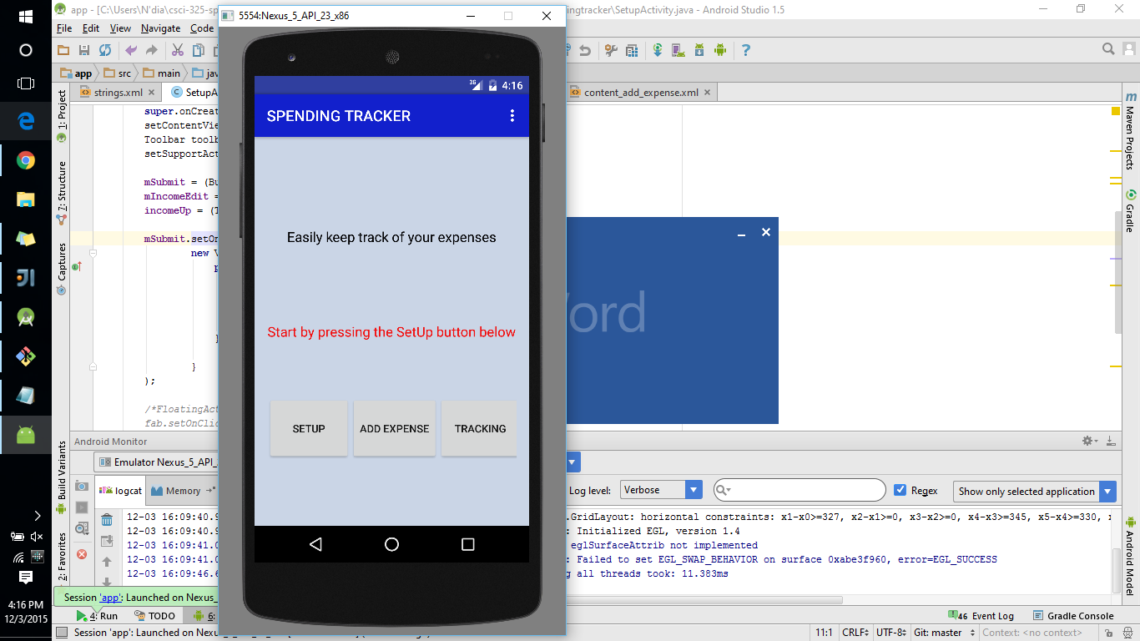

Clicking Setup

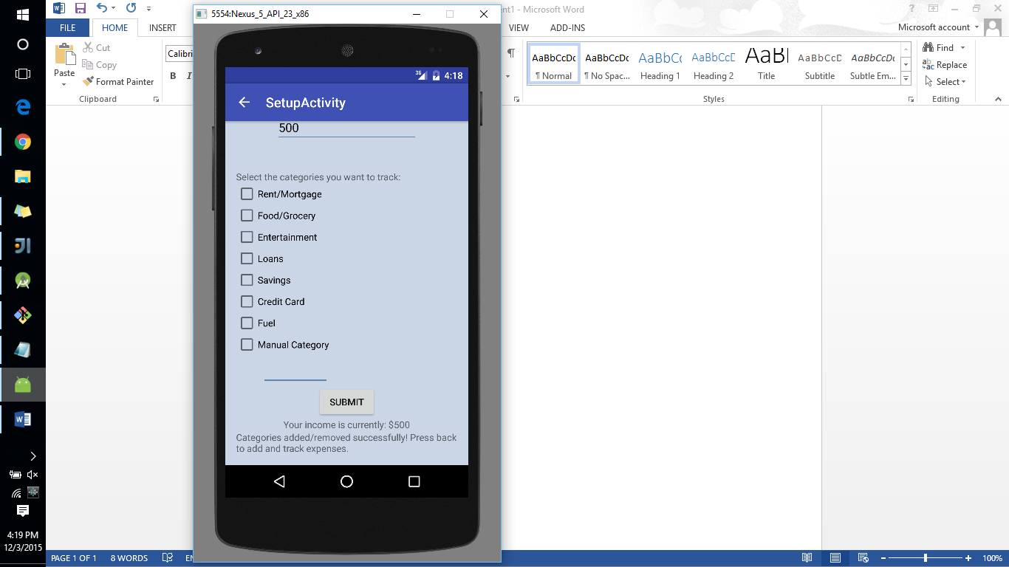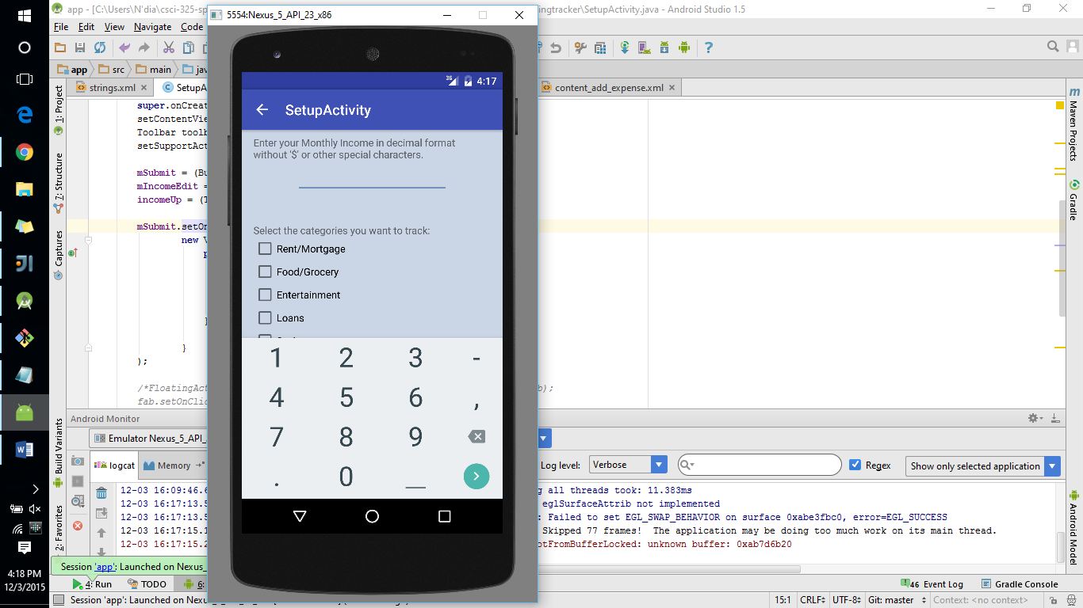

Clicking Add Expense

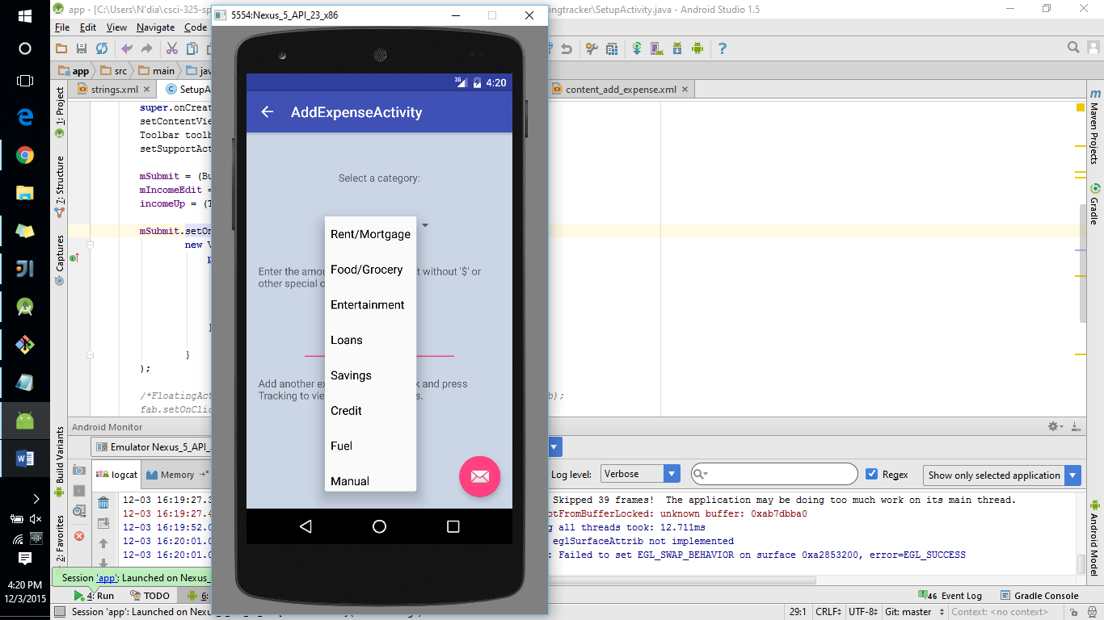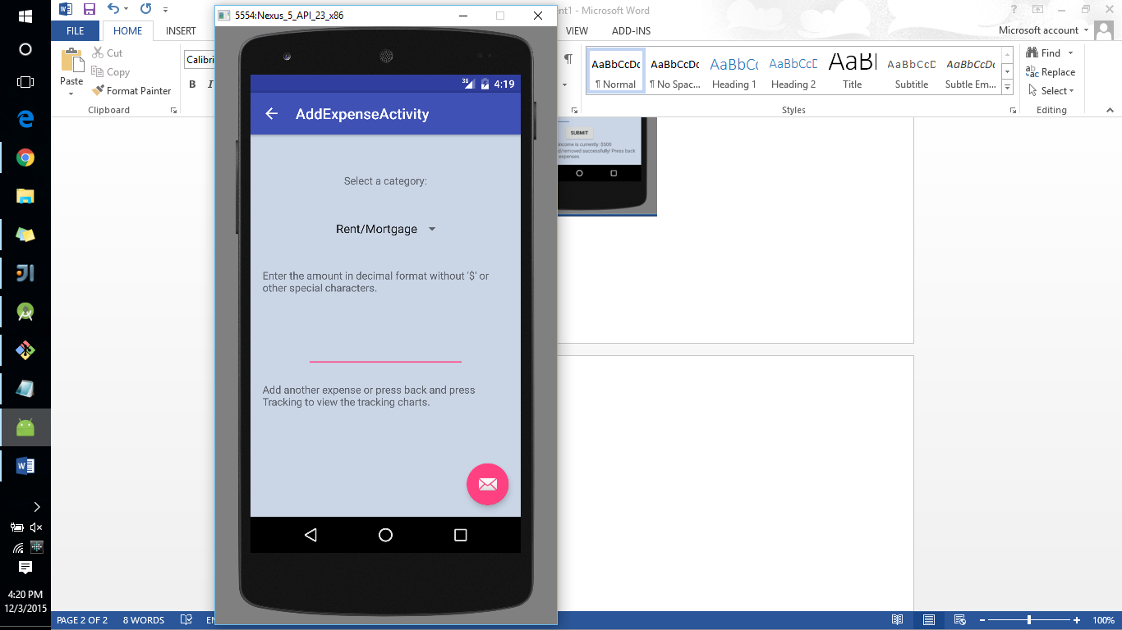

Clicking Tracking

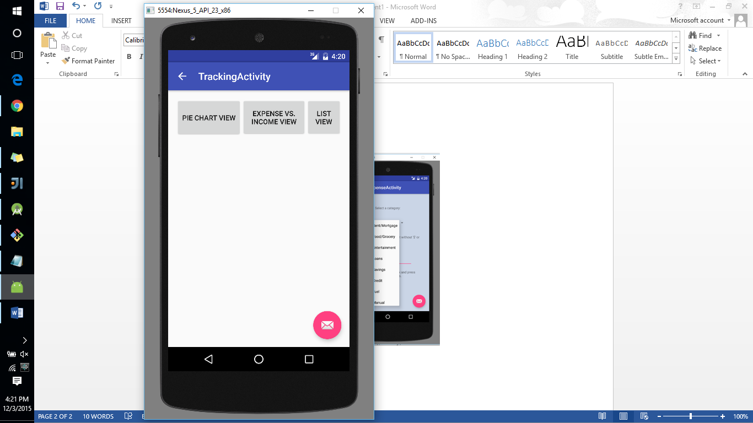

The only things that are currently functional in this app are the buttons from the activity_main.xml and the submit button adding the income to the text view.