**CSC 300 – Data Structures**

**Homework 1**

**Binary Search Trees**

You have the binary search tree pictures below. There are some questions asking you to do operations with the binary search tree. If you scan the image, it will bring up the BST on your phone to see better.

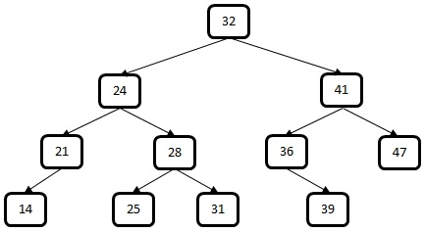

1. A picture containing photo, indoor, white

   Description automatically generatedDraw what the tree would look like if you were to add the node 50. Scanning the QR code next to the space will bring up what the tree will look like with that addition to check your work.
2. A picture containing photo, indoor, white

   Description automatically generatedDraw what the tree would like if you were to remove the node 24. Scanning the QR code below will bring up what the tree will look like after removing that node to check your work.