Report on animal initial conditions and weekly weights

# Summary of experimental animals

This section gives some information on the experimental animals both at the start of the experiment and over the course of the experiment.

Summary of experimental animals at the start of the experiment

|  |  |
| --- | --- |
| Species: | C57BL/6 |
| Total animals: | 140 |
| Sex distribution: | male: 60, female: 80 |
| Experimental groups: | bcg, bcg+id93, saline, saline+id93, saline+noMtb |
| N. of starting cages: | 34 |

# Animal weights

This section provides summaries of mouse weights over the course of the experiment.

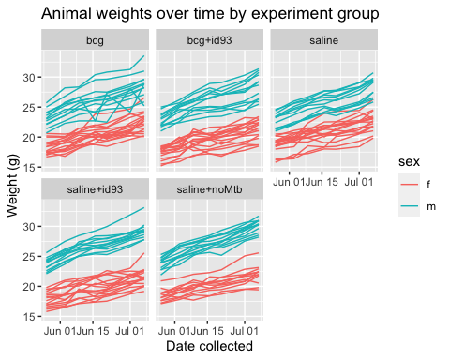

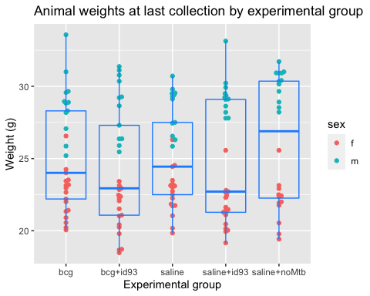

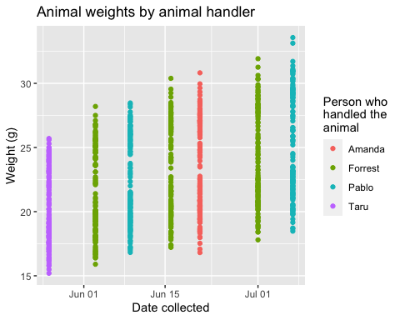

Individual data on weight changes in mice between current measurement and previous measurement.

|  |  |  |  |  |
| --- | --- | --- | --- | --- |
| Mouse | Experimental group | Sex | Weight (g) | Weight change since last measure |
| Cage: 22021 Notch: 1R | bcg | m | 25.20 | -10.4% |
| Cage: 22017 Notch: 1R | saline | f | 23.13 | -4.1% |
| Cage: 22015 Notch: 1L | bcg | f | 23.18 | -3.1% |
| Cage: 22476 Notch: 1R1L | saline+noMtb | f | 20.54 | -2.8% |
| Cage: 22014 Notch: 1L | saline+id93 | f | 21.47 | -2.8% |
| Cage: 22014 Notch: 0 | saline+id93 | f | 21.40 | -2.7% |
| Cage: 22006 Notch: 1R1L | bcg+id93 | f | 21.02 | -2.4% |
| Cage: 22015 Notch: 0 | bcg | f | 20.06 | -1.0% |
| Cage: 22004 Notch: 1R | bcg | f | 21.42 | -1.0% |
| Cage: 22006 Notch: 0 | bcg+id93 | f | 18.67 | -0.7% |
| Cage: 22476 Notch: 0 | saline+noMtb | f | 19.42 | -0.6% |
| Cage: 22016 Notch: 1R1L | bcg+id93 | f | 23.13 | -0.5% |
| Cage: 22012 Notch: 1R | saline+id93 | f | 22.44 | -0.4% |
| Cage: 22015 Notch: 2L | bcg | f | 20.56 | -0.3% |
| Cage: 22013B Notch: 1L | saline+id93 | f | 20.46 | -0.2% |
| Cage: 22009A Notch: 0 | saline | f | 22.50 | -0.1% |
| Cage: 22029 Notch: 0 | saline+id93 | m | 29.12 | 0.3% |
| Cage: 22017 Notch: 1L | saline | f | 21.72 | 0.6% |
| Cage: 22022 Notch: 1R | bcg+id93 | m | 25.90 | 0.6% |
| Cage: 22016 Notch: 2L | bcg+id93 | f | 22.37 | 0.7% |
| Cage: 22004 Notch: 1R1L | bcg | f | 20.91 | 0.8% |
| Cage: 22477 Notch: 1L | saline+noMtb | m | 30.92 | 1.0% |
| Cage: 22013A Notch: 0 | saline+id93 | f | 20.04 | 1.1% |
| Cage: 22007A Notch: 0 | bcg+id93 | f | 20.42 | 1.1% |
| Cage: 22474 Notch: 0 | saline+noMtb | f | 21.93 | 1.2% |
| Cage: 22476 Notch: 1R | saline+noMtb | f | 23.14 | 1.3% |
| Cage: 22476 Notch: 1L | saline+noMtb | f | 19.78 | 1.4% |
| Cage: 22477 Notch: 1R | saline+noMtb | m | 30.15 | 1.4% |
| Cage: 22004 Notch: 0 | bcg | f | 22.20 | 1.5% |
| Cage: 22012A Notch: 1L | saline+id93 | f | 21.10 | 1.5% |
| Cage: 22025 Notch: 0 | saline | m | 29.54 | 1.6% |
| Cage: 22006 Notch: 1R | bcg+id93 | f | 18.72 | 1.6% |
| Cage: 22005 Notch: 1R | bcg | f | 24.25 | 1.8% |
| Cage: 22011 Notch: 0 | saline | f | 23.02 | 1.8% |
| Cage: 22028 Notch: 1L | saline+id93 | m | 28.20 | 1.9% |
| Cage: 22474 Notch: 1R | saline+noMtb | f | 25.57 | 2.0% |
| Cage: 22011 Notch: 1R1L | saline | f | 21.04 | 2.1% |
| Cage: 22020 Notch: 1R1L | bcg | m | 31.00 | 2.1% |
| Cage: 22022 Notch: 1R1L | bcg+id93 | m | 28.65 | 2.2% |
| Cage: 22474 Notch: 1R1L | saline+noMtb | f | 22.42 | 2.2% |
| Cage: 22018 Notch: 1L | saline+id93 | f | 19.16 | 2.4% |
| Cage: 22029 Notch: 1R | saline+id93 | m | 29.50 | 2.4% |
| Cage: 22478 Notch: 1R | saline+noMtb | m | 28.21 | 2.4% |
| Cage: 22475 Notch: 1R | saline+noMtb | f | 22.35 | 2.5% |
| Cage: 22029 Notch: 1L | saline+id93 | m | 28.63 | 2.6% |
| Cage: 22030 Notch: 0 | saline+id93 | m | 29.36 | 2.6% |
| Cage: 22019 Notch: 1R | bcg | m | 27.07 | 2.7% |
| Cage: 22008 Notch: 0 | bcg+id93 | f | 19.80 | 2.8% |
| Cage: 22478 Notch: 0 | saline+noMtb | m | 28.53 | 2.8% |
| Cage: 22019 Notch: 0 | bcg | m | 29.57 | 2.8% |
| Cage: 22013C Notch: 1R1L | saline+id93 | f | 21.28 | 2.8% |
| Cage: 22479 Notch: 1L | saline+noMtb | m | 28.91 | 2.8% |
| Cage: 22017 Notch: 1R1L | saline | f | 23.10 | 2.8% |
| Cage: 22020 Notch: 1L | bcg | m | 28.18 | 2.9% |
| Cage: 22021 Notch: 0 | bcg | m | 28.95 | 3.1% |
| Cage: 22028 Notch: 1R | saline+id93 | m | 29.92 | 3.1% |
| Cage: 22003 Notch: 1R | bcg | f | 20.23 | 3.1% |
| Cage: 22004 Notch: 1L | bcg | f | 24.01 | 3.2% |
| Cage: 22007 Notch: 1R1L | bcg+id93 | f | 21.08 | 3.2% |
| Cage: 22017 Notch: 0 | saline | f | 22.25 | 3.2% |
| Cage: 22016 Notch: 1L | bcg+id93 | f | 22.85 | 3.2% |
| Cage: 22029 Notch: 1R1L | saline+id93 | m | 29.09 | 3.2% |
| Cage: 22010 Notch: 1R1L | saline | f | 23.24 | 3.2% |
| Cage: 22030 Notch: 1R1L | saline+id93 | m | 27.80 | 3.3% |
| Cage: 22007 Notch: 1R | bcg+id93 | f | 22.24 | 3.3% |
| Cage: 22011 Notch: 1L | saline | f | 23.49 | 3.3% |
| Cage: 22025 Notch: 1R | saline | m | 26.55 | 3.3% |
| Cage: 22027 Notch: 1R1L | saline | m | 26.30 | 3.5% |
| Cage: 22024 Notch: 1R | bcg+id93 | m | 31.37 | 3.5% |
| Cage: 22479 Notch: 1R1L | saline+noMtb | m | 30.93 | 3.5% |
| Cage: 22020 Notch: 1R | bcg | m | 25.86 | 3.6% |
| Cage: 22005 Notch: 1L | bcg | f | 22.01 | 3.6% |
| Cage: 22024 Notch: 0 | bcg+id93 | m | 30.35 | 3.7% |
| Cage: 22026 Notch: 1R | saline | m | 29.40 | 3.7% |
| Cage: 22477 Notch: 0 | saline+noMtb | m | 30.41 | 3.8% |
| Cage: 22030 Notch: 1R | saline+id93 | m | 33.13 | 3.8% |
| Cage: 22018 Notch: 2R | saline+id93 | f | 19.94 | 3.8% |
| Cage: 22007 Notch: 1L | bcg+id93 | f | 18.48 | 3.8% |
| Cage: 22023 Notch: 0 | bcg+id93 | m | 25.46 | 3.8% |
| Cage: 22021 Notch: 1L | bcg | m | 28.83 | 3.9% |
| Cage: 22027 Notch: 0 | saline | m | 25.85 | 4.0% |
| Cage: 22024 Notch: 1L | bcg+id93 | m | 26.37 | 4.1% |
| Cage: 22012 Notch: 1R1L | saline+id93 | f | 22.80 | 4.2% |
| Cage: 22028 Notch: 0 | saline+id93 | m | 27.79 | 4.2% |
| Cage: 22030 Notch: 1L | saline+id93 | m | 29.23 | 4.2% |
| Cage: 22475 Notch: 1L | saline+noMtb | f | 22.92 | 4.3% |
| Cage: 22020 Notch: 0 | bcg | m | 29.65 | 4.3% |
| Cage: 22017 Notch: 2L | saline | f | 24.53 | 4.3% |
| Cage: 22477 Notch: 1R1L | saline+noMtb | m | 31.00 | 4.3% |
| Cage: 22009 Notch: 1R1L | saline | f | 20.18 | 4.5% |
| Cage: 22014 Notch: 1R | saline+id93 | f | 21.25 | 4.5% |
| Cage: 22014 Notch: 1R1L | saline+id93 | f | 22.30 | 4.5% |
| Cage: 22479 Notch: 0 | saline+noMtb | m | 29.65 | 4.5% |
| Cage: 22478 Notch: 1R1L | saline+noMtb | m | 31.71 | 4.5% |
| Cage: 22018 Notch: 0 | saline+id93 | f | 22.65 | 4.5% |
| Cage: 22026 Notch: 0 | saline | m | 29.50 | 4.6% |
| Cage: 22022 Notch: 0 | bcg+id93 | m | 27.30 | 4.9% |
| Cage: 22019 Notch: 1R1L | bcg | m | 28.30 | 4.9% |
| Cage: 22008 Notch: 1L | bcg+id93 | f | 21.52 | 5.1% |
| Cage: 22479 Notch: 1R | saline+noMtb | m | 30.92 | 5.1% |
| Cage: 22003 Notch: 0 | bcg | f | 23.14 | 5.2% |
| Cage: 22005 Notch: 0 | bcg | f | 23.52 | 5.2% |
| Cage: 22026 Notch: 1R1L | saline | m | 29.80 | 5.2% |
| Cage: 22478 Notch: 1L | saline+noMtb | m | 30.34 | 5.2% |
| Cage: 22026 Notch: 1L | saline | m | 29.28 | 5.2% |
| Cage: 22009 Notch: 1R | saline | f | 21.85 | 5.3% |
| Cage: 22024 Notch: 1R1L | bcg+id93 | m | 31.11 | 5.4% |
| Cage: 22475 Notch: 0 | saline+noMtb | f | 22.00 | 5.5% |
| Cage: 22006 Notch: 1L | bcg+id93 | f | 23.42 | 5.5% |
| Cage: 22023 Notch: 1R | bcg+id93 | m | 29.27 | 5.7% |
| Cage: 22016 Notch: 0 | bcg+id93 | f | 22.94 | 5.7% |
| Cage: 22025 Notch: 1L | saline | m | 30.71 | 5.8% |
| Cage: 22015 Notch: 1R1L | bcg | f | 21.34 | 5.9% |
| Cage: 22010 Notch: 1L | saline | f | 21.75 | 5.9% |
| Cage: 22008 Notch: 1R1L | bcg+id93 | f | 22.07 | 6.1% |
| Cage: 22025 Notch: 1R1L | saline | m | 27.45 | 6.1% |
| Cage: 22018 Notch: 1R1L | saline+id93 | f | 20.15 | 6.3% |
| Cage: 22023 Notch: 1L | bcg+id93 | m | 29.21 | 6.3% |
| Cage: 22012 Notch: 0 | saline+id93 | f | 22.71 | 6.4% |
| Cage: 22028 Notch: 1R1L | saline+id93 | m | 30.22 | 6.6% |
| Cage: 22475 Notch: 1R1L | saline+noMtb | f | 21.76 | 6.6% |
| Cage: 22022 Notch: 1L | bcg+id93 | m | 30.77 | 6.9% |
| Cage: 22027 Notch: 1R | saline | m | 29.12 | 7.0% |
| Cage: 22008 Notch: 1R | bcg+id93 | f | 20.25 | 7.1% |
| Cage: 22010 Notch: 1R | saline | f | 22.74 | 7.3% |
| Cage: 22019 Notch: 1L | bcg | m | 33.57 | 7.4% |
| Cage: 22018 Notch: 1R | saline+id93 | f | 21.63 | 7.4% |
| Cage: 22005 Notch: 1R1L | bcg | f | 26.56 | 7.6% |
| Cage: 22480 Notch: 1L | saline | f | 26.30 | 7.7% |
| Cage: 22011 Notch: 1R | saline | f | 19.84 | 7.8% |
| Cage: 22023 Notch: 1R1L | bcg+id93 | m | 26.36 | 8.0% |
| Cage: 22016 Notch: 1R | bcg+id93 | f | 22.47 | 8.1% |
| Cage: 22003 Notch: 1R1L | bcg | f | 22.66 | 8.2% |
| Cage: 22474 Notch: 1L | saline+noMtb | f | 22.50 | 8.2% |
| Cage: 22010 Notch: 0 | saline | f | 24.44 | 8.2% |
| Cage: 22027 Notch: 1L | saline | m | 27.50 | 8.5% |
| Cage: 22015 Notch: 1R | bcg | f | 22.96 | 10.4% |
| Cage: 22013 Notch: 1R | saline+id93 | f | 25.57 | 11.1% |
| Cage: 22003 Notch: 1L | bcg | f | 23.45 | 11.3% |
| Cage: 22021 Notch: 1R1L | bcg | m | 28.89 | 19.5% |