Report on bacterial load in animal organs

# Summary of CFU analysis

Organ-specific summary of the experiment

|  |  |  |
| --- | --- | --- |
| organ | name | value |
| lung | Experimental groups: | group_1, group_2, group_3, group_4 |
| lung | Dates counted: | “February 21 2022”, “April 18 2022” |
| lung | Total mice: | 19 |
| lung | Dilutions considered: | 2, 3, 4, 5, 6 |
| spleen | Experimental groups: | group_1, group_2, group_3 |
| spleen | Dates counted: | “April 25 2022” |
| spleen | Total mice: | 10 |
| spleen | Dilutions considered: | 1, 2, 3, 4 |

Conditions of the CFU collection

|  |  |  |  |  |  |
| --- | --- | --- | --- | --- | --- |
| Organ | Percent of organ plated | Aliquot | Dilution factor | Total resuspension | Volume plated |
| lung | 33 | 100 | 5 | 0.5 | 100 |
| spleen | 50 | 100 | 5 | 0.5 | 125 |

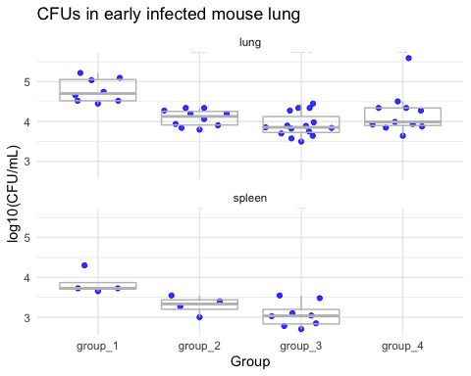

ANOVA results comparing CFUs in each organ across the experimental groups

|  |  |  |  |  |  |  |
| --- | --- | --- | --- | --- | --- | --- |
| organ | contrast1 | contrast2 | estimate | conf.low | conf.high | adj.p.value |
| lung | group_2 | group_1 | -0.6937802 | -1.1459033 | -0.2416571 | 0.0010456 |
| lung | group_3 | group_1 | -0.8587398 | -1.2760306 | -0.4414491 | 0.0000131 |
| lung | group_4 | group_1 | -0.5759227 | -1.0188178 | -0.1330275 | 0.0063696 |
| lung | group_3 | group_2 | -0.1649596 | -0.5540852 | 0.2241660 | 0.6695958 |
| lung | group_4 | group_2 | 0.1178575 | -0.2986077 | 0.5343227 | 0.8724636 |
| lung | group_4 | group_3 | 0.2828172 | -0.0955471 | 0.6611814 | 0.2037662 |
| spleen | group_2 | group_1 | -0.5489921 | -1.0924674 | -0.0055168 | 0.0476326 |
| spleen | group_3 | group_1 | -0.7868889 | -1.2575523 | -0.3162254 | 0.0018789 |
| spleen | group_3 | group_2 | -0.2378968 | -0.7085602 | 0.2327667 | 0.4019569 |