2015年6月英语六级真题及答案（第二套）

Part I Writing (30 minutes)
Directions For this part, you are allowed 80 minutes to write an essay commenting on Alert Einstein'sremark "I have no special talents. I am only passionately curious. " You can give an example or two toillustrate your point of view. You should write at least 15 words but no more than 200 words.
注意：此部分试题请在答题卡1上作答。

Part Ⅱ Listening Comprehension (30 minutes)
听力音频地址：http://www.233.com/cet6/Heare/zhenti/20151001/135533207.html
Section A
Directions: In this section, you will hear 8 short conversations and 2 long conversations. At the end of each conversation, one or more questions will be asked about what was said. BOth the conversation and the questions will be spoken only once. After each question there will be a pause. During the pause , you must
read the four choices marked A ), B., C. and D., and decide which is the best answer. Then mark the corresponding letter on Answer Sheet with a single line through the centre.
注意：此部分试题请在答题卡1上作答。
1. A. The woman thinks she is cleverer than the man.
B. The man behaves as if he were a thorough fool.
C. The man is unhappy with the woman's remark.
D. The woman seldom speaks highly of herself.
2. A. Three crew members were involved in the incident.
B. None of the hijackers carried any deadly weapons.
C. None of the passengers were injured or killed.
D. The plane had been scheduled to fly to Japan.
3. A. At a travel agency.
B. At a hotel front desk.
C. At a checkout counter.
D. At a commercial bank.
4. A. Chinatown has got the best restaurants in the city.
B. The critic thought highly of the Chinese restaurant.
C. The restaurant places many ads in popular magazines.
D. The restaurant was not up to the speakers' expectations.
5. A. ProL Laurence is going into an active retirement.
B. ProL Laurence has stopped conducting seminars.
C. The professor's graduate seminar is well received.
D. The professor will lead a quiet life after retirement.
6. A. signing Leon to a new position.
B. Finding a replacement for Leon.
C. Aranging for Rodney's visit tomorrow.
D. Finding a solution to Rodney's problem.
7. A. Photography is one of Helen's many hobbies.
B. Helen asked the man to book a ticket for her.
C. The photography exhibition will close tomorrow.
D. Helen has been looking forward to the exhibition.
8. A. The speakers share the same opinion.
B. Steve knows how to motivate employees.
C. The man has a better understanding of Steve.
D. The woman is out of touch with the real world.
Questions 9 to 12 are based on the conversation you have just heard.
9. A. It is well paid.
B. It is stimulating.
C. It is demanding.
D. It is fairly secure.
10. A. A quick promotion.
B. Free accommodation.
C. Moving expenses.
D. A lighter workload.
11. A. He has difficulty communicating with local people.
B. He has to spend a lot more traveling back and forth.
C. He has trouble adapting to the local weather.
D. He has to sign a long-term contract.
12. A. The woman will help the man make a choice.
B. The man is going to attend a job interview.
C. The man is in the process of job hunting.
D. The woman sympathizes with the man.
Questions 13 to 15 are based on the conversation you have just heard.
13. A. To inquire about the interest rates at the woman's bank.
B. To inquire about the current financial market situation.
C. To see if he can find a job in the woman's company.
D. To see if he can get a loan from the woman's bank.
14. A. Long-term investment.
B. A three-month deposit.
C. Any high-interest deposit.
D. Any high-yield investment.
15. A. She treated him to a meal.
B. She gave him loans at low rates.
C. She offered him dining coupons.
D. She raised interest rates for him.
Section B
Directions: In this section, you will hear3 short passages. At the end of eachpassage, you will hear some questions. Both the passage and the questions will be spoken only once. After you hear a question, you must choose the best answer from the four choices marked A ), B ), C ) and D ). Then mark the corresponding letter on Answer Sheet 1 with a single line through the centre.
注意：此部分试题请在答题卡1作答。
Passage One
Questions 16 to 18 are bused on the passage you have just heard.
16. A. Strict professional training.
B. Years of practical experience.
C. A refined taste for artistic works.
D. The ability to predict fashion trends.
17. A. Purchasing handicrafts from all over the world.
B. Conducting trade in art works with dealers overseas.
C. Strengthening cooperation with foreign governments.
D. Promoting all kinds of American hand-made specialties.
18. A. She has access to fashionable things.
B. She can enjoy life on a modest salary.
C. She is doing what she enjoys doing.
D. She is free to do whatever she wants.
Passage Two
Questions 19 to 22 are based on the passage you have just heard.
19. A. It is a Portuguese company selling coffee in New York.
B. Its most important task is to conduct coffee studies.
C. It represents several countries that export coffee.
D. Its role is to regulate international coffee prices.
20. A. The freezing weather in Brazil.
B. The impact of global warming.
C. The increased coffee consumption.
D. The fluctuation of coffee prices.
21. A. He is doing a bachelor's degree.
B. He is young, handsome and single.
C. He is a heavy coffee drinker.
D. He is tall, rich and intellieent.
22. A. A visit to several coffee-growing plantations.
B. Coffee prices and his advertising campaign.
C. A vacation on some beautiful tropical beach.
D. A quick promotion and a handsome income.
Passage Three
Questions 23 to 25 are based on the passage you have just heard.
23. A. They were held up in a traffic jam.
B. They boarded a wrong coach in a hurry.
C. They were late for the first morning bus.
D. They were delayed by the train for hours.
24. A. It was canceled because of an unexpected strike.
B. It was the most exciting trip they ever had.
C. It was spoiled by poor accommodations.
D. It was postponed due to terrible weather.
25. A. Go overseas.
B. Stay at home.
C. Take romantic cruises.
D. Take escorted trips.
Section C
Directions: In this section, you will hear a passage three times. When the passage is read for the first time, you should listen carefully for its general idea. When the passage is read for the second time, you are required to fill in the blanks with the exact words you have just heard. Finally, when the passage is read for the third time, you should check what you have written.
注意：此部分试题请在答题卡1上作答。
Why would an animal kill itself? It seems a strange question, and yet it is one that has 26 some people for a long time. The lemming (旅鼠) is one such animal. Lemmings periodically commit mass 27, and no one knows just why!
The small 28, which inhabit the Scandinavian mountains, sustain themselves on a diet of roots and live in nests they make underground. When their food supply is 29 large, the lemmings live a normal, undisturbed life.
However, when the lemmings' food supply becomes too low to support the population, a singular30 commences. The lemmings leave their nests all together at the same time, forming huge crowds. Great numbers of the lemmings begin a long and hard journey across the Scandinavian plains, z journey that may last weeks. The lemmings eat everything in their path, continuing their 31 march until they reach the sea.
The reason for what follows remains a mystery for zoologists and naturalists. Upon reaching the coast, the lemmings do not stop but swim by the thousands into the surf. Most 32 only a short time before they tire, sink, and drown.
A common theory for this unusual phenomenon is that the lemmings do not realize that the ocean is such 33 water. In their cross-country journey, the animals must traverse many smaller bodies of water, such as rivers and small lakes. They may 34 that the sea is just another such swimmable
35. But no final answer has been found to the mystery.

Part III Reading Comprehension (40 minutes)
Section A
Directions: In this section, there is a passage with ten blanks. You are required to select one word for each blank from a list of choices given in a word bank following the passage. Read the passage through carefully before making your choices. Each choice in the bank is identified by a letter. Please mark the corresponding letter for each item on Answer Sheet 2 with a single line through the centre. You may not use any of the words in the bank more than once.
Questions 36 to 45 are based on the following passage.
"That which does not kill us makes us stronger." But parents can't handle it when teenagers put this 36 into practice. Now technology has become the new field for the age-old battle between adults
en adults and their freedom-seeking kids.
Locked indoors, unable to get on their bicycles and hang out with their friends, teens have turned to social media and their mobile phones to socialize with their peers. What they do online often 37what they might otherwise do if their mobility weren't so heavily .38 in the age of helicopter parenting. Social media and smart-phone apps have become so popular in recent years because teens need a place to call their own. They want the freedom to 39 their identity and the world around them.
Instead of 40 out, they jump online.
As teens have moved online, parents have projected their fears onto the Internet, imagining all the41 dangers that youth might face--from 42 strangers to cruel peers to pictures or words that could haunt them on Google for the rest of their lives.
Rather than helping teens develop strategies for negotiating public life and the risks of 43 with others, fearful parents have focused on tracking, monitoring and blocking. These tactics (策略) don't help teens develop the skills they need to manage complex social situations,44 risks and get help
when they're in trouble. "Protecting" kids may feel like the right thing to do, but it 45 the learning that teens need to do as they come of age in a technology-soaked world.
注意：此部分试题请在答题卡2上作答。
A. assess
B.constrained
C.contains
D.explore
E.influence
F.interacting
G.interpretation
H.magnified
I. mirrors
J.philosophy
K.potential
L.sneaking
M.sticking
N. undermines
O. violent
Section B
Directions: In this section, you are going to read a passage with ten statements attached to it. Each statement contains information given in one of the paragraphs. Identify the paragraph from which the information is derived. You may choose a paragraph more than once. Each paragraph is marked with a letter. Answer the questions by marking the corresponding letter on Answer Sheet 2.
Inequality Is Not Inevitable
A) A dangerous trend has developed over this past third of a century. A country that experienced shared growth after World War Ⅱ began to tear apart, so much so that when the Great Recession hit in late 2007, one could no longer ignore the division that had come to define the American economic landscape. How did this "shining city on a hill" become the advanced country with the greatest level of inequality?
B) Over the past year and a half, The Great Divide, a series in The New York Times, has presented a wide range of examples that undermine the notion that there are any truly fundamental laws of capitalism. The dynamics of the imperial capitalism of the 19th century needn't apply in the democracies of the 21st. We don't need to have this much inequality in America.
C) Our current brand of capitalism is a fake capitalism. For proof of this go back to our response to the Great Recession, where we socialized losses, even as we privatized gains. Perfect competition should drive profits to zero, at least theoretically, but we have monopolies making persistently high profits. C. E. O. s enjoy incomes that are on average 295 times that of the typical worker, amuch higher ratio han in the past, without any evidence of a proportionate increase in productivity.
D)If it is not the cruel laws of economics that have led to America's great divide, what is it? The straightforward answer., our policies and our politics. People get tired of hearing about Scandinavian success stories, but the fact of the matter is that Sweden, Finland and Norway have all succeeded in having about as much or faster growth in per capita (人均的 ) incomes than the United States and with far greater equality.
E) So why has America chosen these inequality-enhancing policies? Part of the answer is that as World War Ⅱ faded into memory, so too did the solidarity it had created. As America triumphed in the Cold War, there didn't seem to be a real competitor to our economic model. Without this internat~ competition, we no longer had to show that our system could deliver for most of our citizens.
F) Ideology and interests combined viciously. Some drew the wrong lesson from the collapse of the Soviet system in 1991. The pendulum swung from much too much government there to much too little here. Corporate interests argued for getting rid of regulations, even when those regulations had done so much to protect and improve our environment, our safety, our health and the economy itself.
G) But this ideology was hypocritical (虚伪的). The bankers, among the strongest advocates of laissez- faire (自由放任的 ) economics, were only too willing to accept hundreds of billions of dollars from the government in the aid programs that have been a recurring feature of the global economy since the beginning of the Thatcher-Reagan era of "free" markets and deregulation.
H) The American political system is overrun by money. Economic inequality translates into political inequality, and political inequality yields increasing economic inequality. So corporate welfare increases as we reduce welfare for the poor. Congress maintains subsidies for rich farmers as we cut back on nutritional support for the needy. Drug companies have been given hundreds of billions of dollars as we limit Medicaid benefits. The banks that brought on the global financial crisis got billions while a tiny bit went to the homeowners and victims of the same banks' predatory (掠夺性的) lending practices. This last decision was particularly foolish. There were alternatives to throwing money at the banks and hoping it would circulate through increased lending.
I) Our divisions are deep. Economic and geographic segregation has immunized those at the top from the problems of those down below. Like the kings of ancient times, they have come to perceive their privileged positions essentially as a natural right.
J) Our economy, our democracy and our society have paid for these gross inequalities. The true test of an economy is not how much wealth its princes can accumulate in tax havens (庇护所), but how well off the typical citizen is. But average incomes are lower than they were a quarter-century ago. Growth has gone to the very, very top, whose share has almost increased four times since 1980. Money that was meant to have trickled (流淌) down has instead evaporated in the agreeable climate of the Cayman Islands.
K) With almost a quarter of American children younger than 5 living in poverty, and with America doing so little for its poor, the deprivations of one generation are being visited upon the next. Of course, no country has ever come close to providing complete equality of opportunity. But why is America one of the advanced countries where the life prospects of the young are most sharply determined by the income and education of their parents?
L) Among the most bitter stories in The Great Divide were those that portrayed the frustrations of the young, who long to enter our shrinking middle class. Soaring tuitions and declining incomes have resulted in larger debt burdens. Those with only a high school diploma have seen their incomes decline by 13 percent over the past 35 years.
M) Where justice is concerned, there is also a huge divide. In the eyes of the rest of the world and a significant part of its own population, mass imprisonment has come to define America--a country, it bears repeating, with about 5 percent of the world's population but around a fourth of the world's prisoners.
N) Justice has becom~ a commodity, affordable to only a few. While Wall Street executives used their expensive lawyers to ensure that their ranks were not held accountable for the misdeeds that the crisis in 2008 so graphically revealed, the banks abused our legal system to foreclose (取消赎回权) on mortgages and eject tenants, some of whom did not even owe money.
O) More than a half-century ago, America led the way in advocating for the Universal Declaration of Human Rights, adopted by the United Nations in 1948. Today, access to health care is among the most universally accepted rights, at least in the advanced countries. America, despite the implementation of the Affordable Care Act, is the exception. In the relief that many felt when the Supreme Court did not overturn the Affordable Care Act, the implications of the decision for Medicaid were not fully appreciated. Obamacare's objective--to ensure that all Americans have access to health care--has been blocked: 24 states have not implemented the expanded Medicaid program, which was the means by which Obamacare was supposed to deliver on its promise to some of the poorest.
P) We need not just a new war on poverty but a war to protect the middle class. Solutions to these problems do not have to be novel. Far from it. Making markets act like markets would be a good place to start. We must end the rent-seeking society we have gravitated toward, in which the wealthy obtain profits by manipulating the system.
Q) The problem of inequality is not so much a matter of technical economics. It's really a problem of practical politics. Inequality is not just about the top marginal tax rate but also about our children's access to food and the right to justice for all. If we spent more on education, health and infrastructure (基础设施), we would strengthen our economy, now and in the future.
注意：此部分试题请在答题卡2上作答。
- In theory, free competition is supposed to reduce the margin of profits to the minimum.
- The United States is now characterized by a great division between the rich and the poor.
48. America lacked the incentive to care for the majority of its citizens as it found no rival for its economic model.
49. The wealthy top have come to take privileges for granted.
50. Many examples show the basic laws of imperial capitalism no longer apply in present-day America.
51. The author suggests a return to the true spirit of the market.
52. A quarter of the world's prisoner population is in America.
53. Government regulation in America went from one extreme to the other in the past two decades.
54. Justice has become so expensive that only a small number of people like corporate executives can afford it.
55. No country in the world so far has been able to provide completely equal opportunities for all.
Section C
Directions: There are 2 passages in this section. Each passage is followed by some questions or unfinished statements. For each of them there are four choices marked A. , B. , C. and D.. You should decide on the best choice and mark the corresponding letter on Answer Sheet 2 with a single line through the centre.
Passage One
Questions 56 to 60 are based on the following passage.
I'll admit I've never quite understood the obsession (难以破除的成见 ) surrounding genetically modified (GM) crops. To environmentalist opponents, GM foods are simply evil, an understudied. possibly harmful tool used by big agricultural businesses to control global seed markets and crush local farmers. They argue that GM foods have never delivered on their supposed promise, that money spent on GM crops would be better channeled to organic farming and that consumers should be protected with warning labels on any products that contain genetically modified ingredients. To supporters, GM crops are a key part of the effort to sustainably provide food to meet a growing global population. But more than that, supporters see the GM opposition of many environmentalists as fundamentally anti-science, no different than those who question the basics of man-made climate change.
For both sides, GM foods seem to act as a symbol: you're pro-agricultural business or anti-science. But science is exactly what we need more of when it comes to GM foods, which is why I was happy to see Nature devote a special series of articles to the GM food controversy. The conclusion: while GM crops haven't yet realized their initial promise and have been dominated by agricultural businesses, there is reason to continue to use and develop them to help meet the enormous challenge of Sustainably feeding a growing planet.
That doesn't mean GM crops are perfect, or a one-size-fits-all solution to global agriculture problems. But anything that can increase farming efficiency--the amount of crops we can produce per acre of land-- will be extremely useful. GM crops can and almost certainly will be part of that suite of tools, but so will traditional plant breeding, improved soil and crop management--and perhaps most important of all, better storage and transport infrastructure (基础设施), especially in the developing world. (It doesn't do much good for farmers in places like sub-Saharan Africa to produce more food if they can't get it to hungry consumers. ) I'd like to see more non-industry research done on GM crops--not just because we'd worry
less about bias, but also because seed companies like Monsanto and Pioneer shouldn't be the only entities working to harness genetic modification. I'd like to see GM research on less commercial crops, like corn. I don't think it's vital to label GM ingredients in food, but I also wouldn't be against it--and industry would be smart to go along with labeling, just as a way of removing fears about the technology.
Most of all, though, I wish a tenth of the energy that's spent endlessly debating GM crops was focused
on those more pressing challenges for global agriculture. There are much bigger battles to fight.注意：此部分试题请在答题卡2上作答。
56. How do environmentalist opponents view GM foods according to the passage?
A. They will eventually ruin agriculture and the environment.
B. They are used by big businesses to monopolize agriculture.
C. They have proved potentially harmful to consumers' health.
D. They pose a tremendous threat to current farming practice.
57. What does the author say is vital to solving the controversy between the two sides of the debate?
A. Breaking the GM food monopoly.
B. More friendly exchange of ideas.
C. Regulating GM food production.
D. More scientific research on GM crops.
58. What is the main point of the Nature articles?
A. Feeding the growing population makes it imperative to develop GM crops.
B. Popularizing GM technology will help it to live up to its initial promises.
C. Measures should be taken to ensure the safety of GM foods.
D. Both supporters and opponents should make compromises.
59. What is the author's view on the solution to agricultural problems?
A. It has to depend more and more on GM technology.
B. It is vital to the sustainable development of human society.
C. GM crops should be allowed until better alternatives are found.
D. Whatever is useful to boost farming efficiency should be encouraged.
- What does the author think of the ongoing debate around GM crops?
A. It arises out of ignorance of and prejudice against new science.
B. It distracts the public attention from other key issues of the world.
C. Efforts spent on it should be turned to more urgent issues of agriculture.
D. Neither side is likely to give in until more convincing evidence is found.
Passage Two
Questions 61 to 65 are based on the following passage.
Early decision--you apply to one school, and admission is binding--seems like a great choice for nervous applicants. Schools let in a higher percentage of early-decision applicants, which arguably means that you have a better chance of getting in. And if you do, you're done with the whole agonizing process by December. But what most students and parents don't realize is that schools have hidden motives for offering early decision.
Early decision, since it's binding, allows schools to fill their classes with qualified students; it allows admissions committees to select the students that are in particular demand for their college and know those students will come. It also gives schools a higher yield rate, which is often used as one of the ways to measure college selectivity and popularity.
The problem is that this process effectively shortens the window of time students have to make one of the most important decisions of their lives up to that point. Under regular admissions, seniors have until May 1 to choose which school to attend; early decision effectively steals six months from them, months that could be used to visit more schools, do more research, speak to current students and alumni (校友) and arguably make a more informed decision.
There are, frankly, an astonishing number of exceptional colleges in America, and for any given student, there are a number of schools that are a great fit. When students become too fixated (专注) on a particular school early in the admissions process, that fixation can lead to severe disappointment if they don't get in or, if they do, the possibility that they are now bound to go to a school that, given time forfarther reflection, may not actually be right for them.
Insofar as early decision offers a genuine admissions edge, that advantage goes largely to students who already have numerous advantages. The students who use early decision tend to be those who have received higher-quality college guidance, usually a result of coming from a more privileged background. In this regard, there's an argument against early decision, as students from lower-income families are far less likely to have the admissions know-how to navigate the often confusing early deadlines.
Students who have done their research and are confident that there's one school they would be thrilled to get into should, under the current system, probably apply under early decision. But for students who haven't yet done enough research, or who are still constantly changing their minds on favorite schools, the early-decision system needlessly and prematurely narrows the field of possibility just at a time when students should be opening themselves to a whole range of thrilling options.
注意：此部分试题请在答题卡2上作答。
61. What are students obliged to do under early decision?
A. Look into a lot of schools before they apply.
B. Attend the school once they are admitted.
C. Think twice before they accept the offer.
D. Consult the current students and alumni.
62. Why do schools offer early decision?
A. To make sure they get qualified students.
B. To avoid competition with other colleges.
C. To provide more opportunities for applicants.
D. To save students the agony of choosing a school.
63. What is said to be the problem with early decision for students?
A. It makes their application process more complicated.
B. It places too high a demand on their research ability.
C. It allows them little time to make informed decisions.
D. It exerts much more psychological pressure on them.
64. Why are some people opposed to early decision?
A. It interferes with students' learning in high school.
B. It is biased against students at ordinary high schools.
C. It causes unnecessary confusion among college applicants.
D. It places students from lower-income families at a disadvantage.
65. What does the author advise college applicants to do?
A. Refrain from competing with students from privileged families.
B. Avoid choosing early decision unless they are fully prepared.
C. Find sufficient information about their favorite schools.
D. Look beyond the few supposedly thrilling options.

Part IV Translation (30 minutes)
Directions: For this part, you are allowed 30 minutes to translate a passage from Chinese into English. You should write your answer on Answer Sheet 2.
2011年是中国城市化(urbanization)进程中的历史性时刻，其城市人口首次超过农村人口。在未来20年里，预计约有3．5亿农村人口将移居到城市。如此规模的城市发展对城市交通来说既是挑战，也是机遇。中国政府一直提倡“以人为本’’的发展理念，强调人们以公交而不是私V--$-出行。它还号召建设“资源节约和环境友好型”社会。有了这个明确的目标，中国城市就可以更好地规划其发展，并把大量投资转向安全、清洁和经济型交通系统的发展上。
注意：此部分试题请在答题卡2上作答。

2015年6月大学英语六级考试真题(二)答案与详解
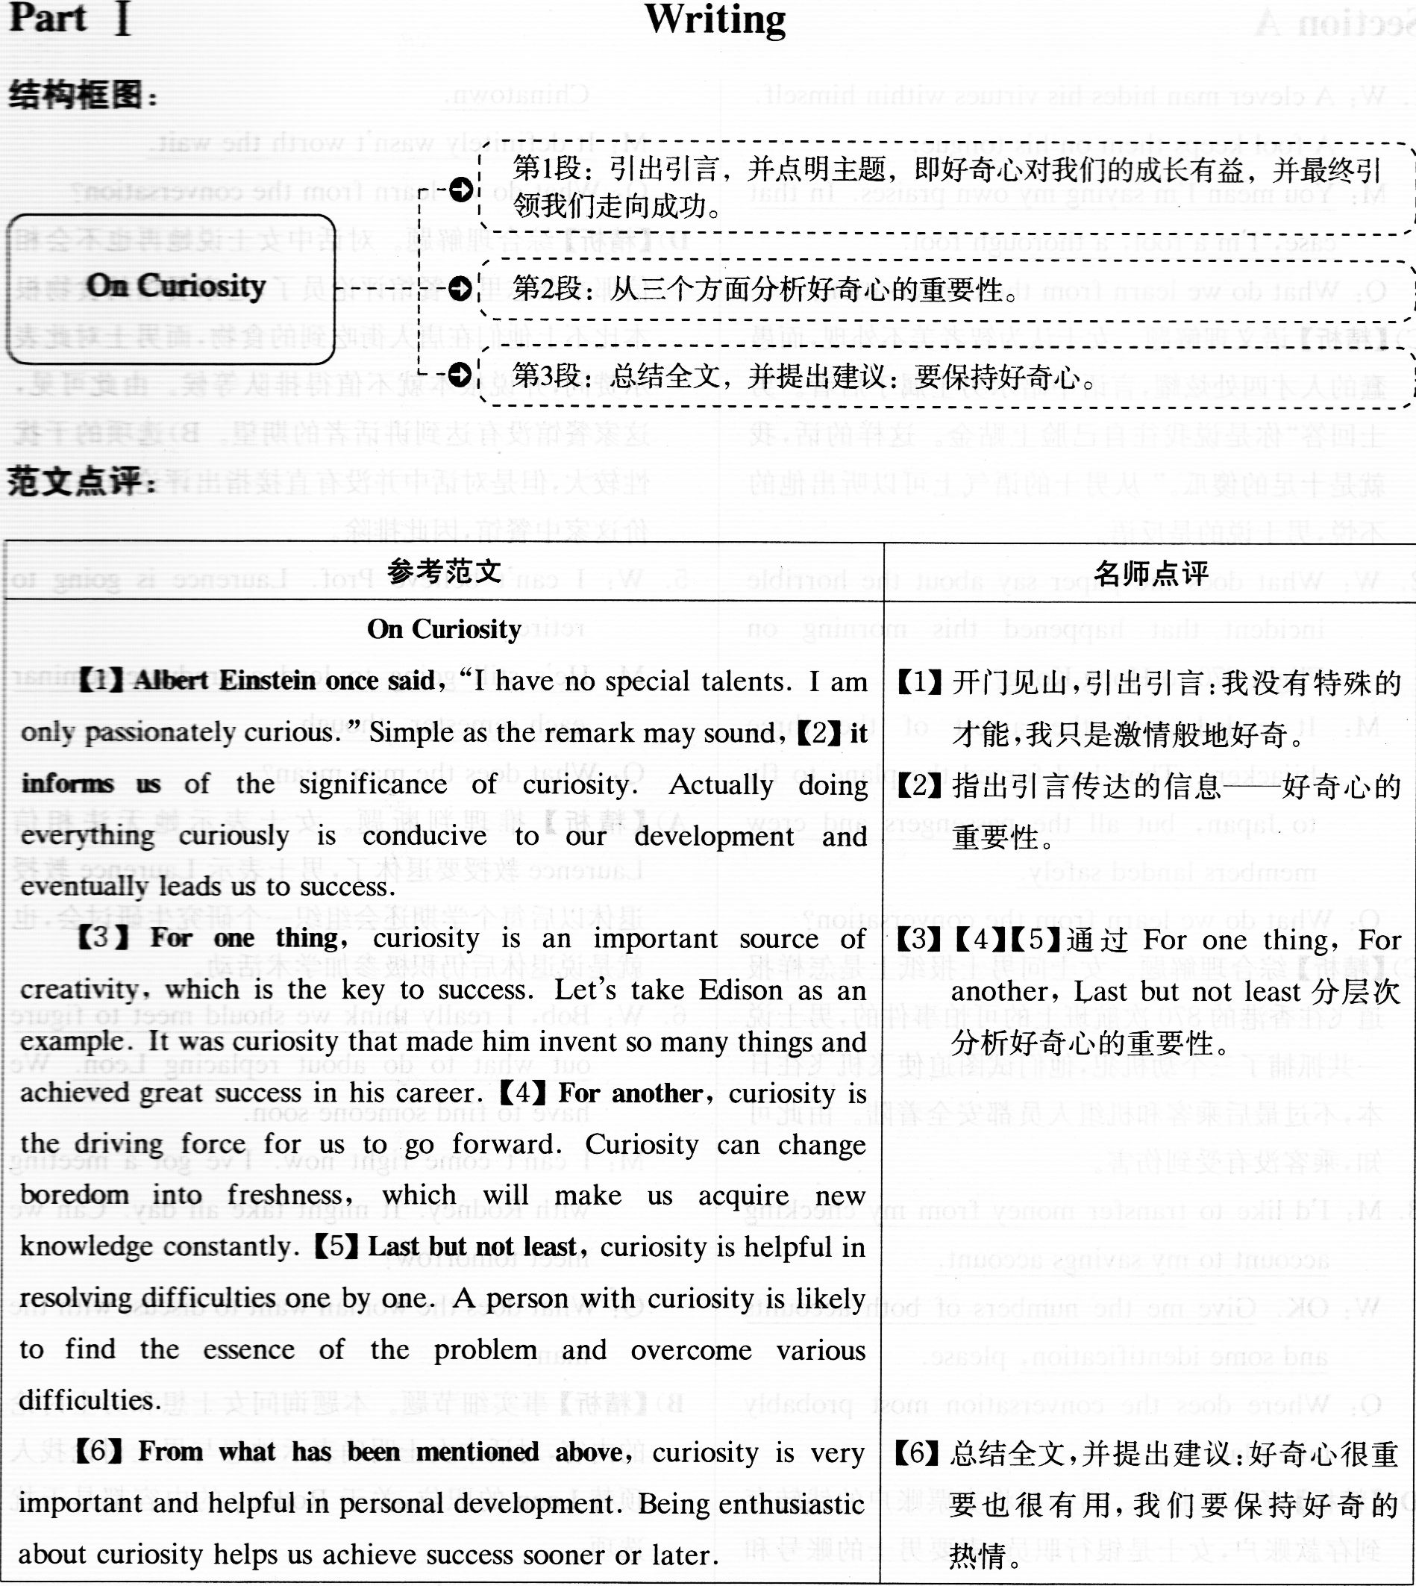
interest 兴趣
stimulate/satisfy one's curiosity 激发/满足某人的好 奇心
innovate 创新
explore 探索
immense intellectual curiosity强烈的求知欲
cultivate 培养
Curiosity killed the cat. 好奇害死猫
enthusiasm 热情
intrigue 激起 的兴趣

Part II Listening Comprehension
Section A
1. W: A clever man hides his virtues within himself.
A fool keeps them on his tongue.
M.. You mean I'm saying my own raises. In that case, I'm a fool, a thorough fool.
Q: What do we learn from the conversation?
C)【精析】语义理解题。女士认为智者美不外现，而愚蠢的人才四处炫耀，言语中暗示男士属于后者。男士回答“你是说我往自己脸上贴金。这样的话，我就是十足的傻瓜‘。”从男士的语气上可以听出他的不悦，男士说的是反语。
2. W: What does the paper say about the horrible incident that happened this morning on Flight 870 to Hong Kong?
M: It ended with the arrest of the three hijackers. They had forced the plane to fly to Japan, but all the passengers and crew members landed safely.
O.. What do we learn from the conversation?
C)【精析】综合理解题。女士问男士报纸上是怎样报 道飞往香港的870次航班上的可怕事件的，男士说一共抓捕了三个劫机犯，他们试图迫使飞机飞往日本，不过最后乘客和机组人员都安全着陆。由此可知，乘客没有受到伤害。
3. M.. I'd like to transfer mone from checkin account to my savings account.
W.. OK. Give me the numbers of both accounts and some identification, please.
Q: Where does the conversation most probably take place?
D)【精析】场景推断题。男士要将支票账户的钱转存到存款账户，女士是银行职员，索要男士的账号和身份证件，因此对话最有可能发生在银行。
4. W: I'm not going to trust the restaurant critic from that magazine again. The food here doesn't taste anything like what we had in Chinatown.
M.. It definitely wasn't worth the wait.
Q: What do we learn from the conversation?
D)【精析】综合理解题。对话中女士说她再也不会相 信那本杂志里的餐馆评论员了，这家餐馆的食物根 本比不上他们在唐人街吃到的食物，而男士对此表 示赞同．并说根本就不值得排队等候。由此可见这家餐馆没有达到讲话者的期望。B)选项的干扰性较大．但是对话中并没有直接指出评论员高度评价这家中餐馆．因此排除．
5. W: I can't believe Prof. Laurence is going to retire.
M: He's still to lead agraduate seminar each semester, though.
Q: What does the man mean?
A)【精析】推理判断题。女士表示她无法相信Laurence教授要退休了，男士表示Laurence教授 退休以后每个学期还会组织一个研究生研讨会，也 就是说退休后仍积极参加学术活动。
6. W: Bob, I really_think we should meet to fig out what to do about replacing Leon. We have to find someone soon.
M: I can't come right now. I've got a meeting with Rodney. It might take all day. Can wemeet tomorrow?
Q: What does the woman want to discuss with the
man?
B)【精析】事实细节题。本题询问女士想和男士讨论 的内容，对话中女士明确表示她想与男士讨论找人 顶替Leon的职位，关于Rodney的内容都是干扰 选项。
- W: Helen won't be coming to work tomorrow. She's finally going to the photography exhibition.
M: Oh, so she managed a ticket after all.
O: What do we learn from the conversation?
D【精析】综台理解题。女士指出Helen为了看摄影展都不来上班了．男士听到这个消息才知道Helen 已经买到票了。看来Helen一直都在期待着能够买到票去看展览。
8. W: Steve has listed a few ways of motivating the employees, but these are out of touch of the real world.
M.. You just took the words out of my mouth. Let's try to persuade him to see things our way.
Q.. What do we learn from the conversation?
A)【精析】语义理解题。女士表示Steve列出的员工 激励措施脱离实际，男士表示“你抢了我的台词”， 即他们想到一块儿去了。
Conversation One
M: I'd like to go to the States, but if I took the job there, I won't get a very good salary.
W: Really? I thought salaries were high there, but there would be some fringe benefits presumably~
M: Oh, yes. (9)It would be stimulating and it has some advantages.
W: What else do you have in mind7 M: Well, this position in Portugal. W: How does it compare?
M: It offers greatest security, because it will be on a home-base contract. W: And salary?
M: Much better. I get an overseas allowance plus free accommodation from the firm. W: Presumably you will be given moving expenses for the Portugal job?
M: (10)Yes, but just to complicate matters, this ssibilit offers a st in Sao Paulo.
W: (10)That's Brazil, isn't it?
M: Yes. (10)I'll a promotion if I took a post there.
W: I'd love to go to Brazil.
M: But there are some disadvantages. (ll)I'd have to do a five-year term there.
W: That's not a problem, surely?
M: Well, not at the moment. But if there were a change in family circumstances, I'd be a long way from home.
W: But if you are worried about distance, isn't that the same problem with the States?
M: Yes, but in the States I will be on an annual contract, so I can leave fairly quickly if I needed to.
W: In Portugal7
M: Well, that's almost next door, isn't it? I can visit home every a few months if necessary.
W: I can see you've got a difficult choice to make.
M: (12)Well, fortunatelv_I don't have to make upmy mind about an~ of them yet. In fact, I haven't even been called for an interview.
；答案详解
9. What does the man say about the job in the States?
B)【精析】细节辨认题。对话中男士指出在美国的工作 工资低，但是这份工作很有新意，而且有一些优点。hat benefit will the man get if he took the post ~ i~ S~o Paulo?
细节辨认题：对话中男士指出选择圣保罗的工作可以为他带来升职：安家费和免费住宿是葡萄牙工作的好处，属于干扰选项。
11. What does the man say is the disadvantage of working in Brazil?
D)【精析】细节推断题。对话中男士指出在巴西工作需要签5年的合约，离家太远，一旦家里有事发生，无法兼顾。
12. What do we learn from the end of the conversation?
C)【精析】推理判断题。对话结尾女士表示她理解男士很难选择，男士却回答，幸运的是，他不需要做出决定，因为他还没有被叫去面试。由此推测，男士现在在找工作的过程当中。
Conversation Two
w: Good morning, High Mountain Savings and Loan. How may we help you?
M: (13)Well, I'm looking for the high sible on a short-term certificate to deposit an account.
W: Well, Let's see what we can do for. you. High Mountain is currently offering a rate of 6.4% on the thirteen-week account for the minimum deposit of only 12 000 dollars, 6.55% on the minimum deposit of 25 000 dollars and 6.7% on a deposit Of 50 000 dollars. Those will have yields of 6.55%, 6.71% and 6.87% respectively.
M: Rate and yield? I'm afraid I don't understand the difference.
W: Well, sir. The rate is the percentage of symbol interest paid on your money, and the yield is the total percentage you will receive on your account if you leave your money with us, frankly to say here, as the same interest rate.
M: Oh, well.., um... (14)But I'm not interested in long-term investing and three months sounds iust fine.
W: Then perhaps you would like to open one of our high finance money market checking accounts. With the minimum balance of only 50 000 dollars, you'll get interest of 6.1% on any amount over that, for a yearly yield of 6.27%. Of course, there is no penalty for early withdraw.
M: No, thank you. I...
W: (15)Or, could we ou to save with us if we offer ou a dining coupon book that will et you a 25% discount at man of the area's leading restaurants and cost 12 dollars and 95 cents?
M: Look, I think I'll just call around for more information. Thank you for your time.
13. What is the man's purpose in making the phone call?
A)【精析】目的原因题。对话中男士想办理一个利率 最高的短期存款，因此打电话向银行询问。
14. What is the man most interested in?
B)【精析】细节辨认题。对话中女士男士介绍了不同的理财产品，男士表示他对长期投资不感兴趣，想选择类似三个月的短期存款。
15. What did the woman do to persuade the man to deposit in her bank?
C)【精析】细节推断题。对话结尾，在男士说出了 N0，thank you之后，女士为了说服男士在银行存款，表示可以提供给他当地一流餐厅的优惠券。
Section B
Passage One
Karen Smith is a buyer for a department store in New York. Department store buyers purchase the goods that their stores sell. (16)The not have to know what is fashionable at the moment, but also have to guess what will become fashionable next season or next year. Most buyers work for just one department in a store. But the goods that Karen finds may be displayed and sold in several different sections of the store. (17)Her job involves buying handicrafts from all over the world. Last year, she made a trip to Morocco and returned with rugs, pots, dishes and pans. The year before, she visited Mexico, and bought back hand-made table cloths, mirrors with frames of tin and paper flowers. The paper flowers are bright and colorful, so they were used to decorate the whole store. This year Karen is travelling in Malaysia, Thailand and Indonesia. Many of the countries that Karen visits have government offices that promote handicrafts. The officials are glad to cooperate with her by showing her the products that are available. Karen especially likes to visit markets in
small towns and villages whenever she can arrange for it. She is always looking for interesting and unusual items. (18)Karen thinks she has the best job she could find. She loves all the travelling that she has to do, because she often visits markets and small out-of-the-way__places. She sees much more of the country she visits than an ordinary tourist would. As soon as she gets back to New York from one trip, Karen begins to plan another.
16. What is said to make a good department store buyer?
D)【精析】细节辨认题。短文开头提到，Karen Smith 是一位百货公司的采购员，作为优秀的采购人员，不仅要了解当时的时尚，还要能够预测将来的时尚趋势：
17. What does Karen's job involve?
A)【精析】细节辨认题。短文中提到．Karen Smith1的工作是到世界各地去购买手工艺品。
18. Why does Karen think she has got the best job?
C)【精析】目的原因题。短文中明确提到Karen觉得她已经找到了最好的工作，因为她喜欢去世界各地出差，她可以借出差的机会去市场和那些人们不常去的小地方。
Passage Two
Vaukin de Silva is a Brazilian who lives and works in New York. Brazil's most important product is coffee and coffee is Vaukin's business. He works for an international coffee institute. (19)It represents Brazil and several other countries that export coffee. The institute wants more people to drink more coffee. That hasn't been easy to do for the last few months. (20)A period of freezing_weather destro ed a lar e art of Brazil's coffee cro1~. As a result, there has been a shorta e~offee throughout the world. The shortage has caused prices to go very high. Many people are talking about giving up coffee until the prices come down again. All the countries that are represented in the institute want people to continue drinking coffee. They spend a lot of time explaining the recent rise in price to newspaper reporters. They want the public to understand the reason for the shortage. Among the goal, Vaukin was put in charge of an advertising campaign. The campaign will try to encourage people to keep on drinking coffee. Sometimes, Vaukin misses the beaches and tropical weather in Rio de Janeiro, but he likes the life in New York. (21)He is only 27years old, and he is a good looking bachelor. There are a lot of women to meet in New York and a lot of places to go with them. When he misses home, there are several Brazilian restaurants where he can go and speak Portuguese, his native language. (22)The last few weeks, however, he's been too busy to think about an thin exce t coffee rices and his advertising campaign.
19. What does the passage say about the international coffee institute?
C)【精析】推理判断题。短文开头提到，Vaukin在一家国际性的咖啡机构工作，这一机构代表着巴西以及其他一些出口咖啡的国家。
20.What caused the recent shortage of coffee throughout the world? A.细节推断题．短文中提到巴西遭遇了严寒 天气．使得大片咖啡树受损．因此全世界出现了咖啡短缺的情况。
21. What do we learn about Vaukin de Silva?
B)【精析】细节辨认题。短文中提到，Vaukin是个27岁的年轻小伙子，长得不错，而且单身。
22. What has occupied Vaukin's mind for the last few weeks?
B)【精析】细节辨认题。短文结尾处提到，Vaukin 最近满脑子都是咖啡价格和咖啡推广活动的 事情。Passage Three
Last summer, my wife and I had saved for a year to be able to take a romantic cruise to several Carib~2, islands. Because the train was scheduled to arrive in Miami, Florida several hours before the sailing, we didn'-= think we'd have any reason to worry about getting to the dock on time. We should've known that long distan~ trains are often many hours late. (23)We should've taken an earlier one to allow extra time. We should have. but we didn't and we missed the boat. Because there wouldn't to be a refund of our cruise fare, if we returned home, we had to pay for a hotel room and meals in the city and an air fare to fly to the first island on the shipped route two days later. We missed half the cruise. This year, we decided to let an experienced travel agent do our vacation planning for us. We had to pay the full price in advance for an escorted tour.(24)We should that relaxing well-planned trip right now. How could we have known there would be a strike against our airline? And why hadn't anyone advised us that the travel agency can't refund your money unless the tour operator can get the passengers' fees back from the reserved hotels, the tour boat's company and so on? To avoid trouble like this, we ought to get more travel experience, but to tell you the truth, we don't want to go anywhere. (25)We're planning to spend our vacations at home for a long time to come.
:
23. Why did the couple fail to get to the cruise in time9
D)【精析】目的原因题。短文中提到，在去年的旅行中，由于男士和妻子乘坐的长途火车晚点，导致他们没有赶上游船之旅。
24. What does the speaker say about their trip this year?
A)【精析】细节辨认题。短文中提到，夫妻二人今年的旅行依然没有如愿，因为他们所乘坐班机的航空公司罢工。
25. What will the speaker do in the future for a vacation?
B)【精析】推理判断题。短文中提到鉴于以往的失败 旅游经历，讲话者只想待在家里过假期。
Section C
26．puzzled 【精析】句意推断题。此空后面是名词some people，前面是has，因此has应该是助动词，此空需要填入一个动词(词组)的过去分词，与has构成现在完成时。 结合录音填入puzzled，意为“使……迷惑”。
27．suicide【精析】固定搭配题。此空前面有commit一词 而前文中提到动物的自杀行为，故联想到固定搭 配commit suicide，为“自杀”之意。结合录音填入 suicide。
28．creatures【精析】修饰关系题。此空前面的The small是 “定冠词+形容词”的形式，因此空格处要填入一个名词作句子的主语；主语后面接定语从句，从旬 中的动词inhabit没有使用第三人称单数形式，因此确定这个名词主语是复数。结合录音填人 creatures，意为“生物”。
29．sufficiently【精析】修饰关系题。此空位于系动词is之后，形 容词large之前，故应填人副词用来修饰后面的形 容词。结合录音填入sufficiently，意为“足够地”。30．migration【精析】句意推断题。此空的前面是“冠词+形容 词”的形式，因此空格处需要填入一个名词；后面 是第三人称单数形式的动词commences，“开始” 之意，进而确定此空的名词为单数。结合录音填 入migration，意为“迁徙”。
31．destructive【精析】修饰关系题。此空与前面的their和后面 的march一起作continuin9的宾语，march此处 是名词，为“行军，前进”之意；此空与their共同作 march的定语，故猜测应该填入一个形容词。结 合录音填入destructive，意为“毁灭性的”。
32 float Oil water【精析】语义推断题：此空前面是Most，后面没有 动词．而是直接出现了名词a short time，由此确定 ．Most为名词．指。大部分旅鼠”，作句子的主语，空 格处赠填入谓语部分。结合录音填入float Oil ’vater．意为。在水上漂浮”。
- a huge body of【精析】修饰关系题。此空前面是such，后面是不 可数名词water，故猜测此空可以填入形容词来修 饰water。此处答案并不是单个的形容词，而是一 个量词词组，结合录音填入a huge body of water，意为“大面积的水域”。
34．assulne【精析】句意推断题。此空位于情态动词may之 后，故应填人动词(词组)原形。结合录音填入 assume意为“假定，认为”。
35．obstacle【精析】句意推断题。此空的前面为another such swimmable，“另一个能够游泳的”，说明此空需要 填入一个名词，而且是单数名词。结合录音填入 obstacle，意为“障碍(物)”。

Part III Reading Comprehension
Section A
【文章来源】本文选自2014年3月13日TIME(((时代》)上的一篇文章，标题为“Let Kids Run Wild Online”(《让孩子们在网络上疯狂》)。
【结构框图】
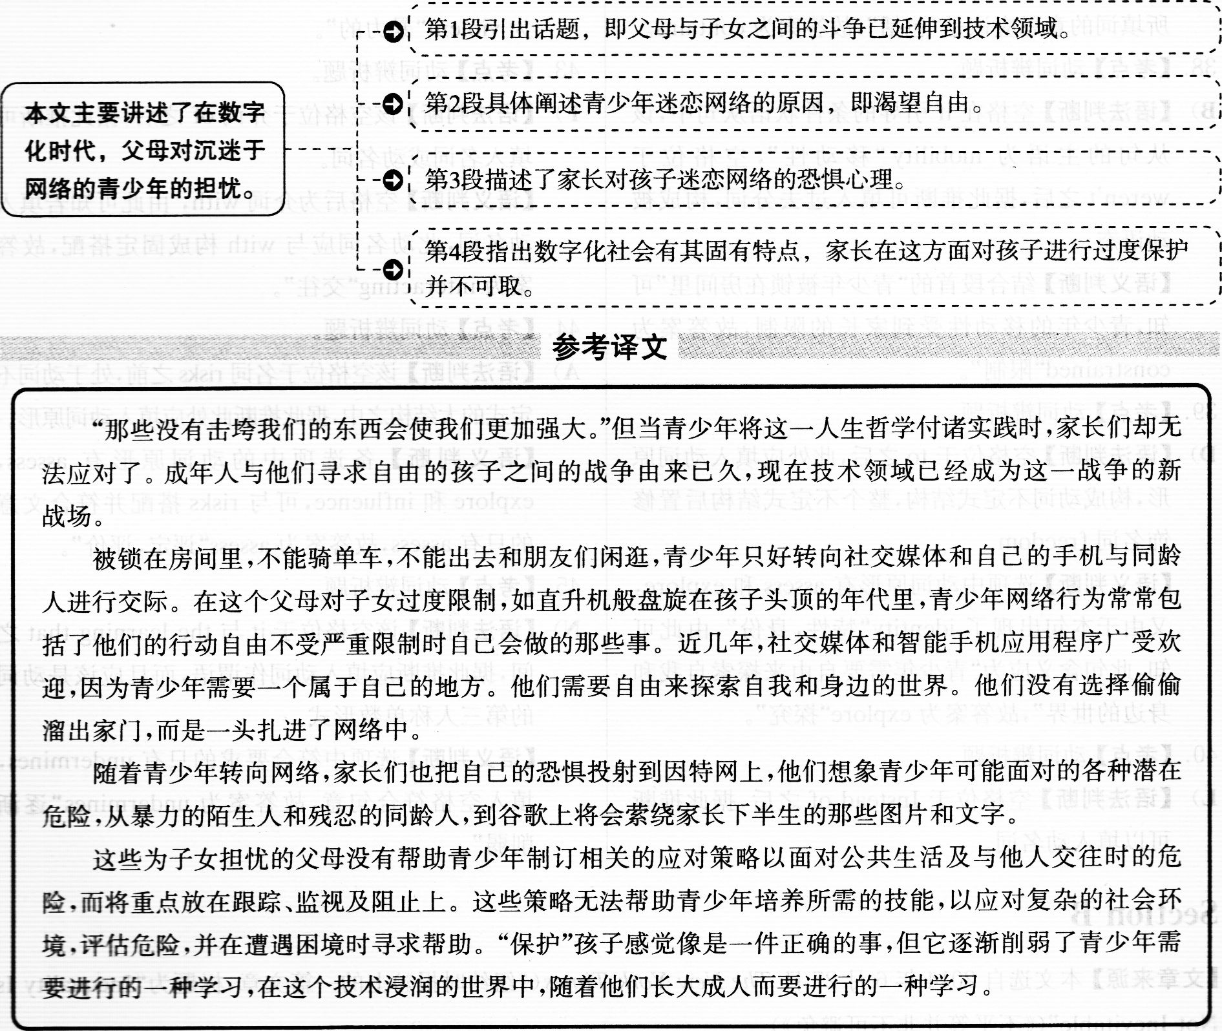

- 【考点】名词辨析题。J)【语法判断】空格位于代词this之后．据此推断可 以填入名词．作put的宾语．构成put．．．into practice的结构：【语义判断】第一句。那些没有击垮我们的东西会 使我们更加强大”是一句俗语．表达了一种人生哲 学=备选名词中．符合句意的只有philosoph}。人 生哲学”：
37．【考点】动词辨析题：c)【语法判断】空格前是What弓l导的主语从句．空 格后是what引导的宾语从句．据此推断空格处 应填入动词第三人称单数作主句的谓语：
【语义判断】选项中．符合要求的动词有contains． mirrors和undermines：空格前面部分句意是。他 们的网络行为”，后面部分大意是。他们的行动自 由不 时自己会做的那些事”．放推断空格 所填词的意思应该是“包括”，故答案为contains。 38．【考点】动词辨析题。B)【语法判断】空格在if引导的条件状语从句中．该 从句的主语为mobility“移动性”．空格位于 weren’t之后，据此推断可填入过去分词，构成被动语态。【语义判断】结合段首的“青少年被锁在房间里”可知，青少年的移动性受到家长的限制，故答案为 constrained“限制”。
39．【考点】动词辨析题。D)【语法判断】空格位于t0之后，此处应填入动词原 形，构成动词不定式结构，整个不定式结构后置修 饰名词freedom。【语义判断】选项中动词原形有assess和explore，又由于本句出现了identity“特性，身份”，由此可 知，此句含义应为“青少年需要自由来探索自我和 身边的世界”，故答案为explore“探究”。
40．【考点】动词辨析题。L)【语法判断】空格位于Instead of之后，据此推断 可以填入动名词。【语义判断】空格后有out，所以所填的词应该可 以和0ut搭配。选项中符合要求的有stickin9和sneakin9。sticking out表示“坚持”，意思与原文不符．故排除。sneaking out“溜走，偷跑”，符合句意．故答案为sneakin9。
41．【考点】形容词辨析题。K)【语法判断】空格位于定冠词the和名词dangers之间．据此推断可填入形容词。【语义判断】由本句中的“残忍的同龄人”和“谷歌上将会萦绕家长们下半生的那些图片和文字”可知，这些危险应该是“潜在的”危险，故答案为 potential。
42．【考点】形容词辨析题。O)【语法判断】该空格位于strangers之前，据此推断 可填入形容词。【语义判断】结合所有备选形容词词义可知，答案为violent。暴力的”：
43．【考点】动词辨析题：F)【语法判断】该空格位于介词of之后，据此推断可 填入名词或动名词．【语义判断】空格后为介词with，由此可知若填入动名词．此动名词壹与with构成固定搭配，故答 案为interactin9。交往”：
44．【考点】动词辨析题：A)【语法判断】该空格位于名词risks之前．处于动词不 定式的大结构之中．据此推断此处应填入动词原形。【语义判断】备选项中的动词原形有assess，explore和influence．可与risks搭配并符合文意的只有aSSess．故答案为assess”评定．评价”：
45．【考点】动词辨析题：N)【语法判断】该空格位于it与the learning that之间，据此推断应填入动词作谓语，而且应该是动词的第三人称单数形式。【语义判断】选项中符合要求的只有undermines，填入空格符合句意，故答案为undermines“逐渐削弱”。
Section B
【文章来源】本文选自2014年6月27日The New York Times(《纽约时报》)上的一篇文章，标题为“Inequality Is Not Inevitable”(《不平等并非不可避免》)。
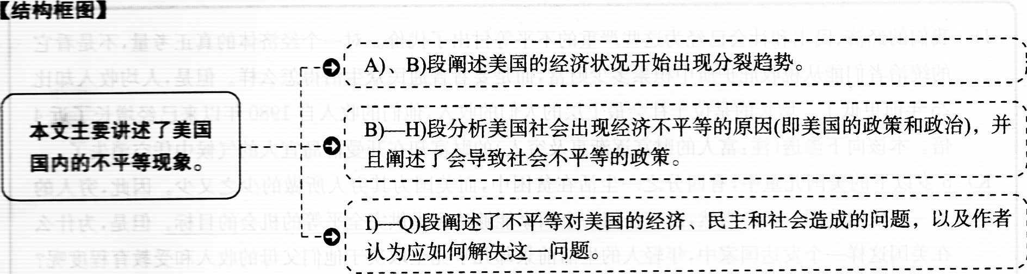

不平等并非不司避免
- 在过去的三分之一个世纪里，出现了一个危险的趋势。(47)二战后，经历共同发展的美国开始出现分裂．这一势头是如此强烈，以至于2007年底，当美国出现经济大萧条时，人们再也无法忽视司以用来说明美国经济状况的分化。那么，这个“山巅上的光辉之城”是如何成为不平等程度最高的发达国家的呢?
B) (50)在过去一年半的时间里，《纽约时报》中的“大鸿沟”系列报道为我们提供了很多削弱一个观点的事例．这一观点是：美国有真正意义上的资本主义的基本法律。l9世纪帝国资本主义的动态不再适用于21世纪的民主国家。美国不需要如此巨大的不平等。
C) 我们现在的这种资本主义并非真正的资本主义。想要证明这一点，可以回顾我们在经济大萧条时期的反应：我们将损失社会化，尽管收益还是私有化的。(46)最好的竞争应该是使利润趋于零，至少理论上是这样，但是我们的垄断行业还在持续赚取高额利润。公司总裁享受着平均是普通工人的295倍的收入，这个比例远远高于过去，而没有任何证据表明他们的生产力在成比例地增长。
D)如果导致美国巨大分化的不是残酷的经济法律，那又是什么呢?最简单的答案就是：我们的政策和政治。人们已经厌倦听到斯堪的纳维亚的成功案例，但事实上，瑞典、芬兰和挪威这些国家都成功地使人均收入增长与美国一样快或者更快，而这些国家国内比美国更平等。
E) 那么，为什么美国要选择这些促使社会更加不平等的政策呢?部分原因在于随着二战逐渐淡出人们的记忆，二战带来的团结也不复存在了。(48)由于美国在冷战中大胜，似乎我们的经济体制已没有真正的竞争对手。没有了这种国际竞争，我们就没有必要证明我们的体制能够为大多数公民带来利益 F) 意识形态和利益发生了恶意结合。有些人从1991年苏联解体事件中吸取了错误的教训。(53)政府干预经济的力度从太大转变为太小。企业利益要求摆脱经济干预，即便这些干预对保护和提高我们的环境、安全、健康以及经济本身起到了很大的作用。
G)但是，这种意识形态是虚伪的。银行家是最支持自由放任的经济体制的群体之一，他们也只是非常愿意接受来自政府援助项目的几千亿美元的资金。从撒切尔一里根时代的“自由”市场和放松管制开始，这些援助项目就已经成为全球经济中一个反复出现的特点。
H)金钱肆意控制着美国的政治体系。经济的不平等造成政治的不平等，而政治的不平等进而又加剧了经济的不平等。所以，当我们减少穷人的福利时，企业的福利增加了。在我们削减对穷人的营养支持的同时，国会保持对富农的补助。在我们限制医疗补助的同时，政府却给医药公司几千亿美元的资助。引起全球金融危机的银行得到了几十亿美元的援助，而只有微不足道的一部分资金进入房主和这些银行掠夺性贷款行为的受害者的口袋里。最后这一决定尤为愚蠢。把钱扔给银行并期待银行通过增加贷款使自己得以周转，除了这样，本可以有其他的选择。
I) 我们的分化程度很深：(49)经济和地理分隔使得上层人群免受底层人群问题的困扰。正如古代的国王．她们认为自己的优越地位本质上是一种与生俱来的权利。
J)我们的经济、民主和社会已经为这些严重的不平等付出了代价。对一个经济体的真正考量，不是看它的统治者们能从税收庇护所中积累多少财富，而是要看普通民众生活得怎么样。但是，人均收入却比25年前更低了。增长的是位于社会最上层的人们的收入，他们的收入自1980年以来已经增长了近4倍。本该向下渗透(注：富人的财富逐渐惠及穷人)的财富却在开曼群岛宜人的气候中凭空消失了。 K)5岁以下的美国儿童中，有四分之一生活在贫困中，而美国为其穷人所做的少之又少。因此，穷人的下一代依旧贫困。(55)当然，没有任何一个国家能够达到提供完全平等的机会的目标。但是，为什么在美国这样一个发达国家中，年轻人的生活前景却几乎完全取决于他们父母的收入和受教育程度呢? L)在“大鸿沟”系列报道中，最悲伤的故事莫过于那些描述年轻人的沮丧的故事。这些年轻人渴望跻身 于不断缩水的中产阶级行列。骤增的学费和不断降低的收入使人们背负着更加沉重的债务负担。那 些只有高中文凭的人们的收入在过去的35年中降低了13％。
M)虽然人们关注公平，但差距还是很大。在世界上其他国家的公民和美国本国很多公民的眼中，美国是一个入狱率极高的国家。(52)如果算上重复入狱的人数，那么这个人口仅为世界人口5％的国家的入狱人数达到了全世界入狱人数的四分之一。
N)(54)公平已经变成了一种商品，但只有少数人才买得起。华尔街的主管利用他们要价高昂的律师来保证他们这一阶层不为自己的恶行承担责任时(2008年的金融危机非常清晰地揭示出他们的恶行)，而银行则滥用了我们的法律体系来取消抵押贷款的赎回权，并把房客驱逐出去，而有些房客甚至没有欠款。 o)半个多世纪以前，美国率先支持联合国在1948年通过的《世界人权宣言》。如今，医疗保健权是最被普遍接受的权利之一，至少在发达国家是这样。而美国，虽然也实施了《平价医疗法案》，却是个例外。很多人在最高法院没有推翻《平价医疗法案》的时候感到一丝欣慰，但有关医疗补助制度的决议的暗示并未得到充分重视。奥巴马医改的目标——确保所有的美国人都能获得医疗保健服务——受到了阻碍：24个州没有实施扩大医疗补助项目，奥巴马医改本想通过这种方式来兑现其对一些最贫穷的 人们的承诺。
P)我们不仅需要对贫穷宣战，还需要为保护中产阶级而战。(51)这些问题的解决方法并不需要多么新颖除恰相反。让市场像正常市场那样运作就是个好起点。我们必须结束我们一直向往的寻租社会，在这样的社会中，富人通过操控体系来获得利益。
Q)不平等问题并非一个技术经济学问题。它实际上是一个实用政治学的问题。不平等不仅关乎最高边 际税率，而且关乎我们的孩子能否获得食物及所有人的公平权。如果我们能在教育、卫生和基础设施方面花费更多，那么我们现在和将来就能更好地加强我们的经济。
46．【定位】由题干中的competition和profits定位到 C)段第三句。C)【精析】同义转述题。定位句指出，最好的竞争应 该是使利润趋于零，至少理论上是这样。题干中的to the minimum是对定位句中的zer0的同义 转述，In theory是对定位旬中的theoretically的 同义转述，故答案为C)。
47．【定位】由题干中的a great division定位到A)段 第二句。A)【精析】细节推断题。定位句提到，2007年底，当美国出现经济大萧条时，人们再也无法忽视可以用来说明美国经济状况的分化。题于中的is now characterized by是对定位句中的come to define 的同义转述，故答案为A)。
48．【定位】由题干中的the majority of its citizens和 economic model定位到E)段第三、四句。E)【精析】同义转述题。定位句提到，由于美国在冷战中大胜，似乎其经济体制已没有真正的竞争对手。没有了这种国际竞争，就没有必要证明美国 的体制能够为大多数公民带来利益。题干中的the majority of its citizens是对定位句中的most of ollr citizens的同义转述，题干中的rival是对定位句中的a real competitor的同义转述，故答案为E)。
49．【定位】由题干中的top和privileges定位到I)段第二、三句。I)【精析】细节归纳题。定位句提到，经济和地理分 隔使得上层人群免受底层人群问题的困扰，正如古代的国王，他们认为自己的优越地位是一种与生俱来的权利。由此可知，上层的富人视其特权为理所当然。题干中的take…for granted是对定位句中的perceive．as a natural right的同义转述，故答案为I)。
50．【定位】由题干中的examples和imperial capitalism定位到B)段第一、二句。B)【精析】同义转述题。定位句提到，在过去一年半的时间里，《纽约时报》中的“大鸿沟”系列报道为我们提供了很多削弱一个观点的事例，这个观点是：美国有真正意义上的资本主义的基本法律。19世纪帝国资本主义的动态不再适用于21世纪的民主国家。题干中的Many examples是对定位句中的a wide range of examples的同义转述，basic laws是对定位句中的fundamental laws的 同义转述，故答案为B)。
51．【定位】由题干中的author和true spirit of the market定位到P)段第二至四句。 P)【精析】细节归纳题。定位句提到，这些问题的解 决方法并不需要多么新颖，恰恰相反，让市场像正常市场那样运作就是个好起点。题于是对定位句的概括，故答案为P)。
52．【定位】由题干中的A quarter of和prisoner population定位到M)段末句。
M)【精析】同义转述题。定位句提到，如果算上重复入狱的人数，那么这个人口仅为世界人口5％的国家的入狱人数达到了全世界入狱人数的四分之一。题干中的A quarter of是对定位句中的a fourth of的同义转述，故答案为M)。
53．【定位】由题干中的Government regulation定位到F)段第三句。
F)【精析】细节推断题。定位句中将政府的干预模式比喻为钟摆，明确指出政府干预经济的力度从太大转变为太小。题于中的from one extreme to the other指的就是定位句中的from much too much government there to much too little here，故答案为F)。
54．【定位】由题干中的Justice，expensive和afford 定位到N)段首句。N)【精析】同义转述题。定位句提到，公平已经变成了一种商品，但只有少数人才买得起。接着第二 句具体说明这种情况。题干中的a small number of people是对定位句中的a few的同义转述，故答案为N)。
55．【定位】由题干中的No country，provide和conapletely equal opportunities定位到K)段第二句。
K)【精析】同义转述题。定位句提到，没有任何一个国家能够达到提供完全平等的机会的目标。题中的completely equal opportunities对应原文中的 complete equality of opportunity，故答案为K)。
Section C
Passage One
【文章来源】本文选自2013年5月14日TIME(《时代》)上的一篇文章，标题为“Modifying the Endless Debate Over Genetically Modified Crops”(《更改有关转基因农作物的无休止的争论》)。
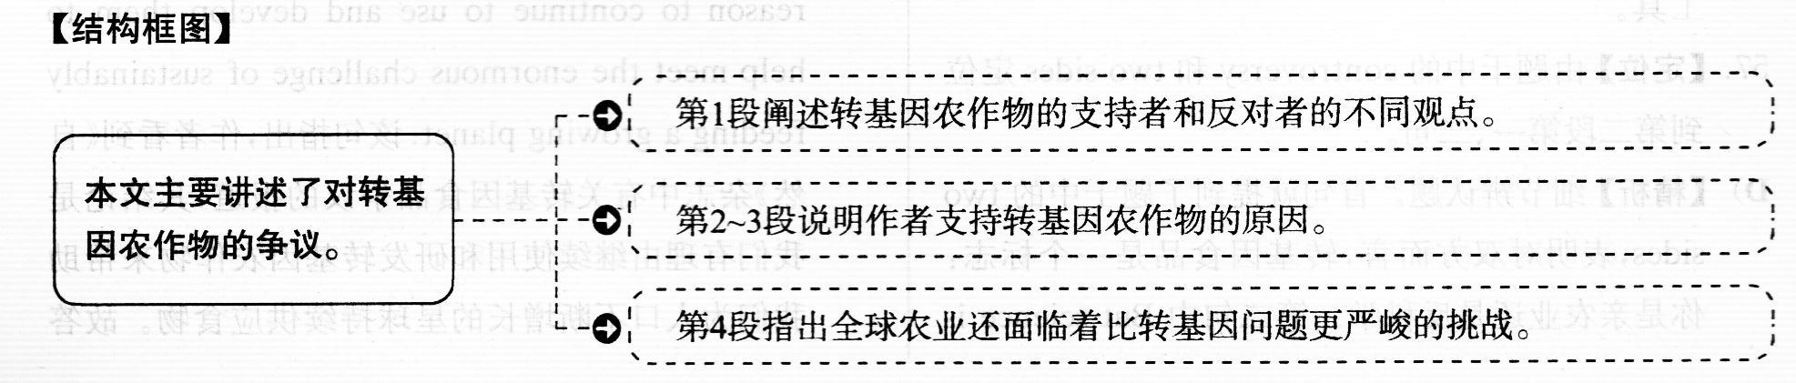
我得承认我一直不太能理解人们对转基因农作物的成见。(56)对奉行环境保护主义的反对者们来说，转基因食品就是很邪恶，还是大型农业公司用来控制全球种子市场和压迫当地农民的未经充分研究且司能有害的工具。他们认为转基因食品从来没有兑现它们所谓的承诺。这些承诺是，用在转基因农作物上的钱最好转用到有机耕作上，并且任何含有转基因成分的产品都应该贴上警告标签，以此来保护消费者。对支持者们来说，为了持续提供食品以满足全球人口不断增长的需求，转基因农作物是所作出的努力的关键部分。但是不仅这样，支持者们认为，很多环境保护主义者对转基因的反对基本上是反科学的，和那些质疑人工改变气候的基础原理的人没有什么不同。
对双方而言，转基因食品是一个标志：你是亲农业还是反科学。(57)(58)但是谈到转基因食品，我们确实更需要科学，基于这个原因，我很高兴看到《自然》杂志的一系列致力于转基因食品争议的特别报道。
- 结论就是：尽管转基因农作物还没有实现它们预期的承诺，并且被一些农业公司控制，我们仍有理由继续使用和研发转基因农作物来帮助我们应对这个巨大的挑战，即为人口不断增长的星球持续供应食物。
(59)这并不意味着转基因农作物很完美，或者这是解决全球农业问题“一劳永逸”的办法。但是任何能提高耕作效率(每英亩土地我们能产出的粮食量)的方法都是极为有用的。转基因农作物可以并且几乎肯定能成为这套工具之一，此外还有传统作物培育、土壤改良和农作物管理——可能最重要的，尤其是对发展中国家来说，更好的存储和运输基础设施。(对于像在撒哈拉沙漠以南地区的农民来说，如果粮食不能送到饥饿的消费者手里，高产是没有什么用处的。)我希望看到在转基因农作物方面有更多非产业化的研究——不仅是因为我们会少些对偏见的担心，还因为像孟山都和先锋这样的种子公司不应该是仅有的掌控基因修改工作的实体。我希望看到在商业化较少的农作物上的转基因研究，如玉米。我认为是否在食品上标明转基因成分并不重要，但是我也不反对这样傲——企业会以一种可以消除科技恐惧的方式对标注进行巧妙处理。
(60)但是最重要的是·我希望人们能拿出花在无休止讨论转基因农作物上时间的十分之一来关注一下全球农业面f临的更紧迫的挑战。我们还有更大的仗要打。
56．【定位】由题干中的environmentalist opponents 定位到首段第二句。B)【精析】推理判断题。定位句指出，奉行环境保护主义的反对者们反对转基因食品是因为转基 因食品邪恶、没有经过充分研究并可能成为大型农业公司控制全球种子市场和压榨当地农民 的工具。由此可见，B)的意思符合文意，即转基因食品是一种被大型农业公司用以垄断的 工具。
57．【定位】由题干中的controversy和two sides定位 到第二段第一、二旬。
D)【精析】细节辨认题。首句就提到了题干中的two sides，表明对双方而言，转基因食品是一个标志你是亲农业还是反科学。第二句中But science is exactly what we need more of when it comes to GM foods接着指出，当涉及转基因食品时，我们更需要的是科学，故答案为D)。
58．【定位】由题干中的Nature定位到第二段第二、三句。
A)【精析】推理判断题。题干问题为：《自然》杂志上的系列报道的主要观点是什么?该题的答案在定位句之后的句子中：The conclusion：…there is reason to continue to use and develop them to help meet the enormous challenge of sustainably feeding a growing planet．该句指出，作者看到《自然》杂志中有关转基因食品争议的报道，其结论是我们有理由继续使用和研发转基因农作物来帮助我们为人口不断增长的星球持续供应食物。故答案为A。
59．【定位】由题干中的the solution tO agricultural peoblems定位第三段第一、二句；
D)【精析】：定位句指出．转基因农作物并不是解决全球农业两题‘一劳永逸”的办法，但 是任何提高耕作效率的方法都是极为有用的，故答案为D)。
60．【定位】由题干中的0ngoing debate定位到末段。 c)【精析】观点态度题。作者在定位段中指出，人们 应该拿出花在无休止讨论转基因农作物上时间的 十分之一来关注一下全球农业面临的更紧迫的挑战，故答案为C)。
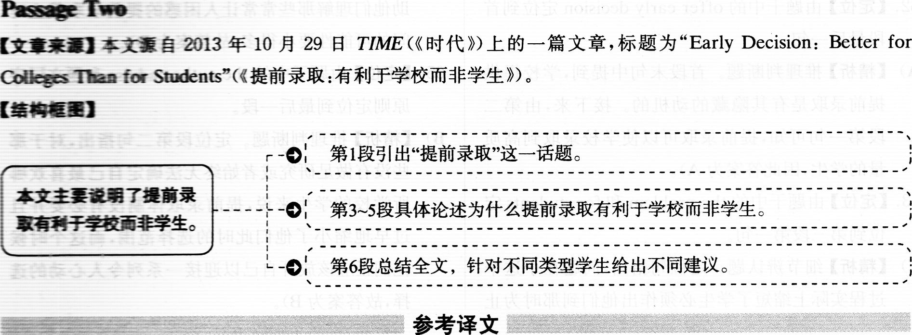
(61)提前录取(你申请一所学校，其录取具有约束力)似乎是那些紧张不安的申请者的很好的选择。学校招收更高比例的提前录取申请者，可以说，这意味着你进入大学的可能性更大。如果你申请了，整个痛苦的过程到l2月就结束了。(62)但是，大多数学生和家长并没有意识到学校提供提前录取是有其隐藏的动机的。
(62)因为提前录取具有约束力，这样学校就能录取到高质量的学生；它允许录取委员会选择对他们学校有特殊需求的学生，并且知道这些学生会来。这也使学校毕业率更高，而这是人们经常用来衡量一所学校的优秀程度和受欢迎程度的方法之一。
(63)问题在于这个过程实际上缩短了学生必须作出他们到那时为止人生最重要的决定的时间。按普通录取流程，高中毕业生一直到5月1日才必须选择上哪所大学；提前录取实际上使学生的考虑时间缩短了6个月，而这段时间可以用来参观更多学校、做更多研究、和现在的学生及校友交谈，按理可以作出一个更全面的决定。
坦率地说，美国有大量优秀的大学，对于任何一个学生来说，都会有很多学校非常适合。如果学生在录取过程早期过于专注某一所学校，那么，如果他们没有被录取，他们就会非常失望，或者是虽然录取了，也有这种可能性：若有时间进一步考虑，这所学校可能实际上并不适合他们而他们现在却不得不去。
就提前录取提供的真正录取优势来说，这个优势大多源于学生本身就具有很多优势。申请提前录取的学生往往是那些因为拥有一个更优越的背景而得到更高质量的大学指导的学生。(64)从这个角度讲，有人反对提前录取，因为低收入家庭的学生收到录取指南以帮助他们理解那些常常让人困惑的提前录取截止时间的可能性要小得多。
已经做过研究并确信自己若被录取到某所学校会特别激动的学生，在目前的体制下，很可能会申请提酋录取。(65)但是，对于那些没有做足研究或者始终无法确定自己最喜欢哪所学校的学生来说，提前录取体割没有必要并且过早地缩小了他们此时的选择范围，而这个时候他们正应该放开自己以迎接一系列令人心动的选择。
61．【定位】由题干中的0bliged to d0和early decision定位到首段首句。
B)【精析】细节辨认题。由定位句可知，在提前录取体制下，你申请一所学校，其录取具有约束力，故答案为B)。
62．【定位】由题干中的0ffer early decision定位到首段最后一句。
A)【精析】推理判断题。首段末句中提到，学校提供提前录取是有其隐藏的动机的。接下来，由第二段第一句可知，提前录取可以使学校录取到高质量的学生，因此答案为A)。
63．【定位】由题干中的the problem和for students定位到第三段第一句。
C)【精析】细节辨认题。定位句指出，问题在于这个过程实际上缩短了学生必须作出他们到那时为止人生最重要的决定的时间，故答案为C)。
64．【定位】由题干中的0pposed定位到倒数第二段最后一句。
D)【精析】细节辨认题。定位句指出，有人反对提前录取，因为低收入家庭的学生收到录取指南以助他们理解那些常常让人困惑的提前录取截止时间的可能性要小得多，故答案为D)。
65．【定位】由题干中的the author advise和题文同序原则定位到最后一段。
B)【精析】推理判断题。定位段第二句指出，对于那些没有做足研究或者始终无法确定自己最喜欢哪所学校的学生来说，提前录取体制没有必要并且过早地缩小了他们此时的选择范围，而这个时候他们正应该放开自己以迎接一系列令人心动的选择，故答案为B)。

Part IV Translation
The year of 2011 is a historic moment in the process of urbanization in China, when the urban population exceeds the rural population for the first time. In the next 20 years, it is estimated that about 350 million rural populations will migrate to cities. Such a scale of urban development is both a challenge and an opportunity for urban transportation. The Chinese government has always been advocating the concept of "people-oriented" development, stressing that people should travel by buses instead of private cars. It also calls for the construction of " resource-saving and environment-friendly society". With this explicit goal, Chinese cities can make better plans for their development, and turn a massive investment to the development of safe, clean and economical transportation system.
1．翻译第一句时，可适当使用定语从句将两个中文分句连接起来。我们可以把“2011年”作为主语，先说明这年是“历史性时刻”，然后用定语从句来强调在这一年，中国的城市人口首次超过农村口。“超过”可以使用动词exceed或者surpass来表达。
2．第二句的中文中缺少主语，在翻译成英文时，我们可以使用固定搭配it is estimated／predicted that…来表达“预计”。
3．翻译第三句时，“既是挑战，也是机遇”除了译文中的表达，也可以译为not only a challenge but also an opportunity。需要注意的是，如果将not only置于句首，则主句用部分倒装，应该译为Not only is such a scale of urban development a challenge but also it is an opportunity for urban transportation．
4．翻译第四句时，需要注意句子的时态。由“一直提倡”可知，该句 应用现在完成进行时，强调从过去到现在一直持续的动作，且动作有可能继续。翻译“强调……”时，既可以同参考译文一样用动 词的．ing形式作伴随状语，也可以使用定语从句，如which stresses／emphasizes that people should travel by buses instead of private cars。
5．翻译第五句时，需要注意“号召”的表达方法，其次要注意如何表达 “‘资源节约和环境友好型’社会”。“号召”可译为call for。“资源节 约和环境友好型’’可译为resource-saving and environment—friendly=6．最后一句比较复杂，“有了这个明确的目标”可以翻译为with复台 结构作整个句子的状语，剩下的中文内容可以翻译为两个并列分。“大量投资”还可以译为a bi9／huge／major investment.urban expansion城市扩张
housing problem住房问题
develop public transportation发展公共交通 traffic jam交通拥堵
adaptability适应性
social skills社交技能
keep pace with the times与时俱进
social security system社会保障体系

