2015年12月大学英语六级考试真题(第3套)

Part I Writing(30 minutes)Directions: For this part, you are allowed 30 minutes to write a short essay based on the picturebelow.You should focus on the harm caused by misleading information online.You arerequired to write at least 150 words but no more than 200 words.

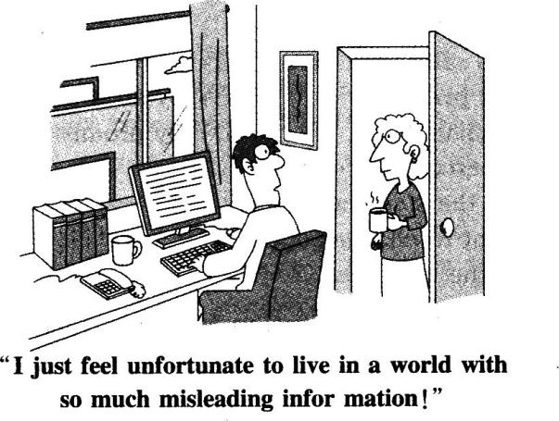

Part Ⅱ Listening Comprehension (30 minutes)

**听力音频地址：**

<http://wximg.233.com/attached/media/20160512/20160512175650_9309.mp3>

Section A

Directions: In this section, you will hear 8 short conversations and 2 long conversations.At the endof each conversation, one or more questions will be asked about what was said.Both theconversation and the questions will be spoken only once.After each question there will bea pause.During the pause, you must read the four choices marked A), B), C.and D),and decide which is the best answer.Then mark the corresponding letter on AnswerSheet I with a single line through the centre.

1.A.She has completely recovered.

B.She went into shock after an operation.

C.She is still in a critical condition.

D.She is getting much better.

2.A.Ordering a breakfast.

B.Booking a hotel room.

C.Buying a train ticket.

D.Fixing a compartment.

3.A.Most borrowers never returned the books to her.

B.The man is the only one who brought her book back.

C.She never expected anyone to return the books to her.

D.Most of the books she lent out came back without jackets.

4.A.She left her work early to get some bargains last Saturday.

B.She attended the supermarket's grand opening ceremony.

C.She drove a full hour before finding a parking space.

D.She failed to get into the supermarket last Saturday.

5.A.He is bothered by the pain in his neck.

B.He cannot do his report without a computer.

C.He cannot afford to have a coffee break.

D.He feels sorry to have missed the report.

6.A.Only top art students can show their works in the gallery.

B.The gallery space is big enough for the man's paintings.

C.The woman would like to help with the exhibition layout.

D.The man is uncertain how his art works will be received.

7.A.The woman needs a temporary replacement for her assistant.

B.The man works in the same department as the woman does.

C.The woman will have to stay in hospital for a few days.

D.The man is capable of dealing with difficult people.

8.A.It was better than the previous one.

B.It distorted the mayor's speech.

C.It exaggerated the city's economic problems.

D.It reflected the opinions of most economists.

Questions 9 to 12 are based on the conversation you have just heard.

9.A.To inform him of a problem they face.

B.To request him to purchase control desks.

C.To discuss the content of a project report.

D.To ask him to flX the dictating machine.

10.A.They quote the best price in the market.

B.They manufacture and sell office furniture.

C.They cannot deliver the steel sheets on time.

D.They cannot produce the steel sheets needed.

11.A.By marking down the trait price.

B.By accepting the penalty clauses.

C.By allowing more time for delivery.

D.By promising better after-sales service.

12.A.Give the customer a ten percent discount.

B.Claim compensation from the steel suppliers.

C.Ask the Buying Department to change suppliers.

D.Cancel the contract with the customer.

Questions 13 to 15 are based on the conversation you have just heard.

13.A.Stockbroker.

B.Physicist.

C.Mathematician.

D.Economist.

14.A.Improve computer programming.

B.Explain certain natural phenomena.

C.Predict global population growth.

D.Promote national financial health.

15.A.Their different educational backgrounds.

B.Changing attitudes toward nature.

C.Chaos theory and its applications.

D.The current global economic crisis.Section B

Directions : In this section, you will hear 3 short passages.At the end of each passage, you will hearsome questions.Both the passage and the questions will be spoken only once.After youhear a question, you must choose the best answer from the four choices marked A), B),C.and D ).Then mark the corresponding letter on Answer Sheet 1 with a single linethrough the centre.

Passage One

Questions 16 to 18 are based on the passage you have just heard.

16.A.They lay great emphasis on hard work.

B.They name 150 star engineers each year.

C.They require high academic degrees.

D.They have people with a very high IQ.

17.A.Long years of job training.

B.High emotional intelligence.

C.Distinctive academic qualifications.

D.Devotion to the advance of science.

18.A.Good interpersonal relationships.

B.Rich working experience.

C.Sophisticated equipment.

D.High motivation.

Passage Two

Questions 19 to 21 are based on the passage you have just heard.

19.A.A diary.

B.A fairy tale.

C.A history textbook.

D.A biography.

20.A.He was a sports fan.

B.He loved adventures.

C.He disliked school.

D.He liked hair-raising stories.

21.A.Encourage people to undertake adventures.

B.Publicize his colorful and unique life stories.

C.Raise people's environmental awareness.

D.Attract people to America's national parks.

Passage Three

Questions 22 to 25 are based on the passage you have just heard.

22.A.The first infected victim.

B.A coastal village in Africa.

C.The doctor who lust identified it.

D.A river running through the Congo.

23.A.They exhibit similar symptoms.

B.They can be treated with the same drug.

C.They have almost the same mortality rate.

D.They have both disappeared for good.

24.A.By inhaling air polluted with the virus.

B.By contacting contaminated body fluids.

C.By drinking water from the Congo River.

D.By eating food grown in Sudan and Zalre.

25.A.More strains will evolve from the Ebola virus.

B.Scientists will eventually fred cures for Ebola.

C.Another Ebola epidemic may erupt sooner or later.

D.Once infected, one will become immune to Ebola.Section C

Directions: In this section, you will hear a passage three times.When the passage is read for the irst time, you should listen carefully for its general idea.When the passage is read forthe second time, you are required to fill in the blanks with the exact words you have justheard.Finally, when the passage is read for the third time, you should check what youhave written.

The ideal companion machine would not only look, feel, and sound friendly but would also beprogrammed to behave in an agreeable manner.Those 26 that make interaction with other peopleenjoyable would be simulated as closely as possible, and the machine would 27 charming,stimulating, and easygoing.Its informal conversational style would make interaction comfortable, andyet the machine would remain slightly 28 and therefore interesting.In its first encounter it might besomewhat hesitant and unassuming, but as it came to know the user it would progress to a more 29 and intimate style.The machine would not be a passive 30 but would add its ownsuggestions, information, and opinions; it would sometimes 31 developing or changing the topicand would have a personality of its own.

The machine would convey presence: We have all seen how a computer's use of personal namesoften 32 people and leads them to treat the machine as if it were almost human.Such features areeasily written into the software.By introducing 33 forcefulness and humor, the machine could bepresented as a vivid and unique character.

Friendships are not made in a day, and the computer would be more acceptable as a friend if it 34 the gradual changes that occur when one person is getting to know another.At an 35 timeit might also express the kind of affection that stimulates attachment and intimacy.

Part m Reading Comprehension (40 minutes)Section A

Directions: In this section, there is a passage with ten blanks.You are required to select one wordfor each blank from a list of choices given in a word bank following the passage.Read thepassage through carefully before making your choices. Each choice in the bank isidentified by a letter.Please mark the corresponding letter for each item on AnswerSheet 2 with a single line through the centre.You may not use any of the words in thebank more than once.

Questions 36 to 45 are based on the following passage.

As it is, sleep is so undervalued that getting by on fewer hours has become a badge of honor.Plus, we live in a culture that 36 to the late-nighter, from 24-hour grocery stores to onlineshopping sites that never close.It's no surprise, then, that more than half of American adults don't getthe 7 to 9 hours of shut-eye every night as 37 by sleep experts.

Whether or not we can catch up on sleep--on the weekend, say--is a hotly 38 topic amongsleep researchers.The latest evidence suggests that while it isn't 39 , it might help.When Liu, theUCLA sleep researcher and professor of medicine, brought 40 sleep-restricted people into the labfor a weekend of sleep during which they logged about 10 hours per night, they showed 41 in theability of insulin (胰岛素) to process blood sugar.That suggests that catch-up sleep may undo some

but not all of the damage that sleep 42 causes, which is encouraging, given how many adults don'tget the hours they need each night.Still, Liu isn't 43 to endorse the habit of sleeping less andmaking up for it later.

Sleeping pills, while helpful for some, are not 44 an effective remedy either."A sleeping pillwill 45 one area of the brain, but there's never going to be a perfect sleeping pill, because youcouldn't really replicate (复制 ) the different chemicals moving in and out of different parts of the brainto go through the different stages of sleep," says Dr.Nancy Collop, director of the Emory UniversitySleep Center.

A.alternatively

B.caters

C.chronically

D.debated

E.deprivation

F.ideal

G.improvements

H.necessarily

I.negotiated

J.pierce

K.presumption

L.ready

M.recommended

N.surpasses

O.target

Section B

Directions: In this section, you are going to read a passage with ten statements attached to it.Eachstatement contains information given in one of the paragraphs.Identify the paragraphfrom which the information is derived.You may choose a paragraph more than once.Each paragraph is marked with a letter. Answer the questions by marking thecorresponding letter on Answer Sheet 2.

Climate change may be real, but it's still not easy being green

How do we convince our inner caveman to be greener? We ask some outstanding social scientists.

[A] The road to climate hell is paved with our good intentions.Politicians may tackle polluters whilescientists do battle with carbon emissions.But the most pervasive problem is less obvious: ourown behaviour.We get distracted before we can turn down the heating.We break our promise notto fly after hearing about a neighbour's trip to India.Ultimately, we can't be bothered to changeour attitude.Fortunately for the planet, social science and behavioural economics may be able todo that for us.

[B] Despite mournful polar beats and charts showing carbon emissions soaring, most people find ithard to believe that global warming will affect them personally.Recent polls by the Pew ResearchCentre in Washington, DC, found that 75-80 per cent of participants regarded climate change as animportant issue.But respondents ranked it last on a list of priorities.

[C] This inconsistency largely stems from a feeling of powerlessness."When we can't actually removethe source of our fear, we tend to adapt psychologically by adopting a range of defencemechanisms," says Tom Crompton, change strategist for the environmental organisation WorldWide Fund for Nature.

[ D] Part of the fault lies with our inner caveman.Evolution has programmed humans to pay mostattention to issues that will have an immediate impact."We worry most about now because if wedon't survive for the next minute, we're not going to be around in ten years' time," says ProfessorElke Weber of the Centre for Research on Environmental Decisions at Columbia University in NewYork.If the Thames were lapping around Big Ben, Londoners would face up to the problem ofemissions pretty quickly.But in practice, our brain discounts the risks--and benefits--associatedwith issues that lie some way ahead.

[E] Matthew Rushworth, of the Department of Experimental Psychology at the University of Oxford,sees this in his lab every day."One of the ways in which all agents seem to make decisions is thatthey assign a lower weighting to outcomes that are going to be further away in the future," hesays."This is a very sensible way for an animal to make decisions in the wild and would have

been very helpful for humans for thousands of years."

[F] Not any longer.By the time we wake up to the threat posed by climate change, it could well betoo late.And ff we're not going to make rational decisions about the future, others may have tohelp us to do so.

[G] Few political libraries are without a copy of Nudge: Improving Decisions About Health, Wealthand Happiness, by Richard Thaler and Cass Sunstein.They argue that governments shouldpersuade us into making better decisions--such as saving more in our pension plans--by changingthe default options.Professor Weber believes that environmental policy can make use of similartactics.If, for example, building codes included green construction guidelines, most developerswould be too lazy to challenge them.

[H] Defaults are certainly part of the solution.But social scientists are most concerned about craftingmessages that exploit our group mentality (,~, ~ )."We need to understand what motivatespeople, what it is that allows them to make change," says Professor Neil Adger, of the TyndallCentre for Climate Change Research in Norwich."It is actually about what their peers think ofthem, what their social norms are, what is seen as desirable in society." In other words, ourinner caveman is continually looking over his shoulder to see what the rest of the tribe are up to.[ I ] The passive attitude we have to climate change as individuals can be altered by counting us in--and measuring us against--our peer group."Social norms are primitive and elemental," says Dr.Robert Cialdini, author of Influence: The Psychology of Persuasion."Birds flock together, fishschool together, cattle herd together...just perceiving norms is enough to cause people to adjusttheir behaviour in the direction of the crowd."

[J] These norms can take us beyond good intentions.Cialdini conducted a study in San Diego inwhich coat hangers bearing messages about saving energy were hung on people's doors.Some ofthe messages mentioned the environment, some financial savings, others social responsibility.Butit was the ones that mentioned the actions of neighbours that drove down power use.

[K] Other studies show that simply providing the facility for people to compare their energy use withthe local average is enough to cause them to modify their behaviour.The Conservatives plan toadopt this strategy by making utility companies print the average local electricity and gas usage onpeople's bills.

[L] Social science can also teach politicians how to avoid our collective capacity for serf-destructivebehaviour.Environmental campaigns that tell us how many people drive SUVs unwittingly (不经意的) imply that this behaviour is widespread and thus permissible.Cialdini recommends somecareful framing of the message."Instead of normalising the undesirable behaviour, the messageneeds to marginalise it, for example, by stating that if even one person buys yet another SUV, itreduces our ability to be energy-independent."

[M] Tapping into how we already see ourselves is crucial.The most successful environmental strategywill marry the green message to our own sense of identity.Take your average trade unionmember, chances are they will be politically motivated and be used to collective action--muchlike Erica Gregory.A retired member of the Public and Commercial Services Union, she is settingup one of 1,i00 action groups with the support of Climate Solidarity, a two-year environmentalcampaign aimed at trade unionists.

[N] Erica is proof that a great-grandmother can help to lead the revolution if you get the psychologyright--in this case, by matching her enthusiasm for the environment with a fondness for organisinggroups."I think it's a terrific idea," she says of the campaign."The union backing it makesmembers think there must be something in it." She is expecting up to 20 people at the firstmeeting she has called, at her local pub in the Cornish village of Polperro.

[O] Nick Perks, project director for Climate Solidarity, believes this sort of activity is where the futureof environmental action lies. "Using existing civil society structures or networks is a more effective way of creating change.., and obviously trade unions are one of the biggest civil societynetworks in the UK," he says. The " Love Food, Hate Waste" campaign entered into acollaboration last year with another such network--the Women's Institute.Londoner Rachel Taylor

joined the campaign with the aim of making new friends.A year on, the meetings have madelasting changes to what she throws away in her kitchen."It's always more of an incentive if you'redoing it with other people," she says."It motivates you more if you know that you've got toprovide feedback to a group."

[P]The power of such simple psychology in fighting climate change is attracting attention across thepolitical establishment.In the US, the House of Representatives Science Committee has approveda bill allocating $10 million a year to studying energy-related behaviour.In the UK, new studiesare in development and social scientists are regularly spotted in British government offices.Withthe help of psychologists, there is fresh hope that we might go green after all.

46.When people find they are powerless to change a situation, they tend to live with it.

47.To be effective, environmental messages should be carefully framed.

48.It is the government's responsibility to persuade people into making environment-friendly decisions.

49.Politicians are beginning to realise the importance of enlisting psychologists' help in fighting climatechange.

50.To find effective solutions to climate change, it is necessary to understand what motivates people to make change.

51.In their evolution, humans have learned to pay attention to the most urgent issues instead of long-term concerns.

52.One study shows that our neighbours' actions are influential in changing our behaviour.

53.Despite clear signs of global warming, it is not easy for most people to believe climate change will affect their own lives.

54.We should take our future into consideration in making decisions concerning climate change before it is too late.

55.Existing social networks can be more effective in creating change in people's behaviour.Section C

Directions: There are 2 passages in this section.Each passage is followed by some questions orunfinished statements.For each of them there are four choices marked A), B), C.andD ).You should decide on the best choice and mark the corresponding letter on AnswerSheet 2 with a single line through the centre.

Passage One

Questions 56 to 60 are based on the following passage.

More than a decade ago, cognitive scientists John Bransford and Daniel Schwartz, both then atVanderbilt University, found that what distinguished young adults from children was not the ability toretain facts or apply prior knowledge to a new situation but a quality they called "preparation for futurelearning." The researchers asked fifth graders and college students to create a recovery plan to protectbald eagles from extinction. Shockingly, the two groups came up with plans of similar quality(although the college students had better spelling skills ). From the standpoint of a traditionaleducator, this outcome indicated that schooling had failed to help students think about ecosystems andextinction, major scientific ideas.

The researchers decided to go deeper, however.They asked both groups to generate questionsabout important issues needed to create recovery plans.On this task, they found large differences.College students focused on critical issues of interdependence between eagles and their hab/tats (栖息地).Fifth graders tended to focus on features of individual eagles ( "How big are they?" and "What dothey eat?" ).The college students had cultivated the ability to ask questions, the cornerstone of criticalthinking.They had learned how to learn.

Museums and other institutions of informal learning may be better suited to teach this skill than elementary and secondary schools.At the Exploratorium in San Francisco, we recently studied howlearning to ask good questions can affect the quality of people's scientific inquiry.We found that when

we taught participants to ask "What if?" and "How can?" questions that nobody present would knowthe answer to and that would spark exploration, they engaged in better inquiry at the next exhibit--asking more questions, performing more experiments and making better interpretations of their results.Specifically, their questions became more comprehensive at the new exhibit.Rather than merely askingabout something they wanted to try, they tended to include both cause and effect in their question.Asking juicy questions appears to be a transferable skill for deepening collaborative inquiry into thescience content found in exhibits.

This type of learning is not confined to museums or institutional settings.Informal learningenvironments tolerate failure better than schools.Perhaps many teachers have too little time to allowstudents to form and pursue their own questions and too much ground to cover in the curriculum.Butpeople must acquire this skill somewhere.Our society depends on them being able to make criticaldecisions about their own medical treatment, say, or what we must do about global energy needs anddemands.For that, we have a robust informal learning system that gives no grades, takes all comers,and is available even on holidays and weekends.

56.What is traditional educators' interpretation of the research outcome mentioned in the first paragraph ?

A.Students are not able to apply prior knowledge to new problems.

B.College students are no better than fifth graders in memorizing facts.

C.Education has not paid enough attention to major environmental issues.

D.Education has failed to lead students to think about major scientific ideas.

57.In what way are college students different from children?

A.They have learned to think critically.

B.They are concerned about social issues.

C.They are curious about specific features.

D.They have learned to work independently.

58.What is the benefit of asking questions with no ready answers?

A.It arouses students' interest in things around them.

B.It cultivates students' ability to make scientific inquiries.

C.It trains students' ability to design scientific experiments.

D.It helps students realize not every question has an answer.

59.What is said to be the advantage of informal learning?

A.It allows for failures.

B.It is entertaining.

C.It charges no tuition.

D.It meets practical needs.

60.What does the author seem to encourage educators to do at the end of the passage?

A.Train students to think about global issues.

B.Design more interactive classroom activities.

C.Make full use of informal learning resources.

D.Include collaborative inquiry in the curriculum.Passage Two

Questions 61 to 65 are based on the following passage.

"There's an old saying in the space world: amateurs talk about technology, professionals talkabout insurance." In an interview last year with The Economist, George Whitesides, chief executive ofspace-tourism fu'm Virgin Galactic, was placing his company in the latter category.But insurance willbe cold comfort following the failure on October 31st of VSS Enterprise, resulting in the death of onepilot and the severe injury to another.

On top of the tragic loss of life, the accident in California will cast a long shadow over the future of space tourism, even before it has properly begun.

The notion of space tourism took hold in 2001 with a $ 20 million flight aboard a Russianspacecraft by Dennis Tito, a millionaire engineer with an adventurous streak.Just haft a dozen holiday-makers have reached orbit since then, for similarly astronomical price tags. But more recently,companies have begun to plan more affordable "suborbital" flights--briefer ventures just to the edge ofspace's vast darkness.Virgin Galactic had, prior to this week's accident, seemed closest to startingregular flights.The company has already taken deposits from around 800 would-be space tourists,including Stephen Hawking.

After being dogged by technical delays for years, Sir Richard Branson, Virgin Galactic's founder,had recently suggested that a SpaceShipTwo craft would carry its first paying customers as soon asFebruary 2015. That now seems an impossible timeline. In July, a sister craft of the crashedspaceplane was reported to be about half-finished.The other half will have to walt, as authorities ofAmerica's Federal Aviation Administration (FAA.and National Transportation Safety Board work out:what went wrong.

In the meantime, the entire space tourism industry will be on tenterhooks (坐立不安 ).The 2004Commercial Space Launch Amendments Act, intended to encourage private space vehicles andservices, prohibits the transportation secretary (and thereby the FAA.from regulating the design oroperation of private spacecraft, unless they have resulted in a serious or fatal injury to crew or.passengers.That means that the FAA could suspend Virgin Galactic's licence to fly.It could also insiston checking private manned spacecraft as thoroughly as it does commercial aircraft.While that may:make suborbital travel safer, it would add significant cost and complexity to an emerging industry thathas until now operated largely as the playground of billionaires and dreamy engineers.

How Virgin Galactic, regulators and the public respond to this most recent tragedy will determinewhether and how soon private space travel can transcend that playground.There is no doubt that space flight entails risks, and to pioneer a new mode of travel is to face those risks, and to reduce them.with the benefit of hard-won experience.

61.What is said about the failure of VSS Enterprise?

A.It may lead to the bankruptcy of Virgin Galactic.

B.It has a strong negative impact on space tourism.

C.It may discourage rich people from space travel.

D.It has aroused public attention to safety issues.

62.What do we learn about the space-tourism firm Virgin Galactic?

A.It has just built a craft for commercial flights.

B.It has sent half a dozen passengers into space.

C.It was about ready to start regular business.

D.It is the first to launch "suborbital" flights.

63.What is the purpose of the 2004 Commercial Space Launch Amendments Act?

A.To ensure space travel safety.

B.To limit the FAA's functions.

C.To legalize private space explorations.

D.To promote the space tourism industry.64.What might the FAA do after the recent accident in California?

A.Impose more rigid safety standards.

B.Stop certifying new space-tourist agencies.

C.Amend its 2004 Commercial Space Launch Amendments Act.

D.Suspend Virgin Galactic's licence to take passengers into space.

65.What does the author think of private space travel?

A.It is worth promoting despite the risks involved.

B.It should not be confined to the rich only.

C.It should be strictly regulated.

D.It is too risky to carry on.

Part IV Translation(30 minutes)Directions: For this part, you are allowed 30 minutes to translate a passage from Chinese intoEnglish.You should write your answer on Answer Sheet 2.

在帮助国际社会于2030年前消除极端贫困过程中，中国正扮演着越来越重要的角色。

自20世纪70年代未实施改革开放以来，中国已使多达四亿人摆脱了贫困。在未来五年中，中国将向其他发展中国家在减少贫困、发展教育、农业现代化、环境保护和医疗保健等方面提供援助。

中国在减少贫困方面取得了显著进步，并在促进经济增长方面做出了不懈努力，这将鼓励其他贫困国家应对自身发展中的挑战。在寻求具有自身特色的发展道路时，这些国家可以借鉴中国的经验。

2015年l2月大学英语六级考试真题答案与详解

(第3套)

Part I Writing

审题思路

这是一篇六级考试中常见的图画作文。本篇话题是“误导性信息”，题干中明确要求focus on the harmcaused by misleading information online，所以文章重点应该放在harm“危害”这个词上面。简单描述图片之后，可以从网络信息带给我们的好处过渡到主题词misleading information“误导性信息”，之后重点讨论误导性信息的严重危害，内容层层递进。在论述时可以举例加以佐证。文章最后采用建议式的结尾方式，针对之前提到的危害提出解决措施。

写作提纲

一、描述图片内容，并介绍图片令人关注的关键信息(the most striking feature)

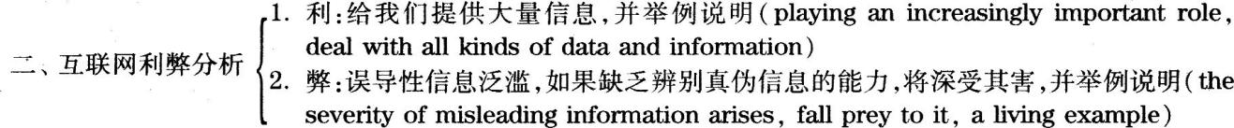

三、提出建议：采取措施来防止我们被垃圾信息误导，并提出个人见解——学习识别信息的真实性(someeffective measures be taken，learning to identify the authenticity of information)

范文点评

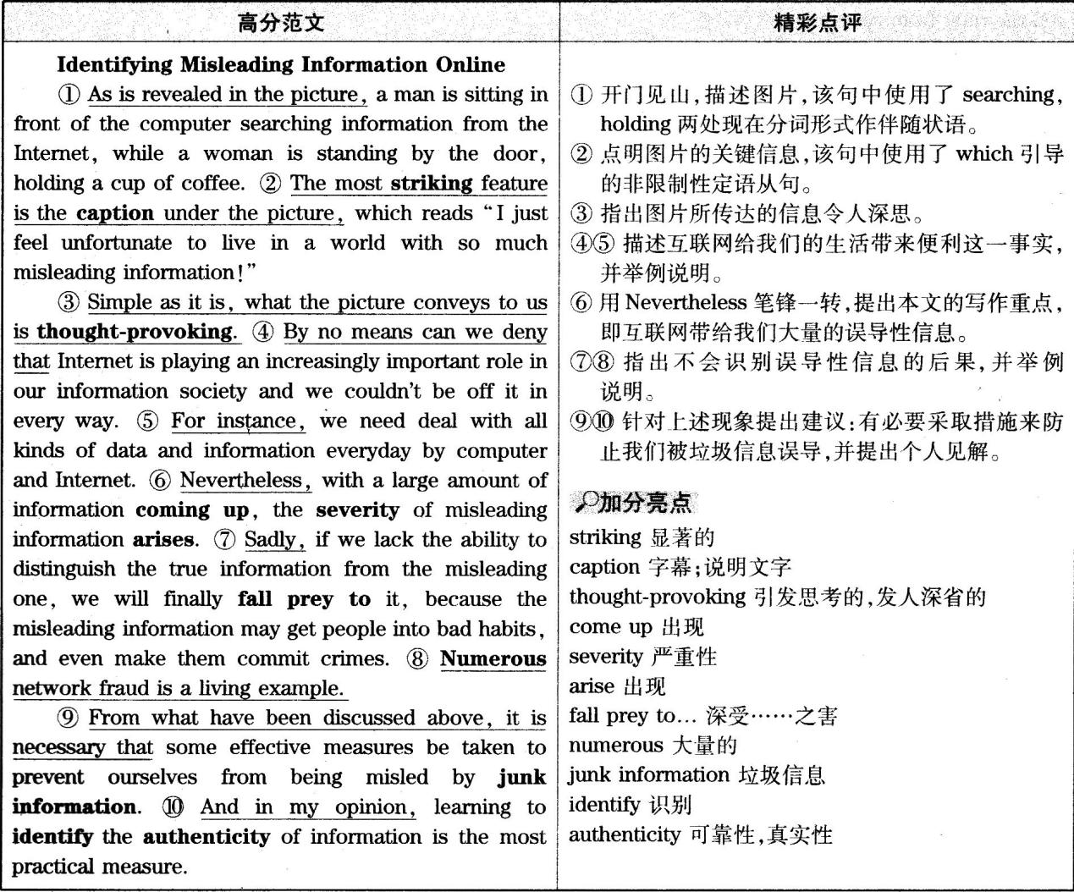

扩展内容

主题词汇

convenience便利性hinder阻碍webpage网页violate违反spread传播regulate规范judge判断harmful impacts不利影响tell the right from the wrong辨别是非severe consequences严重后果critical thinking批判性思考

句式拓展

1.Along with the development of society and technology，an increasing number of problems are brought to ourattention，one of which is that…随着社会和技术的发展，越来越多的问题日益引起我们的关注，其中一个就是……

2.If the misleading news isn't corrected soon.there may bea trust crisis between…and…如果误导性信息没有及时被改正，将会造成……与……之间的信任危机.

Part ⅡListening Comprehension

1.W：I Was shocked to hear of your wife’s illness.Is she going to be all right?

M：A—t first,the doc—tors weren't sure,but she's really improved.一She’II be home next week.

Q：What do we learn about the man’s wife from the conversation?

D)。未听先知.四个选项的主语均为She，且出现了recovered，operation，critical condition，getting much better，故推测本题考查的内容与某位女士的身体状况相关。

详解.对话中，女士说她对听说男士的妻子生病感到十分震惊，并询问是不是好转了；男士说最初连大夫都没把握，但现在他的妻子已经好多了，下周就会出院：由此可知，男士妻子的身体状况已经有了很大的好转，故答案为D)。

2.M：Excuse me.Can I get a ticket for a sleeping compartment on this train?

W：Yes.There are four left.The price is 60 pounds per person，including a confrontal breakfast.

Q：What is the man doing?

C)。未听先知.四个选项都是以动词的.ing形式开头，故推测本题考查的内容与动作行为相关。

详解.对话一开头，男士就明确说要买一张火车卧铺票；女士告诉他票价为60英镑，其中包含一顿免费欧式早餐。可见，男士正在做的事情是购买火车票，故答案为C)。

3.M：Janet，here’s the book I borrowed from you，but I'm SO sorry that I can’t find its jacket.

W；It doesn’t matter.Anyway,you are one of the few people who actually return books to me.

Q：What does the woman imply?

A)。未听先知.四个选项中均出现了book(S)一词，且出现了borrowers，returned，lent out等词，故推测本题考查的内容与借书、还书相关。

详解.对话中，男士把女士的书还给她，但对找不到书的封皮表示抱歉；女士表示没有关系，还说，除了男士之外，几乎没有人借了她的书后会归还。由此可知，大多数从女士那里借书的人都没有把书还给她，故答案为A)。

4.M：Lisa，have you been to the new supermarket yet?

W：Yes，and n0.I went there last Saturday for their grand opening sale,but I drove around the parking lot f0r nearly an h0ur,looking for a space before I finally gave up and came home.

Q：What does the woman mean?

D)。未知先知.四个选项主语都是She，且出现了bargains，supermarket’s，parking等词，故推测本题考查的内容与女士去超市购物相关。

详解.对话中，男士问女士有没有去过新开的那家超市；女士先说去了，又说没去，说去了是因为她的确在上周六超市开业那天到了超市门口，说没去是因为她在停车场转了一个小时，也没找到停车的地方，只好又开走了。由此可知，女士上周六没能进到超市里面，故答案为D)。

5.W：You’ve been sitting at the computer for hours.Let’s take a coffee break，shall we?

M：1 wish I could.You know,I'm up to my neck in work.I've got to finish this report.I don't want to missthe deadline.

Q：What does the man mean?

C)。未知先知.四个选项主语都是He，且出现了bothered，report，computer，coffee break，missed等

词，故推测本题考查内容与男士的学习与休息相关。

详解.对话中，女士说男士已经在电脑前坐了好几个小时了，想邀请他一起去喝杯咖啡休息一下；男士却说他忙得不可开交，去不了，因为他不想错过交报告的最后期限。由此可知，男士没有时间去喝咖啡，故答案为C)。

6.M：What do you think of this gallery space?They offered to let me exhibit some of my paintings here.W：Are you kidding?Any art student I know would die to have an exhibition here.

Q：What Can we infer from the conversation?

A)。未知先知.选项中出现了art students，gallery，paintings，exhibition layout等词，故推测本题考查的内容与在画廊展出作品相关。

详解.对话中，男士问女士对画廊的看法，因为他有机会在那里展出他的一些画作；女士说，她所认识的所有学艺术的学生都愿意不惜一切代价在那个画廊展出作品。由此可知，那家画廊很棒，只有优秀的艺术生才能有机会在那里展出自己的作品，故答案为A)。

7.W：Garry，my assistant is in hospital now.Is there anyone in your department can give a hand for a few days?

M：I think SO.I'll ask around and get back to you.

Q：what do we learn from the conversation?

A)。未知先知.选项中出现了woman，assistant，man，department，hospital，difficult等词，故推测本题考查的内容与对话中的两个人在工作中碰到的困难相关。

详解.对话中，女士问男士能否在他的部门里找人帮她几天，因为她的助手生病住院了；男士说应该没问题，他先找找看，然后给女士回话。由此可知，女士需要临时助理，故答案为A)。

8.W：Did you read the article in the paper about the mayor's speech at the economic forum?

M：—Sure I did,b—ut I think they twisted the meaning of what he said.一And it’s。not the first tiine for them to doSO.

Q：What does the man say about the paper’s article?

B)。未知先知.四个选项主语都是It，且出现了better，distorted，exaggerated，reflected等词，故推测本题考查的内容与It的行为状态相关。

详解.对话中女士问男士有没有看到报纸上那篇关于市长在经济论坛上的演讲的文章；男士说他看过了，认为这篇文章歪曲了市长的原意，并且说这种现象已经不是第一次了。可见，男士认为报纸上的文章曲解了市长的讲话，故答案为B)。

Conversation One

W. Oh, hello, John. Are you using your dictating machine this morning? I've got a long report I must dictate.Can I borrow your machine?

M: Of course. But can you spare me a second? (9-1) It's the message you sent to me about the delivery delayon the control desks. What's gone wrong?

W: Everything, John. (9-2) We have to get the steel sheets we need for these desks from new suppliers.Well,the suppliers have got some trouble or other. (10)They say they will be a bit later for the delivery.M：But they can’t be!These control desks are a special order.They are wanted for one of the big computercompmfies.It’s a very important contract.

W：When did we promise delivery?

M：On Thursday next week.And there’s a penalty’clause.We stand to lose lo percent of our price for each week of overdue delivery.

W：(11-1)Oh,these penalty clauses!Why did you sales people accept them?

M：(1l-2)We have to accept them,otherwise we don't get the contracts.

W：Well，let’s get on to the Buying Department.I only heard about the delay yesterday because we kept tlle

production line clear to handle these special sheets.It’s a dreadful nuisance.

M：tt will be more than a nuisance.If we don’t meet on the delivery date，it will cost us a lot of money.

W：Keep caIin，John.(12)We can perhaps claim compensation from the steel suppliers for failure to deliver on time.That’ll offset the penalty clause.

M：Well.ifwe can.

未听先知.预览四道题各选项，其中出现了problem，deliver，discount，suppliers，customer等词，由此推测对话与商务往来相关。

9.Why did the woman send the message to the man?

A)。详解.在对话开头女士向男士借录音机，男士说没问题，但是提到了女士给他发的一条信息，想问问是怎么回事，接下来女士说他们的供货方出了问题，以致他们的控制台要延迟交货。由此可知，女士给男士发信息的目的就是想告诉男士他们碰到的难题，故A)为答案。

10.What does the woman say about the new suppliers?

C)。详解.对话中女士明确告诉男士，新的供货商无法按时供应钢板，故C)为答案。

11.How did the man get the contracts?

B)。详解.对话中女士问男士为什么要接受这样的惩罚条款，男士说如果他不接受这样的条款，就根本拿不到合约。由此可知，男士拿到合约的前提条件是接受惩罚条款，故B)为答案。

12.What does the woman suggest they do?

B)。详解.对话末尾部分，女士说或许他们可以让钢板供货商承担起没有按时供货的责任，让他们赔偿，这样可以弥补惩罚条款带来的损失，故B)为答案。

Conversation Two

M: Cathy, chaos theory seems to be a branch of physics or mathematics. (13) You are an economist, so howdoes it influence your work?

W: Well, in several ways. I'm responsible for financial development programmes in many parts of theworld, so forecasting long range trends and making predictions on the basis of present evidence is what Ido. (14) Chaos theory was developed by scientists trying to explain the movement of the planets andchanges in environmental conditions. Both of these things are also about making long term predictions onthe basis of present evidence.

M: Are many econonmists involved in this field?

W: An increasing number. In the 1990s, many economists began to look at chaos theory as a way of providingmodels for forecasting.

M: What kind of "models" are we talking about here?

W: Well, that's a good question. Because the basic idea of chaos theory is that there aren't any "models" as such-there aren't guaranteed forms, but rather patterns of change in development.

M: Doesn't that mean that forecasting is impossible?

W: No, but it certainly makes it more of a challenge, Mandelbrot, who did the experiment with stockexchange prices, for example, noted that although the outcomes were variable, there were in fact certainconstants. What we have to do is make sure we know what these are and take into account all the possiblevariables.

M: But do economics and finance work in the same way as weather conditions or the movement of planets?W: Well, no, of course not.There are certain underlying similarities. But we have to leave them for anothertime.

未听先知.预览三道题各选项，其中出现了Economist，financial health，Chaos theory，global econorniccrisis等词，可以判断对话是有关经济方面的，并涉及了混沌理论。

13.What is the woman’s profession?

D)。详解.在对话开头，男士就问女士，作为一位经济学家，混沌理论对她的工作有什么影响。由此可

见，女士是一位经济学家，故D)为答案。

14.What was chaos theory supposed to do when it Was first formulated?

B)。详解.女士在回答男士问题的时候，对混沌理论进行了解释，说科学家们在提出这一理论的时候，是为了解释行星的运行轨迹以及环境条件的变化。由此可见，混沌理论最初是为了解释某些自然现象而提出的，故B)为答案。

15.What are the speakers mainly talking about?

C)。详解.在对话开头，男士就询问女士混沌理论对她工作的影响，女士对此进行了解释；男士又问混沌理论能够提供什么样的经济预测模型，女士对此也进行了解答；接着两人又谈论了经济预测是否可行，以及利用混沌理论进行经济预测与通过该理论预测自然天象是否一样等内容，综合整篇对话的内容，可以归纳出两个人谈论的是混沌理论及其应用，故C)为答案。

Section B

Passage One

People write to ask me if there's correlation between academic intelligence and emotional intelligence. Myanswer is no. You can have a high IQ and a high EQ, which, of course is a winning combination, or be highin one and low in the other. (16) The best study was done at Bell Labs in New Jersey, a very high IQ place.They do research in development for the communications industry. In the division of electronics engineers,who were designing equipment so advanced that they work in teams of up to 150, co-workers and managerswere asked to nominate the standouts--the stars in productivity and effectiveness. They came up with 10 or 15names, and that group of stars was compared with everyone else. It turned out there was no difference in IQ,no difference in academic qualifications, no difference in years on the job.(17) The only difference wasemotional intelligence. The stars were people who knew how to get along. He knew how to motivatethemselves, usually the kind of people you like to hang out with. When these people nm up against to atechnical problem, to which they have to turn to someone else for an answer, they e-mail and get the answerright away, because they built up networks of people before they needed them. The other people would e-malland walt up to two weeks for an answer. (18) So you can see how being good in the interpersonal reahnactually was a direct benefit, even for effectively pursuing a technical task.

未知先知.预览三道题各选项，由选项中的hard work，star engineers，job training，Devotion，interpersonalrelationships.working experience等词，可以推测短文与员工所具备的素质相关。

16.What does the speaker say about Bell Labs?

D)。详解.短文中提到，位于新泽西州的贝尔实验室是一个高智商的地方，即那里的员工都是智商非常

高的人，故D)为答案。

17.What categorizes the stars nominated at Bell Labs?

B)。详解.短文中提到，在电子工程部，人们提名的那些明星员工与普通员工相比，智商没有差别，学术

文凭没有差别，工作年限也没有差别，唯一的区别表现在他们的情商上，故B)为答案。18.What does the speaker say contributes to effectively pursuing a technical task?

A)。详解.短文结尾部分提到，即使是为了有效地解决技术问题，拥有良好的人际关系也会使人们直接受益。由此可知，良好的人际关系会帮助人们有效地完成技术上的任务，故A)为答案。

Passage Two

(19) Here's Biography of John Muir-John Muir's own writings to bring readers a life story of thisremarkable man who did so much to raise the America's awareness of environmental issues. As America's firstenvironmentalist, John Muir lived his life for ever daring for undertaking new adventures. He spent most of hisdays outdoors and had deep love for the wild lands. In the book, we meet John Muir as a youth fearlesslyclimbing the roof of his house. He captures birds only to let them go when he realizes the cruelty involved. He

becomes an inventor and sells his inventions in order to attend the .tmiversity. (20) As a young man, he beganwalking over tens of thousands of miles during his lifetime, through the south to Florida, the west to Californiaand north to Alaska, where readers are taken a long and particularly hair-raising adventure on a large mass offloating ice. Muir's learning in observation throughout his life led him to devote his last years to preserving thenatural environment. (21) His writing and speaking raised the awareness of the importance of conservationand helped bring about our national park system. Readers may feel they know John Muir after reading his storyand may catch his passion for preserving the riches of our land. The others' port,it of Muir's life is a testmonyto what it means to be lifelong learners and to use that learning to inform and bring about change.

未知先知.预览三道题各选项，第l9题的选项中给出了四种文字作品的类型，再结合第20、21题中出现的He，disliked，liked，people等词，可以推测短文的主要内容与人物介绍相关。

19.What kind of book is the speaker introducing?

D)。详解.短文开头提到了《约翰·缪尔传》这本书。接着对这部自传进行了介绍，故D)为答案。

20.What do we learn about John Muir when he was young?

B)。详解.短文开头提到约翰·缪尔的一生都在冒险，接着说道在他年轻的时候，他就开始到全国各地

旅游，并且在他的传记中，他将读者带到了一个令人毛骨悚然的冒险世界，故B)为答案。

21.what did John Muir intend to do through writing and speaking?，C)。详解.短文中提到缪尔通过写作与演讲让人们意识到环境保护的重要性，也促成了国家森林公园体系的建立，故C)为答案.

Passage Three

Disaster movies often portray catastrophes that destroy, or at least threaten to destroy eaxthS entirepopulation. In fact, a virus emerged in the 1970s that could've been just that fatal. (22) Named after a riverthat passes through the Congo, the Ebola virus originally manifested itself in the interior of Africa in 1976.(23) Two strains of the disease, with almost identical symptoms, affected humans: Ebola Zaire and EbolaSudan. The Sudan version was deadly enough, killing 50% of those infected.However, Zaire with its90% mortality rate was even worse. The origins, though not the cause of Ebola Sudan, can be traced backto a single individual in a Sudanese town. Ebola Zaire seemed to erupt in over 50 villages simultaneously.(24) Both strains quickly invaded local hospitals when needles sharing and other unhealthy practices ensuredthe rapid spreading of the infection by bringing people into contact with contaminated body fluids. If the virushad been capable of spreading through the air, or if one infected person had unknowingly entered a largepopulation center, Ebola might have become a worldwide epidemic.However, soon after these fierceoutbreaks, the virus died out, at least temporarily. Ebola was so deadly and killed so quickly that within ashort period of time, there was no one around to infect. Hospital workers in at least one case deserted theirworkplace in panic, thus halting the administering of potentially unclean disease-spreading injections, butEbola has not disappeared. (25) With no known vaccination or cure available, it seems only a matter of timeuntil another epidemic erupts.

未知先知.预览四道题各选项，出现了Africa，doctor，Cong0，symptoms，dru9，Ebola epidemic等词，可以推断本文与出现在非洲的Ebola病毒有关。

22.what is Ebola viras named after?

D)。详解.短文一开始就提到，Ebola病毒的名字来自于一条穿过刚果的河流，故D)为答案：

23.what do we learn about Ebola Zaire and Ebola Sudan?

A)。详解.短文中提到，人类感染的Ebola病毒有两种，分别是Ebola Zaire和Ebola Sudan，而且这两种病毒所导致的症状几乎完全相同，故A)为答案。

24.How did people get infected with the disease according to the speaker?

B)。详解.短文中间部分提到了Ebola病毒快速传播的原因，其中包括当地医院的针头不经消毒继续使用，以及其他一些不良的操作过程使得人们接触到了患病者的体液，而病毒就是通过这种方法传播的，故B)为答案。

25.What does the speaker believe?C)。详解.短文末尾部分提到，Ebola病毒到目前为止，并没有消失，而且也没有找到合适的疫苗或是有效的治疗方法，因此，下一波病毒的爆发只是时问问题，即迟早还会爆发Ebola病毒，故C)为答案。

26.qnalltie8：.详解.空格处需要填人一个名词作主语，且由空格前面的Those得知应选用复数形式，综合第一句中提到的机器伴侣应该具有的一些特点可知，空格处需要填人一个表示“特征，特性”的复数名词。qualities意为“素质；特性”。

27.appear to be。详解.空格处应填入一个动词或系动词，与前面的would一同构成谓语，并连接后面的表语charming，stimulating，and easygoing。appear to be意为“看起来是，似乎是”。

28.unpredictable详解.空格处应填入一个形容词，被副词slightly修饰。unpredictable意为“出乎意料的，无法预测的”。

29.relaxed。详解.空格处应填入一个形容词，并且能够与intimate并列修饰名词style。relaxed意为“放松的.轻松的”。

30.participant。详解.空格处应该填入一个名词，被形容词passive修饰。participant意为“参与者，参加者”。

31.take the initiative in。详解.空格处应填入一个动词或动词短语，作句子的谓语。take the initiative in意为“采取主动；主动提起”。

32.fascinates.详解.空格处应填入一个谓语动词。fascinates意为“使着迷”，注意这里需要用第三人称单数形式。

33.a degree of.详解.空格处应填入一个形容词或能对后面的名词进行修饰限制的短语。a degree of意为“一定程度的”。

34.simulated。详解.空格处应填人一个谓语动词，连接主语it和宾语the gradual changes。simulated意为“模拟，模仿”，由于这里用了虚拟语气，故用动词过去式。

35.appropriate。详解.空格处应填入一个形容词，修饰time。appropriate意为“合适的”。

Part Ⅲ Reading Comprehension

Section A

选项归类

名词：E)deprivation剥夺，匮乏；G)improvements提高，改进；K)presumption推测，假定

动词：B)caters迎合，满足；D)debated争论，辩论；I)negotiated谈判，磋商；J)pierce刺穿；M)recommended推荐；N)surpasses超过，优于；0)target针对，把……定为目标

形容词：F)ideal理想的；L)ready准备好的，乐意的

副词：A)alternatively非此即彼，二者择一地；C)chronically慢性地，持久地；H)necessarily必要地，必然地

详解详析

36.B)caters。详解.该空格位于以that引导的定语从句中，并且充当定语从句的谓语，其主语是先行词aculture，因此应填入动词第三人称单数形式，且此动词还应能与t0连用构成固定搭配，综合上下文考虑，此处可填人catem，cater t0为固定搭配，含义为“迎合”，本句句意为“除此之外，我们的文化也在迎合那些晚睡者的需要”。备选项中其他动词与上下文语义不符，故均排除。

37.M)recommended。详解.该空格位于as之后，by sleep experts之前，可填入一个过去分词，表示“就像被睡眠专家所……的一样”，综合上下文考虑，可选择recommended，本句含义为“超过半数的美国成年人做不到睡眠专家所推荐的每晚7到9个小时的睡眠”。在备选项中debated及negotiated与上下文语义不符，故均排除。

38.D)debated。详解.该空格位于副词hotly之后，名词topic之前，可填入一个形容词，综合上下文考虑，此处可选择debated，过去分词充当形容词。本句含义为“这已成为睡眠研究专家们激烈争论的话题”。备选项中negotiated具有相同的语法功能，但与上下文语义不符，故排除。

39.F)ideal。详解.该空格位于主系表结构的句型中，并处于系动词is之后，可填人形容词或名词作表语，综合上下文考虑，应选择ideal，本句含义为“利用周末补充睡眠虽然不是理想的解决方法，但也可能有所帮助”。备选项中ready虽然满足语法要求，但其含义与上下文语义不符，故排除。

40.C)chronically。详解.该空格位于动词brought之后，复合形容词sleep.restricted之前，应填入副词修饰复合形容词，综合上下文考虑，此处可填人chromcally，本句含义为“他在厨末将一些长期睡眠不足的人请进实验室”。备选项中alternatively及necessarily与上下文语义不符，故排除。

41.G)improvements。详解.该空格位于及物动词showed之后，因此应填入不可数名词或复数名词，综合上下文考虑，应选择improvements，本句含义为“这些人的胰岛素处理血糖的能力明显改善”。备选项中其他名词均与上下文语义不符，故均排除。

42.E)deprivation。详解.该空格位于以that引导的定语从句中，该定语从句中主要结构齐全，因此应填入修饰成分。根据常识判断，造成身体损害的不是睡眠本身，而是睡眠不足，因此应选择deprivation，本句含义为“这意味着补觉能够弥补部分由睡眠不足造成的损害”。备选项中其他名词均与上下文语义不符，故排除。

43.L)ready。详解.该空格位于系动词is之后，动词不定式to endorse之前，可填入形容词，综合上下文考虑，应选择ready，be readyt0是固定搭配，意思是“乐意的，准备好的”。本句含义为“但是，刘教授并不愿意认可这种先是睡眠不足，然后再补觉的生活习惯”。备选项中只剩ready一个可选形容词。

44.H)necessarily。详解.二该空格位于系动词之后，表语之前，经分析发现，全句意思完整，主要结构齐全，因此判断需要填入副词，综合上下文及空格所处的位置考虑，此处应填入副词necessarily，本句含义为“并不一定是有效的解决方法”。备选项中只剩一个副词necessarily可选。

45.O)target。详解.该空格位于情态动词will之后，应填入动词原形：综合上下文考虑。可选择target“针对，把……定为目标”，本句含义为“一种安眠药只针对大脑中的一个特定区域”。备选项中其他动词均与上下文语义不符，故排除。

Section B

详解详析

46.When people find they ale powerless tochange a situation，they tend to live with it.译文.当人们发现自己无力改变一种情形时，就会选择去接受它。

定位.由题干关键词powerless定位到原文画线处。

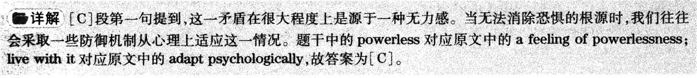

47.To be effective.environmentalmessages should be carefullyframed.

译文.为了提高效率，应精心设计环境信息。

定位.由题干关键词envi—ronmental messages定位到原文画线处。



48.It is the government’s responsibilityto persuade people into makingenvironment—friendly decisions.

译文.政府有责任劝说公民做出有利于环保的决策。

定位.由题干关键词government’sresponsibility和persuade people定位到原文画线处。

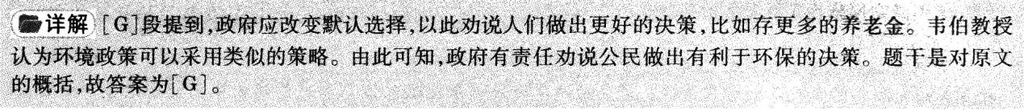

49.Politicians are beginning to realise theimportance of enlisting psychologists’help in fighting climate change.

译文.政治家们开始意识到在应对气候变化时谋求心理学家帮助的重要性。定位.由题干关键词psychologists’help和fighting climate change定位到原文画线处。

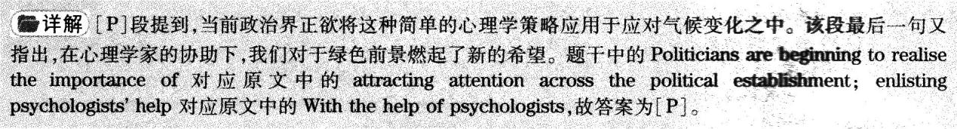

50.To find effective solutions to climatechange，it is necessary to understandwhat motivates people to makechange.

译文.为了找到有效解决气候变化的方法，我们需要了解人们做出改变的动机。

定位.由题干关键词what motivatespeople，和make change定位到原文画线处。

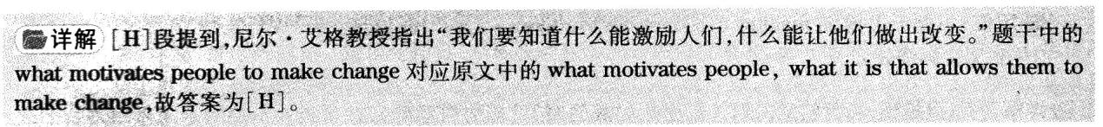

51.In their evolution.humans havelearned to pay attention to the mosturgent issues instead of long—term Concerns.

译文.在人类进化过程中，人们已经学会关注最紧急的问题，而非做长远的考虑。

定位.由题干关键词evolution，humans以及the most urgent issues定位到原文画线处。



52.One study shows that our neighbours’actions are influential in changing ourbehaviour.

译文.一项研究表明，邻居的行为对于我们自身行为的改变有影响。

定位.由题干关键词neighbours’actions定位到原文画线处。

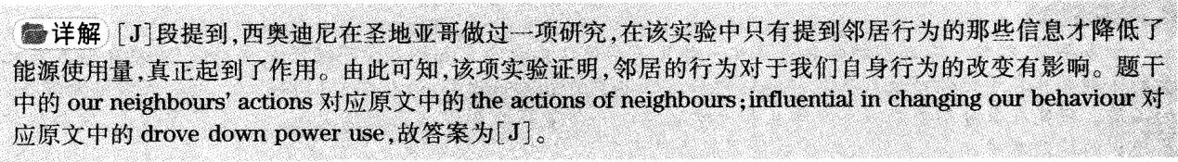

53.Despite clear signs of global warming.it isnot easy for most people to befeve climatechange will affect their own fives.

译文.尽管全球变暖迹象很明显，大多数人还是难以相信气候变化会影响到他们自身的生活。

定位.由题干关键词global warnting，most people和befeve定位到原文画线处。

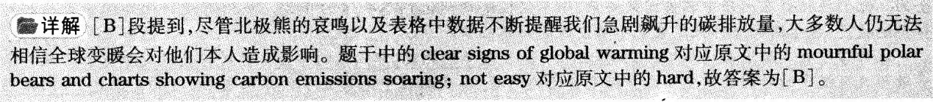

54.We should take our future into consideration inmalting decisions concerning climate change before itis too late.

译文.我们在做与气候变化有关的决策时应考虑未来，以免为时过晚。

定位.由题干关键词making decisions和too late定位到原文画线处。

详解.[F]段提到，当我们意识到气候变化的威胁时，可能为时已晚。如果我们不能为未来做出理智的决策，鄢么其他人就不得不替我们完成这个决定。由此可知，我们在做与气候变化有关的决策时应考虑未来。题于是对原文的概括，故答案为[F]。

55.Existing social networkscall be more effective increating change inpeople’s behaviour.

译文.现存的社会网络能更有效地改变人类的行为。

定位.由题干关键词social networks 和creating change定位到原文画线处。

详解.[0]段提到，尼克·帕克斯指出，使用现有的民间社会机构或网络能够更有效地创造变化，显然英国工会是最大的民间社会网络之一。题于中的can be more effective对应原文中的is a more effective way，故答案为[O]。

Section C

Passage One

详解详析

56.D)。定位.由题干中的traditional educators’interpretation定位到文章首段最后一句：From thestandpoint of a traditional educator，this outcome indicated that schooling had failed to help students think about ecosystems and extinction，major scientific ideas·

详解.推理判断题。定位句指出“从传统教育工作者的角度来看，这一结果表明，学校教育未能帮助学生思考生态系统和物种灭绝这两个重要的科学理念”，由此可见，传统教育工作者认为教育没有引导学生思考重要的科学理念，故答案为D)。

点睛.A)“学生不能把之前学到的知识应用于新问题”，虽然第一段第一句提到过，但这是指研究发现年轻人与儿童的区别并非在于记住事情或将之前学到的知识应用于新情况的能力，故排除；B)“大学生在记忆力方面不比五年级的学生强”，首段第三句只提到大学生的拼写能力比五年级的学生出色，而没有对记忆力进行对比，故排除；C)“教育没有对主要的环境问题给予足够的关注”，首段末句提到学校教育未能帮助学生思考生态系统和物种灭绝这两个重要的科学理念，但并不是指教育本身对主要的环境问题没有给予足够的关注，故C)与原文表达的中心思想不符，故排除。

57.A)。定位.由题干中的college students，different和children定位到文章第二段第三句：0n this task，they found large difference.和第六句：The college students had cultivated the ability to ask questions，the cornerstone of critical thinking.

详解.推理判断题。定位句指出，研究发现大学生和儿童之间存在着巨大差异，“大学生已培养出了提问的能力，这是批判性思维的基石”，由此可见，大学生与儿童的区别在于大学生已学会了批判性地思考，故答案为A)。

点睛.B)“他们关注社会问题”，原文并未提及，故排除；C)“他们对个体特征感到好奇”，第二段第五句提到“五年级的学生们则倾向于关注秃鹰的个体特征”，而大学生关注的是秃鹰与其栖息地之间相互依存的关键问题，故排除；D)“他们已经学会了独立工作”，第二段最后两句提到大学生学会了提问和学习，但没有提到学会了独立工作，故排除。

58.B)。定位。根据题干中的benefit of asking questions和no ready answers定位到文章第三段第三句：Wefound that when we taught participants to ask“What if?”and“How can?”questions that nobodypresent would know the answer to and that would spark exploration，they engaged in better inquiry atthe next exhibit--asking more questions，performing more experiments and malting betterinterpretations of their results.

详解.推理判断题。定位句指出，当教学员提出“如果?”和“如何?”这些现场没有人知道答案但又会激发其探索欲的问题时，学员们在下次展览时会进行更好的探究——提出更多的问题，进行更多的实验并对其研究结果做出更好的解释，由此可知，提出没有现成答案的问题，其好处是培养了学生们进行科学探究的能力，故答案为B)。

点睛.A)“它引起了学生们对身边事物的兴趣”，定位句只提到这些问题会激发其探索欲，但没有提到会引起学生们对身边事物的兴趣，故排除；C)“它培养了学生们设计科学实验的能力”，定位句只提到学生们会进行更多的实验，但没有提到学生们设计科学实验，故排除；D)“它帮助学生们意识到并非所有的问题都有答案”，定位句提到的是教学生们提出没有人知道答案的问题，但并没有指出这会帮助学生们意识到并非所有的问题都有答案，故排除。

59.A)。定位.由题干中的advantage和informal learning定位到文章第四段第二句：Informal learning environments tolerate failure better than schools.

详解.事实细节题。定位句指出，与学校相比，非正式的学习环境对待失败更加宽容，也就是说非正式的学习允许失败，故答案为A)。

点睛.B)“它很有趣”，原文并未提及非正式学习是否有趣，故排除；C)“它不收学费”，文章最后一句提到非正式学习系统不打分、来者皆收、甚至在节假日和周末都能使用，但没有提到是否收取学费，故排除；D)“它符合实际需要”，原文没有提及，故排除。

60.C)。定位.由题干中的encourage educators和at the end of the passage定位到文章最后一段最后三句：But people must acquire this sldll somewhere.Our society depends on them being able to makecritical decisions about their own medical treatment，say，or what we must do about giobal energyneeds and demands.For that，we have a robust informal learning system that gives no grades，takesall comers，and is available even on holidays and weekends.

详解.推理判断题。定位句指出，“人们必须从某个地方获得这个技能。我们的社会依赖于能对自己的医疗方案做出关键决定，或者说对关于全球能源需求必须做出重大决定的人。为此，我们需要一个健全的非正式学习系统，不打分、来者皆收、甚至在节假日和周末都能使用”，由此可知，为了传授人们技能，为了培养社会所依赖的人，我们应该使用非正式的学习系统，也就是说教育者应该充分利用非正式学习的资源，故答案为C)。

点睛.A)“训练学生思考全球问题”，文中只提到社会依赖于那些能对关于全球能源需求必须做出关键决定的人，但没有提及训练学生思考全球问题，故排除；B)“设计更多互动的教室活动”，原文没有提及，故排除；D)“课程涵盖协作探究”，最后一段第三旬只提到很多教师在课程中有太多的东西要教，但没有提及课程涵盖协作探究，故排除。

高频词汇及短语

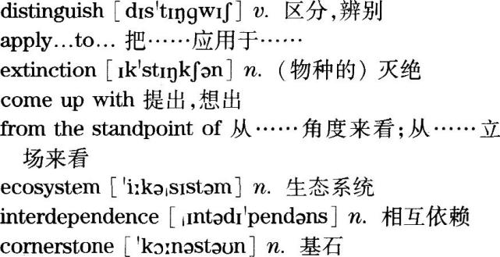

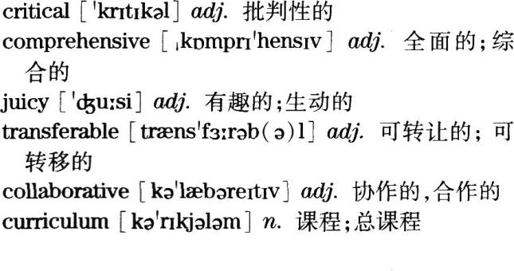

Passage TWO

详解详析

61.B)。定位.由题干中的failure和VSS Enterprise定位到文章首段最后一句：But insurance will be coldcomfort following the failure on October 31st of VSS Enterprise，resulting in the death of one pilotand the severe injury to another.和第二段：0n top of the tragic loss of life，the accident in Californiawill cast a long shadow over the future of space tourism，even before it has properly begun.

详解.推理判断题。文章首段最后一句指出，在10月31日，进取号维京太空船的坠毁导致了两名飞行员一死一重伤，然后第二段整段都在介绍此次坠毁事件所带来的影响，除了造成人员的惨痛伤亡，还令太空旅行的前景长期笼罩在阴影之下，由此可见，进取号维京太空船的坠毁对太空旅行造成了极大的负面影响，故答案为B)。

点睛.A)“它会导致维珍银河公司破产”，这句在原文并未提及，故排除；C)“它会阻碍富人去太空旅行”，第三段最后一句提到维珍银河公司已向包括史蒂芬·霍金在内的800余名未来太空旅客收取了押金，由此可见，此次事故并未阻碍富人去太空旅行，该选项是对原文的曲解，故排除；D)“它引起了公众对安全问题的关注”，原文并未提及公众对安全问题的关注，故排除。

62.C)。定位.由题干中的the space-tourism firm Virgin Galactic定位到文章第三段第四句：Virgin Galactic had，prior to this week’s accident，seemed closest to starting regular flights.

详解事实细节题。定位句指出，“在本周事故之前，维珍银河公司似乎就要启动定期太空航班了”，由此可见，维珍银河公司差不多准备好开展定期业务了，故答案为C)。

点睛.A)“它已建好了一个商用飞行器”，第四段第三句提到维珍银河公司的商用飞行器只完工了大约一半，故排除；B)“它已经将6名乘客送入太空”，第三段前两旬提到自从2001年丹尼斯·蒂托花费了2000万美元乘坐俄罗斯的宇宙飞船进行太空旅行之后，只有6名度假者花费了同样的天价抵达太空轨道，但并未指出是维珍银河公司搭载这6位乘客去太空旅行，故排除；D)“它是第一家推出‘亚轨道’飞行的公司”，第三段第三句提到一些公司开始计划推出价格更为实惠的“亚轨道”飞行，但并没有表明维珍银河公司就是第一家推出“亚轨道”飞行的公司，故排除。

63.D)。定位.根据题干中的the 2004 Commercial Space Launch Amendments Act定位到文章第五段第二句：The 2004 Commercial Space Launch Amendments Act，intended to encourage private spacevehicles and services，prohibits the transportation secretary(and thereby the FAA)from regulatingthe design or operation of private spacecraft，unless they have resulted in serious or fatal iaiury tocrew or passengers.

详解.推理判断题。定位句指出，2004版《商业太空发射修正案》旨在鼓励私人太空航天器和服务的发展，由此可知，2004版《商业太空发射修正案》是为了推动太空旅游业的发展，故答案为D)。

点睛.A)“为了确保太空旅行的安全”，第五段最后一句提到“虽然这可能会使“亚轨道”旅行更加安全，但也会增加这一新兴行业的成本和复杂性”，这只是表明2004版《商业太空发射修正案》带来的好处和坏处，而不是发布该修正案的目的，故排除；B)“为了限制联邦航空局的职能”，定位句提到“禁止交通部长(以及联邦航空局)管理私人航天器的设计或操作，除非它们对机组人员或乘客造成了严重或致命的伤害”，这只是2004版《商业太空发射修正案》的规定，而不是目的，故排除；C)“为了使私人太空探索合法化”，原文并未提及2004版《商业太空发射修正案》是否使私人太空探索合法化，故排除。

64.D)。定位.由题干中的FAA和the recent accident定位到文章第五段第三句：That means that the FAA could suspend virgin Galactic’s licence to fly.

详解.事实细节题。定位句指出，联邦航空局可能会暂停维珍银河公司的飞行执照，故答案为D)。点睛.A)“实行更严格的安全标准”，第五段第四句提到联邦航空局可能还会坚持要求对私人载人航天器进行彻底的检查，就像其对商用飞机所做的那样，但并没有表明联邦航空局会实行更严格的安全标准，故排除；B)“不再给新的太空旅行机构发执照”，原文并未提及联邦航空局是否会给新的太空旅行公司发执照，故排除；C)“修改其2004版《商业太空发射修正案》”，原文没有提到是否要继续修改2004版《商业太空发射修正案》，故排除。

65.A)。定位.由题干中的private space travel定位到文章最后一段最后一句：’Illere is no doubt thatspaceflight entails dsl(s，and to pioneer a new mode of travel is to face those risks，and to reducethem with the benefit of hard—won experience.

详解.观点态度题。原文最后一句指出，航天有风险，而且开拓一种新的旅行方式不仅要面对这些风险，还要通过来之不易的经验降低此类风险，这里新的旅行方式就是指私人太空旅行，也就是说太空旅行尽管存在风险，但仍值得推广，故答案为A)。

点睛.B)“它不应该只限于在富人之间展开”，第三段第三句只提到一些公司开始计划推出价格更为实惠的“亚轨道”飞行，但并没有表明太空旅行不应该只限于在富人之间展开，故排除；C)“它应该被严格规范”，原文没有提及，故排除；D)“它的风险太大，不能开展”，定位句提到太空旅行有风险，但应该去面对，还要降低这些风险，而不是停止太空旅行，故排除。高频词汇及短语

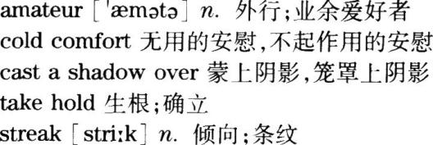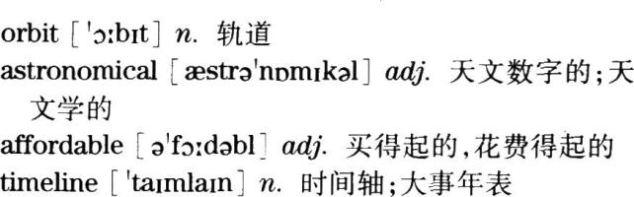

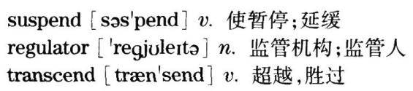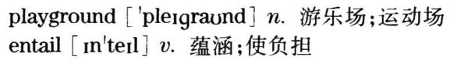

Part Ⅳ Translation

参考译文

China is playing an increasingly important role in helping the international community to eliminate extreme

poverty by 2030.

Since the late 1970s, having implemented the reform and opening up policy, China has helped up to fourhundred million people out of poverty. In the next five years, China will provide assistance to other developingcountries in reducing poverty, developing education, agricultural modernization, environmental protection andmedical care.

China has made remarkable progress in reducing poverty, and has made unremitting efforts to promoteeconomic growth, which will encourage other poor countries to respond to the challenges of their owndevelopment. These countries can learn from the experience of China when they seek to develop their owncharacteristics.

难点注释

1.翻译第一段时，可按照原文顺序将“帮助国际社会于2030年前消除极端贫困”作为目的状语，将“中国正扮演着越来越重要的角色”作为主句，即To help the international community to eliminate extreme poverty by2030，China is acting a more and more important role.另外一种译法是用play a role in sth.结构来翻译。此外，要注意“消除极端贫困”的正确译法是eliminate extreme poverty。

2.翻译第二段第一句时要注意时态，根据关键句式“自……以来”可知，应用现在完成时，可由since来引导。另外需要注意“改革开放”和“摆脱了贫困”的翻译方法。“改革开放”是专有词组，常泽为the reform andopening up poficy；“摆脱了贫困”可译为get rid ofpoverty，也可像参考译文那样译为help…out ofpoverty。

3.翻译第二段第二句时，主要使用provide aid／assistance to sb.in(doing)sth.结构，需要注意原文中的“减少贫困、发展教育、农业现代化、环境保护和医疗保健”等既有动词结构，也有名词结构，上述句式in后面的动词结构需转化为动名词结构，而原有的名词结构既可按照参考译文直接按照名词形式翻译，也可把名词结构转化为动词结构，即把“农业现代化…‘环境保护”和“医疗保健”分别译为modernizing agriculture，improvingenvironmental protection and medical care。

4.翻译第三段第一句时，有两种方法。第一种是像参考译文那样翻译成非限制性定语从句；另外一种翻译方法就是把整个句子分成两部分来翻译，即China has made significant progress in poverty reduction，and hasmade unremitting efforts in promoting economic growth.Both the progress and the efforts will encourageother poor countries to cope with challenges brought by development.此外，这句话中难度比较大的是“不懈努力”的翻译，若知晓unreming意为“不懈的”，则就很容易了。还有“应对自身发展中的挑战”既可以按照参考译文译为“对自身发展中的挑战做出回应”，即respond to the challenges oftheir own development，也可以把“发展中的”译为一个过去分词短语，修饰“挑战”，即cope with challenges brought by development。

5.第三段最后一句话包含一个时间状语从句，需要注意的是时间状语从句的位置比较灵活，既可以像参考译文那样把主句前置，也可以把状语从句前置，即When…，these countries Can learn from China's experience.值得注意的是，当时间状语从句的主语和主句的主语一致时，可以将从句主语省略，把从句谓语动词变成V-ing形式，即When exploring the distinctive development road of their own.these countries call learn fromChina's expenence.“寻求具有自身特色的发展道路”可以直译为explore the distinctive development road oftheir own，也可以像参考译文那样简略译为“发展自己的特色”，即develop their own characteristics。此外，“借鉴经验”可翻译为learn from…或draw lessons from…。

**附：最全历年英语四六级真题答案及下载大汇总！**

**<http://www.233.com/cet4/zhuanti/linianzhenti/>**