Qiang Zhu
School of Chemistry and Chemical Engineering Tel: (+86) 15051818615
Nanjing University Email: csu1505110121@163.com
ResearchGate: https://www.researchgate.net/profile/Qiang_Zhu29

Experience
2020 - present Postdoctoral Fellow
Institute of Theoretical and Computational Chemistry, Key Laboratory of Mesoscopic Chemistry of MOE, School of Chemistry and Chemical Engineering, Nanjing University
Supervisor: Prof. Jing Ma

Education
2015 - 2020 Ph.D. in Theoretical and Computational Chemistry
Institute of Theoretical and Computational Chemistry, Key Laboratory of Mesoscopic Chemistry of MOE, School of Chemistry and Chemical Engineering, Nanjing University (Supervisor: Prof. Jing Ma & Hao Dong)
2011 - 2015 B.S. in Department of pharmaceutical engineering
Chemistry and Chemical Engineering, Central South University

Research Interests
- Enhanced sampling method
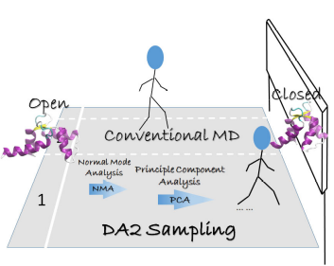
Molecular dynamics (MD) simulation serves as a robust tool to study large biological systems such as the protein, it could provide time-dependent motions of a protein which is difficult to be probed experimentally. However, suffering from the rough energy landscape of proteins, the time-scale of conformational changes from one state to another state often spans from microseconds to seconds, which exceeds the capacity of conventional MD simulation. To bridge the gap between the experiment and simulations, a new algorithm named data-driven accelerated (DA2) method, which applied a linear dimensional reduction (Principle Component Analysis, PCA) method on short parallel conventional MD simulations to extract the directions of dominant motions, is developed by me. (Adv. Theory and Simu., 2019, 2(4): 1800171.)
- Mechanism of small molecule in biological membranes
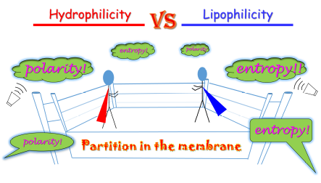
Absorption, distribution, metabolism, and elimination (ADME) are four criteria to influence the drug levels and kinetics of drug exposure. The capacity of drug to move across membranes is a prerequisite factor. Molecular dynamics (MD) simulations are utilized by me to unveil how a small molecule penetrates into membrane at atomic level. Machine Learning is also applied to disclose that entropy and polarity play an important role in drugs’ potency. (Sci. Rep. 2017, 7, 17749.)
- Property of bulk water in external electrical field
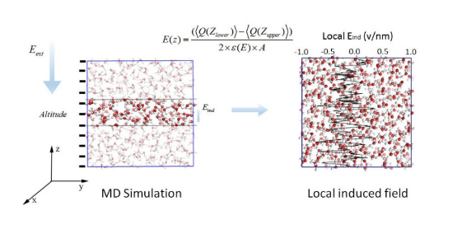
The simplicity of continuum electrostatic model makes it popular in accounting for the long-ranged electrostatics interactions in biological and materials. Experimentally, measurement of dielectric constant is usually under some mild conditions, and it is hard under some extreme conditions, such as high pressure and high temperature. Taking these into consideration, using molecular dynamics (MD) simulations is becoming increasingly appealing. A clear profile of dielectric constant under different external electrical field was provided by us with molecular dynamics (MD) simulations, which is helpful for understanding the electrostatic polarization and distribution of local induced electric fields. (J. Electrochem. 2017, 23, 391)

Publications
(1) "A Data-Driven Accelerated Sampling Method for Searching Functional States of Proteins"
Q. Zhu, Y. Yuan, J. Ma*, and H. Dong*, Adv. Theory and Simu., 2019, 2(4): 1800171.

(2) "Entropy and Polarity Control the Partition and Transportation of Drug-like Molecules in Biological Membrane"
Q. Zhu, Y. Lu, X. He, T. Liu, H. Chen, F. Wang, D. Zheng, H. Dong*, and J. Ma*. Sci. Rep. 2017, 7, 17749.

(3) "Electrostatic Interactions of Water in External Electric Field: Molecular Dynamics Simulations"
Q. Zhu, Z. Kan, and J. Ma*. J. Electrochem. 2017, 23, 391.

(4) "Direct Extracellular Electron Transfer of the Geobacter Sulfurreducens Pili Relevant to Inter-aromatic Distances"
C. Shu≠, Q. Zhu≠, K. Xiao, Y. Hou, H. B. Ma, J. Ma, X. Sun. BioMed Research Internatioal 2019(2019)(contributed equally)

(5) "A Two-ended DAta-Driven Accelerated Sampling Method for Exploring the Transition Pathways between Two Known States of Protein"
Y. Yuan, Q. Zhu, R. Song, J. Ma, H. Dong. J. Chem. Theory Comput. 2020. DOI: 10.1021/acs.jctc.9b01184.

(6) "Polarization Effects on the Cellulose Dissolution in Ionic Liquids: Molecular Dynamics Simulations with Polarization Model and Integrated Tempering Enhanced Sampling Method"
Z. Kan, Q. Zhu, L. Yang, Z. Huang, B. Jin, and J. Ma*. J. Phys. Chem. B, 2017, 121(17): 4319.

(7) "Tuning the collective switching behavior of azobenzene/Au hybrid materials: flexible versus rigid azobenzene backbones and Au (111) surfaces versus curved Au nanoparticles"
C. Liu, D. Zheng, W. Hu, Q. Zhu, Z. Tian, J. Zhao, Y. Zhu, and J. Ma*. Nanoscale, 2017, 9(43): 16700.

(8) "Synergistic steric pairing effects of terfluorenes with ternary side groups on β-conformation transition: experiments and computations"
X. Yuan, M. Yu, Q. Zhu, W. Zhang, L. Xie, W. Huang, and J. Ma*. J. Mater. Chem. C, 2018, 6(6): 1551.

(9) "On-Demand Electrical Switching of Antibody-Antigen Binding on Surfaces"
B. S. Gomes, E. Cantini, S. Tommasone, J. S. Gibson, X. Wang, Q. Zhu, J. Ma, J. D. McGettrick, T. M. Watson, J. A. Preece, J. C. Krikman-Brown, S. J. Publicover, and P. M. Mendes*. ACS Appl. Bio Mater., 2018, 1(3): 738.

Awards
2011-2012 National Scholarship of Central South University
2011-2013 Excellent Student of Central South University, (Two times)
2011-2012, 2013-2014 The First Prize Scholarship of Central South University
2012-2013 The Second Prize Scholarship of Central South University
2013-2014 BYD Scholarship
2015 Outstanding graduate of Central South University
2015-2018 The First Prize Scholarship of Nanjing University, (Three times)
2017-2018 The Ph.D. Second Talent Scholarship of Nanjing University

Academic Workshops and Conferences
- 2016 International Workshop on Frontiers in Molecular Biophysics, Shanghai, China, 2016/07/23~07/25
- The 10th National Conference on Soft Matter and Biophysics, Xiamen, China, 2017/03/24~03/27 (Poster)
- The 13th Chinese Quantum Chemistry, Dalian, China, 2017/06/08~06/11 (Poster)
- 2017 Summer School on Machine Learning in the Molecular Sciences, Shanghai, China, 2017/06/12~06/16
- The 14th National Computational Chemistry, Nanjing, China, 2017/11/17~11/20
- The 31th Chinese Chemical Society Congress, Hangzhou, China, 2018/05/05~05/08 (Poster)
- The 4th China-Japan-Korea Workshop on Theoretical & Computational Chemistry, Nanjing, China, 2019/01/09~01/12 (Poster)
- Theory and computational biology: From molecule to System, Dongguan, China, 2019/08/01~08/04 (Poster)
- Energy Landscape 2019, Belgrade, Serbia, 2019/08/26~08/30 (Poster)
- 2019 The Workshop on Computational Statistical Mechanics of Complex Systems, Nanjing, China, 2019/10/26~10/28 (Poster)
- From Free Energy Perturbation to Biomedicine: Bridging Experiment and Computation, Shenzhen, China, 2019/11/09~11/13

Technical Skills
I could perform molecular dynamics simulation with NAMD, GROMACS, AMBER package suite, and analyze the output such as trajectories and log file with homemade Tool Command Language (TCL script) embedded in VMD, and present these data with Gnuplot. In addition, Python script is also utilized to perform some tasks such as Machine Learning (ML) and Windows, Mac, and Linux OS are frequently used.

References

Prof. Jing Ma (Advisor)
Institution of Theoretical and Computational Chemistry, Nanjing University, Nanjing, 210023, P. R. China
Tel: 86-25-89681772, Fax: 86-25-89681772, Email: majing@nju.edu.cn

Prof. Hao Dong (Cooperative Advisor)
Kuang Yaming Honors School, Nanjing University, Nanjing, 210023, P. R. China
Email: donghao@nju.edu.cn

