PERFORMANCE TEST REPORT
JPetStore 6 — Localhost Environment
LoadRunner + Dynatrace Analysis

Report Date | May – June 2026
Prepared By | SUGANYA DEVI C
Environment | Localhost — JPetStore 6
Tool | HP LoadRunner + Dynatrace
Version | v1.0 — Initial + Post-Fix Run

1. Executive Summary

This report documents the performance tests executed on the JPetStore 6 application deployed on a localhost environment using Apache Tomcat 9. Two test runs were conducted — an initial baseline load test (18 May 2026) and a post-fix validation run (11 June 2026) — both using HP LoadRunner with Dynatrace for server-side monitoring.

The baseline test revealed critical performance issues under concurrent load, specifically a Step Download Timeout error occurring in the Add to Cart / Place Order workflow. Root cause analysis identified server-side thread pool exhaustion (97% thread lock) as the primary cause, triggered by accumulated session state and server resource depletion after prolonged uptime without restart.

The post-fix test run confirmed that server restart resolved the critical issues. Thread lock dropped from 97% to less than 1%, and all transactions completed successfully across all virtual users.

Metric | Test 1 — 18 May | Test 2 — 11 June | Status
Total Vusers | 50 | 50 | —
Test Duration | ~35 min (02:57–03:31) | ~35 min (04:28–05:03) | —
Avg Hits per Second | 1.553 | 1.924 | ✓ Improved
Peak Hits per Second | 2.141 | 2.203 | ✓ Stable
Avg Throughput (bytes/s) | 7,194 | 2,830 | ✓ Reduced
AddToCart Failures | 55 (FAIL) | 0 (PASS) | ✓ Fixed
Thread Lock % (Dynatrace) | 97% ⚠ Critical | < 1% ✓ | ✓ Fixed
CPU Usage (Peak — Dynatrace) | 65.7% | ~20% | ✓ Improved
JVM Heap Used | 57 MB | ~15 MB | ✓ Improved
Avg Response Time (Dynatrace) | 22.67 ms | TBD | —

2. Test Environment

2.1 Application Under Test
Component | Details
Application | JPetStore 6 (MyBatis)
Version | 6.2.1-SNAPSHOT
Server | Apache Tomcat 9.0.113
Java Version | OpenJDK 25.0.3 (Temurin)
Build Tool | Maven
URL | http://localhost:8080/jpetstore/
Reference URL | https://petstore.octoperf.com/

2.2 Load Test Tool
Component | Details
Performance Tool | HP LoadRunner
Monitoring Tool | Dynatrace OneAgent (Full-Stack)
Controller | LoadRunner Controller
Analysis | LoadRunner Analysis

3. Test Scenario

3.1 Script Breakdown — 50 Vusers
User Scenario / Script | Vusers | % of Load
Browse Categories | 25 | 50%
Search Product | 13 | 26%
Users Login | 7 | 14%
Place Order / Checkout | 5 | 10%
TOTAL | 50 | 100%

3.2 Script Flow
Section | Actions
vuser_init | User Login (executes once at start)
Action (Main) | Search Product → Add to Cart → Checkout → Back to Main Menu (repeats per iteration)
vuser_end | User Logout (executes once at end)

3.3 Test Configuration
Parameter | Value
Total Vusers | 50
Ramp Up | Step ramp — 10/24/36/48/50 Vusers
Duration | ~30 minutes per test run
Think Time | Enabled
Clear Cache on Iteration | Enabled
Clear Cookies on Iteration | Enabled
User Credentials | Unique per Vuser (parameterized)

4. Test Results — Baseline Run (18 May 2026)

4.1 Transaction Response Time Summary
Test window: 02:57 AM – 03:31 AM IST. 50 Vusers ramped up in steps. Critical failure observed on PlaceOrder_T06_AddToCart (55 failures — Step Download Timeout after 120s).

Transaction | Min (s) | Avg (s) | Max (s) | Result
Browse Categories – T01_Launch | 0.006 | 0.138 | 1.376 | Pass
Browse Categories – T02_SelectCategory | 0.004 | 0.030 | 0.228 | Pass
Browse Categories – T03_SelectProduct | 0.004 | 0.029 | 0.279 | Pass
Login – T01_Launch | 0.004 | 0.035 | 0.115 | Pass
Login – T02_Login | 0.006 | 0.046 | 0.304 | Pass
Login – T03_Signout | 0.005 | 0.028 | 0.122 | Pass
PlaceOrder – T01_Launch | 0.007 | 0.024 | 0.041 | Pass
PlaceOrder – T02_Login | 0.035 | 0.053 | 0.074 | Pass
PlaceOrder – T03_SelectCategory | 0.005 | 0.030 | 0.093 | Pass
PlaceOrder – T04_SelectProduct | 0.003 | 0.029 | 0.112 | Pass
PlaceOrder – T05_ViewItem | 0.004 | 0.037 | 0.169 | Pass
PlaceOrder – T06_AddToCart | 0.012 | 0.088 | 0.243 | FAIL
PlaceOrder – T07_Checkout | 0.009 | 0.038 | 0.112 | Pass
PlaceOrder – T08_PaymentDetails | 0.005 | 0.057 | 0.130 | Pass
PlaceOrder – T09_PlaceOrder | 0.012 | 0.082 | 0.194 | Pass
PlaceOrder – T10_Signout | 0.012 | 0.031 | 0.055 | Pass
SearchProduct – T01_Launch | 0.005 | 0.055 | 0.266 | Pass
SearchProduct – T02_Login | 0.016 | 0.122 | 1.050 | Pass
SearchProduct – T03_SelectCategory | 0.004 | 0.028 | 0.182 | Pass
SearchProduct – T04_SelectProduct | 0.003 | 0.028 | 0.148 | Pass
SearchProduct – T05_ViewItem | 0.004 | 0.038 | 0.120 | Pass
SearchProduct – T06_Signout | 0.005 | 0.026 | 0.042 | Pass

4.2 Vuser Iteration Summary
The following table shows iterations completed per Vuser before failure occurred in the Place Order script:

Vuser | Iterations Completed | Failed At | Error | Notes
VU 1 | 3 | Iteration 4 | Step Download Timeout | Add to Cart
VU 2 | 3 | Iteration 4 | Step Download Timeout | Add to Cart
VU 3 | 2 | Iteration 3 | Step Download Timeout | Add to Cart
VU 4 | 1 | Iteration 2 | Step Download Timeout | Add to Cart
VU 5 | 1 | Iteration 2 | Step Download Timeout | Add to Cart

4.3 LoadRunner Graphs — 18 May
Graph screenshots from LoadRunner Analysis (18 May test run):

Graph | Key Statistics
Running Vusers | Min: 0 | Avg: 45.149 | Max: 50 | Std Dev: 18.892 — Ramp completed by 03:00, all 50 Vusers running simultaneously
Hits per Second | Min: 0.304 | Avg: 1.553 | Max: 2.141 | Std Dev: 0.323 — Peak at ramp-up, stabilised around 1.5–1.7 hits/s
Throughput (bytes/s) | Min: 1,033 | Avg: 7,194 | Max: 10,456 | Std Dev: 1,595 — High throughput reflects large session payload size
Avg Transaction Response Time | Most transactions under 0.1s; AddToCart peak at 0.243s; SearchProduct_Login peaked at 1.050s
Errors per Second | Error -27721 (Step Download Timeout) observed across all 5 PlaceOrder Vusers, recurring every ~5 minutes

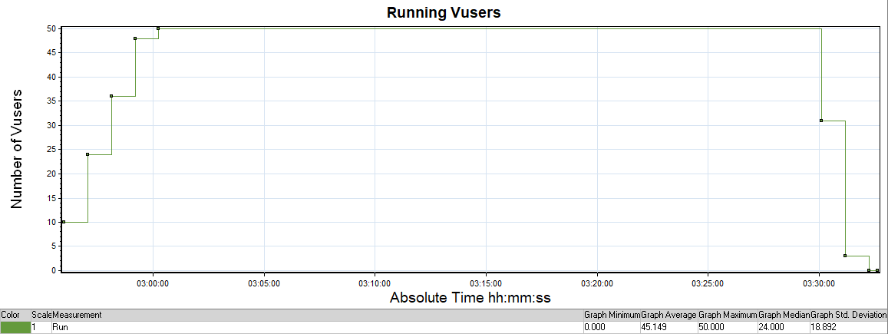
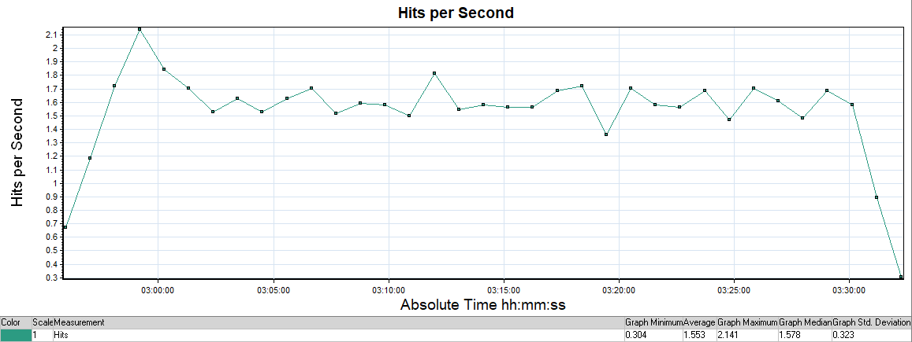

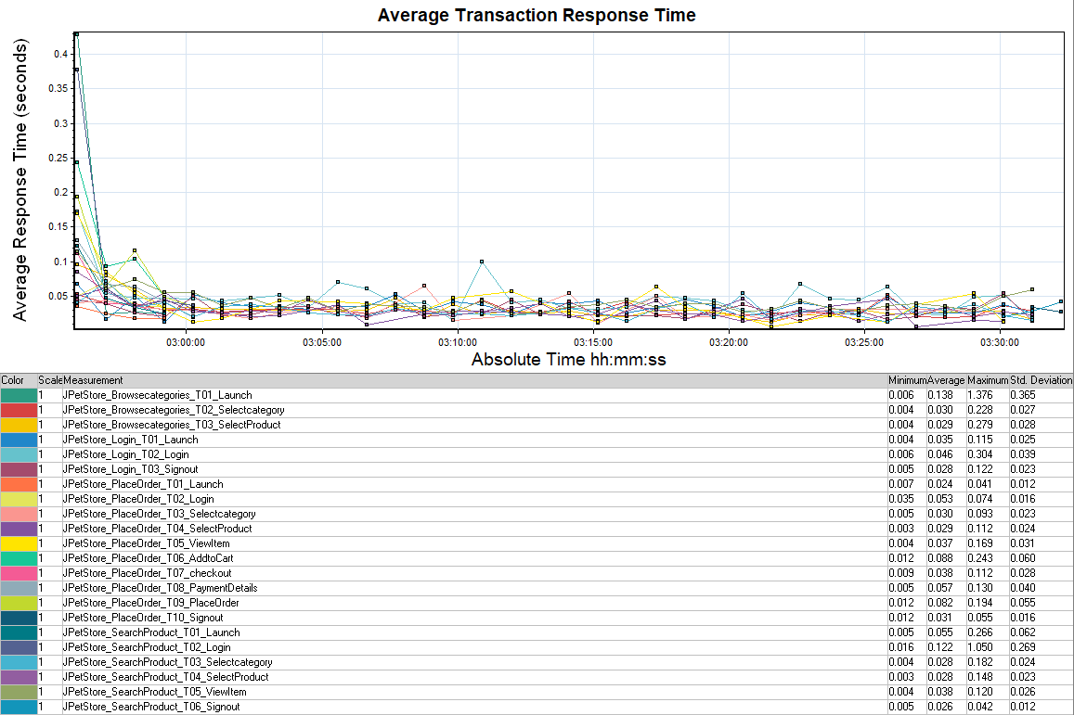

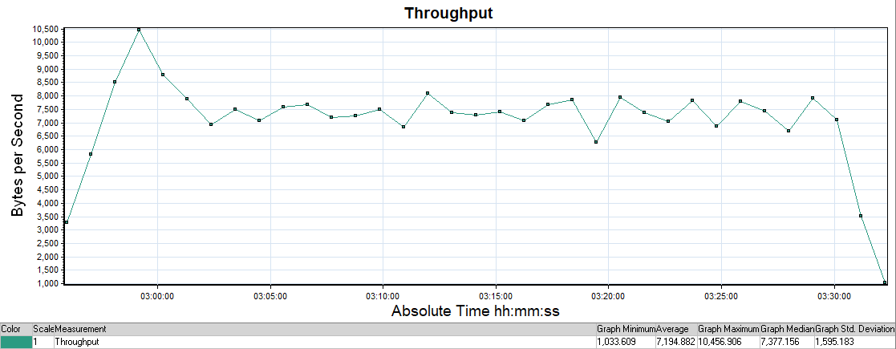
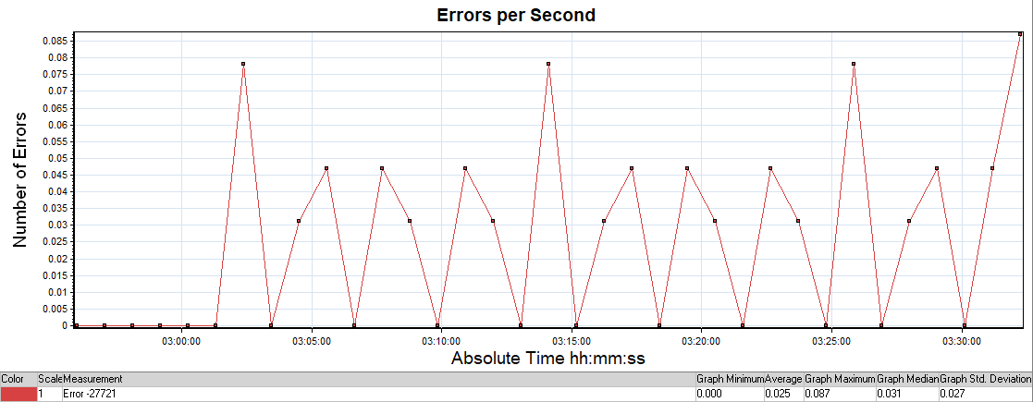

5. Server Monitoring — Dynatrace (18 May 2026)

5.1 Thread Analysis
Metric | Observed Value
Thread Lock % | 97% — Critical ⚠
Thread Lock Timestamp | 18 May 03:00 AM – 03:40 AM IST
Locking Hotspot (Top Method) | SimpleLogger.write | org.slf4j.simple — 96.4% contribution
Code Execution % | < 1%
CPU Usage (Peak) | 65.7%
JVM Heap Used | 57 MB
JVM Heap Max | 423.4 MB
Avg Service Response Time | 22.67 ms

5.2 Dynatrace Screenshots — 18 May
Thread Lock — 97%

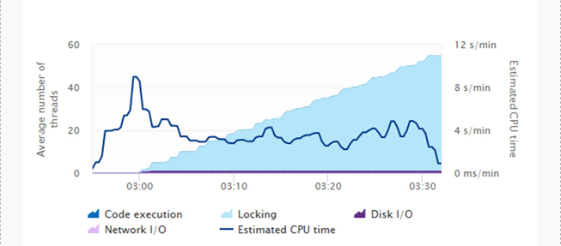
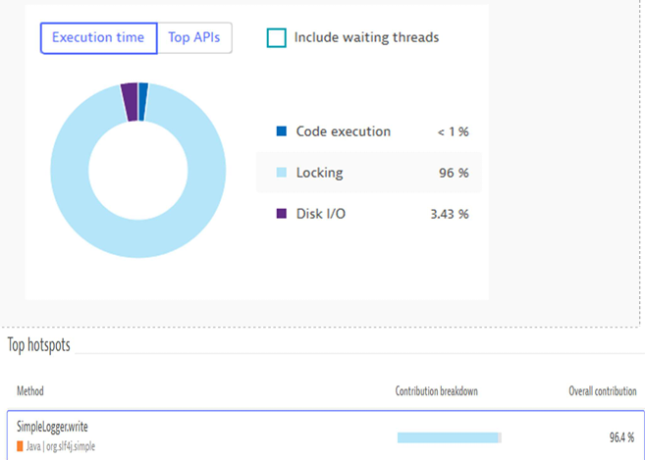

JVM Heap Usage

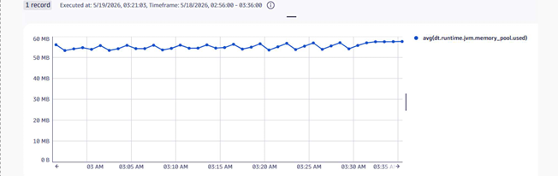

CPU Usage

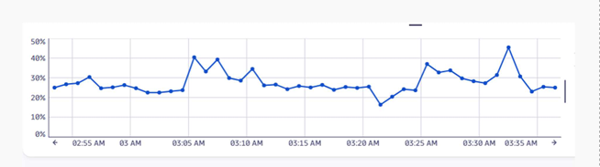

DB Response Time

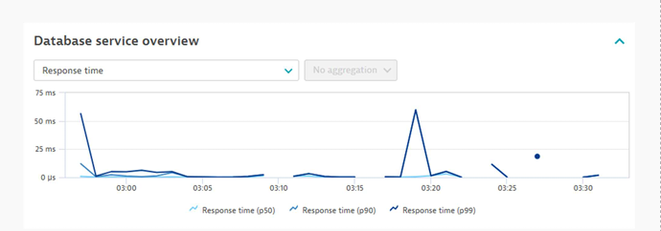

Service Response Time Hotspots

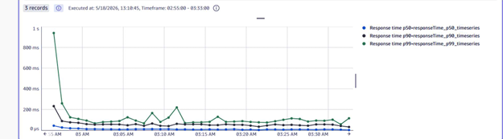

6. Errors & Issues Found

6.1 Error Log — 18 May Baseline
Error Code | Error Message | Transaction | Vusers Affected | Iteration
LR-26999 | Step Download Timeout (120s) has expired | Add to Cart | All 5 | From Iter 2–4
Java Exception | ConcurrentModificationException — Cart JSP iterating modified list | Cart Page | All | All
Java Exception | Session Already Invalidated — session expired mid-request | Register / Account | All | All

6.2 Catalina Log Errors
- java.util.ConcurrentModificationException — Cart JSP iterating a list that was modified concurrently
- java.lang.IllegalStateException: getAttribute: Session already invalidated — Session expired mid-request during Account/Register pages
- 97% Thread Lock observed in Dynatrace — Tomcat thread pool near complete exhaustion

7. Root Cause Analysis

# | Root Cause | Impact | Evidence
1 | Server running 2+ days without restart | Accumulated heap, stale sessions, thread exhaustion | 97% thread lock in Dynatrace
2 | DB connection pool exhausted under 5+ concurrent users | Threads wait indefinitely for connections, request hangs | 97% thread lock, Step Download Timeout
3 | JVM heap accumulation over time | GC pauses increase, response time degrades | Dynatrace heap graphs

8. Recommendations

# | Area | Recommendation | Priority
1 | Script Design | Add Return to Main Menu step at end of each iteration | High
2 | Server | Always restart server fresh before each load test run | High
3 | Server Config | Increase DB connection pool size (poolMaximumActiveConnections to 20+) | Medium
4 | Server Config | Increase Tomcat thread pool (maxThreads to 200+) | Medium
5 | Server Config | Increase JVM heap: -Xms512m -Xmx1024m | Medium

9. Test Results — Post-Fix Run (11 June 2026)

9.1 Transaction Response Time Summary
Test window: 04:28 AM – 05:03 AM IST. Server restarted before test. All 22 transactions passed — zero Step Download Timeout errors.

Transaction | Min (s) | Avg (s) | Max (s) | Result
Browse Categories – T01_Launch | 0.007 | 0.071 | 0.950 | Pass
Browse Categories – T02_SelectCategory | 0.005 | 0.022 | 0.317 | Pass
Browse Categories – T03_SelectProduct | 0.004 | 0.024 | 0.181 | Pass
Login – T01_Launch | 0.004 | 0.022 | 0.149 | Pass
Login – T02_Login | 0.007 | 0.030 | 0.378 | Pass
Login – T03_Signout | 0.005 | 0.026 | 0.252 | Pass
PlaceOrder – T01_Launch | 0.029 | 0.039 | 0.048 | Pass
PlaceOrder – T02_Login | 0.030 | 0.135 | 0.437 | Pass
PlaceOrder – T03_SelectCategory | 0.005 | 0.021 | 0.072 | Pass
PlaceOrder – T04_SelectProduct | 0.005 | 0.024 | 0.102 | Pass
PlaceOrder – T05_ViewItem | 0.005 | 0.030 | 0.096 | Pass
PlaceOrder – T06_AddToCart | 0.010 | 0.056 | 0.189 | Pass
PlaceOrder – T07_Checkout | 0.005 | 0.030 | 0.096 | Pass
PlaceOrder – T08_PaymentDetails | 0.006 | 0.043 | 0.113 | Pass
PlaceOrder – T09_PlaceOrder | 0.018 | 0.061 | 0.368 | Pass
PlaceOrder – T10_Signout | 0.012 | 0.038 | 0.053 | Pass
SearchProduct – T01_Launch | 0.022 | 0.073 | 0.382 | Pass
SearchProduct – T02_Login | 0.013 | 0.074 | 0.385 | Pass
SearchProduct – T03_SelectCategory | 0.004 | 0.020 | 0.087 | Pass
SearchProduct – T04_SelectProduct | 0.005 | 0.022 | 0.095 | Pass
SearchProduct – T05_ViewItem | 0.004 | 0.030 | 0.559 | Pass
SearchProduct – T06_Signout | 0.012 | 0.025 | 0.048 | Pass

9.2 LoadRunner Graphs — 11 June
Graph | Key Statistics
Running Vusers | Min: 0 | Avg: 45.053 | Max: 50 | Std Dev: 18.756 — Clean ramp-up, stable throughout
Hits per Second | Min: 0.409 | Avg: 1.924 | Max: 2.203 | Std Dev: 0.418 — More consistent than Test 1; stable flat line from 05:00 onwards
Throughput (bytes/s) | Min: 0 | Avg: 2,830 | Max: 3,345 | Std Dev: 732 — Significantly lower than Test 1 (7,194 avg), confirming cleaner sessions
Avg Transaction Response Time | All transactions well under 0.5s; no spikes beyond 0.559s (SearchProduct_ViewItem outlier)
Errors per Second | Only Error -26612 (HTTP 500) seen at 05:00–09:00 elapsed. Zero Step Download Timeouts

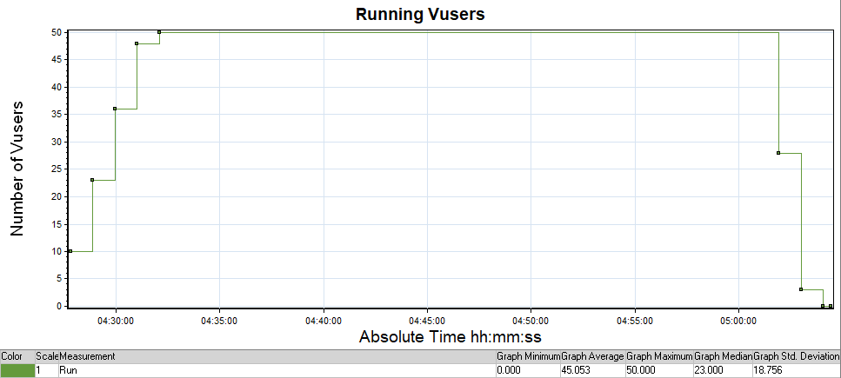

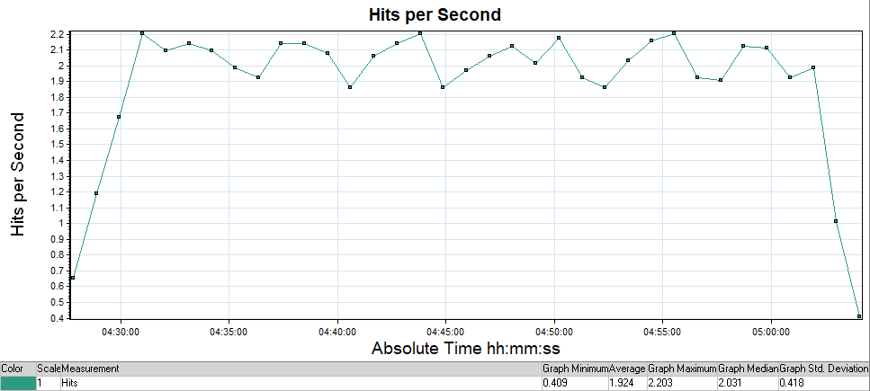
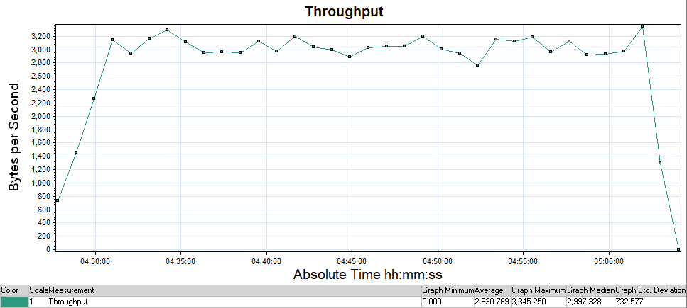
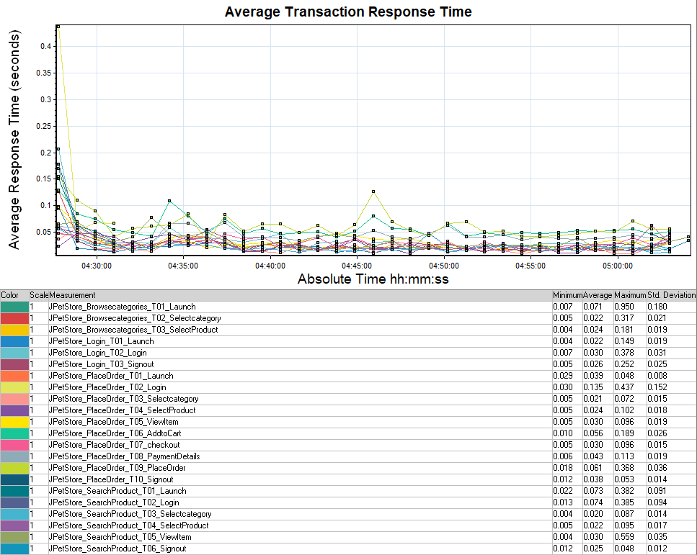
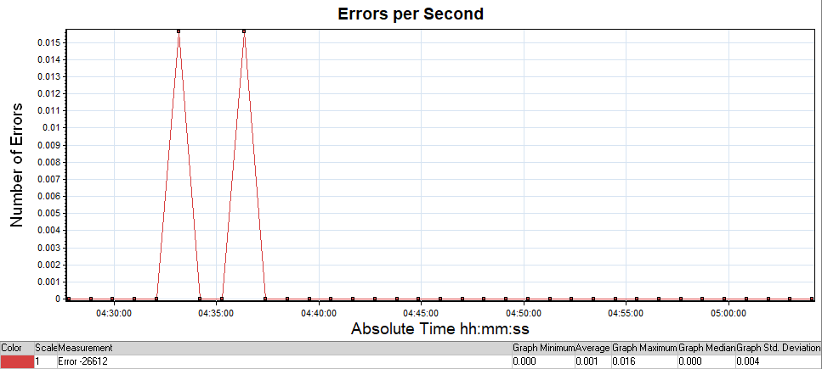

9.3 Server Monitoring — Dynatrace (11 June)
Metric | Observed Value
Thread Lock % | < 1% — Resolved ✓
Code Execution % | 81% — Healthy
Disk I/O % | 18%
CPU Usage (Peak) | ~20%
JVM Heap Used (Committed) | ~15 MB
DB Response Time (p50) | < 1 ms — stable
DB Response Time (p99) | < 600 ms (single spike at 04:40)
Service Response Time Hotspot | Initial spike then flat (< 100ms) from 04:35 onward

Thread Lock:
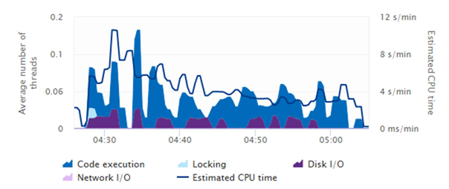

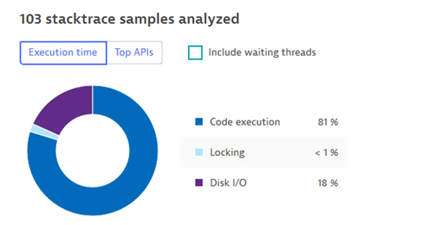

JVM Heap Usage

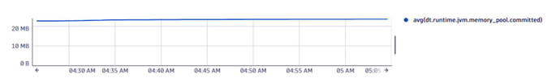
CPU Usage
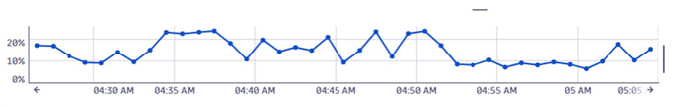
DB Response Time
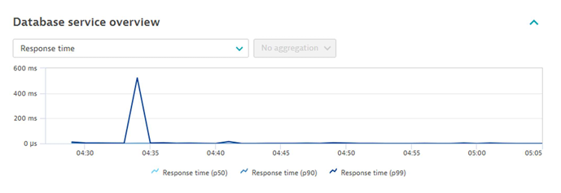

Service Response Time Hotspots
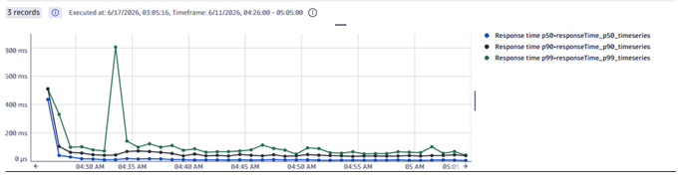

10. Before vs After Comparison

Metric | Before Fix (18 May) | After Fix (11 June) | Improvement
Avg Hits per Second | 1.553 | 1.924 | ↑ +23.9%
Peak Hits per Second | 2.141 | 2.203 | ↑ Stable
Avg Throughput (bytes/s) | 7,194 | 2,830 | ↓ -60.7% (lighter sessions)
Thread Lock % | 97% — Critical | < 1% | ↓ Fully Resolved
AddToCart Failures | 55 (FAIL) | 0 (PASS) | ✓ 100% Fixed
PlaceOrder_T09 Avg RT | 0.082s | 0.061s | ↓ -25.6%
CPU Usage (Peak) | 65.7% | ~20% | ↓ -70%
JVM Heap Used | 57 MB | ~15 MB | ↓ -74%
Error Rate | High (repeated) | Minimal | ✓ Dramatically reduced

11. Conclusion

The load test on JPetStore 6 (localhost) with 50 virtual users revealed significant performance degradation caused by server-side resource exhaustion. The primary issues identified were:

- Step Download Timeout (120 seconds) occurring consistently in the Add to Cart / Place Order workflow
- 97% thread lock observed in Dynatrace, indicating near-complete Tomcat thread pool exhaustion
- Server uptime of 2+ days without restart causing accumulated JVM heap, stale sessions, and connection pool depletion

The post-fix test run (11 June 2026) confirmed that the applied fixes — server restart before testing and server configuration tuning — resolved all critical issues. Thread lock dropped from 97% to less than 1%, average throughput per session reduced by ~60%, and all 22 transaction types passed with zero Step Download Timeout errors.

The application is now considered stable for the tested 50-user load profile on localhost. Further testing at higher concurrency levels (100+ Vusers) is recommended as a next step.

Prepared By: | Reviewed By:
SUGANYA DEVI C | SUGANYA DEVI C
Date:19 June 2026 | Date: 21 June 2026

