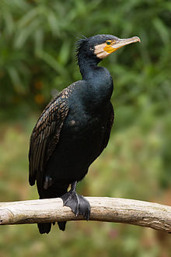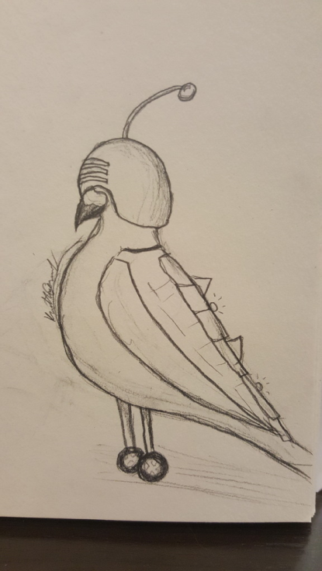Bosses:

[tiáo](https://www.purpleculture.net/mp3/tiao2.mp3) [jié](https://www.purpleculture.net/mp3/jie2.mp3) [qì](https://www.purpleculture.net/mp3/qi4.mp3)

调节器 – Controller (Chinese)

or

[yú](https://www.purpleculture.net/mp3/yu2.mp3) [yīng](https://www.purpleculture.net/mp3/ying1.mp3) (Great Cormorant)

魚鷹

Rooftop

Great Cormorant

Largest Weights ~12lbs

(Biologically Modified Bigger)

Powers:

Mind Control of Pigeons

Great Size

Wing Attacks

Beak Attack

Slam (Crashes Down)

Possible Fight Mechanic:

Stage 1: Includes various jet-propelled pigeons wearing mind control helmets. The pigeons dive-bomb MEEK at the command of the Great Cormorant. However, they don’t fly back up on their own. They dodge all attacks by MEEK, moving to another space if attacked or another part of the zone if approached. Tenth comes out to harrass the birds back up to their perches. If MEEK attacks Tenth, the control helmet gets knocked off the bird and it will attack the Great Cormorant as a result.

Stage 2: After all the pigeons have attacked the Great Cormorant, it will jump down from its nest and attack MEEK using beak, wings and possibly a stomping attack.

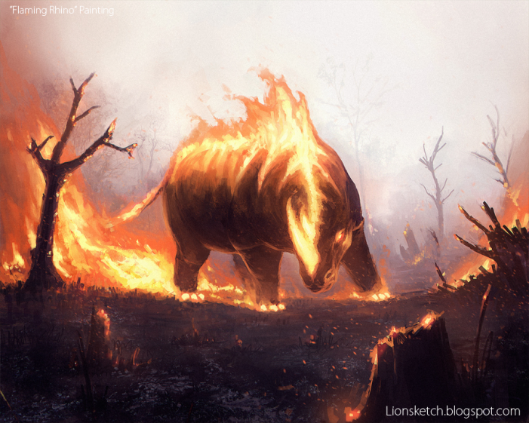

Badak – Rhinocerous (Malay)

Factory

Powers:

Flame Blast (a straight blast of flame that moves as Badak turns)

Charge (A quick charging attack that must be dodged)

Gouge (Uses the remaining horn to stab MEEK)

Possible Fight Mechanic:

1-Stage Fight:

Badak attacks using one of three abilities, based on range. If MEEK is near melee range, Badak will use gouge to stab. If farther away, Badak will use Flame Blast and Charge. The charge must be directed towards some coolant pipes. The coolant will freeze Badak, giving MEEK a chance to do damage. While doing damage, Tenth will jump on Badak and warm it up (maybe reigniting the flame-horn), so that the fight continues.

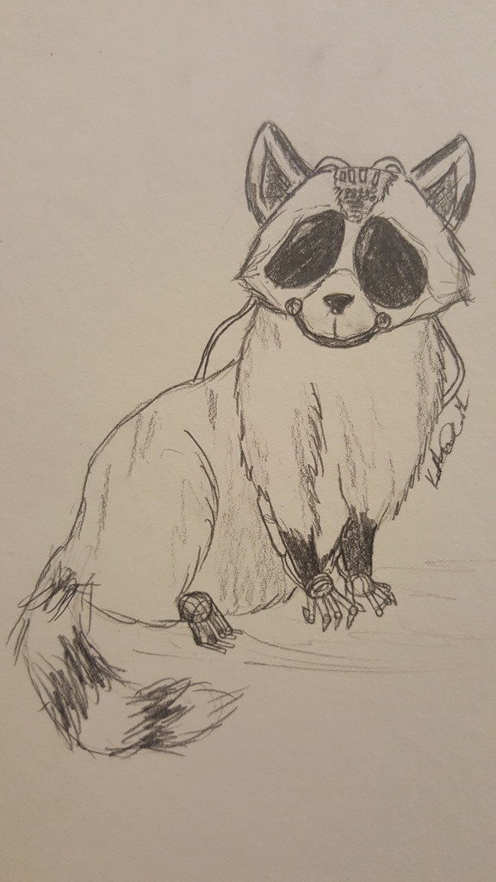Waschbären – Trash Pandas – Raccoons

Streets

Possible Fight Mechanic:

Version of Bullet Hell

Water tanks on the raccoons refilled with assistance of Tenth.

Probably from fire hydrants.

Note: Do we need to find a way to speed up MEEK for this fight?

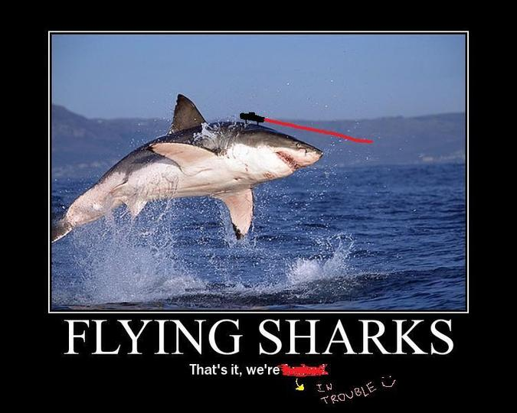

Xoc – Shark (Yucatan Mayan)

Sewers

Possible Fight Mechanic:

Fight takes place on a slow-moving river of trash. MEEK cannot move over water, but must keep from flowing off a waterfall at one side of the river. Sharks with lasers attached to their foreheads perform one of three attacks.

Attack 1: A red spot appears in the moving trash, a hole melts away and a shark pops out to try and bite MEEK. If MEEK is not standing on the spot the bite misses (chance to attack).

Attack 2: If MEEK does not do damage to the shark on the attack, it will use a laser beam to attempt to shoot MEEK. This attack can be either after attempting a bite or after sticking a head out of a water opening. Laser does not move and attacks possible.

Attack 3: Jump (think the shark catching the bird) in which a shark jumps from an opening it is in (or an opening it is entering) to another open water spot. Attackable in the air.

Note: Need a way for Tenth to hinder during this fight.

Secondary Note: Instead of fighting a mini-boss, perhaps you find Tenth trying to pull the shark body across the ground like a fish… credit for achievement given if Tenth is driven off.

Los Singes – Apes (French, spoken in DR Congo)

Animal Sanctuary (Zoo)

The apes are techies, having taken over the security system, there are various routes we can take. One possible:

Apes physically attack, I’m thinking a wind up, close range move that MEEK can dodge.

There will be some computer terminals in the room with visible (perhaps red with yellow warning triangles) indications that they are under the control of the apes. The goal is to turn off all the computers and reboot them all, gaining control of the system… that’s right, I said, “Turn them off and then turn them back on.” Based on the number of apes, it will take longer to fight, because during the time that MEEK is fighting other apes, they can come up to the computers and re-hack them.

Tenth will be along the rafters, knocking down power cables to attempt to strike MEEK. These could be either long (laying across the floor) or hanging down. MEEK must use attacks to knock the apes into the cables to keep them away (without touching the cables itself!).

Added difficulty could be rate of cable drops and drones under the control of the apes. In the case of drones, hacking terminals should take control of drones.

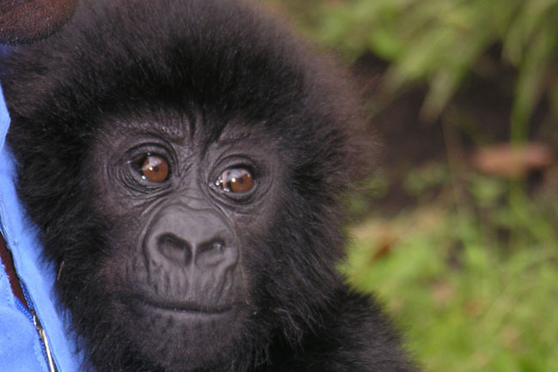

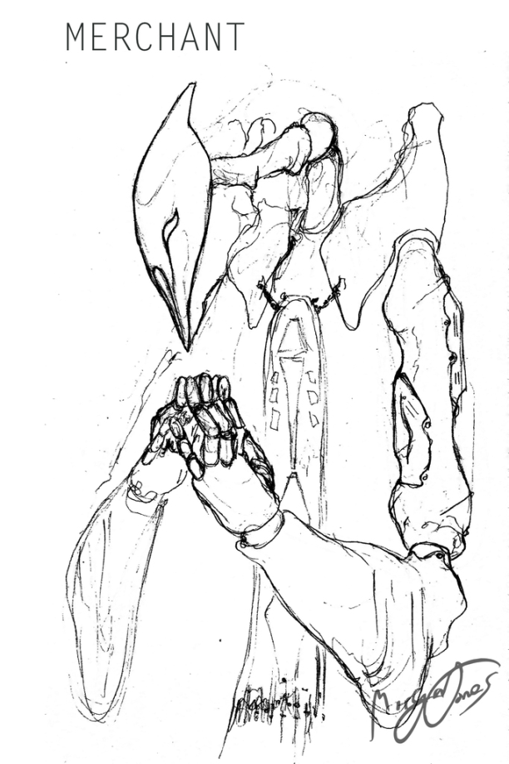

Shounin - Merchant (in Japanese) - 商人

In-Progress