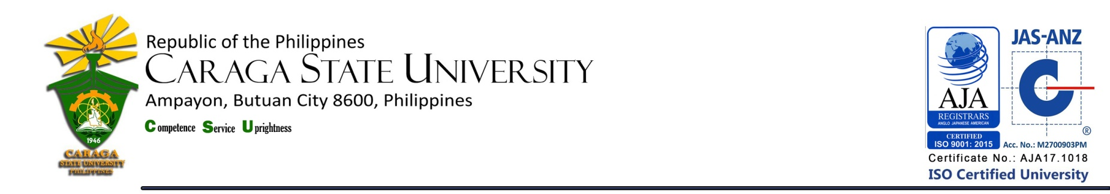
LIBRARY AND INFORMATION SERVICE UNIT
LIST OF NEW ACQUISITIONS
College of Education

as of December 2018

Title / Acc. No. | Author | No. of Copies | Year | Call #
School bullying : teachers helping students cope / 20185 | Slee, Phillip T. | 1 | 2017 | Cir.  371.58  Sl23  2017
Teach like a champion 2.0 / 20225 | Lemov, Doug | 1 | 2015 | Cir.  378.125  L5448  2015
Professional studies in primary education / 20224 | Cooper, Hilar (ed.) | 1 | 2014 | Cir.  372.241  P9427  2014
Learning theory and classroom practice in the lifelong learning sector / 20223 | Gould, Jim | 1 | 2012 | Cir.  370.1523  G73  2012
Essentials of physical education one and two | Manalo, Africa D. | 1 | 2012 | Fil.  613.7  M311  2012
Principles of teaching 1 : a modular approach | Magno, Lydia N. | 1 | 2009 | Fil.  371.102  Ag66  2009
Handbook on principles of teaching 1 | Casinto, Carlo C. | 1 | 2009 | Fil.  371.102  C269  2009

Total Number of Titles = 7
Total Number of Volumes = 7

Prepared by :

MERCY G. REYES, RL
College Librarian 1

Noted by :

MARIA CORAZON L.TERCERA, RL
University Librarian

