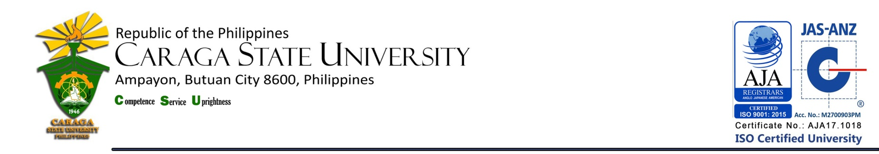

LIBRARY AND INFORMATION SERVICE UNIT

**LIST OF NEW ACQUISITIONS**

**College of Agriculture and Agri-Industries**

**as of December 2018**

|  |  |  |  |  |
| --- | --- | --- | --- | --- |
| **Title / Acc. No.** | **Author** | **No. of Copies** | **Year** | **Call #** |
| Plant taxonomy / 20272 |  | 1 | 2018 | Cir.  631.53  P6941  2018 |
| Introduction to plant reproduction / 20267 | Cohen, Seth (ed.) | 1 | 2018 | Cir.  575.6  In891  2018 |
| Lab manual to accompany the science of agriculture / 20305 | Herren, Ray V. | 1 | 2018 | Cir.  630.02  H4334  2018 |
| Food production and nature conservation / 20257 | Gordon, Ian (ed.) | 1 | 2017 | Cir.  338.19  F7391  2017 |
| Animal models and human reproduction / 20307 | Schatten, Heide (ed.) | 1 | 2017 | Cir.  571.84  An541  2017 |
| Celebrating soil : discovering soils and landscapes / 20076 | Balks, M.R. | 1 | 2016 | Cir.  631.4  B199  2016 |
| Agricultural law / 20069 | Rodgers, Christopher P. | 1 | 2016 | Cir.  343.076  R616  2016 |
| Taxonomy |  | 1 | 2016 | Cir.  574.14  T199  2016 |
| Food and industrial microbiology |  | 1 | 2016 | Cir.  576  F683  2016 |
| Eco-technological practices for sustainable development | Yanczyk, Matthias (ed.) | 1 | 2015 | Cir.  630.024  Ec71  2015 |
| Career guide : agriculture |  | 1 | 2015 | Cir.  630  C180  2015 |
| Genetic engineering in agriculture | Branchk, Mark (ed.) | 1 | 2015 | Cir.  631.5233  G286  2015 |
| Insecticides of natural origin | Rabinovich, Ivan, (ed.) | 1 | 2015 | Cir.  632.951  In71  2015 |
| **Title / Acc. No.** | **Author** | **No. of Copies** | **Year** | **Call #** |
| Microirrigation for crop production | Cena, David, (ed.) | 1 | 2015 | Cir.  633  M583  2015 |
| Water stress and management in plants | Klemm, Shannon, (ed.) | 1 | 2015 | Cir.  633.372  W291  2015 |
| Biotechnology for agriculture breeding | Malyshev, Styopa, (ed.) | 1 | 2015 | Cir.  634.043  B524  2015 |
| Biotechnology in animal husbandry | Edberg, Liam, (ed.) | 1 | 2015 | Cir.  636  B524  2015 |
| Agricultural environment and food safety | Leach, Karson, (ed.) | 1 | 2015 | Cir.  664.00289  Ag83  2015 |
| Modern food processing biotechnology | Zhou, Peng (ed.) | 1 | 2015 | Cir.  664.8  M720  2015 |
| Handbook of composite organic farming | Luxemburg, Charles (ed.) | 1 | 2015 | Gen. Ref.  631.58402  H191  2015 |
| Relationships among key plant families : assessments, actions and interactions | Stewart, Conrad, (ed.) | 1 | 2014 | Cir.  581.1  R279  2014 |
| Agricultural biotechnology | Healey, Allan, (ed.) | 1 | 2014 | Cir.  631.5233  Ag83  2014 |
| Handbook of functional anatomy and physiology of domestic animals | Kang, Sun Woo, (ed.) | 1 | 2014 | Gen. Ref.  636.089  H191  2014 |
| Handbook of biofertilizers biotechnology for improving crop productivity in sustainable agriculture | Karnik, Sangeeta, (ed.) | 1 | 2014 | Gen. Ref.  631.847  H192  2014 |
| Handbook of scientific strategies in integrated pest management | Gallegy, M.A. | 1 | 2014 | Gen. Ref.  632.902  G135  2014 |
| Genetic techniques and procedures of relevance to plant breeding | Collins, Regis, (ed.) | 1 | 2014 | Cir.  631.53  G286  2014 |
| Plant virology / 20296 | Hull, Roger | 1 | 2014 | Cir.  579.28  H8772  2014 |
| Efficient and environmentally sound crop production practices | Collins, Regis, (ed.) | 1 | 2014 | Cir.  633  Ef41  2014 |
| Genetic engineering and in vitro culture of crops | Baun, Maria, (ed.) | 1 | 2014 | Cir.  633.4  G286  2014 |
| **Title / Acc. No.** | **Author** | **No. of Copies** | **Year** | **Call #** |
| Advances in animal breeding biotechnology | Amla, Kareem, (ed.) | 1 | 2014 | Cir.  636.082  Ad95  2014 |

**Total Number of Titles = 30**

**Total Number of Volumes = 30**

Prepared by :

MERCY G. REYES, RL

College Librarian 1

Noted by :

MARIA CORAZON L.TERCERA, RL

University Librarian