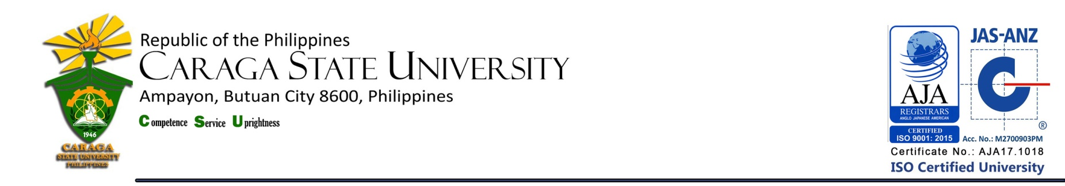

LIBRARY AND INFORMATION SERVICE UNIT

**LIST OF NEW ACQUISITIONS**

**College of Computing and Information Sciences**

**as of December 2018**

|  |  |  |  |  |
| --- | --- | --- | --- | --- |
| **Title / Acc. No.** | **Author** | **No. of Copies** | **Year** | **Call #** |
| Beginning programming with Java for dummies / 20251 | Burd, Barry | 1 | 2017 | Cir.  005.133  B894  2017 |
| Web design with HTML 5 & CSS 3 / 20221 | Minnick | 1 | 2017 | Cir.  004.67  M666  2017 |
| Learn to implement games with code / 20208 | Quick, John M. | 1 | 2017 | Cir.  794.81536  Q401  2017 |
| Making deep games / 20209 | Rusch, Doris C. | 1 | 2017 | Cir.  790.1  R893  2017 |
| Making it in IT / 20210 | Critchley, Terry | 1 | 2017 | Cir.  004.023  C869  2017 |
| MIS 7 : management information systems / 20211 | Bidgoli | 1 | 2017 | Res.  003  B474  2017 |
| Microsoft office 365 : excel 2016 / 20213 | Freund, Steven M. | 1 | 2017 | Cir.  005.133  F896  2017 |
| A guide to selecting software measures and metrics / 20193 | Jones, Capers | 1 | 2017 | Cir.  005.1  J7101  2017 |
| Cognitive hack : the new battleground in cybersecurity / 20197 | Bone, James | 1 | 2017 | Cir.  003.5  B6411  2017 |
| Introduction to scientific and technical computing / 20254 | Willmore, Frank T. (ed.) | 1 | 2017 | Cir.  502.85  In891  2017 |
| Digital signal processing using MATLAB / 20255 | Ingle, Vinay K. | 1 | 2017 | Cir.  621.3822  In44  2017 |
| Distributed source coding / 20200 | Wang, Shuang | 1 | 2017 | Cir.  004.36  W1841  2017 |
| Indoor wireless communications / 20253 | Aragon-Zavala, Alejandro | 1 | 2017 | Cir.  384.5  Ar12  2017 |
| **Title / Acc. No.** | **Author** | **No. of Copies** | **Year** | **Call #** |
| Implementing cybersecurity / 20205, 20252 | Kohnke, Anne | 2 | 2017 | Cir.  003.5  K827  2017 |
| Interconnections for computer communications and packet networks / 20206 | Rojas-Cessa, Roberto | 1 | 2017 | Cir.  004.6  R6381  2017 |
| Network routing / 20214 | Misra, Sudip | 1 | 2017 | Cir.  004.6  M691  2017 |
| Object-oriented programming with SIMOTON / 20215 | Braun, Michael | 1 | 2017 | Cir.  005.133  B7381  2017 |
| Computer organization and design / 20226 | Patterson, David A. | 1 | 2017 | Res.  004.22  P2773  2017 |
| Operating systems / 20231 |  | 1 | 2017 | Res.  005.43  Op26  2017 |
| Mobile security and privacy / 20303 | Au, Man Ho (ed.) | 1 | 2017 | Cir.  003.5  M7133  2017 |
| CompTIA A+ guide to software : managing, maintaining, and troubleshooting / 20070 | Andrews, Jean | 1 | 2017 | Cir.  005.74  An26  2017 |
| Information security science / 20227 | Young, Carl S. | 1 | 2016 | Cir.  025.04  Y841  2016 |
| Building information modeling for dummies / 20164 | Mordue, Stefan | 1 | 2016 | Cir.  005.43  M812  2016 |
| Integrated IT performance management / 20228 | Bainey, Kenneth | 1 | 2016 | Cir.  004.0683  B1614  2016 |
| Implementing virtual design and construction using BIM / 20169 | Andersson, Lennart | 1 | 2016 | Cir.  005.43  Im75  2016 |
| Data structures and algorithms / 20078 | Delfinado, Cecil Jose A. | 1 | 2016 | Fil.  005.73  D378  2016 |
| Learning object-oriented programming in C# 5.0 / 20229 | Harwani, B.M. | 1 | 2015 | Cir.  005.133  H264  2015 |
| Image processing, analysis, and machine vision / 20102 | Sonka, Milan | 1 | 2015 | Cir.  006.42  So58  2015 |
| Joomla! 3 boot camp : 30-minute lessons to joomla! 3 mastery / 20105 | Turner, Robin D. | 1 | 2015 | Cir.  004.62  T851  2015 |
| **Title / Acc. No.** | **Author** | **No. of Copies** | **Year** | **Call #** |
| Values at play in digital games / 20306 | Flanagan, Mary | 1 | 2014 | Cir.  794.8  F6131  2014 |
| Ethics for I.T. professionals with legal aspects in computing | Laviña, Charlemagne G. | 1 | 2012 | Fil.  174.9  Et37  2012 |

**Total Number of Titles = 31**

**Total Number of Volumes = 32**

Prepared by :

MERCY G. REYES, RL

College Librarian 1

Noted by :

MARIA CORAZON L.TERCERA, RL

University Librarian