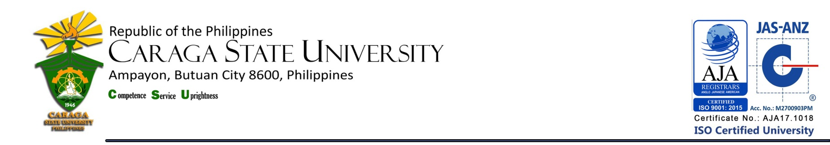

LIBRARY AND INFORMATION SERVICE UNIT

**LIST OF NEW ACQUISITIONS**

**College of Education**

**as of December 2018**

|  |  |  |  |  |
| --- | --- | --- | --- | --- |
| **Title / Acc. No.** | **Author** | **No. of Copies** | **Year** | **Call #** |
| School bullying : teachers helping students cope / 20185 | Slee, Phillip T. | 1 | 2017 | Cir.  371.58  Sl23  2017 |
| Teach like a champion 2.0 / 20225 | Lemov, Doug | 1 | 2015 | Cir.  378.125  L5448  2015 |
| Professional studies in primary education / 20224 | Cooper, Hilar (ed.) | 1 | 2014 | Cir.  372.241  P9427  2014 |
| Learning theory and classroom practice in the lifelong learning sector / 20223 | Gould, Jim | 1 | 2012 | Cir.  370.1523  G73  2012 |
| Essentials of physical education one and two | Manalo, Africa D. | 1 | 2012 | Fil.  613.7  M311  2012 |
| Principles of teaching 1 : a modular approach | Magno, Lydia N. | 1 | 2009 | Fil.  371.102  Ag66  2009 |
| Handbook on principles of teaching 1 | Casinto, Carlo C. | 1 | 2009 | Fil.  371.102  C269  2009 |

**Total Number of Titles = 7**

**Total Number of Volumes = 7**

Prepared by :

MERCY G. REYES, RL

College Librarian 1

Noted by :

MARIA CORAZON L.TERCERA, RL

University Librarian