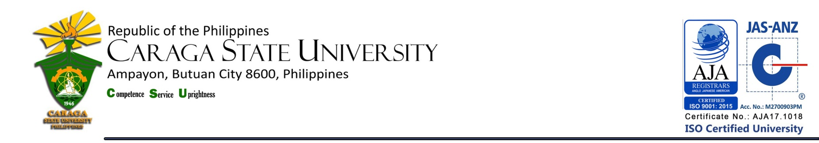

LIBRARY AND INFORMATION SERVICE UNIT

**LIST OF NEW ACQUISITIONS**

**College of Forestry and Environmental Sciences**

**as of December 2018**

|  |  |  |  |  |
| --- | --- | --- | --- | --- |
| **Title / Acc. No.** | **Author** | **No. of Copies** | **Year** | **Call #** |
| Aquatic biodiversity and water pollution / 20259 | Snyder, Ethan (ed.) | 1 | 2018 | Cir.  577.6  Aq35  2018 |
| Air pollution control and analysis / 20195 | Cui, Quan (ed.) | 1 | 2017 | Cir.  363.7392  Ai714  2017 |
| Air quality monitoring and control strategies / 20196 | Gallo, Jurex C. (ed.) | 1 | 2017 | Cir.  333.92  Ai715  2017 |
| A climate for change |  | 2 | 2015 | Fil.  551.68  C614  2015 |
| Environmental protection laws | Murthy, S.K. | 1 | 2010 | Cir.  346  M969  2010 |

**Total Number of Titles = 5**

**Total Number of Volumes = 6**

Prepared by :

MERCY G. REYES, RL

College Librarian 1

Noted by :

MARIA CORAZON L.TERCERA, RL

University Librarian