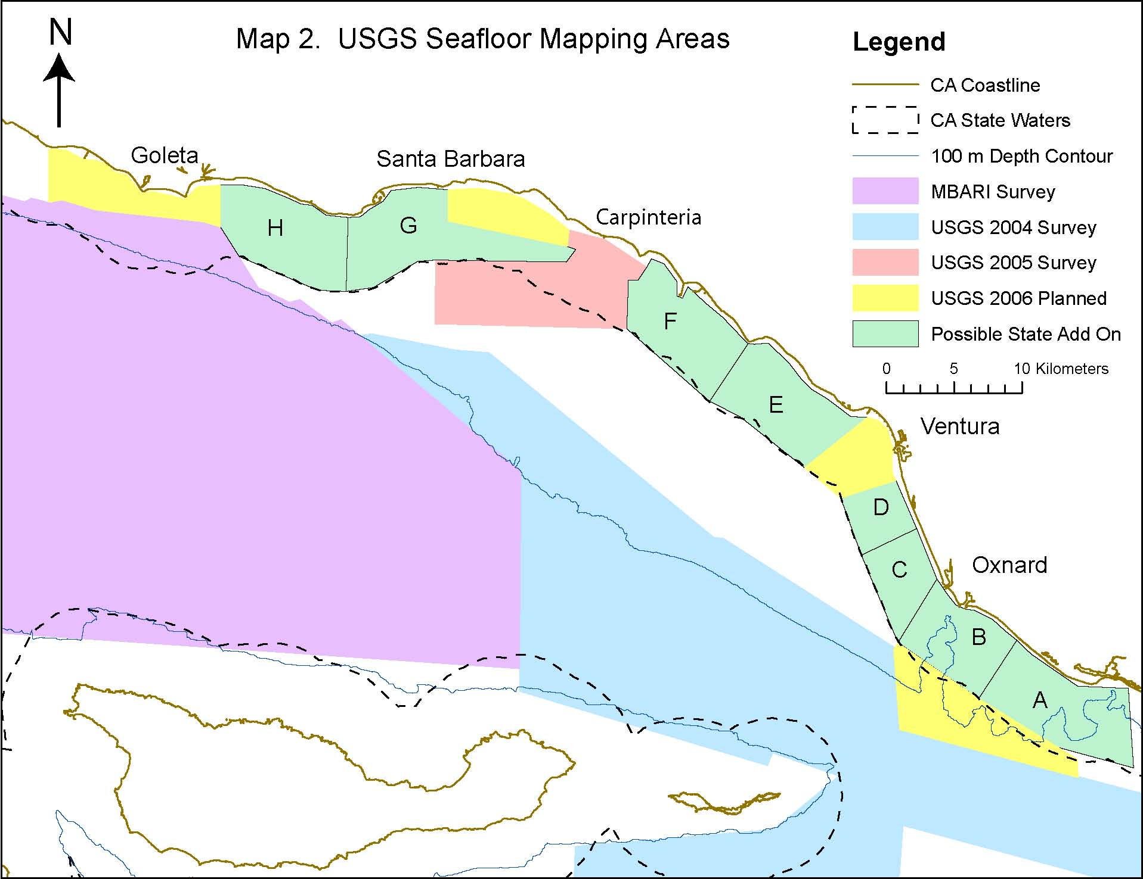
Planned Seafloor Mapping Areas
CC 2006-07 planned

