DOMOIC ACID IN THE BENTHIC FOOD WEB
OF
MONTEREY BAY, CALIFORNIA

A Thesis Presented to
The Faculty of California State University Monterey Bay
through
Moss Landing Marine Laboratories

In Partial Fulfillment
of the Requirements for the Degree
Master of Science in Marine Science

by
Judah D. Goldberg
December 2003

© 2003
Judah D. Goldberg
ALL RIGHTS RESERVED

APPROVED FOR THE INSTITUTE OF EARTH SYSTEMS SCIENCE AND POLICY AND FOR MOSS LANDING MARINE LABORATORIES

_______________________________________________________
Dr. Nicholas A. Welschmeyer, Moss Landing Marine Laboratories

_______________________________________________________
Dr. Rikk G. Kvitek, California State University, Monterey Bay

_______________________________________________________
Dr. Mary W. Silver, University of California, Santa Cruz

_______________________________________________________
Dr. G. Jason Smith, Moss Landing Marine Laboratories

APPROVED FOR THE UNIVERSITY

_______________________________________________________
ABSTRACT

DOMOIC ACID IN THE BENTHIC FOOD WEB OF MONTEREY BAY, CALIFORNIA

by Judah D. Goldberg

Phytoplankton that have flocculated and settled to the sea floor are an important potential food source for benthic communities. If the flocculate is composed of harmful algal bloom (HAB) species like Pseudo-nitzschia australis, a producer of domoic acid (DA), the flocculate could represent an important source of phycotoxins to benthic food webs. Here we test the hypothesis that DA contaminates benthic organisms during local blooms of P. australis (≥10⁴ cells L⁻¹). To test for trophic transfer and uptake of DA into the benthic food web we sampled eight benthic species comprising four feeding types: filter feeders (Emerita analoga and Urechis caupo); a predator (Citharicthys sordidus); scavengers (Nassarius fossatus and Pagurus samuelis); and deposit feeders (Callianassa californiensis, Dendraster excentricus, and Olivella biplicata). Sampling occurred before, during, and after blooms of P. australis, in Monterey Bay, CA during 2000 and 2001. Domoic acid was detected in all eight benthic species, with DA contamination persisting over variable time scales. Maximum DA levels in N. fossatus (673 ppm), E. analoga (278 ppm), C. sordidus (514 ppm), C. californiensis (144 ppm), P. samuelis (55 ppm), D. excentricus (13 ppm), and O. biplicata (2 ppm) coincided with P. australis blooms. For five of the species, these concentrations exceeded levels thought to be safe for consumers (i.e. safe for humans: ≥ 20 ppm). These high concentrations of DA are thus likely to have deleterious effects on higher-level consumers (marine birds, sea lions, and the endangered California Sea Otter) known to prey upon these benthic species.
ACKNOWLEDGEMENTS

This thesis was completed with the help and dedication of many, especially my committee members and their respective lab technicians and students.
I would like to thank Dr. Rikk Kvitek for instilling in me the determination and tenacity to undertake such a comprehensive project. I also wish to thank Dr. Jason Smith for kindly offering the use of his HPLC instrument and expertise, without which this thesis would have been significantly delayed. I would like to express many thanks to Dr. Nick Welschmeyer and the Biological Oceanography Lab for instruction, lab space, support, and friendship. And to Dr. Mary Silver, who, through the years, has always guided and inspired me: Thank you for introducing me to the world of phycotoxins!
I am very grateful for the funding from the Dr. Earl H. and Ethel M. Myers Oceanographic and Marine Biology Trust, and the David and Lucille Packard Foundation.
Finally, to my friends and family, especially my wife Kirsten, thank you for your love and support.
TABLE OF CONTENTS

List of Tables ………………………………………………………………. vii
List of Figures ……………………………………………………………… viii
Introduction ………………………………………………………….…….. 1
Methods …………………………………………………………………… 5
Sample Collection …………………………………………………. 5
Pseudo-nitzschia Species Identification …………………………… 6
Animal Sample Preparation ……………………………………….. 7
HPLC Analysis ……………………………………………………. 7
Extraction Efficiency ………………………………………………. 9
DA Verification in U. caupo ………………………………………. 9
Results ……………………………………………………………….…….. 11
DA Detection ……………………………………………………… 11
Emerita analoga Sentinel Species ………………………………… 12
Discussion …………………………………………………………………. 13
Literature Cited ……………………………………………………………. 18
Table ………………………………………………………………………. 25
Figures …………………………………………………………………….. 26

LIST OF TABLES

- Average and maximum domoic acid concentrations in benthic
species ……………………………………………………………… 26

LIST OF FIGURES

- P. australis cell densities and particulate DA versus time ………… 27

- Absorption spectra of DA standard and DA extracted from Urechis
caupo ………………………………………………………………. 28

- DA body burdens in filter-feeding benthic species versus time …… 29

- DA body burdens in the predatory sanddab Citharicthys
sordidus and the scavenging snail Nassarius fossatus versus time … 30

- DA body burdens in the deposit-feeding Callianassa californiensis
and the scavenging hermit crab Pagurus samuelis versus time ……. 31

- DA body burdens in the deposit-feeding Dendraster excentricus
and Olivella biplicata ……………………………………………… 32

- DA body burden in Emerita analoga and particulate DA
concentrations versus time ………………………………………… 33
INTRODUCTION

Phytoplankton are the base of marine food webs supporting filter-feeders, micro-grazers, and ultimately most marine animals via trophic transfer of the organic nutrients they produce via photosynthesis. When blooms of some net-plankton sized phytoplankton occur, cells may adhere to one another and form aggregate masses, termed flocculate or marine snow, particles that subsequently sink out of surface waters (Smetacek 1985, Alldredge and Silver 1988). Flocculation provides an additional food source to sub-euphotic-waters and benthic communities because of the accelerated delivery rate of the larger sized aggregates to depth. Flocculate may also be directly ingested by organisms farther up the food chain because of its increased size, as compared with individual phytoplankton cells. The potential for enhanced delivery of DA-contaminated food to the benthos through flocculation of overlying blooms, however, has received little attention to date.
When harmful algal bloom (HAB) species are present, flocculation provides a mechanism for rapid and increased toxin flux to the benthos. Filter and deposit feeders could then act as vectors passing toxins on to predators. Contaminated organisms can become neurologically and, hence, behaviorally impaired and, therefore, easier prey (Lefebvre et al. 2001), or they may die directly from intoxication. Predators and scavengers feeding upon these organisms at depth could then be exposed to the toxins produced in overlying waters through trophic transfers within the benthic food web (Lund et al. 1997).
In Monterey Bay, California, blooms of several species of the diatom Pseudo-nitzschia have been shown to produce the neuroexcitatory toxin domoic acid (DA) (Bates et al. 1989, Fritz et al. 1992, Garrison et al. 1992) responsible for amnesic shellfish poisoning (ASP) in humans (Wright et al. 1989). In recent years, domoic acid events have been well documented here and the toxins have been shown to be incorporated into pelagic food webs of Monterey Bay. Northern anchovy (Engraulis mordax) were shown to be the vector of DA intoxication of sea lions (Lefebvre et al. 1999, Scholin et al. 2000) and marine birds (Fritz et al. 1992); and krill (euphausiids) have been proposed as vectors of the toxin to squid and baleen whales (Bargu et al. 2002, Lefebvre 2002). Anchovy and krill are now realized to be key pelagic vector species of DA because of their abundance and position in the food chain: both species are conspicuous planktivores that offer immediate trophic links from primary producers to higher trophic-level consumers such as birds and pinnipeds.
Trophic transfer of DA through the benthic food web, however, has not been thoroughly investigated. Domoic acid has been detected in a variety of commercially important bivalve and crustacean shellfish species (Martin et al. 1993, Altwein et al. 1995, Douglas 1997) since the 1987 ASP event in Canada, when three people died after consuming contaminated blue mussels (Mytilus edulis, e.g. Quilliam and Wright 1989), but little is known regarding the uptake and retention of DA in other benthic organisms. In shallow neritic environments, where the euphotic zone can extend to the bottom, blooms of Pseudo-nitzschia may encompass the entire water column and be in contact with the sea floor. Also, offshore blooms may be pushed onshore by wind and wave action, where they could encounter the seafloor at sufficiently shallow depths. As a result, benthic organisms as well as fish and other mid-water species may be directly exposed to high concentrations of particulate DA. As the Pseudo-nitzschia bloom persists, more cells begin to aggregate and settle to the benthos, delivering toxic food bundles to bottom dwellers. The benthic environment may then become a source for DA contamination well after the Pseudo-nitzschia bloom subsides (Welborn, pers. commun.). Cells deposited onto the bottom may be ingested by benthic deposit feeders, or resuspended into the water column via bioturbation and bottom flow.
The purpose of this study was to test the hypothesis that that DA derived from overlying waters is transferred into benthic food webs in nearshore environments. Our general approach was to monitor representative benthic species with four different feeding modes for the uptake and retention of DA over a two-year period in Monterey Bay, an area known for seasonal blooms of toxic Pseudo-nitzschia. During 2000 and 2001 we collected eight benthic species including the filter-feeding echiuran worm Urechis caupo, the common filter-feeding sand crab Emerita analoga, the scavenging snail Nassarius fossatus, the predatory flat fish Citharicthys sordidus, the deposit-feeding ghost shrimp Callianassa californiensis, the scavenging hermit crab Pagurus samuelis, the deposit- and filter-feeding sand dollar Dendraster excentricus, and the deposit-feeding olive snail Olivella biplicata (Ricketts et al. 1985).
These organisms represent not only links in the benthic food chain, but connections to other food web systems as well. Urechis caupo are common prey species for leopard sharks (Triakis semifasciata); shore birds and surf fish are known to feed upon E. analoga; and the endangered California Sea otter (Enhydra lutris) is a voracious predator of nearly all the organisms sampled in our study (Wenner et al. 1987, Kvitek and Oliver 1988, Blokpoel et al. 1989, Riedman and Estes 1990, Webber and Cech 1998). In this study we reveal rapid and substantial incorporation of DA into the benthic food web and discuss consequences to higher-level consumers connected to this system.
METHODS

Sample Collection
Our collection site was located at Del Monte Beach in the southern bight of Monterey Bay, California (36°36’41.27”N, 121°51’32.77”W) along a depth gradient extending from the intertidal zone out to 15 m. Sampling began in August 2000 when a bloom of P. australis was observed off Del Monte Beach and ended in November 2001. We sampled every two weeks during non-bloom conditions (P. australis <10⁴cells/L), but shifted to three times a week during bloom conditions, if weather permitted.
Subtidal samples were collected by SCUBA divers using a variety of methods depending on the target organisms. The benthic surface dwellers D. excentricus, N. fossatus, O. biplicata, and P. samuelis were collected by hand and placed in grab bags. The burrowing organisms U. caupo and C. californiensis were sampled by inverting an underwater scooter (Dacor SeaSprint) and excavating the sandy bottom with bursts from the exhaust fan. The flat fish, C. sordidus, was collected by spiking the fish through the operculum with a screw fastened at a right angle to the end of a 0.3 m PVC pipe. Care was taken not to puncture the viscera of the fish, which are the tissues analyzed for DA. Emerita analoga are surf zone benthic dwellers so they were sampled from shore using a 0.5 m diameter 5mm mesh bait net.
Water was collected in Nalgene bottles on each subtidal sampling date to quantify the abundance of Pseudo-nitzschia and particulate DA. Two liters each were collected at the surface, in mid-water, and at depth (within the meter above the sediment). Swash zone water was collected in two 1-L bottles during the intertidal sampling of E. analoga.
All samples were immediately placed in coolers packed with ice. Animal samples were transported to California State University Monterey Bay where they were held in a –70°C freezer until analysis. Water samples were transported to the University of California at Santa Cruz and aliquots of 3 to 20 mL (depending on cell concentrations) were analyzed for potentially toxic Pseudo-nitzschia species. All sampling was completed by 12 November 2001.

Pseudo-nitzschia Species Identification
Pseudo-nitzschia species identification and enumeration was accomplished using species-specific large subunit rRNA-targeted probes based on the methods developed by Miller and Scholin (1996, 1998). Water samples were filtered onto 13 mm, 1.2 μm Isopore polycarbonate filters (catalog number RTTP01300, Millipore, Billerica, MA, USA), and incubated at room temperature in saline ethanol solution for 1-2 h. Samples were then filtered, rinsed once with hybridization buffer, resuspended in the buffer, and incubated with fluorescently labeled Pseudo-nitzschia species-specific probe for 1-2 h. Filters were then rinsed with buffer, placed on microscope slides in the presence of SlowFade Light reagent (catalog number S-7461, Molecular Probes, Eugene, OR, USA) and viewed with a Zeiss Standard 18 compound microscope equipped with a fluorescence Illuminator 100 (Zeiss, Thornwood, NY, USA). Entire filter surface areas were counted for Pseudo-nitzschia species.

Animal Sample Preparation
Animal samples were prepared for analysis by placing 3-10 individuals (depending on specimen size) in a blender cup, and homogenizing with an equal weight of Milli-Q water. Eight grams of homogenate were then extracted via methanol based on methods described by Quilliam et al. (1995) and Hatfield et al. (1994), except for extractions of E. analoga, which followed methods modified by Powell et al. (2002). Crude methanolic extracts were filtered through 0.45 μm nylon syringe filters (catalog number 6870-2504, Whatman Inc., Clifton, NJ, USA) then subjected to solid phase extraction (SPE) using Bakerbond strong anion exchange (SAX) SPE columns (catalog number 7091-03, J.T. Baker, Phillipsburg, NJ, USA), except for E. analoga (which does not require SPE clean-up: Powell et al. 2002), to remove any competing compounds that would elute off the HPLC column at the same time as DA. Domoic acid was quantitatively recovered from the SAX matrix by elution with 0.5M NaCl in 10% acetonitrile (MeCN). Finally, samples were transferred to GHP Nanosep MF centrifugal tubes (0.45 μm, catalog number ODGHPC35, Pall Corporation, Ann Arbor, MI, USA) and spun at 7000 rpm for 10 min to remove any remaining particulates.

HPLC Analysis
Clean extracts were analyzed by high-performance liquid chromatography (HPLC) using an isocratic elution profile with a Waters spectrophotometric detector set at 242nm. All samples, except those of E. analoga, were analyzed on a Shimadzu LC 10 AD equipped with a reverse phase Inertsil 5μ ODS-3 column (catalog number 0396-030X020, 2.0 mm x 30 mm, MetaChem Technologies, Inc., Lake Forest, CA, USA), MetaChem Safeguard guard ODS-3 cartridge (catalog number 0396-CS2), MetaChem MetaSaver precolumn filter (0.5 μm), and MetaChem MetaTherm column heater set at 42°C. Extracts from E. analoga were analyzed using a Hewlett-Packard HP1090M HPLC equipped with a reverse phase Vydac C₁₈ column (catalog number 201TP52, 2.1 mm x 25 mm, Separations Group, Hesperia, CA, USA) and Vydac guard column (particle size 5 μm). The mobile phase for both systems consisted of 90:10:0.1 water:MeCN:trifluoroacetic acid (TFA).
Particulate domoic acid concentrations in water column samples were determined by the HPLC-FMOC method described by Pocklington et al. (1990) and run on the HP1090M HPLC mentioned above. The mobile phase consisted of 60:40:0.1 water:MeCN:TFA.
DACS-1D certified domoic acid standard (Canadian National Research Council, Institute for Marine Biosciences, Halifax, NS, Canada) and 90% pure domoic acid standard (Sigma Chemical Company, St. Louis, MO, USA) were used for HPLC calibration, DA verification, and spike and recovery analysis. Trifluoroacetic acid, analysis grade sodium chloride, methanol, and acetonitrile from Fisher Scientific (Pittsburgh, PA, USA) were used during sample extraction and HPLC analysis.

Extraction Efficiency
Extraction efficiencies for SPE columns and species in major taxa not previously tested for DA (the echiuran worm U. caupo and the echinoderm D. excentricus) were determined using spike and recovery experiments. Briefly, SPE columns were spiked with known amounts of DA standard, eluted via the same protocol as described above, and recoveries quantified via HPLC. Extraction efficiencies for new tissue matrices were determined by injecting known amounts of DA standard into the tissues, extracting by the methods stated above, and quantifying the recoveries via HPLC. Results obtained from the HPLC were compared to the original spiked concentration and the recovery calculated as a percentage.

DA Verification in U. caupo
Verification of the DA compound was desired for U. caupo samples due to the high concentrations of DA detected via HPLC in this species throughout the entire study period, including samples taken from a separate location one year later. We verified the DA compound by collecting fractions representing the domoic acid peaks on the HPLC and analyzed them on a Shimadzu UV-3101 spectrophotometer. Several samples of U. caupo were also sent to the Marine Biotoxin Laboratory at the Northwest Fisheries Science Center in Seattle, WA for coanalysis via HPLC and spectrophotometer. Additional samples also were tested at the Center for Coastal Environmental Health and Biomolecular Research in Charleston, SC using the receptor binding assay. Ultimate confirmation of the DA compound will be determined by liquid chromatography coupled with tandem mass spectroscopy (LC-MS/MS).
RESULTS

DA Detection
Two major P. australis dominated bloom events (cells L⁻¹ ≥ 10⁴) were encountered during the study period (see Figure 1), with domoic acid detected in each of the eight benthic species collected. Extracts from the echiuran worm U. caupo exhibited high abundance and constitutive presence of a maximum peak absorbance at 242 nm, equivalent to DACS certified DA standard. Spectroscopic analysis of the HPLC peak also reveals high similarity to DACS certified DA standard (Figure 2). As DA has heretofore not been reported in the phylum Echiura, full analysis of U. caupo will be reported separately following LC-MS/MS confirmation of the tentative spectroscopic peak identification (Figure 2).
Body burdens of DA varied with species and in relation to P. australis bloom events. Maximum DA concentrations ranged from 751 ppm in U. caupo to 2 ppm in O. biplicata (Table 1) and occurred during the blooms, except in the case of U. caupo and N. fossatus. Urechis caupo had maximum DA values during November 2000 (751 ppm) and April 2001 (550 ppm; see Figure 3) when no P. australis were present in overlying water samples collected at the time. Nassarius fossatus had maximum DA values during May 2001 (407 ppm; see Figure 4), also when no P. australis or particulate DA were detected in water samples. The remaining six species all had maximum DA levels occurring during the two distinct bloom periods.
By grouping species together into trophic groups, our samples fall into four categories: filter feeding species, predator species, scavenger species, and deposit feeding species. Two of the three filter-feeding species, the echiuran worm U. caupo and the sand crab E. analoga, had the highest average DA concentrations of 481 ppm and 120 ppm, respectively (Figure 3). The predatory flat fish C. sordidus, the deposit-feeding shrimp C. californiensis, and the scavenging snail and hermit crab species (N. fossatus and P. samuelis, respectively) had the next highest average concentrations of DA of 83 ppm, 82 ppm, 90 ppm, and 23 ppm, respectively (Figures 4 and 5). The lowest average DA concentrations were detected in the filter- and deposit-feeding species D. excentricus and the deposit-feeding species O. biplicata, with 6 ppm and >1 ppm, respectively (Figure 6).

Emerita analoga Sentinel Species
In addition to the detection of DA at different trophic groups, we evaluated the long-term utility of using E. analoga as an indicator species for nearshore DA, as suggested by Ferdin et al. (2002) and Powell et al. (2002). Emerita analoga had the highest average bloom-time concentration of DA (within the seven species collected that have been analyzed and DA toxin compounds confirmed) and shared the lowest average non-bloom concentration. Domoic acid occurred in E. analoga only when P. australis were present, and dissipated within days after no P. australis cells were detected in the water samples (Figure 7).

DISCUSSION

Several species of Pseudo-nitzschia on the US west coast are known to produce highly toxic blooms in the water column. During dense blooms, long chains of cells can coalesce to form aggregates that provide not only a rain of phytoplankton rich flocculate to benthic food webs, but also provide a source of DA for these communities. Two such bloom and flocculation events occurred in Monterey Bay, CA during this study and provided us with the opportunity to document the aftermath of the surface event and determine the extent of DA contamination in the benthic food web.
At this shallow, nearshore site, we saw flocs of diatoms throughout the water column and on the benthos, demonstrating that domoic acid originating from overlying Pseudo-nitzschia populations had flocculated and descended to the seafloor. During the two major bloom events, surface waters exceeded cell concentrations of 10⁴ and even 10⁵ cells L⁻¹, with cell densities varying significantly over periods of a few days (Figure 1). Such high variability may also result artificially from the accidental inclusion or exclusion of individual flocs in the aliquots of water analyzed. Particulate DA concentrations were also high in the water during the two events, reaching levels that exceeded 20 μg L⁻¹ (Figure 1). With sinking rates of flocculating diatoms, including chain-forming Nitzschia-like species, exceeding 50 m per day in the water column (Alldredge and Gotschalk, 1989), the flocs in overlying waters would easily reach the sediments at this shallow site in less than a day, suggesting mass delivery of DA to the benthos.
We observed high concentrations of DA in four trophic groups in the benthos: filter-feeders (U. caupo and E. analoga), predators (C. sordidus), scavengers (N. fossatus and P. samuelis), and deposit feeders (C. californiensis). All species were contaminated to some degree, including those that directly remove particles from the water (the filter-feeders) as well as those that likely intercept the toxin from benthic sources - the deposit feeders that consume sediments and associated microorganisms, the predators that consume contaminated benthic prey, and the scavengers that consume decomposing prey on the bottom.
The filter-feeding echiuran worm U. caupo filters large volumes of water, potentially containing individual DA-ladened Pseudo-nitzschia cells or groups of cells in flocculate, through its burrow and into a mucus net used for feeding (MacGinitie 1945). The ingestion of mucous net and, therefore, particulate DA during the two bloom events would explain DA contamination in U. caupo during those times. However, detection of consistently high (>200 ppm) DA body burdens throughout the study period suggests the occurrence of either cryptic blooms or benthic reservoirs of particulate DA, or the ability of U. caupo to retain DA for extended periods of time. Such a biophysical mechanism could potentially curb predation on contaminated individuals.
The filter-feeding species E. analoga occurs in the swash zone and feeds upon particles, such as diatoms, with each passing wave (Wenner et al. 1987). Harmful algal blooms that have been advected onshore would supply toxic food to E. analoga, which acquired high concentrations of DA during the two bloom periods of our study. Emerita analoga generally represent the dominant biomass within sandy beach communities (Dugan et al. 1992, Jaramillo et al. 2001) and serve as an important food source for surf fishes and birds. The apparent rapid contamination of such a community dominant species during bloom events can have deleterious effects upon these predators, who, can then serve as toxin vectors to organisms still higher in the food chain.
Both predatory and scavenging species could be effected by the trophic transfer of phycotoxins derived from surface blooms, passed to filter feeders, and then onto these secondary consumers. Maximum DA concentrations detected in the predatory flat fish species C. sordidus supports this assumption. Citharicthys sordidus could have preyed upon organisms already enriched with DA, especially considering the possibility that DA intoxication may hamper their defenses and make them easier to catch (Lefebvre et al. 2001). Scavengers, such as N. fossatus, may take advantage of the remains of such prey and become contaminated as well, which is evident by the similarity between the average concentrations of DA in N. fossatus and the predatory species C. sordidus. The two highest DA concentrations detected in N. fossatus (673 and 407 ppm) may illustrate the discovery of recent DA contaminated prey remains that N. fossatus happened upon. Fresh remains will have higher DA concentrations compared to older dead and decayed material, due to the water solubility of DA. Other scavengers, such as P. samuelis, that rely more upon organic detritus as a food source, will have lower DA concentrations for the same reason.
Deposit feeding species also rely on organic detritus as a food source, but typically are restricted to a burrow or localized area, as compared with wider-ranging scavengers. The two species with the lowest DA concentrations were the filter/deposit-feeding sand dollar (D. excentricus) and the deposit-feeding olive snail (O. biplicata); neither species ever had DA body burdens reach 20 ppm (the level deemed safe for human consumption) during the entire study. Dendraster excentricus has two primary feeding methods: protruding vertically from the sediments and filtering, as well as lying flat and deposit feeding on and in the sediment. We expected D. excentricus to contain greater concentrations of DA because of these feeding strategies, so the lesser values detected may indicate some form of loss of toxin or alternative food preference. Perhaps the size and shape of Pseudo-nitzschia frustules make them difficult to transfer down the food grooves to the mouth, or they are broken by the pedicellariae prior to ingestion, spilling substantial amounts of toxin into the water, or possibly pennate diatoms are not the preferred diet. Timko (1975) found that pennate diatoms represented only 1-3% of the gut contents of D. excentricus sampled throughout the year. The deposit feeding O. biplicata contained the lowest concentration of DA in its tissues, possibly due to its preference for foraminifera (Hickman and Lipps 1983).
In contrast to these low DA body burdens, the deposit-feeding detritovore C. californiensis, a burrowing shrimp, had only somewhat lower DA concentrations compared with the predatory flat fish, C. sordidus, during bloom periods. Because C. californiensis is a burrow inhabitant, it must be obtaining DA from a source below the sediment surface. Welborn (pers. commun.) has suggested that flocculate buried within the sediment may contain intact DA containing Pseudo-nitzschia cells that could serve as a cryptic source for DA contamination in benthic deposit feeders.
Previous studies of DA contaminated invertebrates have focused on filter-feeders, especially commercially relevant shellfish, and both benthic and pelagic crustaceans. The maximum DA concentrations for such invertebrates found in previous studies (<130 ppm, e.g. Langlois et al. 1993, Wekell et al. 1993 and 1994, Lund et al. 1997, Bargu et al. 2002, Ferdin et al. 2002), were lower than those reported here (Table 1). Five of the eight species reported in our study had maximum DA concentrations >140 ppm, with the highest maximum concentration equal to 751 ppm (in U. caupo). In contrast to prior DA body burdens reported for invertebrates, the maximum values presented here are on the order of DA concentrations found in pelagic planktivorous finfish associated with sea lion mortalities along the central California coast during 1998 (Lefebvre et al. 1999, Scholin et al. 2000). Our results suggest the species we investigated would represent potent toxin sources for marine predators.
Some phytoplankton species that produce harmful algal blooms may be increasing in frequency as anthropogenic pollution adds nutrients into coastal waters (Smayda 1989, Hallegraeff 1993), though the relationship of the bloom-former in our study, P. australis, to nutrient inputs in not clear. Our results do show, however, that any increase in the geographic range, duration or frequency of DA producing Pseudo-nitzschia blooms is likely to be reflected in the accumulation and transfer of high levels of DA through benthic food webs, along with the attendant risks to higher level consumers.
LITERATURE CITED

Alldredge, A. L., and C. C. Gotschalk. 1989. Direct observations of the mass flocculation of diatom blooms: characteristics, settling velocities, and formation of diatom aggregates. Deep Sea Research 36:159-171.

Alldredge, A. L., and M. W. Silver. 1988. Characteristics, dynamics and significance of marine snow. Progress in Oceanography 20(1):41-82.

Altwein, D. M., K. Foster, G. Doose, and R. T. Newton. 1995. The detection and distribution of the marine neurotoxin domoic acid on the Pacific coast of the United States 1991-1993. Journal of Shellfish Research 14(1):217-222.

Bargu, S., C. L. Powell, S. L. Coale, M. Busman, G. J. Doucette, and M. W. Silver. 2002. Krill: a potential vector for domoic acid in marine food webs. Marine Ecology Progress Series 237:209-216.

Bates, S. S., C. J. Bird, A. S. W. de Freitas, R. Foxal, L. A. Hanic, G. R. Johnson, A. W. McCulloch, P. Odense, R. Pocklington, M. A. Quilliam, and others. 1989. Pennate diatom Nitzschia pungens as the primary source of domoic acid, a toxin in shellfish from eastern Prince Edward Island, Canada. Canadian Journal of Fisheries and Aquatic Sciences 46:1203-1215.

Blokpoel, H., D. C. Boersma, R. A. Hughes, and G. D. Tessier. 1989. Field observations of the biology of common terns and elegant terns wintering in Peru. Colonial Waterbirds 12(1):90-97.

Douglas, D. J., E. R. Kenchington, C. J. Bird, R. Pocklington, B. Bradford, and W. Silvert. 1997. Accumulation of domoic acid by the sea scallop (Placopecten magellanicus) fed cultured cells of toxic Pseudo-nitzschia multiseries. Canadian Journal of Fisheries and Aquatic Sciences 54:907-913.

Dugan, J. E., D. M. Hubbard, and A. M. Wenner. 1992. Geographic variation in life history of the sand crab, Emerita analoga (Stimpson) on the California coast: relationships to environmental variables. Journal of Experimental Marine Biology and Ecology 181(2):255-278.

Ferdin, M. E., R. G. Kvitek, C. K. Bretz, C. L. Powell, G. J. Doucette, K. A. Lefebvre, S. Coale, and M. W. Silver. 2002. Emerita analoga (Stimpson) – possible new indicator species for the phycotoxin domoic acid in California coastal waters. Toxicon 40:1259-1265.

Fritz, L., M. A. Quilliam, J. L. C. Wright, A. M. Beal, and T. M. Work. 1992. An outbreak of domoic acid poisoning attributed to the pennate diatom Pseudo-nitzschia australis. Journal of Phycology 28:439-442.

Garrison, D. L., S. M. Conrad, P. Eilers, and E. M. Waldron. 1992. Confirmation of domoic acid production by Pseudo-nitzschia australis (Bacillariophyceae) cultures. Journal of Phycology 28:604-607.

Hallegraeff, G. M. 1993. A review of harmful algal blooms and their apparent global increase. Phycologia 32(2):79-99.

Hatfield, C. L., J. C. Wekell, E. J. Gauglitz Jr., and H. J. Barnett. 1994. Salt clean-up procedure for the determination of domoic acid by HPLC. Natural Toxins 2:206-211.

Hickman, C. S., and J. H. Lipps. 1983. Foraminiferivory: selective ingestion of foraminifera and test alterations produced by the neogastropod Olivella. Journal of Foraminiferal Research 13:108-114.

Jaramillo, E., H. Contreras, C. Duarte, and P. Quijon. 2001. Relationships between community structure of the intertidal macroinfauna and sandy beach characteristics along the Chilean coast. Marine Ecology 22(4):323-342.

Kvitek, R. G., and J. S. Oliver. 1988. Sea otter foraging habits and effects on prey populations and communities in soft-bottom environments. In: VanBlaricom, G. R., and J. A. Estes, editors. The community ecology of sea otters. New York: Springer-Verlag. p 22-47.

Langlois, G. W., K. W. Kizer, K. H. Hansgen, R. Howell, and S. M. Loscutoff. 1993. A note on domoic acid in California coastal molluscs and crabs. Journal of Shellfish Research 12(2):467-468.

Lefebvre, K. A., C. L. Powell, M. Busman, G. J. Doucette, P. D. R. Moeller, J. B. Silver, P. E. Miller, M. P. Hughes, S. Singaram, M. W. Silver, and R. S. Tjeerdema. 1999. Detection of domoic acid in northern anchovies and California sea lions associated with an unusual mortality event. Natural Toxins 7:85-92.

Lefebvre, K. A., D. L. Dovel, and M. W. Silver. 2001. Tissue distribution and neurotoxic effects of domoic acid in a prominent vector species, the northern anchovy Engraulis mordax. Marine Biology 138:693-700.

Lefebvre, K. A., S. Bargu, T. Kieckhefer, and M. W. Silver. 2002. From sanddabs to blue whales: the pervasiveness of domoic acid. Toxicon 40:971-977.

Lund, J. A. K., H. J. Barnett, C. L. Hatfield, E. J. Gauglitz Jr., J. C. Wekell, and B. Rasco. 1997. Domoic acid uptake and depuration in Dungeness crab (Cancer magister Dana 1852). Journal of Shellfish Research 16(1):225-231.

MacGinitie, G. E. 1945. The size of the mesh openings in mucous feeding nets of marine animals. Biological Bulletin 88(2):107-111.

Martin, J. L., K. Haya, and D. J. Wildish. 1993. Distribution and domoic acid content of Nitzschia pseudodelicatissima in the Bay of Fundy. In: T. J. Smayda and Y. Shimizu, editors. Toxic phytoplankton blooms in the sea. Amsterdam, The Netherlands: Elsevier Science Publishers. p 613-618.

Miller, P. E., C. A. Scholin. 1996. Identification of cultured Pseudo-nitzschia (Bacillariophyceae) using species-specific LSU rRNA-targeted fluorescent probes. Journal of Phycology 32:646-655.

Miller, P. E., C. A. Scholin. 1998. Identification and enumeration of cultured Pseudo-nitzschia using species-specific LSU rRNA-targeted fluorescent probes and filter based whole cell hybridization. Journal of Phycology 34:371-382.

Pocklington, R., J. E. Milley, S. S. Bates, C. J. Bird, A. S. W. de Freitas, and M. A. Quilliam. 1990. Trace determination of domoic acid in seawater and phytoplankton by high-performance liquid chromatography of the fluorenylmethoxycarbonyl (FMOC) derivative. International Journal of Environmental Analytical Chemistry 38:351-368.

Powell, C. L., M. E. Ferdin, M. Busman, R. G. Kvitek, and G. J. Doucette. 2002. Development of a protocol for determination of domoic acid in the sand crab (Emerita analoga): a possible new indicator species. Toxicon 40:485-492.

Quilliam, M. A., and J. L. C. Wright. 1989. The amnesic shellfish poisoning mystery. Analytical Chemistry 61(18):1053A-1060A.

Quilliam, M. A., M. Xie, and W. R. Harastaff. 1995. A rapid extraction and clean-up procedure for the liquid chromatographic determination of domoic acid in unsalted seafood. Journal of AOAC International 78:543-554.

Ricketts, E. F., J. Calvin, and J. W. Hedgpeth. 1985. Between Pacific tides. 5th ed. Stanford, California: Stanford University Press. 652 p.

Riedman, M. L., and J. A. Estes. 1990. The sea otter (Enhydra lutris): behavior, ecology, and natural history. Fish and Wildlife Service Biological Report 90(14):41-45.

Scholin, C. A., F. Gulland, G. J. Doucette, S. Benson, M. Busman, F. P. Chavez, J. Cordaro, R. DeLong, A. De Vogelaere, J. Harvey, and others. 2000. Mortality of sea lions along the central California coast linked to a toxic diatom bloom. Nature 403:80-84.

Smayda, T. S. 1989. Primary production and the global epidemic of phytoplankton blooms in the sea: a linkage? In: Cosper, E. M., V. M. Briceli, and E. J. Carpenter, editors. Novel phytoplankton blooms: causes and impacts of recurrent brown tides and other unusual blooms. New York: Springer. p 449-483.

Smetacek, V. S. 1985. Role of sinking in diatom life-history cycles: ecological, evolutionary and geological significance. Marine Biology 84(3):239-251.

Timko, P. L. 1975. High density aggregation in Dendraster exentricus (Escholtz): analysis of strategies and benefits concerning growth, age structure, feeding, hydrodynamics and reproduction [Thesis Dissertation]. University of California, Los Angeles. p 305.

Webber, J. D., and J. J. Cech Jr. 1998. Nondestructive diet analysis of the leopard shark from two sites in Tomales Bay, California. California Fish and Game 84:18-24.

Wekell, J. C., E. J. Gauglitz Jr., H. J. Barnett, C. L. Hatfield, D. Simons, and D. Ayres. 1993. Occurrence of domoic acid in Washington State razor clams (Siliqua patula) during 1991-1993. Natural Toxins 2:197-205.

Wekell, J. C., E. J. Gauglitz Jr., H. J. Barnett, C. L. Hatfield, and M. Eklund. 1994. The occurrence of domoic acid in razor clams (Siliqua patula), dungeness crab (Cancer magister), and anchovies (Engraulis mordax). Journal of Shellfish Research 13(2):587-593.

Wenner, A. M., R. Yann, and J. Dugan. 1987. Hippid crab population structure and food availability on Pacific shorelines. Bulletin of Marine Science 41(2):221-233.

Wright, J. L. C., R. K. Boyd, A. S. W. de Freitas, R. A. Foxall, W. D. Jamieson, M. V. Laycock, A. W. McCulloch, A. G. McInnes, P. Odense, V. P. Pathak, and others. 1989. Identification of domoic acid, a neuroexcitatory amino acid, in toxic mussels from eastern Prince Edward Island. Canadian Journal of Chemistry 67:481-490.

Table 1. Average and maximum domoic acid concentrations (ppm) detected by HPLC from extracted tissues of each of the eight benthic species collected during P. australis bloom (≥10⁴ cells L⁻¹) and non-bloom conditions, from Del Monte Beach, CA during August 2000 through November 2001, listed by trophic feeding group.

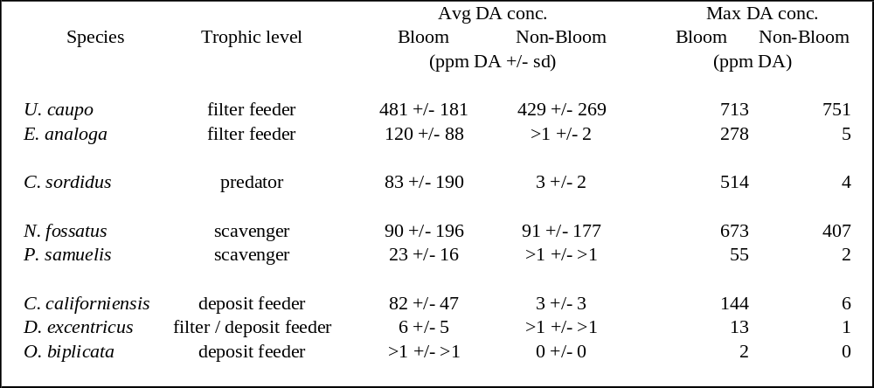

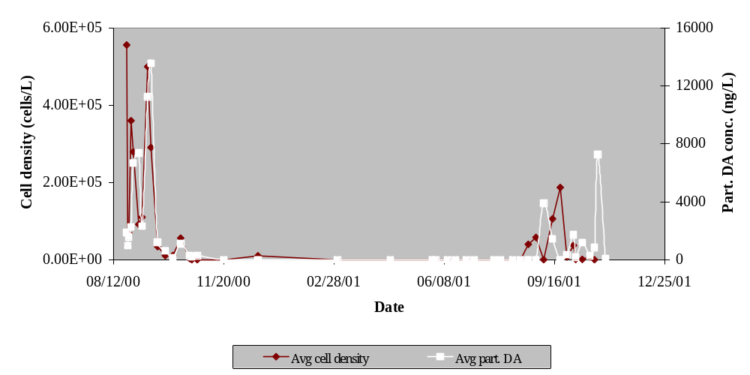

Figure 1. Toxic Pseudo-nitzschia species average cell densities (cells L⁻¹) and average particulate domoic acid concentrations (ng L⁻¹) versus time (August 2000 through November 2001) at Del Monte Beach, CA collected at surface, mid-water, and depth (12 m). Both bloom events during our study consisted of mostly P. australis cells.

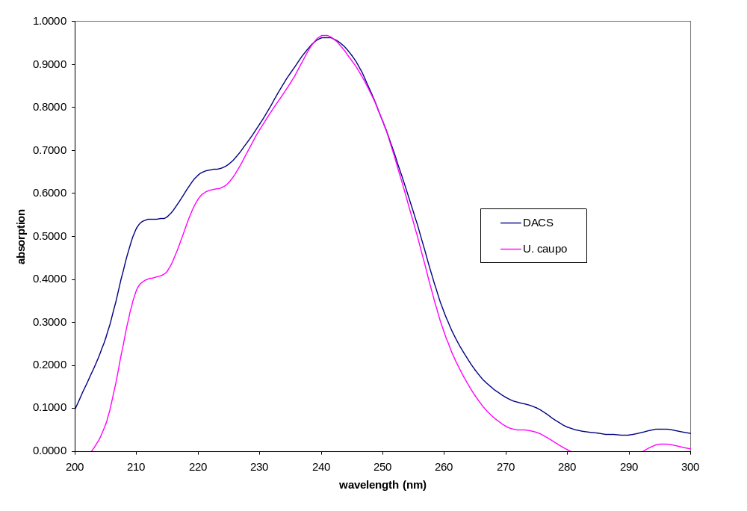

Figure 2. Absorption spectra (200-300 nm) of DACS domoic acid standard (16 ppm) and DA compound captured from HPLC peak identification of DA extracted from U. caupo.

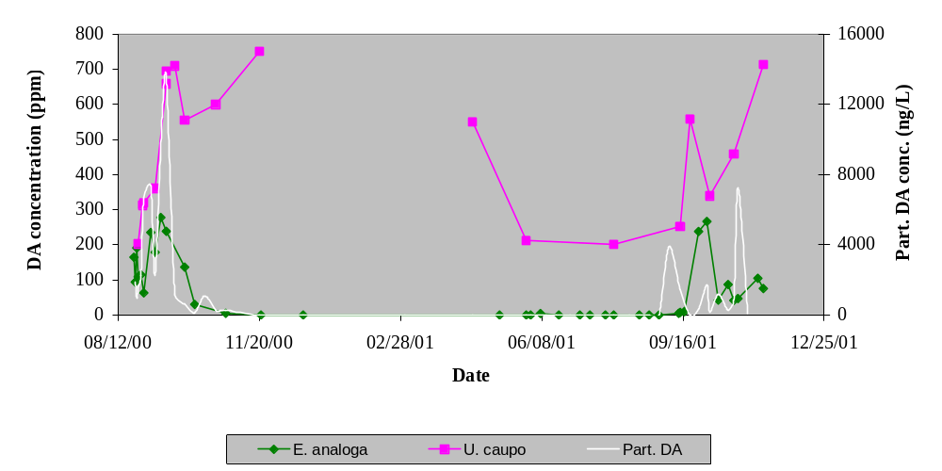

Figure 3. Domoic acid concentrations (ppm) in filter-feeding benthic species and average particulate DA concentrations (ng L⁻¹) in the water versus time (August 2000 through November 2001) collected at Del Monte Beach, CA.

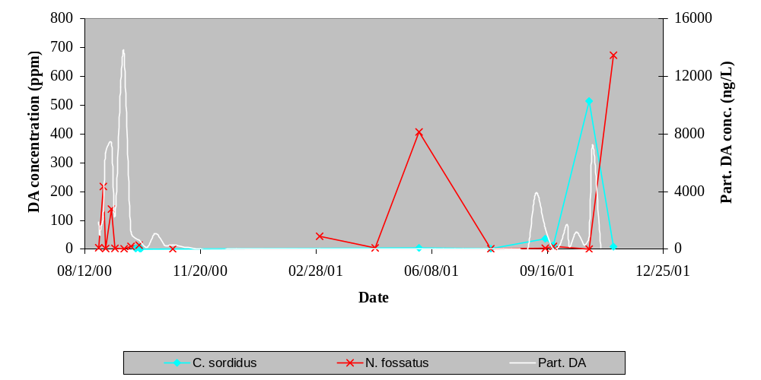

Figure 4. Domoic acid concentrations (ppm) in the predatory species C. sordidus and the scavenging species N. fossatus, and average particulate DA concentrations (ng L⁻¹) in the water versus time (August 2000 through November 2001) collected at Del Monte Beach, CA.
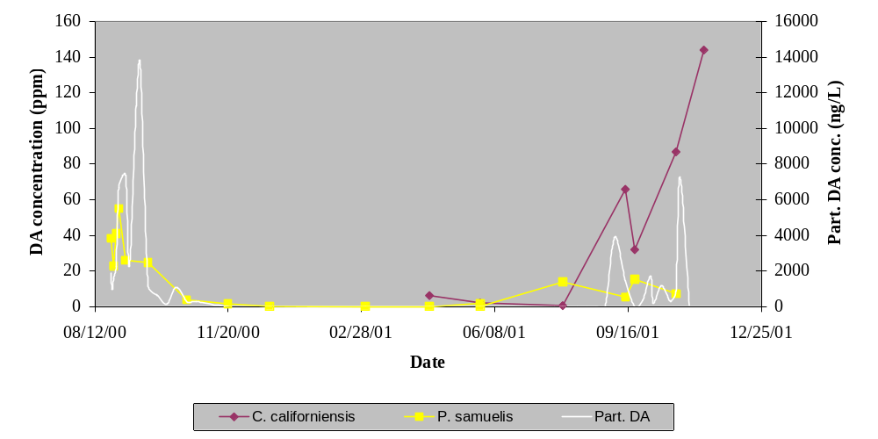

Figure 5. Domoic acid concentrations (ppm) in the deposit-feeding species C. californiensis and the scavenging species P. samuelis, and average particulate DA concentrations (ng L⁻¹) in the water versus time (August 2000 through November 2001) collected at Del Monte Beach, CA.

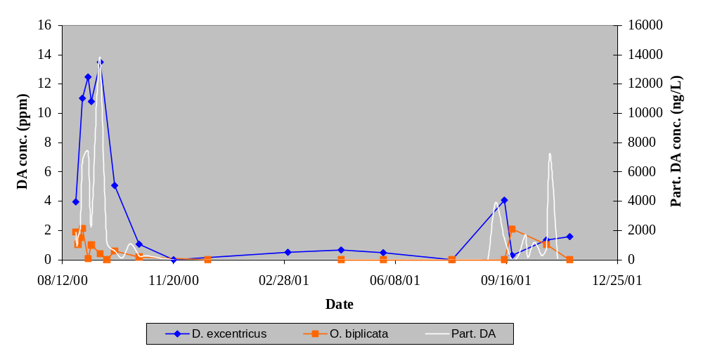

Figure 6. Domoic acid concentrations (ppm) in the deposit- and filter-feeding D. excentricus, and the deposit-feeding O. biplicata, and average particulate DA concentrations (ng L⁻¹) in the water versus time (August 2000 through November 2001) collected at Del Monte Beach, CA.

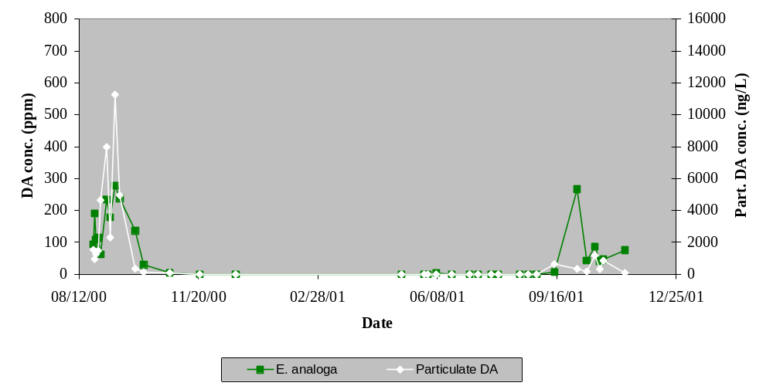

Figure 7. Domoic acid concentration (ppm) in E. analoga and particulate DA concentration (ng L⁻¹) from P. australis in surface waters versus time (August 2000 through November 2001) collected at Del Monte Beach, CA.

