November 23, 1999

Dear Task Force Participant,
I would like to thank you again for your willingness to represent your institution's interests at the first California Marine Habitat Task Force Strategic Planning Meeting on January 20-21, 2000. Attached please find the draft meeting agenda along with the survey sheets and reference maps designed to assess your institution's mapping needs and data holdings. More information and updates about the meeting can be found at the Task Force web site: http://skyler.monterey.edu/~cahabmap.
To insure the success of, and your participation in, the Task Force Strategic Planning Meeting, we must receive the information on your institution's data needs, selection criteria and holdings no later than December 15, 1999. Our plan is to compile this information into maps and tables in advance of the January meeting that will show the distribution of existing or planned data sets as well as the areas where data is most needed. These summaries will be used to perform a data gap analysis that will be presented at the beginning of the meeting and used to focus our discussions on setting mapping priorities and data sharing. This advance work on the part of each of the participants is essential if we are to achieve the goals of the meeting in just two days. Participants outside of California can use the enclosed information as the framework for the task force meeting.
By marine habitat mapping we mean spatial quantification of those physical parameters of greatest value in defining seafloor habitat (e.g. depth, substrate type, slope, and aspect). These data can then be classified according to the marine habitat classification scheme we will be discussion at the January meeting. Examples of various marine habitat GIS products for the Big Creek Marine Reserve can be viewed on the California Marine Habitat Task Force web site. Additional information on the theory, methods and considerations of resolution and scale for marine habitat is also available on the web site.
Following are the instructions for using and completing the enclosed survey material templates. These materials are also being emailed to you as attachments should you wish to use them in electronic form. We are using the long established 10' x 10' fishing blocks (see enclosed maps) as a way to define areas of interest and data holdings. Use the enclosed forms and maps as templates that can be copied and filled out as needed.
We need four different sets of information from each Task Force member representative relating to Data Needs and Data Holdings. (Remember, as a Task Force participant you are representing your agency or institutional interests.)
- The criteria that you set and used for selecting and ranking sites for habitat mapping.
- List of top 10 sites in rank order for your institution’s habitat maps needs.
- ONE completed Data Needs Worksheet for EACH area for your institution’s habitat maps needs, along with ONE set of regional maps that illustrates the total needs.
- ONE completed Data Holdings Worksheet for EACH area for which your institution has or will be collecting habitat mapping data, along with ONE regional set of maps that illustrates the total holdings of your organization.

Thank you again, and please feel free to contact me if you have any questions. I look forward to seeing you in January. Regards,
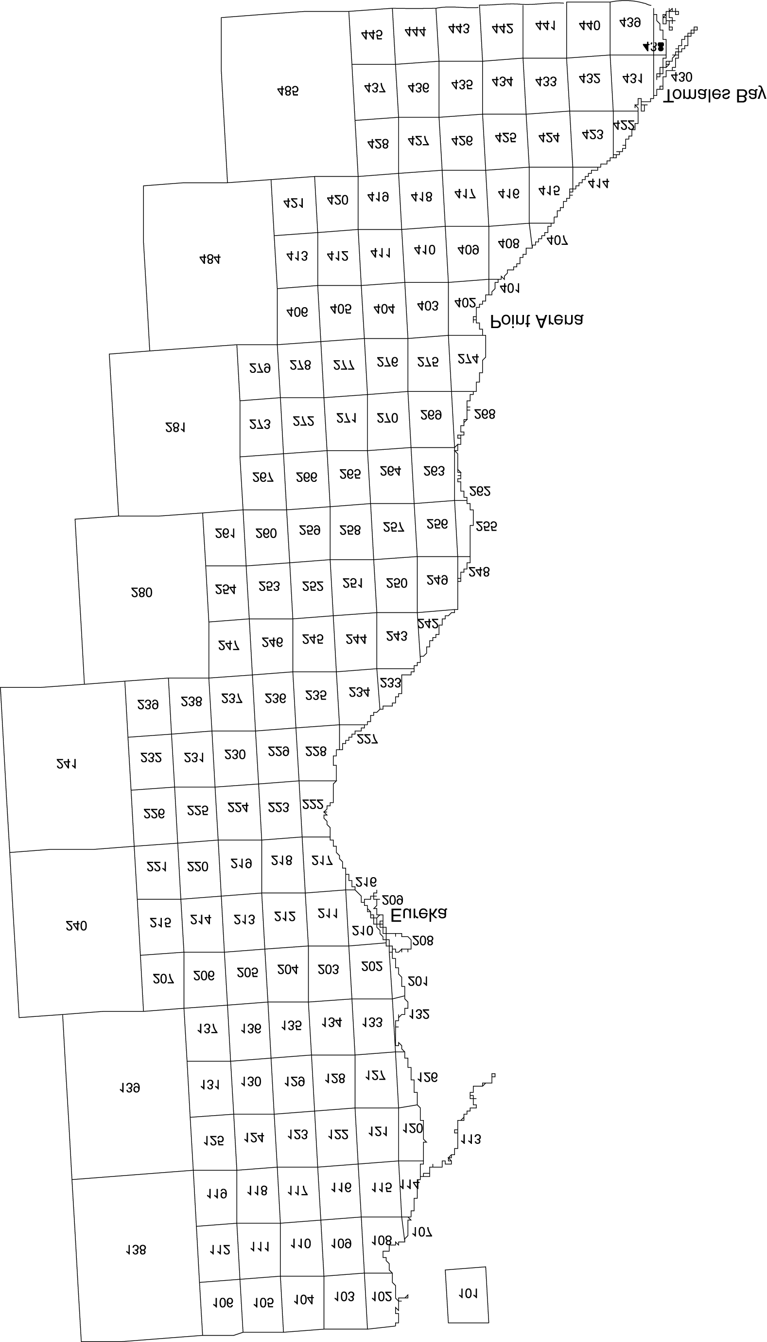

Amanda Green
California Marine Habitat Task Force Coordinator

