Apache beam pipeline is used to extract, transform and load the data between these tables using Cloud Data Flow as the execution engine. The pipeline is in Python.

The **item_dim and psku** are the source tables in BQ. These 2 tables are joined and transformations are done on them. The resultant data is loaded into the results_dataset item_table.

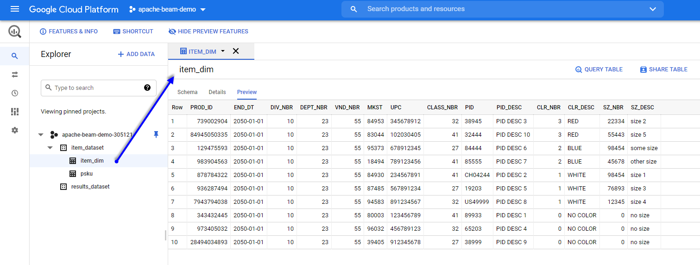

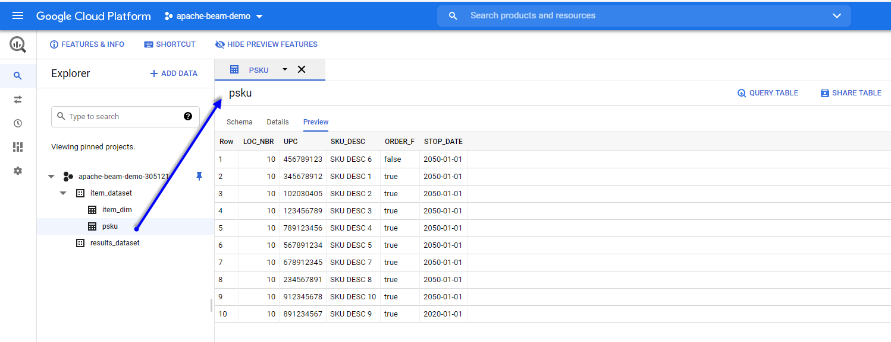

results_dataset is where the transformed tables will be loaded:

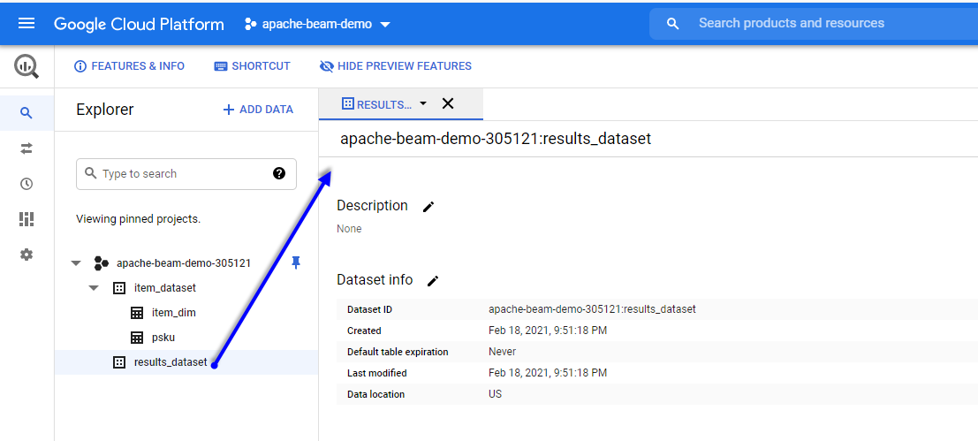

Activate Cloud Shell and run the readwrite_bq.py that is within the examples folder:

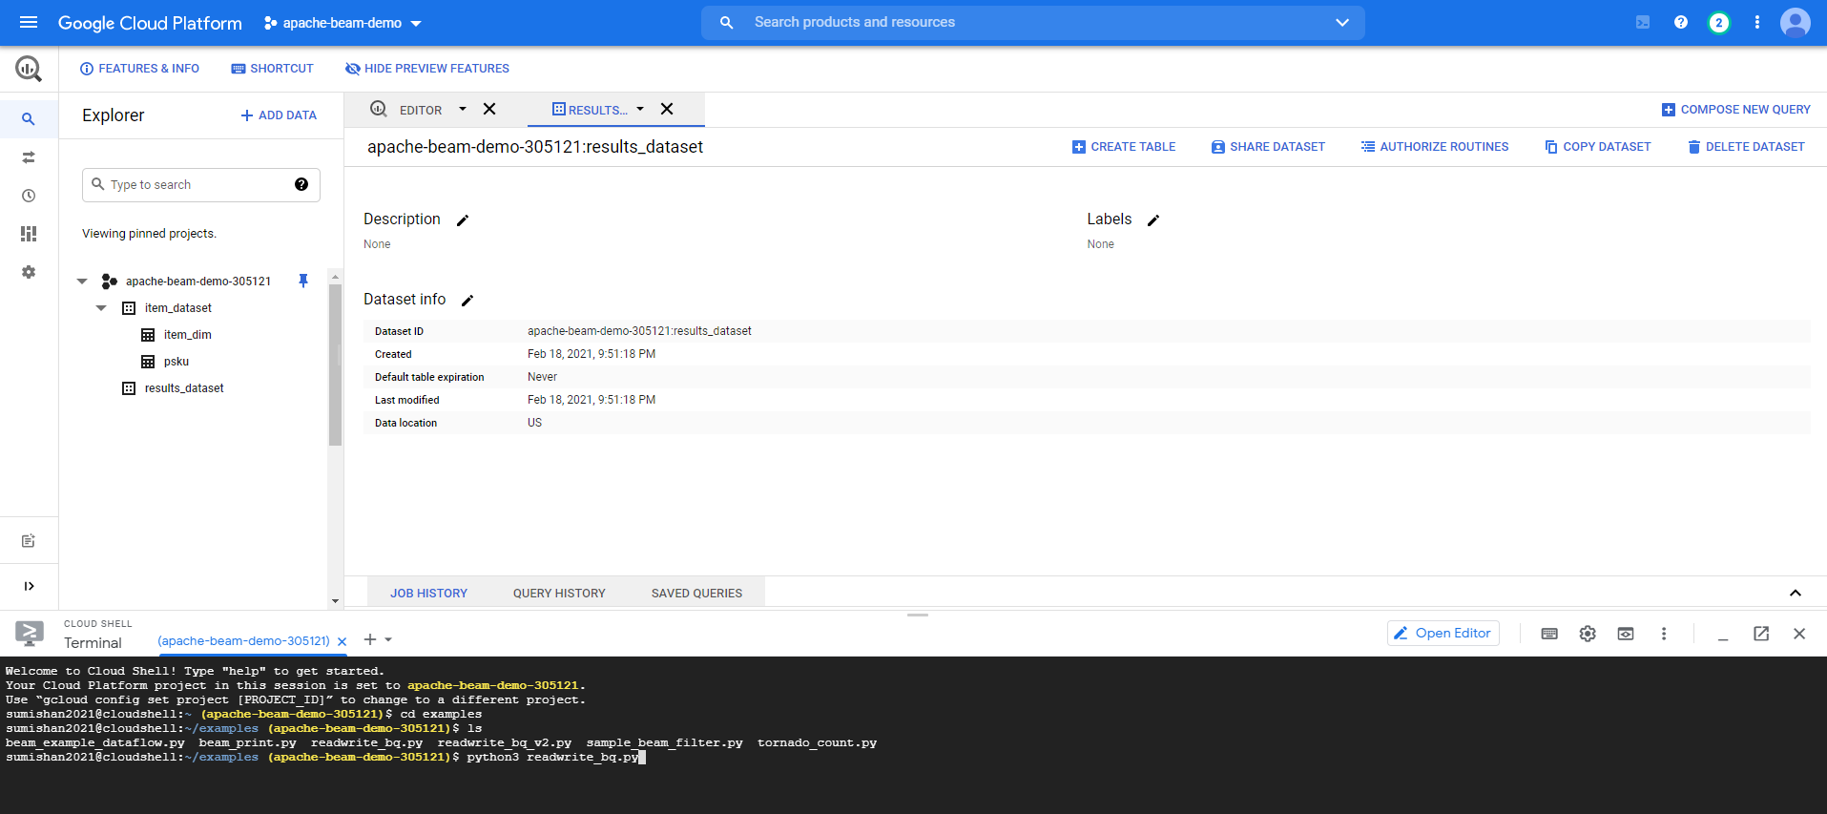

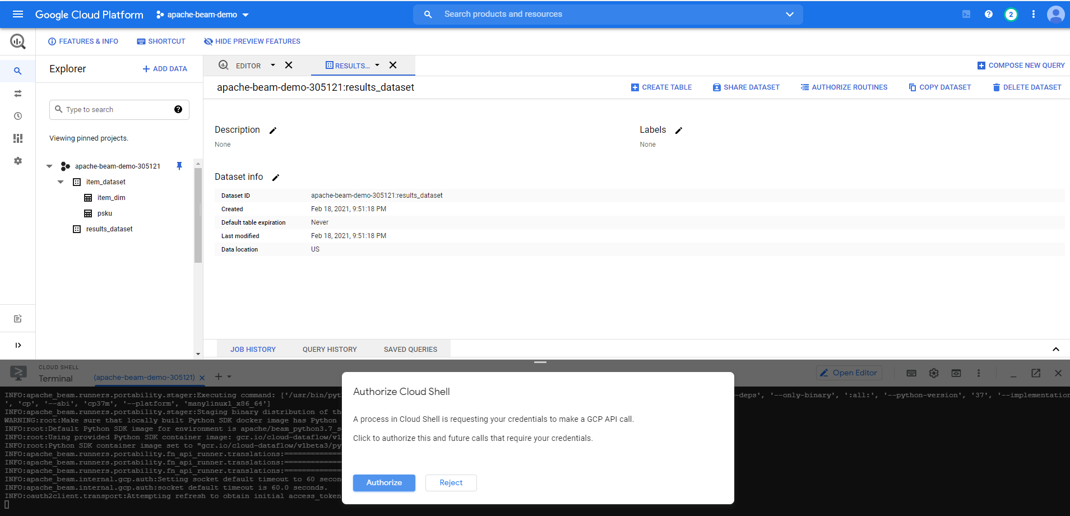

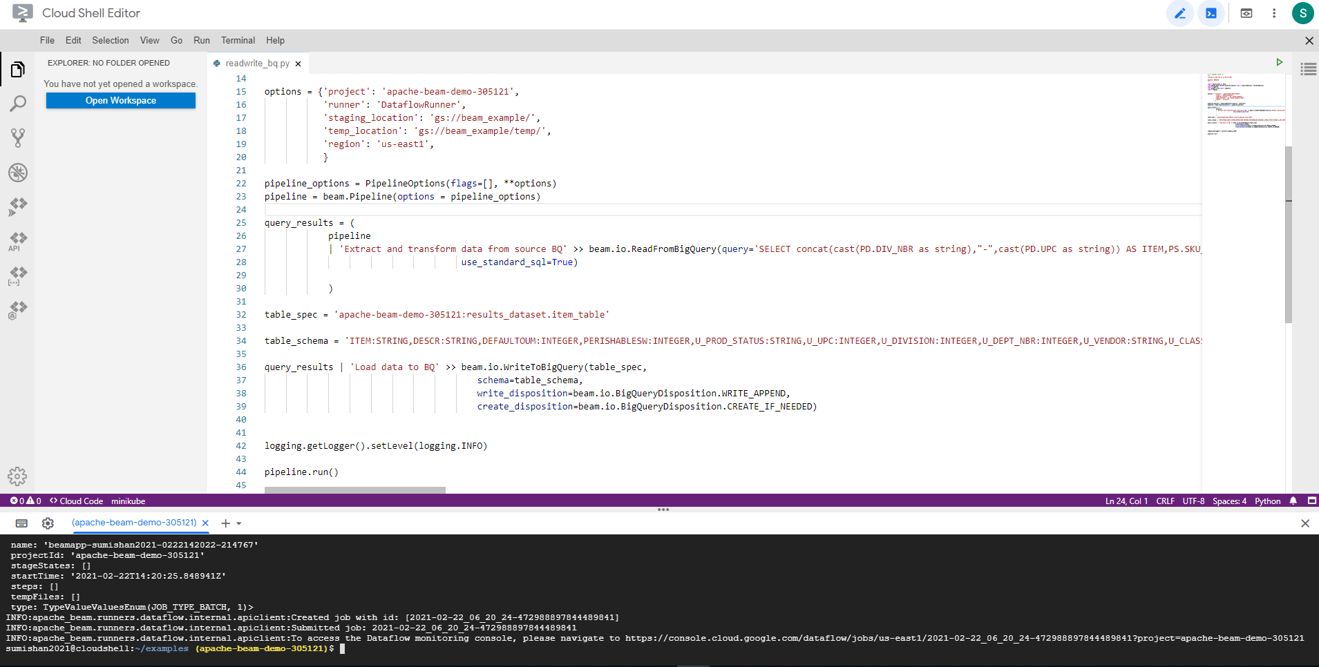

Data Flow:

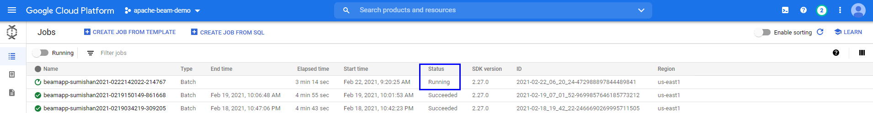

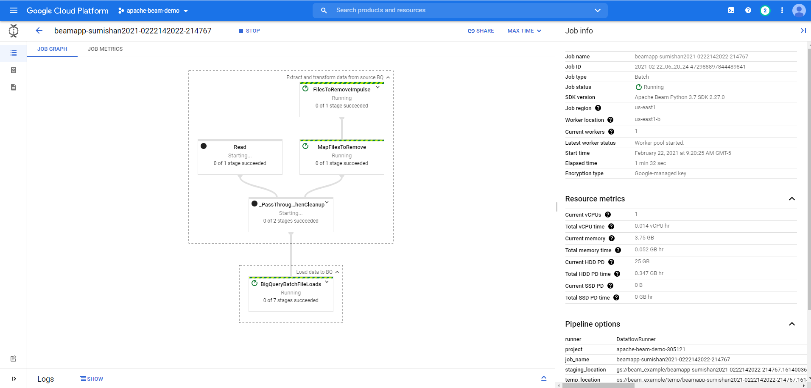

After job completion:

