UDC Website Back Up on GitHub

# **Last Update**

08/24/17

# **Purpose of this Document**

The Universal Design Center from California State University, Northridge has created a repository on GitHub with all the body and multi-body elements from the UDC web pages on the CSUN website. Our goal is to have an easy to access and easy to manage method of organizing and updated the HTML and CSS elements used within Drupal.

# Account information

# Navigation

First page in the GitHub CSUN-UniversalDesignCenter repository.

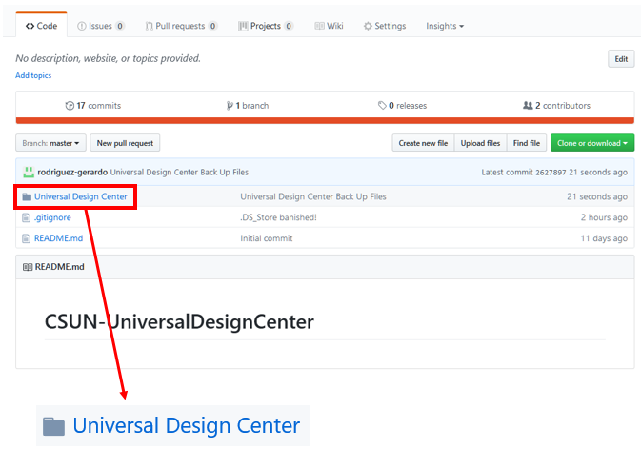

The first folder shown above represents the homepage for the UDC website, when clicked on we will find this next page.

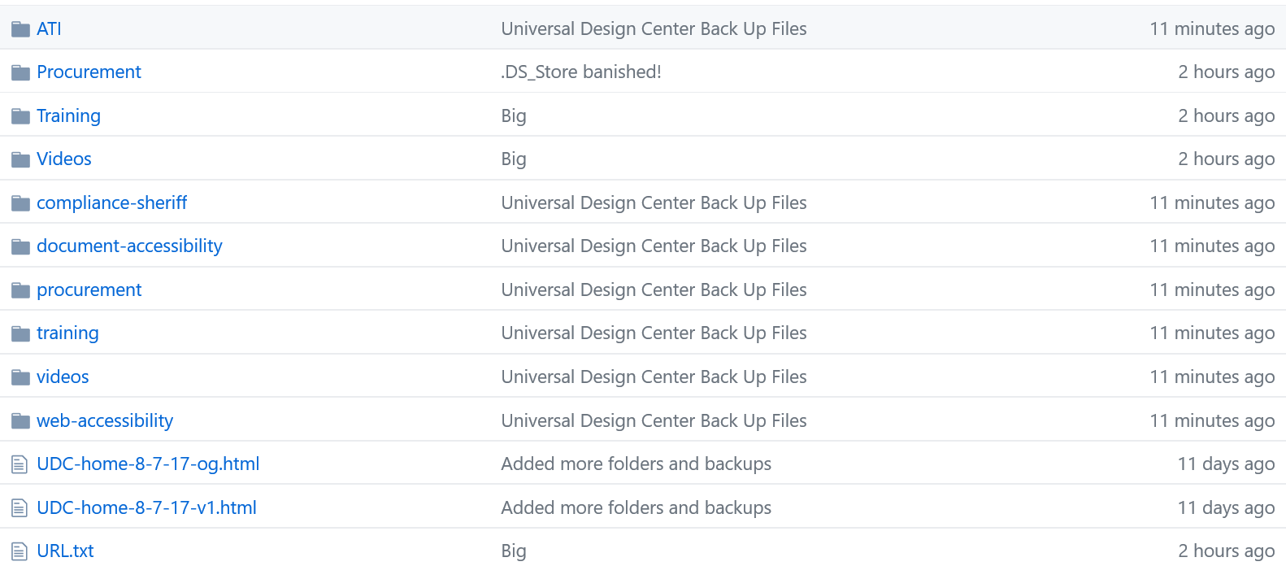

The image above is a representation of the UDC homepage as where each folder is name in accordance to global navigation items.



Within each folder, we will also find the subfolders in accordance to the subcategories within the drop-down menu bar.

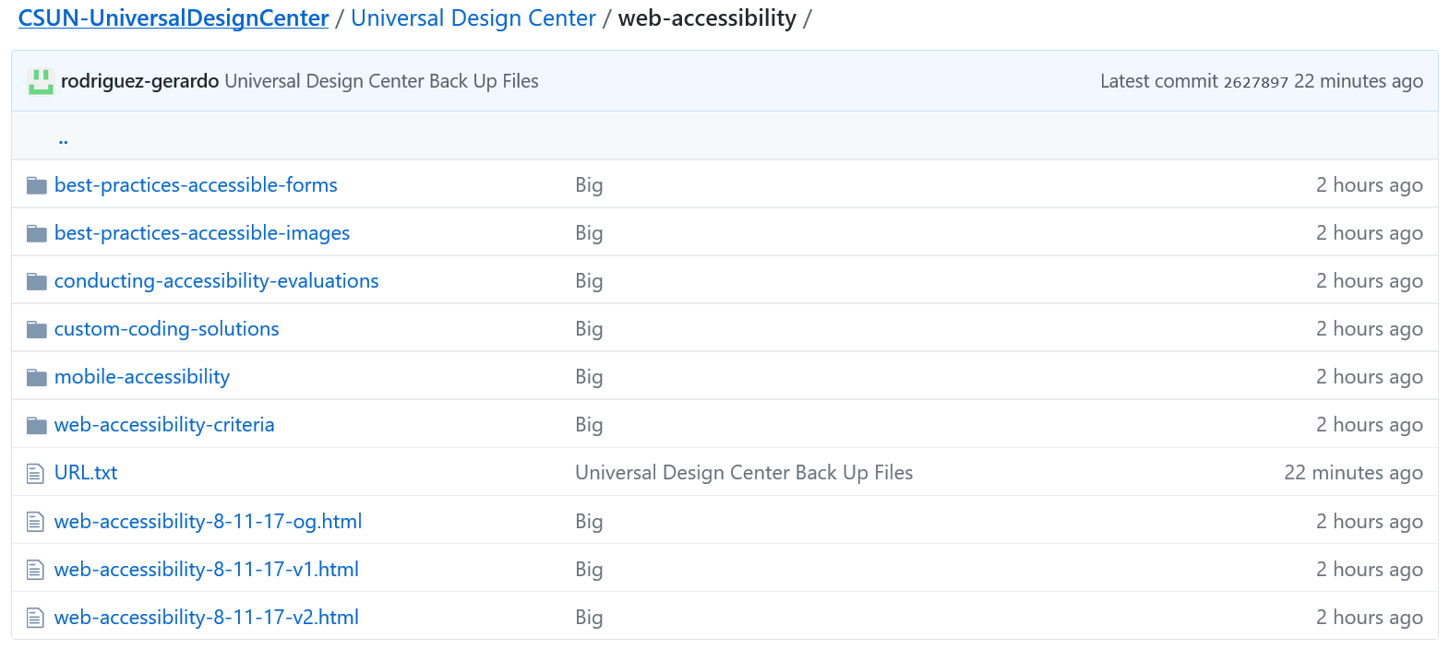For example, on the web accessibility folder we see this.

Which contains the 2nd level global navigation items from the drop-down menu like this:

We have split the html files into 2 types

Main body files can be found when first opening the page folder and will have a “.html” extension.

If you see a “multibody” folder within the page folder such as seen here

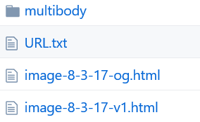

When clicking on the folder, you will see that this multibody folder contains folders which are going to match the names of the accordions within the page, as shown below.

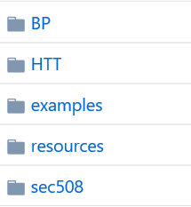

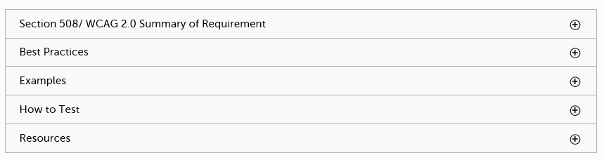

# File and Folder Naming Conventions

## **Folders**

Each folder represents a page with a body html file within it. The folders will be named in accordance to the page, all lower case and dashes in places of spaces.

**Examples**:

Page: PowerPoint and Excel

Folder: powerpoint-and-excel

Page: Web Accessibility Criteria

Folder: web-accessibility-criteria

If the page contains an accordion, then create a folder labeled “multibody”.

Within the multibody folder, create a folder for every accordion item.

## **Files**

The .html files contain what is placed within the body or multibody in Drupal. These files need to be saved as .html and the naming will be all lower case with the page name first followed by numerical backup date then version number.

### **Example:**

Page: Compliance Deputy

File: compliance-deputy-08-22-2017-v1

# **Making Changes to Files**

## **Directly on GitHub**

### **Editing Files**

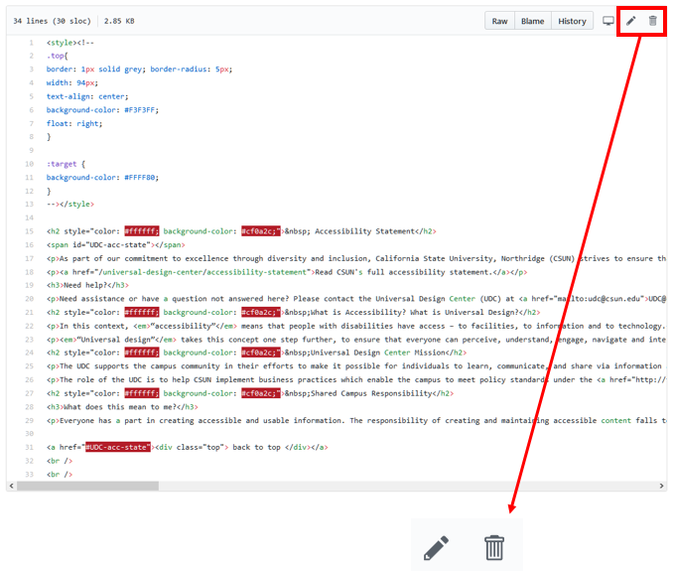Click on the desired HTML file which will take you to a page with this box in it showing all the contents of the file.

The icons on the top right allow file alteration. The pencil allows for editing of the file, and the trashcan deletes it.

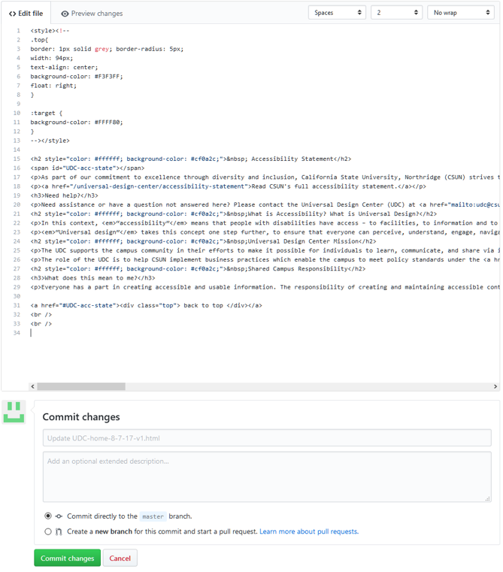At the edit page you can change the contents of the file then to save you click on the commit changes button.

### **Creating a New File**

Go to the desired folder where you wish to create your file

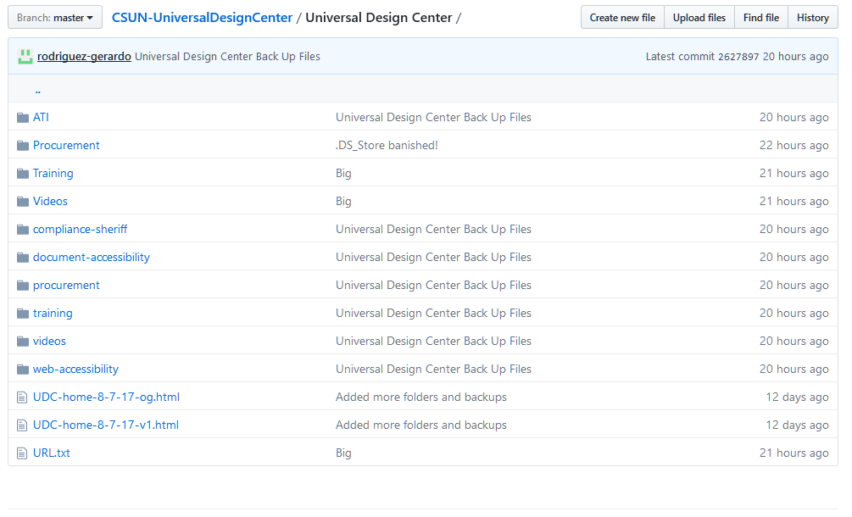Click on the “Create new File” button on the top right

Add the backup code to the file in the text box

Code will be from full html mode in webone

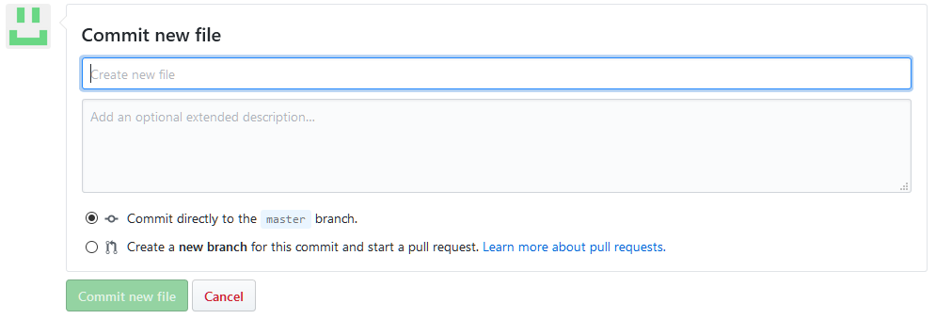

Name the file as shown below in compliance with file naming conventions.

Name of the file will be header 1 of the corresponding page unless it is a multibody.

If multibody, then the header of the multibody item will be the name of the file.

Click on the commit new file button

## **Creating a Local Repository**

There are 3 ways you can download the project onto your computer and uploading which are through the website, desktop app, and command line

Website

Go to <https://github.com/rodriguez-gerardo/CSUN-UniversalDesignCenter>

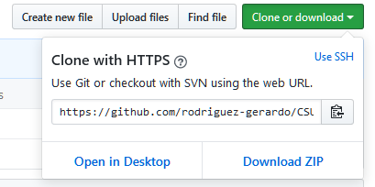Click on the “Clone or Download” button then “Download ZIP”

At this point you can alter the file as you desire, once it is complete you can upload the files by clicking on the “Upload Files” button and proceed to drag in drop the changes files in their respective folders.

Desktop App

Terminal

* + - * 1. In the terminal navigate to your GitHub folder containing all your repositories
        2. Type in git clone <https://github.com/rodriguez-gerardo/CSUN-UniversalDesignCenter.git> then hit enter.
        3. You should now have a folder labeled “CSUN-UniversalDesignCenter” in your GitHub folder.
        4. If you wish to update the folder with any changes previously made navigate the the UDC folder and in your terminal type: “git pull origin master” This will download any changes that have been made to the git repository.
        5. You want to make sure to update your local repository before making any changes because if any changes were made after your last update, you will run into complications when trying to upload your changes.
        6. To commit your changes once you are finished with your addditions, type in this series of commands

git add .

git commit -m “Enter any message here”

git push origin master

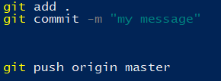

# Upload History

Second Monday of every month: A – Z backup

Third Monday of every month: local repository backup on Web drive