Instant Messenger Service

Project Proposal

Introduction
The Project Plan outlines the functions, mechanisms and objectives for the implementation of an Instant Messenger Service for business environments The Instant Message Service is an IP based communication system for individual users to communicate real-time and post-time messages. The system is implemented with a client-server structure to facilitate the delivery and archiving of message between clients.
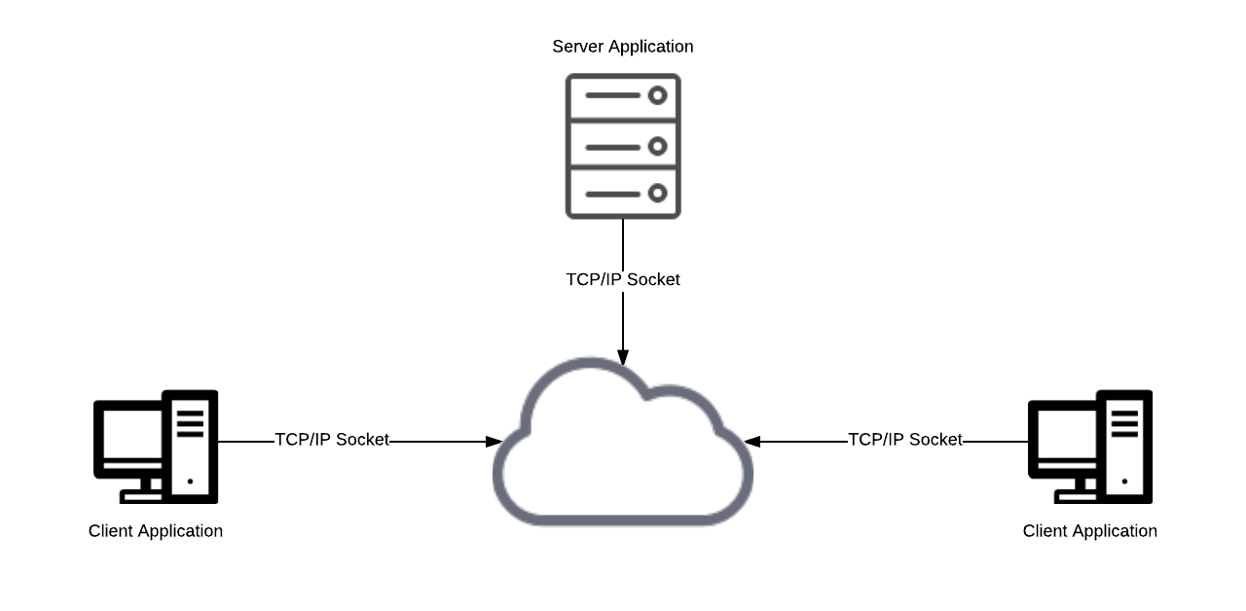

Business Case
A Company wants the implementation of a feature rich messaging service for simple business communication. The messaging service will enable real-time messaging between colleagues on remote devices. The service is integral to business function and therefore requires an importance on the maintainability, reliability and confidentiality of systems. To allow this, the use of international standards and open-source frameworks will be utilized for the underlying communication protocols, client and server APIs.

Project practices and measurements
Use Case Diagram:
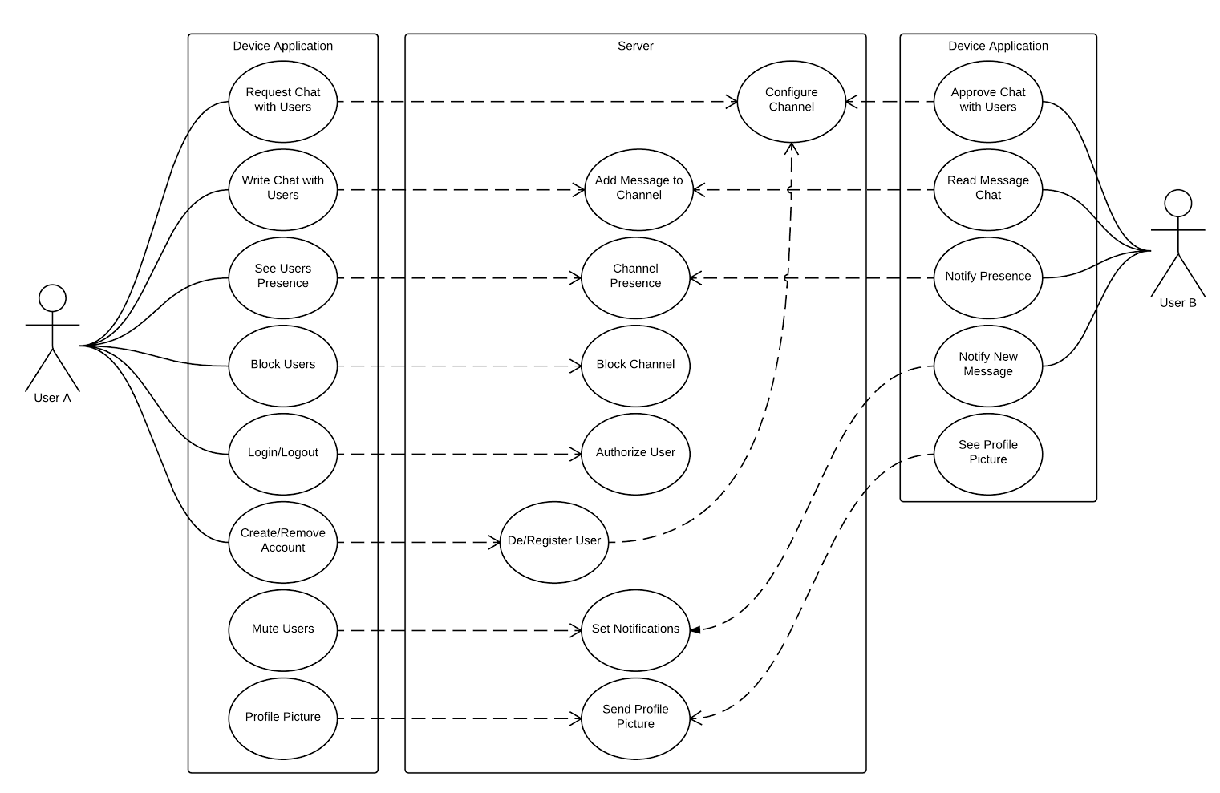

Use Cases:
-Create account
-Manage/delete account
-Login/Logout, was send user credentials

-Find another user (add another user) was requested channel
-Search users
-Save users as contacts
-Chat with another user, was send message [fallback target]
-Group chat

-Set presence
-See a contacts presence
-Remove contacts
-Block contacts
-Mute contacts [standard target]

-Search contacts/conversations, (This looks hard to implement)
-Read/unread status on conversation

-Add profile picture [stretch target]

Major Components
Client Device
- User Interface.
- Server Connection and Authentication.
- Message retrieval and delivery.
Server Service
- User Management.
- User Authentication.
- Client Connection and Authentication.
Database
- Database design.
- Database access.
- Data Archiving.

Required Skills
- GUI Design.
- SQL, DB Connections, Event-Driven, Threads, Socket programing.
- Data Structures, Database design (depending on design constraints, we won't necessarily require a OO or OR Database, we could use some form of data structure from Java Collections).
- Preferred Java platform (Most components can be build with Java SE and some EE).

Tools
- Java SE and EE.
- Git Version Control with GitHub.
- Slack as Push Communication.
- Eclipse IDE. You can download prepackaged edition, for example a JavaFX edition, this will unify team members environments, minimizing conflicts. Git build in.

Deployment

Project milestones and objectives

Subject | Phase | Iteration | Dates | Primary objectives (risks and use case scenarios)
ITC303 – Software Development Project 1 | Inception Phase | I-1 | 13/03 – 26/03 | Establish Vision  Establish Initial Use Case Model  Complete Preliminary Non-functional Requirement Analysis  Identify/Document Candidate Architectures  Establish Version Control
ITC303 – Software Development Project 1 | Inception Phase | I-2 | 27/03 – 9/04 | Establish Risk List  Complete Full Description for Critical Core Risky Difficult (CCRD)Use Case  Implement Technical Competency Demonstrator  Create Test Plan  Establish Initial Project Plan  Deliver Life Cycle Objectives Milestone (LCOM)  Complete Inception Phase Project Assessment
ITC303 – Software Development Project 1 | Elaboration Phase | E-1 | 10/04 – 23/04  (Session Break) | Mitigate Highest Priority Risk(s)  Implement Highest Priority Architectural Element(s) to Support CCRD Use Case  Complete Development Testing for Highest Priority Architectural Element(s)
ITC303 – Software Development Project 1 | Elaboration Phase | E-2 | 24/4 – 7/05 | Mitigate 2nd Highest Priority Risk(s)  Implement 2nd Highest Priority Architectural Element(s) to Support CCRD Use Case  Complete Development and Integration Testing for 2nd Highest Priority Architectural Element(s)
ITC303 – Software Development Project 1 | Elaboration Phase | E-3 | 8/05 – 21/05 | Mitigate 3rd Highest Priority Risk(s)  Implement 3rd Highest Priority Architectural Element(s) to Support CCRD Use Case  Complete Development and Integration Testing for 3rd Highest Priority Architectural Element(s)  Deploy Executable Architecture in Trial Environment  Complete Internal User Acceptance Testing for CCRD Use Case in Trial Environment
ITC303 – Software Development Project 1 | Elaboration Phase | E-4 | 22/05 – 2/06 | Contingency  Deliver Life Cycle Architecture Milestone (LCAM)  Complete Elaboration Phase Project Assessment
Mid-year Semester Break

Mid-year Semester Break
ITC309 – Software Development Project 2 | Construction Phase | C-1 | 10/07 – 23/07 | Implement 2nd Highest Priority Use Case(s)  Complete Development and Integration Testing for 2nd Highest Priority Use Case(s)  Complete Internal User Acceptance Testing for 2nd Highest Priority Use Case(s)
ITC309 – Software Development Project 2 | Construction Phase | C-2 | 24/07 – 6/08 | Implement 3rd Highest Priority Use Case(s)  Complete Development and Integration Testing for 3rd Highest Priority Use Case(s)  Complete Internal User Acceptance Testing for 3rd Highest Priority Use Case(s)
ITC309 – Software Development Project 2 | Construction Phase | C-3 | 7/0 – 20/08 | Implement 4th Highest Priority Use Case(s)  Complete Development and Integration Testing for 4th Highest Priority Use Case(s)  Complete Internal User Acceptance Testing for 4th Highest Priority Use Case(s)
ITC309 – Software Development Project 2 | Construction Phase | C-4 | 21/08 – 3/09  (Session Break) | Contingency  Deliver Initial Operation Capability Milestone (IOCM)  Complete Construction Phase Project Assessment
ITC309 – Software Development Project 2 | Transition Phase | T-1 | 4/09 – 17/09 | Deploy Application in Trial Environment  Complete 1st Round External User Acceptance Testing  Resolve Any Identified Issues
ITC309 – Software Development Project 2 | Transition Phase | T-2 | 18/09 – 1/10 | Complete 2nd Round External User Acceptance Testing  Resolve Any Identified Issues
ITC309 – Software Development Project 2 | Transition Phase | T-3 | 2/10 – 13/10 | Contingency  Deliver Product Release Milestone (PRM)  Complete Final Project Assessment

