**Team Orange  
Instant Messenger  
User Manual**

**Contents:**

Download App

Run App

Status Bar

Create Account

Login

Navigation Bar

Logout

Send a Contact-Add Request

Respond to a Contact-Add Request

Chat with a Contact

Create a Group

Open a Group (view and participate)

Delete a Contact

Block a Contact

Delete a Group Chat

Invite Contacts to a Group Chat

**Download App**

1. Download the folder “TeamOrangeInstantMessenger.zip” by clicking [here](https://github.com/csuproject/instantmessenger/raw/master/ExecutableJar/TeamOrangeInstantMessenger.zip)
2. Unzip the downloaded folder “TeamOrangeInstantMessenger.zip”  
   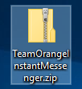
3. Move the unzipped folder “TeamOrangeInstantMessenger” somewhere that you will be able find it.  
   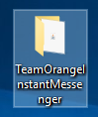
4. If you do not have Java installed, then download and install it from [here](https://java.com/inc/BrowserRedirect1.jsp?locale=en)

**Back To Contents**

**Run App**

1. Open the unzipped folder “TeamOrangeInstantMessenger”  
   
2. Double click on “TeamOrangeInstantMessenger.jar”  
   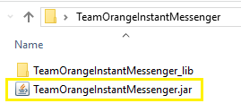
3. You will see the “Account” Screen.  
   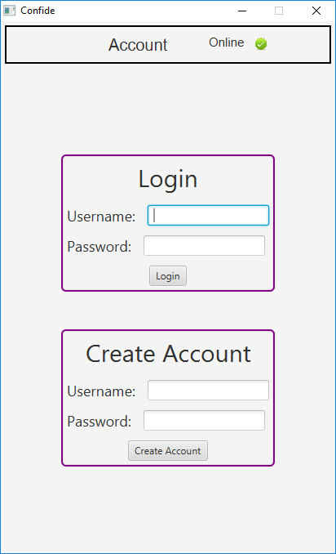

**Back To Contents**

**Status Bar**

Up the top of the screen there is a status bar, which displays the connection status on the right, the current screen in the center, and the user who is logged in on the left (if a user is logged in).

Example:

1. Account Screen with no connection and no user logged in  
   
2. Account Screen with a connection and no user logged in  
   
3. Contacts Screen with a connection and user1 logged in  
   

**Back To Contents**

**Create Account**

1. Open the application and fill in the user-name and password fields in the create account section.
2. Press “Enter” or click on the “Create Account” button.  
   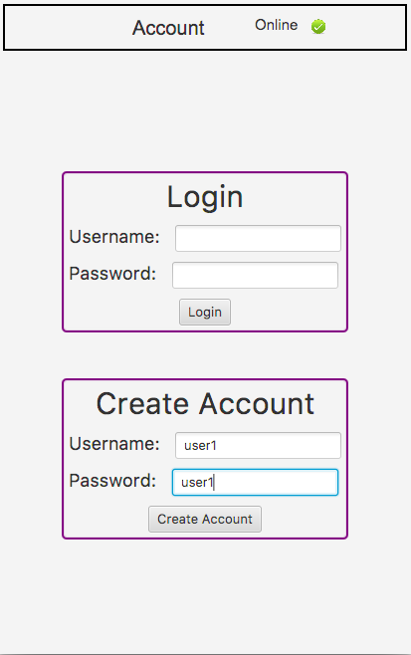
3. You will see an alert pop up that will alert you too the result.  
   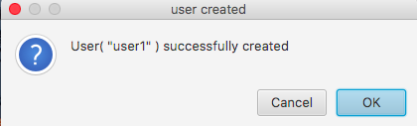

**Back To Contents**

**Login**

1. Open the application and fill in the user-name and password fields in the login section.
2. Press “Enter” or click on the “Login” button.  
   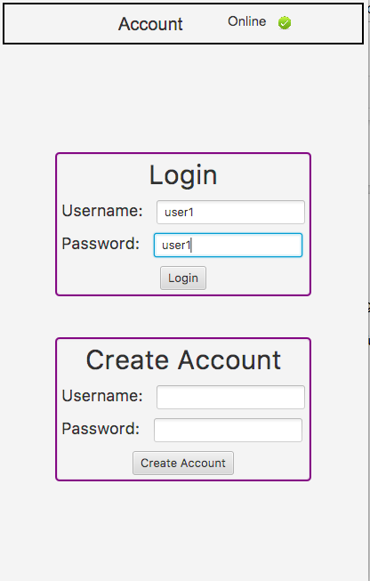
3. You will either see the screen change to the contacts screen upon successful login, or an alert will be displayed providing further information.  
   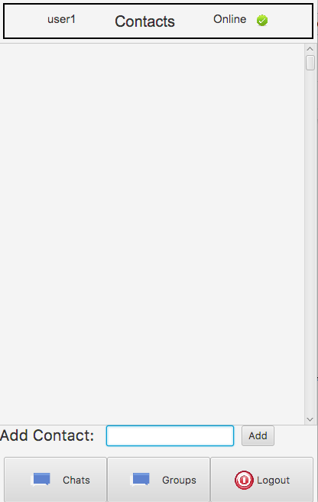

**Back To Contents**

**Navigation Bar**When logged in, the navigation bar will always be present at the bottom of the screen.

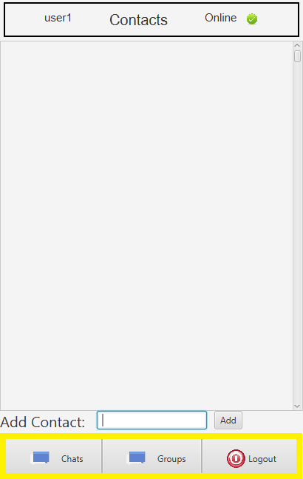

1. The “Chats” button will take you to your contacts list, from here you can engage in a one on one chat with any of your contacts.
2. The “Groups” button will take you to the “Group Chat” screen, where you can view your current group chats, and create new group chats.
3. The “Logout” button will log you out, and return you to the “Account Screen”.

**Back To Contents**

**Logout**

1. Click on the “Logout” button on the bottom right of the screen (right of the navigation bar).

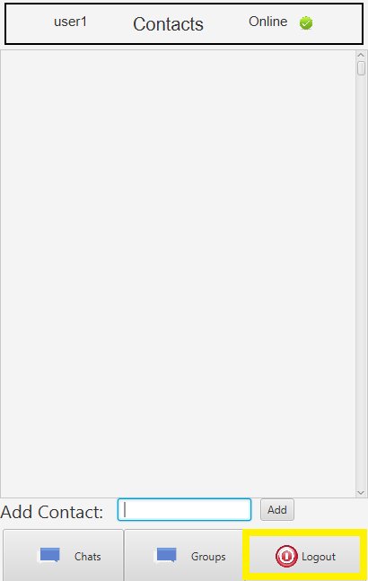

1. You will see the “Account” Screen.  
   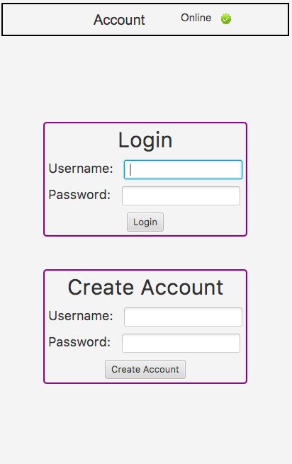

**Back To Contents**

**Send a Contact-Add Request**  
 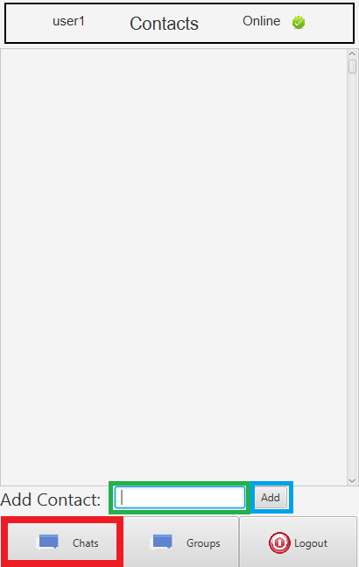

1. Once logged in, go to the “Contacts” Screen (if you are not already), by pressing the “Chats” button at the bottom left of the screen (left of the navigation bar).
2. In the “Add Contact” input box, type the user-name of the user you wish to send a contact request to.
3. Press “Enter” or click on the “Add” button.
4. You will see an alert notifying you that the contact-add request was successfully sent.  
   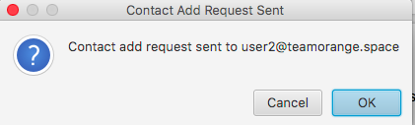

**Back To Contents**

**Respond to a Contact-Add Request**

1. Once logged in, go to the “Contacts” screen (if you are not already), by clicking on the “Chats” button on the left of the navigation bar.  
   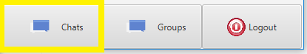
2. You will see a contact request. 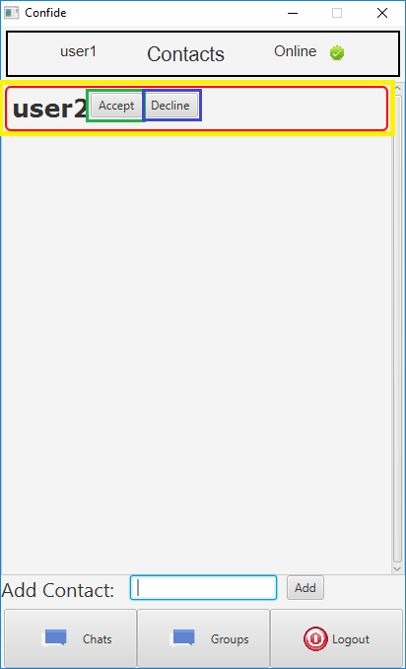  
   1. Click the “Accept” button to accept the request and become contacts with this user. The request will disappear, and the contact will be added.  
      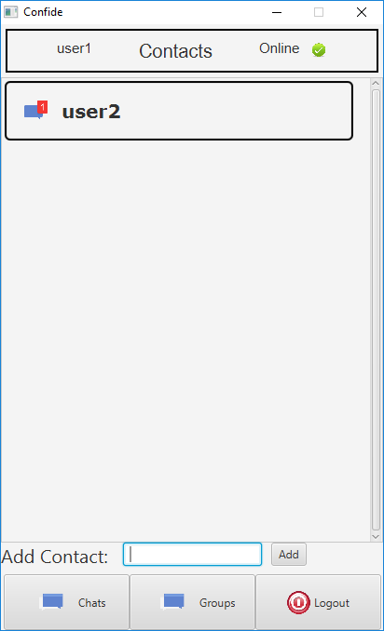
   2. Click the “Decline” button to decline the request. The contact request will be removed, and you will not become contacts with this user.

**Back To Contents**

**Chat with a Contact**

Chats with your contacts are temporary real time chats, they are not saved or stored between sessions.

1. Once logged in, go to the “Contacts” screen (if you are not already), by clicking on the “Chats” button on the left of the navigation bar.  
   
2. Click on the contact you wish to chat with.  
   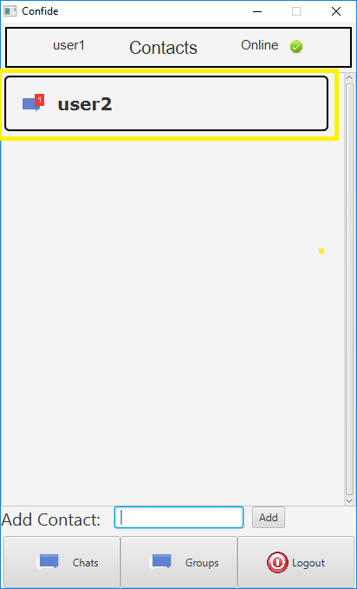
3. You will see the chat screen.  
   The user that you are chatting with is displayed at the top, below the status bar.  
   To create a message, type into the input box.  
   To send a message, either press “Enter” or click on the “Send” button.  
   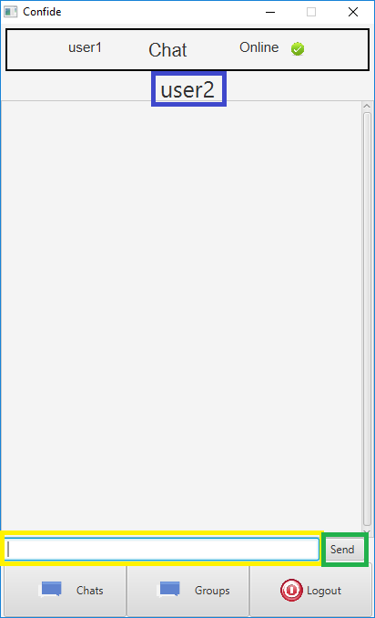

**Back To Contents**

**Create a Group**

**// need to get rid of the “Add Group” button**

Group chats can have multiple members. These chats are stored between sessions.

1. Once logged in, go to the “Groups” screen (if you are not already), by clicking on the “Groups” button at the center of the navigation bar.  
   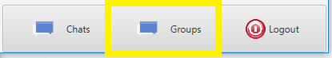
2. Click on the “Create Group” button.

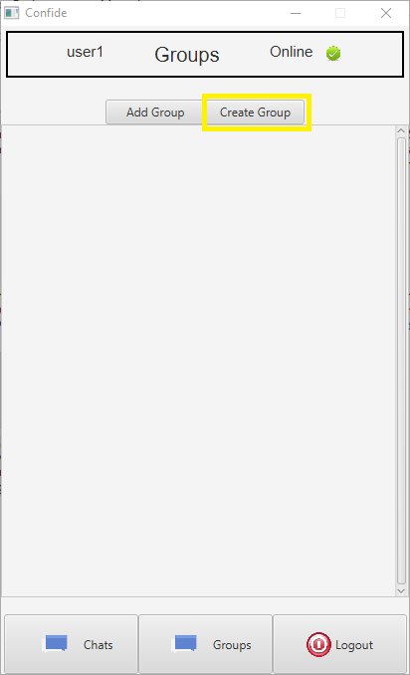

1. Name the group by clicking on the “Name this group chat” text field and typing.
2. Click on the contacts that you wish to invite to this group chat.
3. Create or Cancel this group creation.
   1. Create the group by either pressing “Enter” or clicking on the “Create” button.
   2. Cancel the group by either pressing “Escape” or clicking on the “Cancel” button.

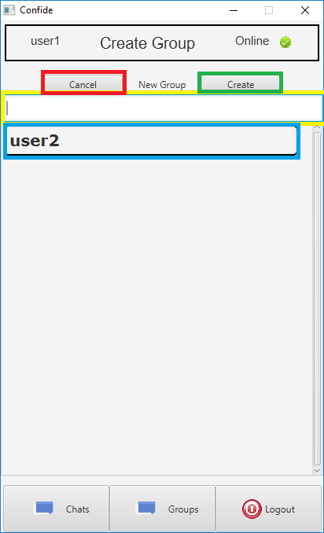

**Back To Contents**

**Open a Group (view and participate)**

**// Change “Exit” button to “Delete”**

1. Once logged in, go to the “Groups” screen (if you are not already), by clicking on the “Groups” button at the center of the navigation bar.  
   
2. You will see a list of your groups.  
   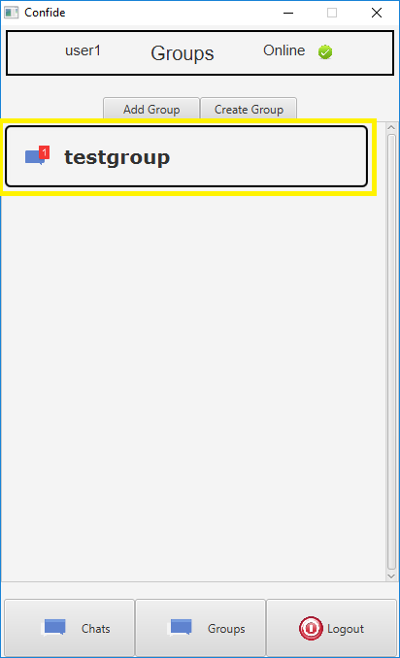
3. Click on a group to open it.
4. From here you can:
   1. Send a message
      1. Type a message in the textfield.
      2. Either press “Enter” or click on the “Send” button.
   2. Exit this group
      1. Click on the “Back” button.
   3. Delete this group
      1. Click on the “Delete” button.

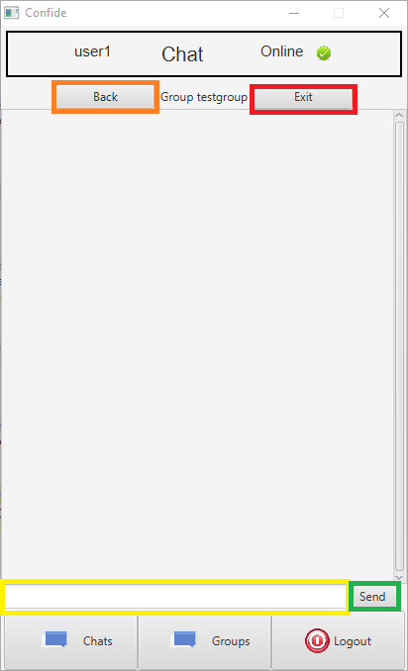

**Back To Contents**