Create Accounts  
 One Two

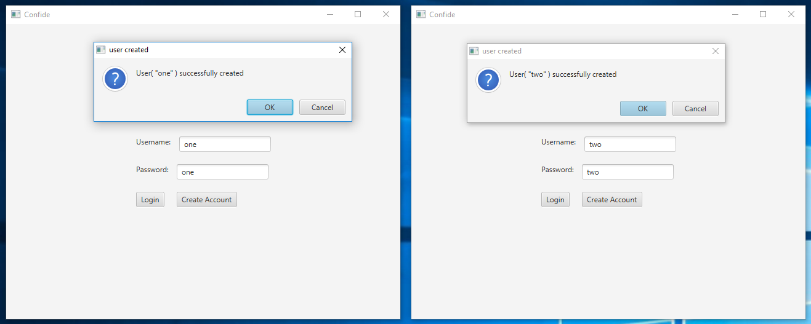

Login  
 One Two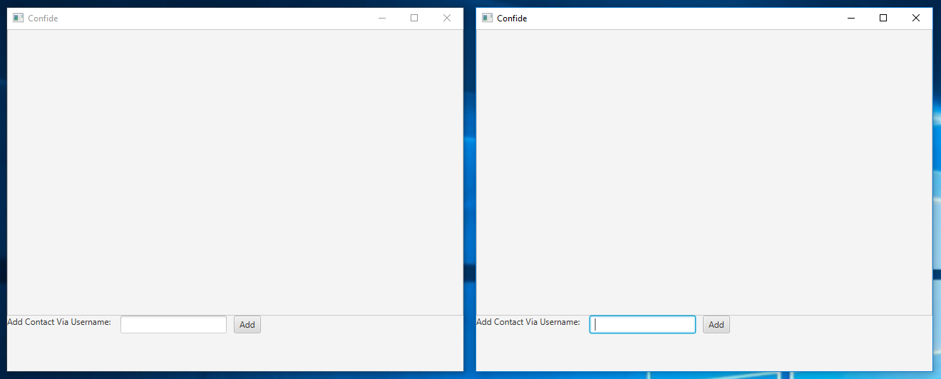  
  
 Request Contact Add  
 One Two

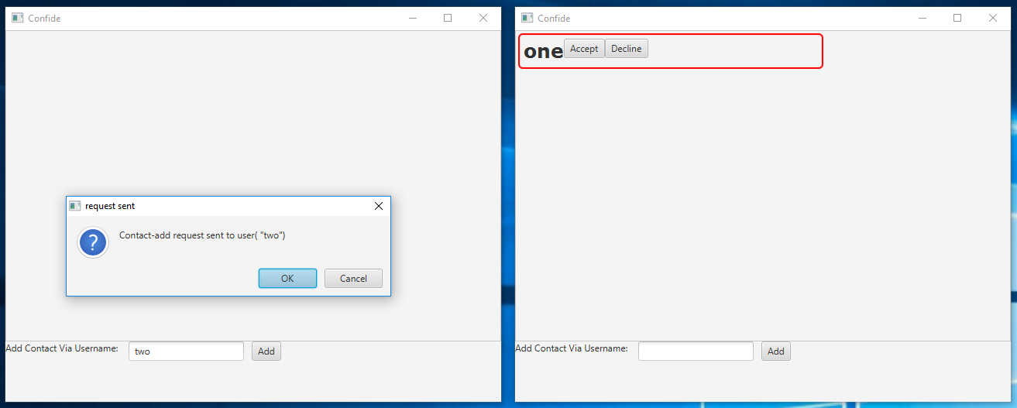

Decline Contact Add  
 One Two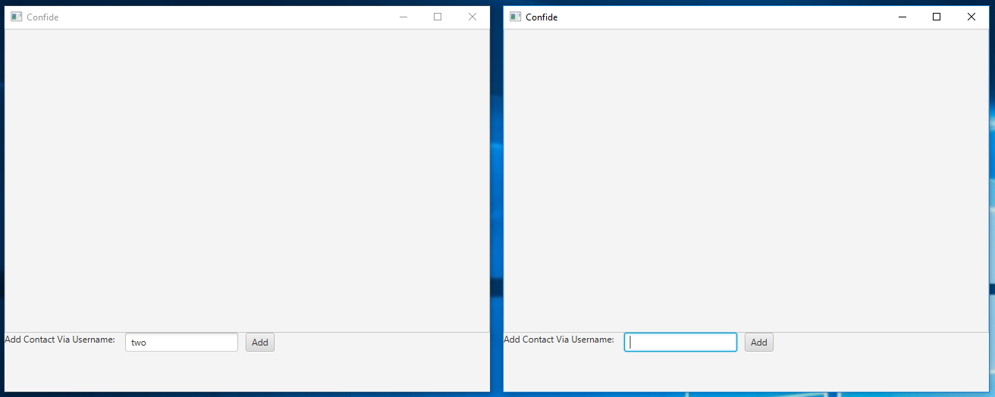

Accept Contact Add   
 One Two  
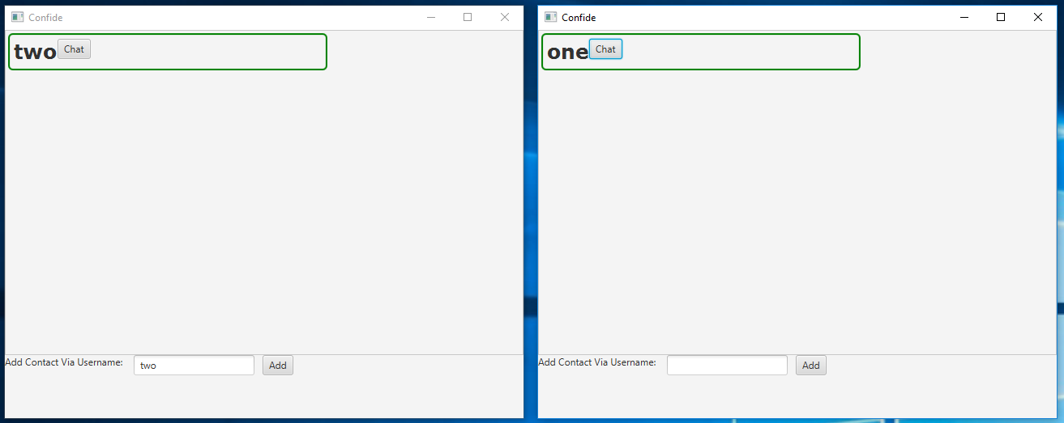  
  
 Open Chats  
 One Two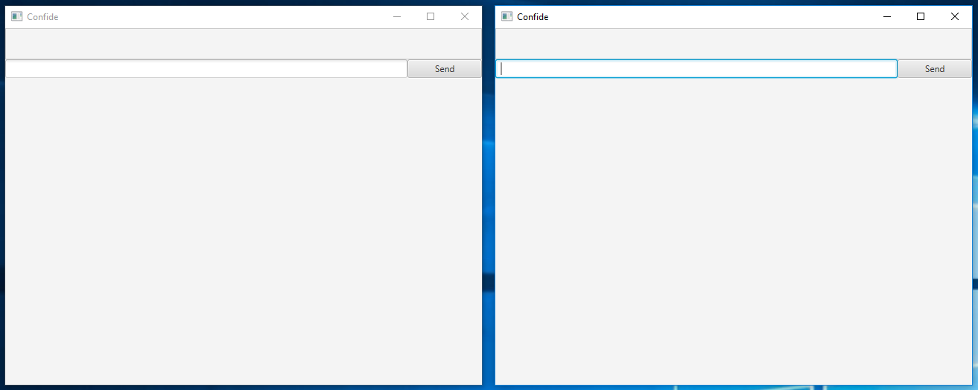

First Message (from “one” to “two”)   
 One Two  
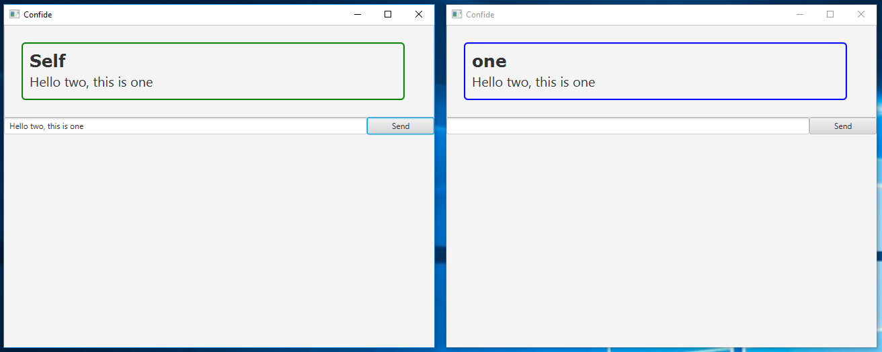  
  
 Second Message (from “two” to “one”)  
 One Two  
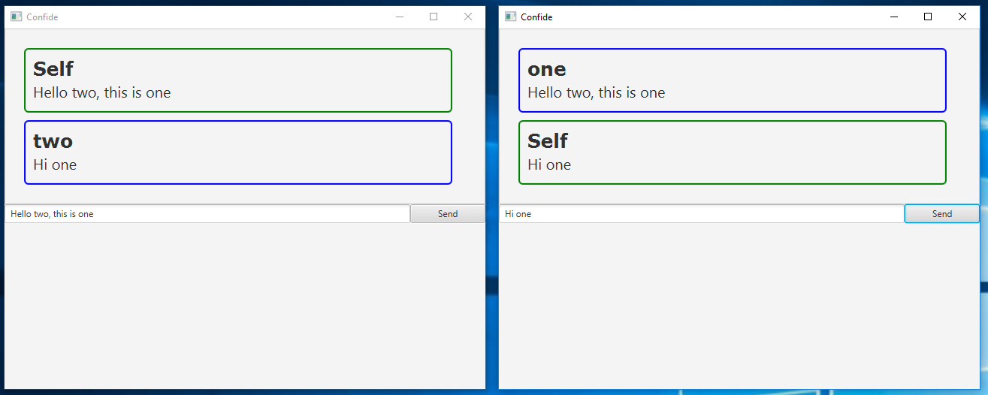  
  
 Third Message (long message from “one” to “two”)  
 One Two  
