**Remote XMPP Server**

An XMPP Server build on the OpenFire project was installed and utilized for testing through the elaboration phases.

Find the Server here: teamorange.space:9090; username: jim, password: jim.

Login Screen

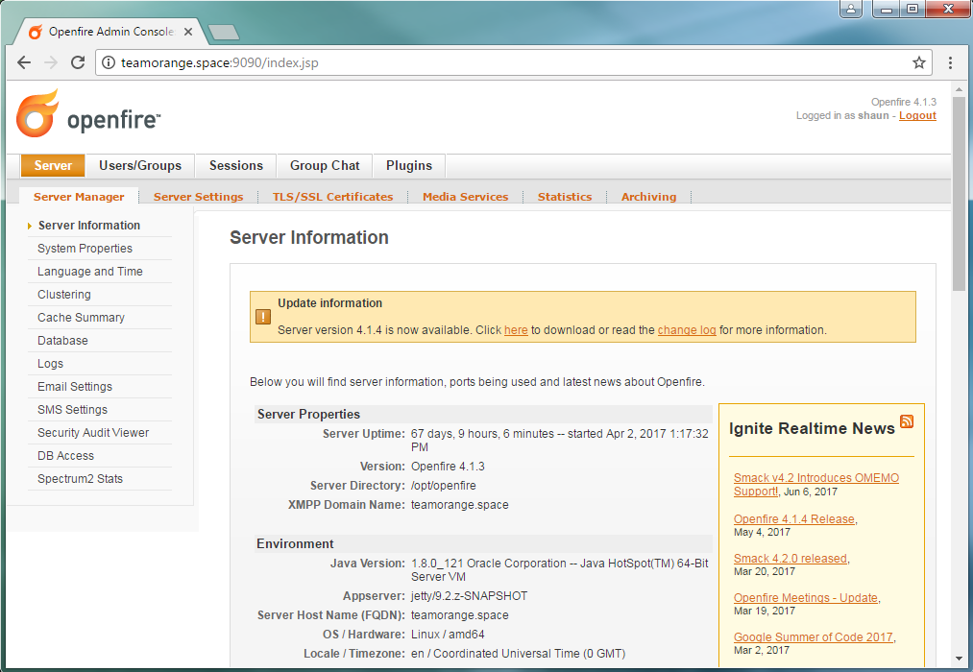

Admin Home



User Summary; List of created users.

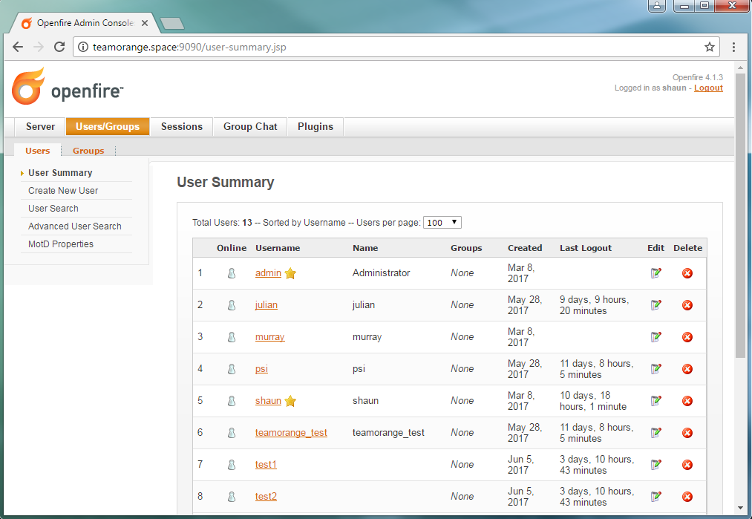

User Properties

