**Team Orange  
Instant Messenger  
User Manual**

**Contents:**

**Getting Started**

**Download App**

**Run App****Application Status and Navigation**

**Status Bar****Navigation Bar****Notifications**

**Accounts**

**Create an Account**

**Login**

**Logout**  
**Contacts**

**Send a Contact-Add Request**

**Respond to a Contact-Add Request**

**Delete a Contact**

**Block a Contact**

**Chat with a Contact**  
**Determine if a Contact is Online**  
**Groups**

**Create a Group**

**Delete a Group**

**Invite Contacts to a Group**

**Open a Group**

**Getting Started****Download App**

1. Download the folder **“TeamOrangeInstantMessenger.zip”** by clicking [**here**](https://github.com/csuproject/instantmessenger/raw/master/ExecutableJar/TeamOrangeInstantMessenger.zip)
2. Unzip the downloaded folder **“TeamOrangeInstantMessenger.zip”**  
   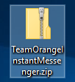
3. Move the unzipped folder **“TeamOrangeInstantMessenger”** somewhere that you will be able find it.  
   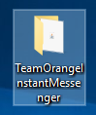
4. If you do not have Java installed, then download and install it from[**here**](https://java.com/inc/BrowserRedirect1.jsp?locale=en)

**Back To Contents**

**Run App**

1. Open the unzipped folder **“TeamOrangeInstantMessenger”**
2. Double click on **“TeamOrangeInstantMessenger.jar”**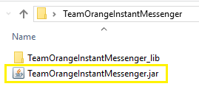
3. You will see the **“Account” Screen**.  
   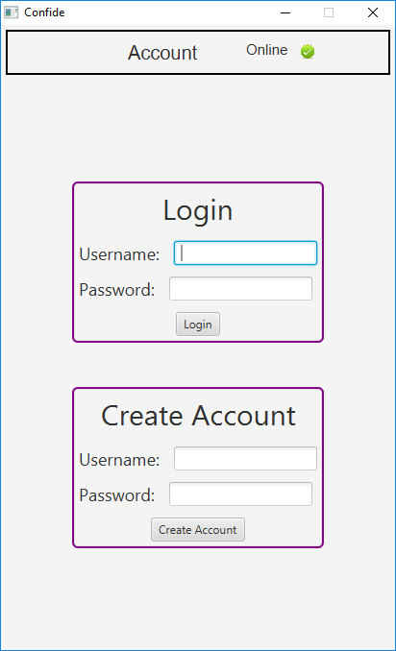

**Back To Contents**

**Application Status and Navigation****Status Bar**

Up the top of the screen there is a status bar, which displays the connection status on the right, the current screen in the center, and the user who is logged in on the left (if a user is logged in).

Examples:

1. Account Screen with no connection and no user logged in  
   
2. Account Screen with a connection and no user logged in  
   
3. Contacts Screen with a connection and user1 logged in  
   

**Back To Contents**

**Navigation Bar**When logged in, the navigation bar will always be present at the bottom of the screen.  
The currently selected button is displayed in white, in the example below the **“Contacts” button** is selected.

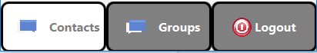

1. The **“Contacts” button** will take you to the **“Contacts” screen**, from here you interact with and manage your contacts.
2. The **“Groups” button** will take you to the **“Groups” screen**, from here you can interact with and manage your groups.
3. The **“Logout” button** will log you out, and return you to the **“Account” screen**.

**Back To Contents**

**Notifications**

If there is new activity in one of your contact or group chats, then the image will display a red one on the top right of the image.  
 For example:  
 **No New Activity New Activity  
  **

**Accounts**

**Create an Account**

1. Open the application and fill in the **user-name** and **password** fields in the **create account section**.
2. Press **“Enter”** or click on the **“Create Account” button**.  
   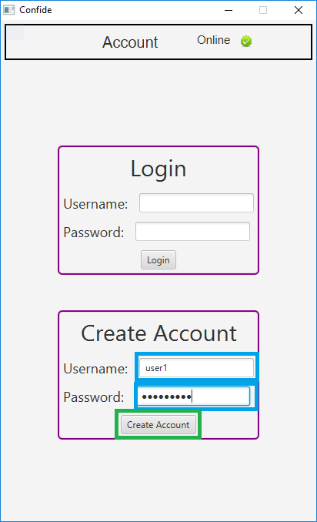
3. You will see an alert pop up that will alert you too the result.  
   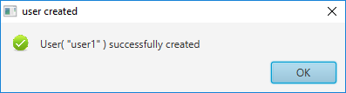

**Back To Contents**

**Login**

1. Open the application and fill in the **user-name** and **password** fields in the **login section**.
2. Press **“Enter”** or click on the **“Login” button**.  
   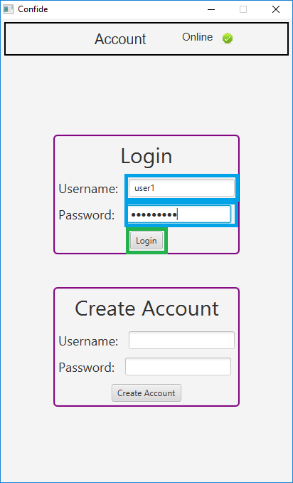
3. You will either see the screen change to the contacts screen upon successful login, or an alert will be displayed providing further information.  
   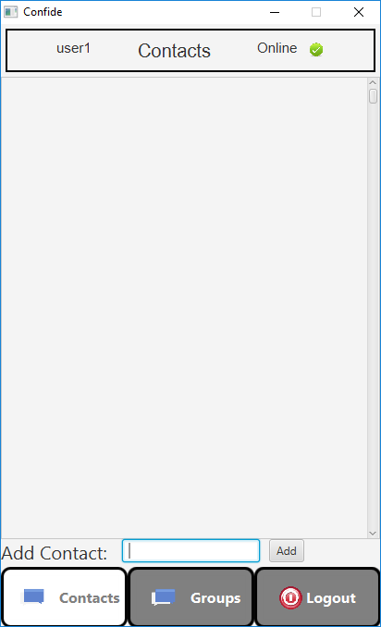

**Back To Contents**

**Logout**

1. Click on the **“Logout” button** on the right of the right hand side of the **Navigation Bar**.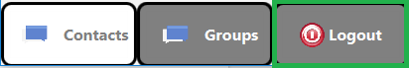
2. You will see the **“Account” Screen**.  
   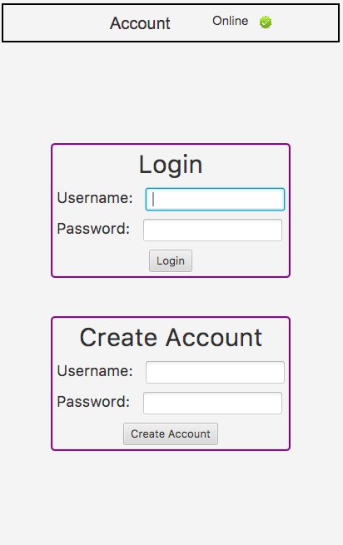

**Back To Contents**

**Contacts**  
**Send a Contact-Add Request** 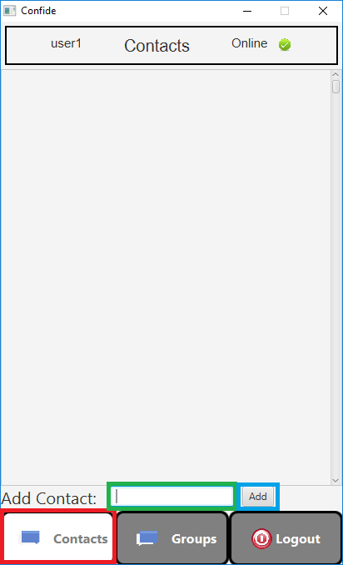

1. Once logged in, go to the **“Contacts” screen** (if you are not already), by pressing the **“Contacts” button** on the left hand side of the **Navigation Bar**.
2. In the **“Add Contact” input box**, type the user-name of the user you wish to send a contact request to.
3. Press **“Enter”** or click on the **“Add” button**.
4. You will see an alert notifying you that the contact-add request was successfully sent.  
   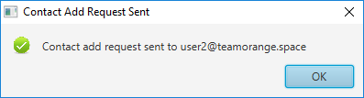

**Back To Contents**

**Respond to a Contact-Add Request**

1. Once logged in, go to the “Contacts” screen (if you are not already), by clicking on the **“Contacts” button** on the left hand side of the **Navigation Bar**.  
   
2. You will see a **contact request**. 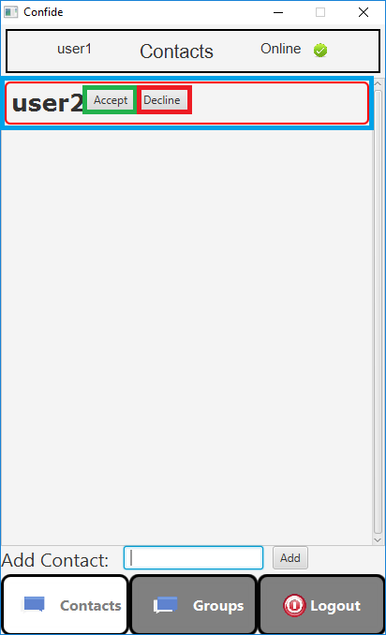  
   1. Click the **“Accept” button** to accept the request and become contacts with this user. The request will disappear, and the contact will be added.  
      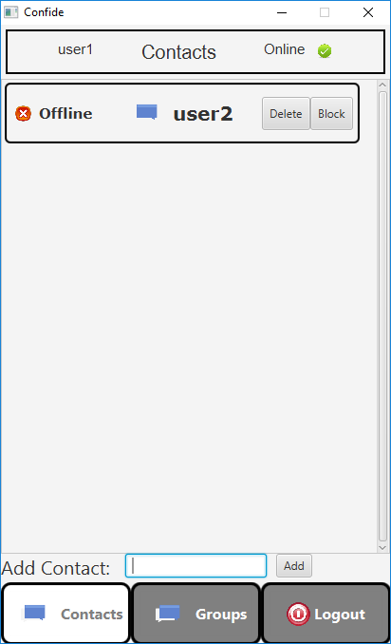
   2. Click the **“Decline” button** to decline the request. The contact request will be removed, and you will not become contacts with this user.

**Back To Contents**

**Delete a Contact**

1. Once logged in, go to the **“Contacts” screen** (if you are not already), by clicking on the **“Contacts” button** on the left hand side of the **Navigation Bar**.  
   
2. Click on the **“Delete” button** next to the contact that you wish to delete.  
   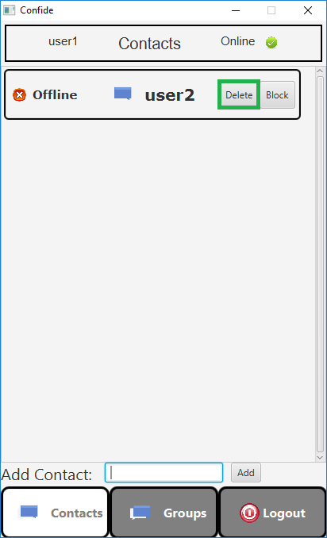
3. You will see the contact disappear from your contact list.

**Back To Contents**

**Block a Contact**

1. Once logged in, go to the **“Contacts” screen** (if you are not already), by clicking on the **“Contacts” button** on the left hand side of the **Navigation Bar**.  
   
2. Click on the **“Block” button** next to the contact that you wish to block.  
   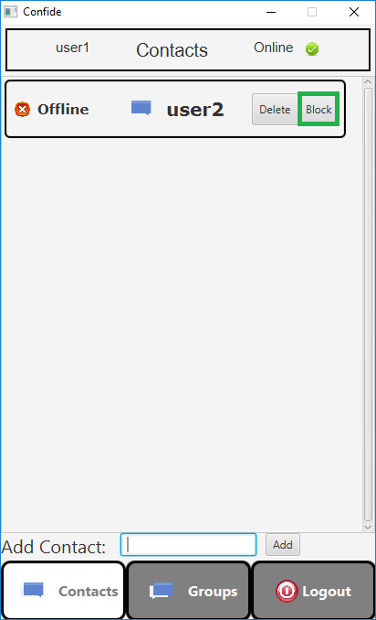
3. You will see the contact disappear from your contact list.

**Back To Contents**

**Chat with a Contact**

Chats with your contacts are temporary real time chats, they are not saved or stored between sessions.

1. Once logged in, go to the **“Contacts” screen** (if you are not already), by clicking on the **“Contacts” button** on the left and side of the **Navigation Bar**.  
   
2. Click on the **contact** you wish to chat with.  
   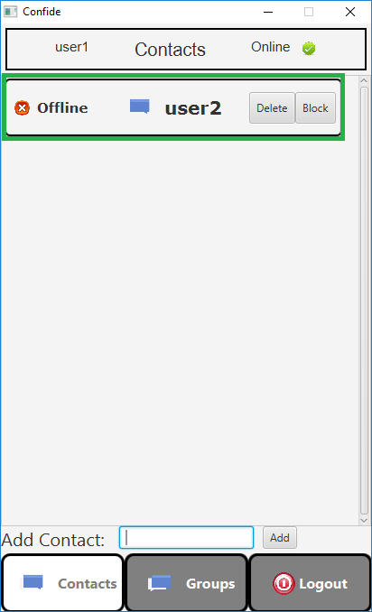
3. You will see the chat screen.  
   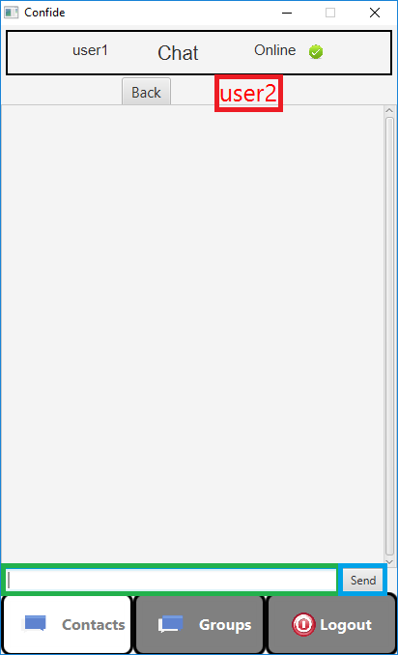
   1. The user that you are chatting with is displayed at the **top**, below the status bar. Their name will be written in green if they are online, or red if they are offline.
   2. To create a message, type into the **input box**.
   3. To send a message, either press “Enter” or click on the **“Send” button**.

**Back To Contents**

**Determine if a Contact is Online**

1. Once logged in, go to the **“Contacts” screen** (if you are not already), by clicking on the **“Contacts” button** on the left and side of the **Navigation Bar**.  
   
2. All Contacts will display if they are online or offline.  
   For example, below **user2** is online while **user3** is offline.  
   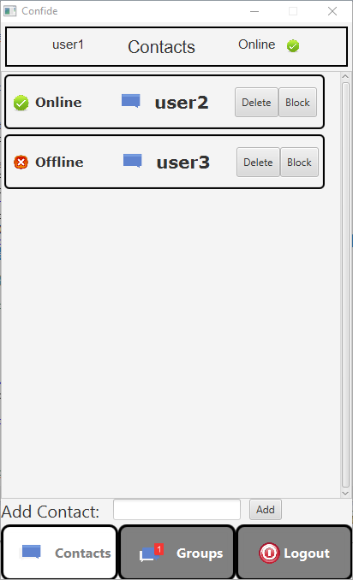

**Back To Contents**

**Groups****Create a Group**

Group chats can have multiple members. These chats are stored between sessions.

1. Once logged in, go to the **“Groups” screen** (if you are not already), by clicking on the **“Groups” button** at the center of the **Navigation Bar**.  
   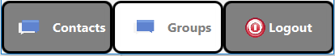
2. Click on the **“Add Group” button**.

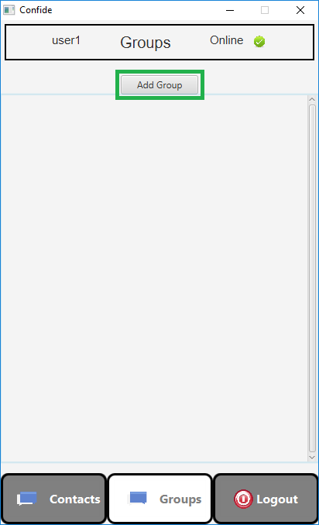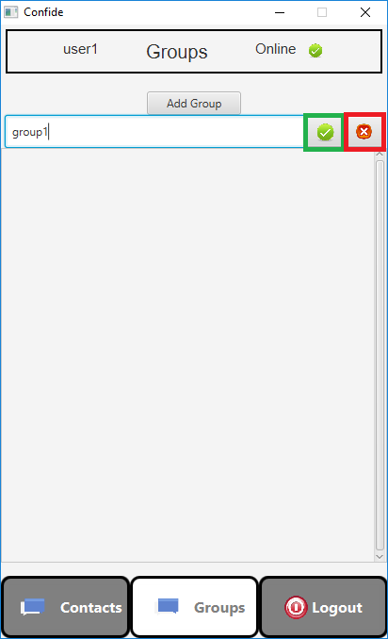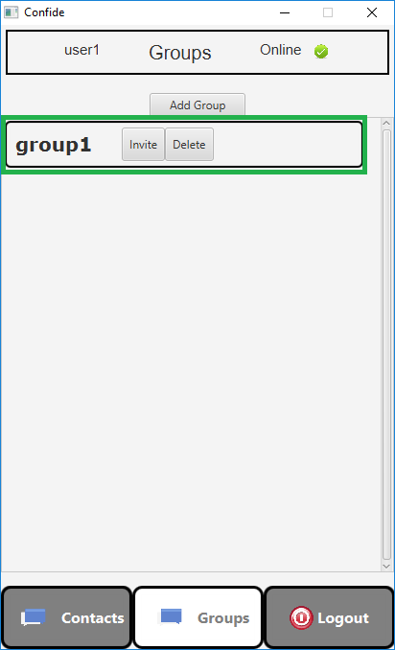

1. Name the group by typing the chosen name.
2. Confirm or Cancel this group creation.
   1. Create the group by either pressing “Enter” or clicking on the **“Create” button**.
   2. Cancel the group by either pressing “Escape” or clicking on the **“Cancel” button**.
3. You will see the new **group** appear.

**Back To Contents**

**Delete a Group Chat**

1. Once logged in, go to the **“Groups” screen** (if you are not already), by clicking on the **“Groups” button** at the center of the **Navigation Bar**.  
   
2. Click on the **“Delete” button** of the group that you wish to delete.  
   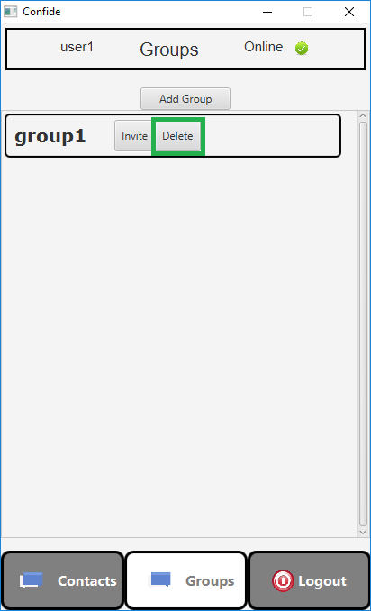
3. You will see the group disappear.

**Back To Contents**

**Invite Contacts to a Group Chat**

1. Once logged in, go to the **“Groups” screen** (if you are not already), by clicking on the **“Groups” button** at the center of the **Navigation Bar**.  
   
2. Click on the **“Invite” button** of the group that you wish to delete.  
   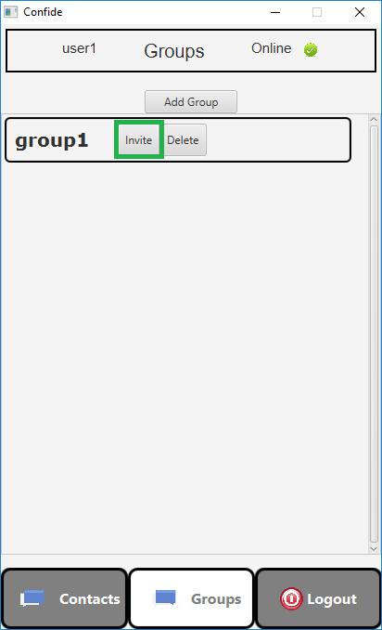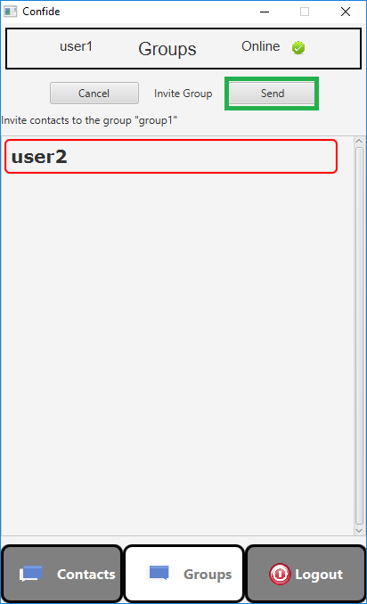
3. You will see a list of your contacts.
4. Select any contacts you wish to invite, and click on the **send button**.**Back To Contents**

**Open a Group**

1. Once logged in, go to the **“Groups” screen** (if you are not already), by clicking on the **“Groups” button** at the center of the **Navigation Bar**.  
   
2. You will see a list of **your groups**.  
   
3. Click on a group to open it.
4. From here you can:
   1. Send a message
      1. Type a message.
      2. Either press “Enter” or click on the **“Send” button**.
   2. Exit this group
      1. Click on the **“Back” button**.
   3. View messages
      1. Messages you have sent are **green**.
      2. Messages others have sent are **blue**.
      3. Messages that have not yet finished sending are **red**.

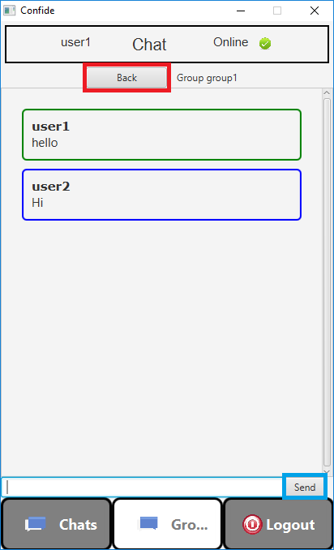

**Back To Contents**