SUPPLEMENTARY FIGURES

Figure S1. Maximum likelihood tree based on ND2 sequences from Welton et al. (2017) for Philippine Gonocephalus, with highlighted clades indicating the 12 putative lineages they identified. Filled circles at the nodes indicate ultrafast bootstrap values. The scale bar shows the substitution rate per site.
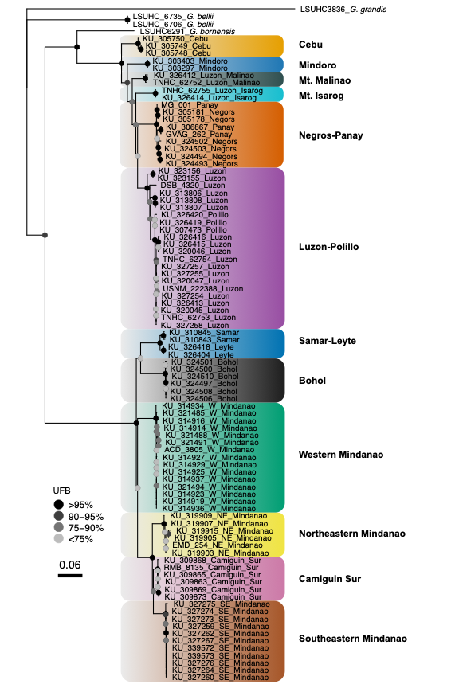
Figure S2. Maximum likelihood tree based on reduced ND2 sequences of Philippine Gonocephalus from Welton et al. (2017). This tree was used as input for the Multi-rate Poisson Tree Processes (mPTP) species delimitation analysis. Filled circles at the nodes indicate ultrafast bootstrap values. The scale bar shows the rate of substitutions per site.
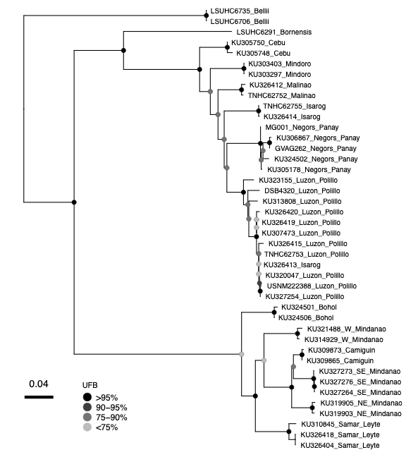

Figure S3. Cloudogram generated using StarBeast3, based on six nuclear DNA genes involving Philippine Gonocephalus and G. bellii from Welton et al. (2017). The consensus species tree is depicted by solid blue lines, with highly supported posterior probabilities (>0.95) denoted by filled black circles. This species tree served as a guide input tree for the Hierarchical Heuristic Species Delimitation (HHSD) analysis.

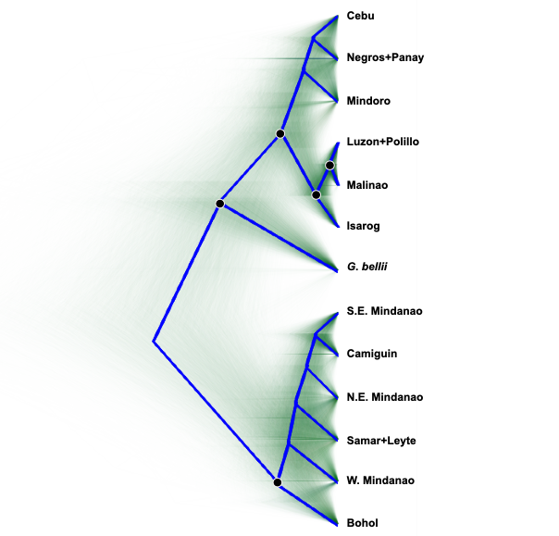

Figure S4. Stacked bar charts depicting ancestry assignments for each sample in relation to the number of unique clusters, according to expected clusters as informed by our phylogenetic and morphological assessment (K = 2), the optimal number of clusters indicated by the lowest cross-validation error (K = 9,11), and the number of clusters corresponding to the previously identified putative lineages (K = 13). The admixture results are based on the filtered SNP dataset containing singletons (i.e., SNPs with a minor allele count of one; A), the filtered dataset without singletons (B), and the thinned dataset without singletons (C). The color schemes correspond to the number of cluster assignments.

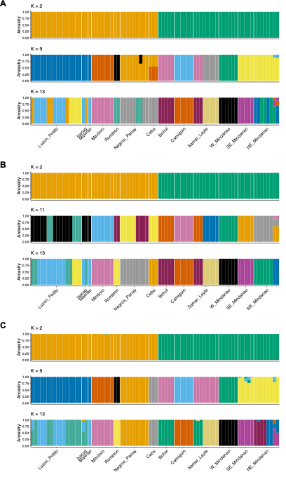
Figure S5. Results of univariate comparisons of mensural and meristic characters across Gonocephalus populations using the combined dataset, derived from Tukey’s HSD, Dunn, and the Chi-square tests (for details, see methods). Statistically significant p-values are denoted in dark blue, while non-significant p-values are indicated in light blue. The size of each point reflects the magnitude of the p-value. Pairwise comparisons are color-coded based on the inferred species. The solid box highlights comparisons between putative lineages within each of the two Philippine species, showing characters with fewer traits that are significantly different relative to comparisons between species. See methods for character acronyms.

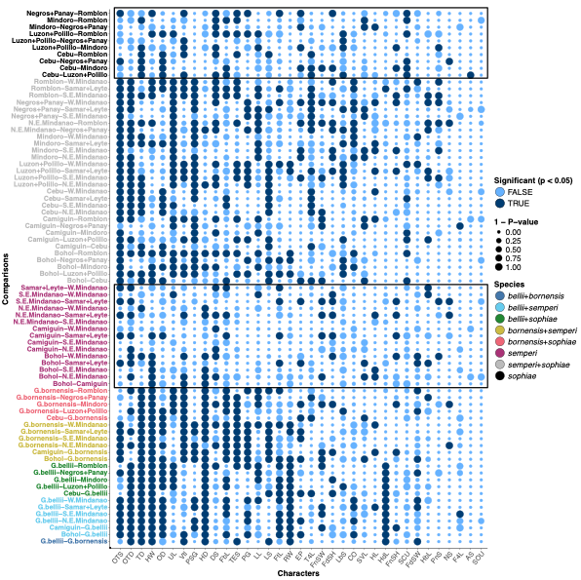

Figure S6. Results of univariate comparisons of mensural and meristic characters across Gonocephalus populations using a female-only dataset. P-values were derived from Tukey’s HSD, Dunn, and the Chi-square tests (for details, see Methods). Statistically significant p-values are denoted in dark blue, while non-significant p-values are indicated in light blue. The size of each point reflects the magnitude of the p-value. Pairwise comparisons are color-coded based on the inferred species. See methods for character acronyms.

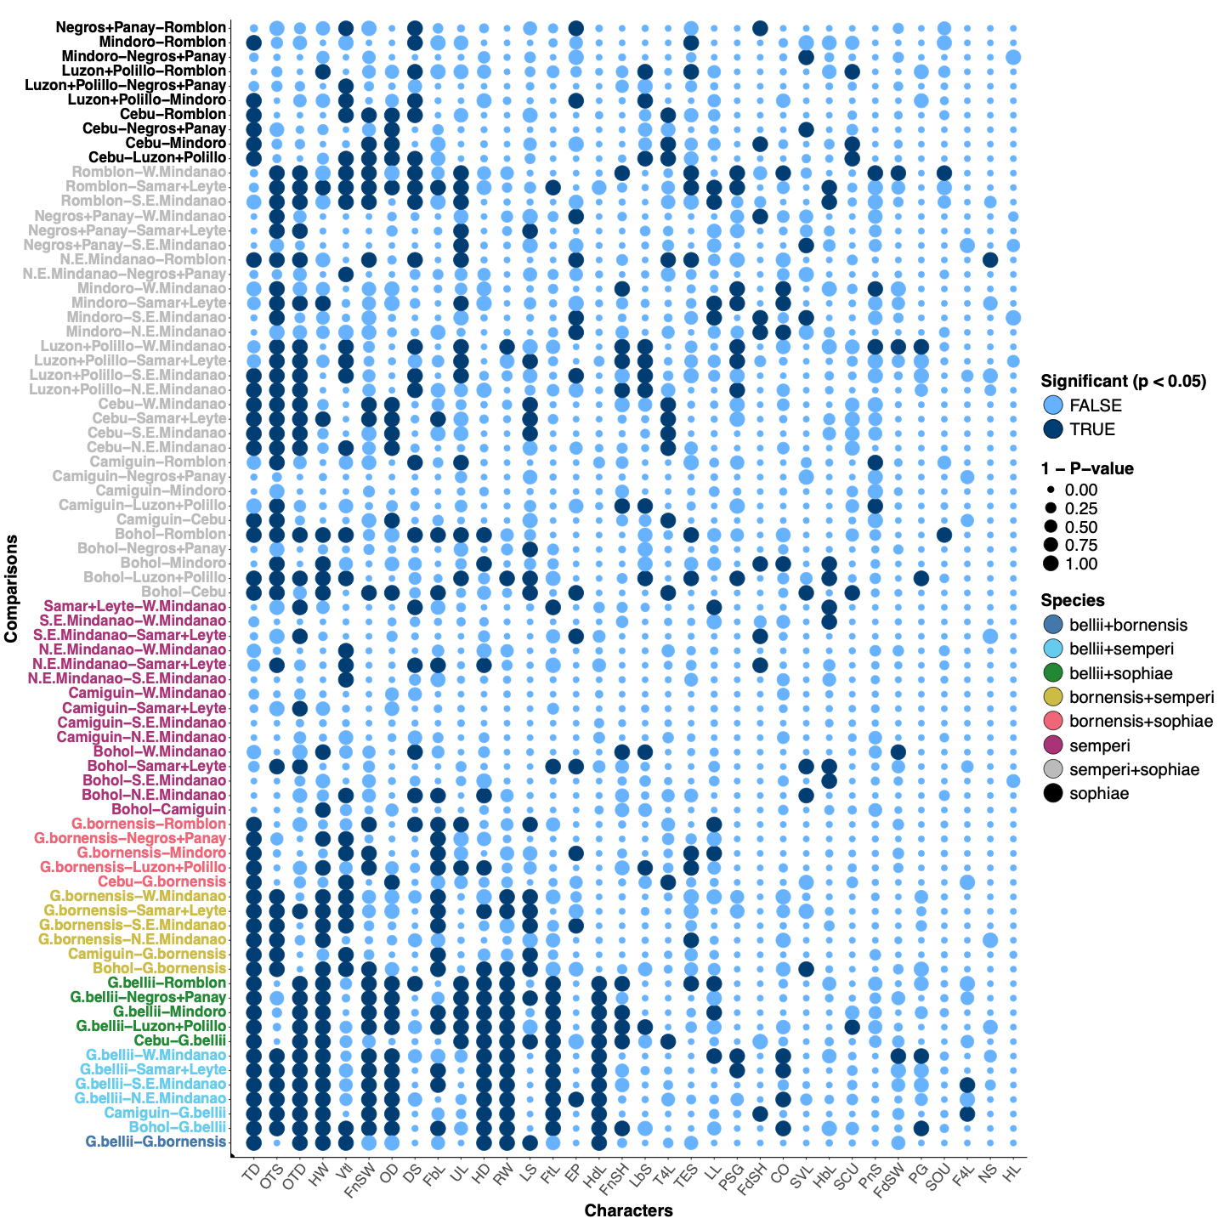

Figure S7. Results of univariate comparisons of mensural and meristic characters across Gonocephalus populations using a male-only dataset. P-values were derived from Tukey’s HSD, Dunn, and Chi-square tests (for details, see Methods). Statistically significant p-values are denoted in dark blue, while non-significant p-values are indicated in light blue. The size of each point reflects the magnitude of the p-value. Pairwise comparisons are color-coded based on the inferred species. See methods for character acronyms.

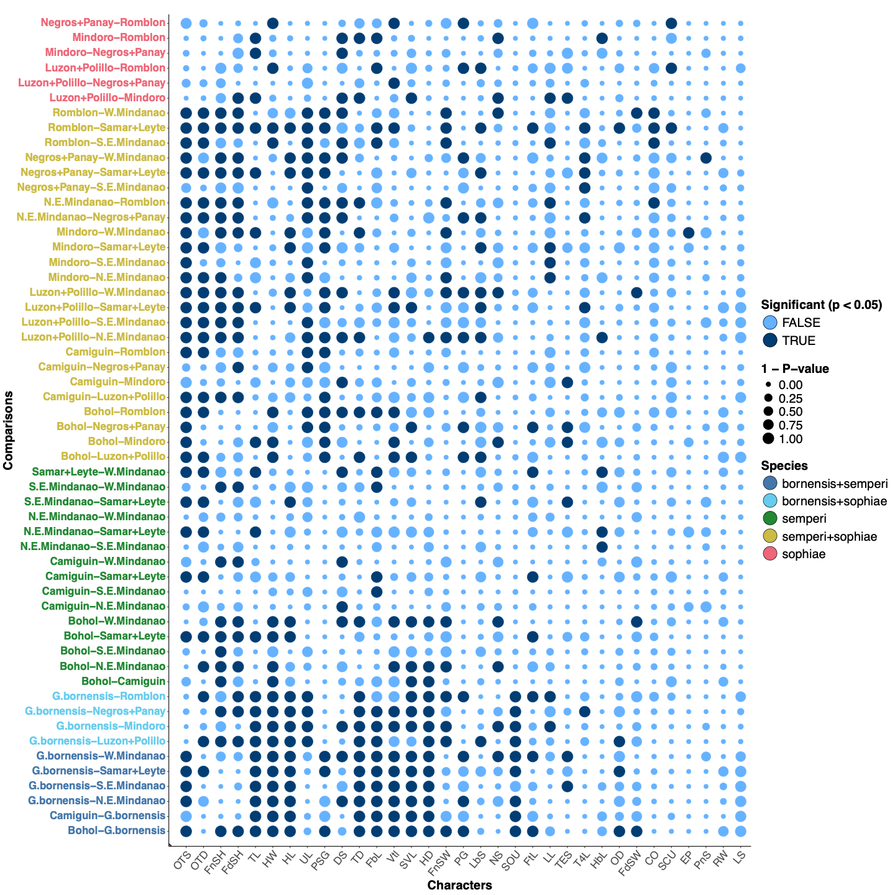

Figure S8. Principal component analysis of mensural and meristic characters using the adult combined dataset (A), male-only dataset (B), and female-only dataset (C). Point shapes indicate samples from the outgroup, putative lineages, and known types of Philippine Gonocephalus. Dashed polygons represent the 95% confidence ellipse for each group of samples.

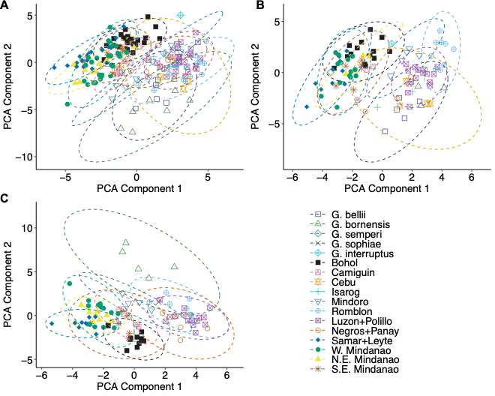

Figure S9. Principal component analysis of mensural and meristic characters using the juvenile dataset. Point shapes indicate samples from the putative lineages and known types of Philippine Gonocephalus. Dashed polygons represent the 95% confidence ellipse for each group of samples.

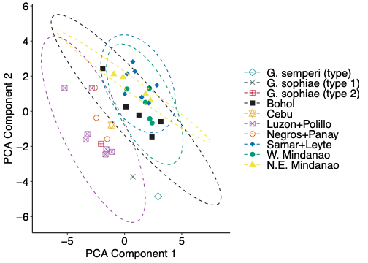

Figure S10. A biplot showing the results of Support Vector Machine (SVM) analysis on the first and second components of Principal Component Analysis (PCA), based on adult mensural and meristic characteristics. Colored polygons indicate the predicted classifications (putative lineages), while point shapes represent the a priori classifications. The classification accuracy stands at only 52%, suggesting challenges in accurately assigning putative lineages to their respective classes, potentially due to the considerable overlap of morphological traits.

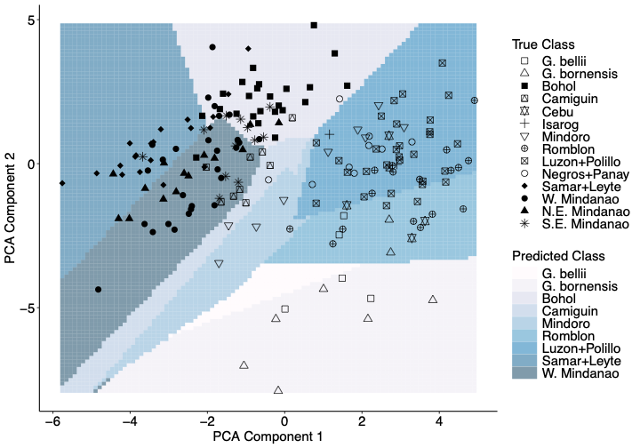

Figure S11. A biplot showing the results of SVM analysis on the first and second components of PCA, based on juvenile mensural and meristic characteristics. Colored polygons indicate the predicted classifications, while point shapes represent the a priori classifications. The classification accuracy is only 57%, suggesting challenges in accurately assigning putative lineages to their respective classes, potentially due to the considerable overlap of morphological traits.

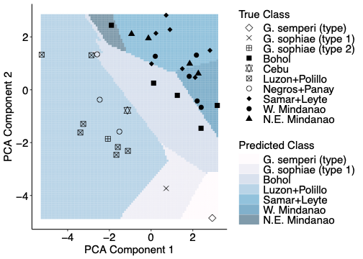

Figure S12. Summary of estimated migration rates derived from HSSDm for each iteration in populations with specified bidirectional migration using nDNA. The dot indicates the mean posterior migration rate, and the error bar shows the 95% credible interval.

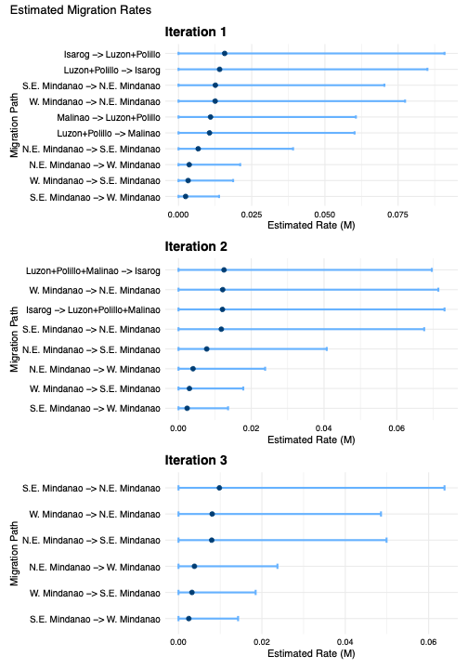

Figure S13. Summary of estimated migration rates derived from HSSDm for iterations 1–3 in populations with and without specified bidirectional migration using ddRAD loci. The dot indicates the mean posterior migration rate, and the error bar shows the 95% credible interval.

