Design Document for:

Psychic Showdown

(working title)

# Design History

## 0.1

-Basic GDD is created with a rough overview of the game.

## 0.2 (10/16/2016)

* Hydrokinesis User has been removed as a game character. The game now only has 3 characters: Psychokinesis User, Martial Artist, Pyrokinesis User.
* Board Size changed to 5x7.
* Added a Game Mechanics section and a large portion of the cards.

## 0.3 (10/28/2016)

* System Requirements, Game Controls & Interface, Replayability, and Asset List sections were added. (Nothing was yet added to the Asset List)

## 0.4 (10/31/2016)

* Added Inspiration and Examples section. Added Psychokinetic and Pyrokinetic character designs to the Asset List.

# Genre

* Strategy (Card Game Specifically)

# System Requirements

Playable on most PCs with plans to move to mobile distributions as well. (Primarily phones and tablets.)

# Game Mechanics

## General Features

* 3 Playable Characters
* Single Player Campaign that allows you to level up to unlock cards
* Possible multiplayer

## Gameplay

Players pick one of three playable characters to battle with on a 5x7 board. The board has obstacles of 3 sizes (Small, Medium, and Large) placed on it (Either randomly or pre-placed). Obstacle spaces cannot be walked on or over, but can be manipulated with card effects. Obstacles can take damage and break into smaller obstacles, with Small Obstacles being removed from the map if broken. Players start with 20 health and lose if their health drops to 0. If a player would draw a card when they’re out of cards in their deck, their discard pile is shuffled and becomes their new deck.

Outside of combat players earn experience and gain levels for their chosen character to unlock cards to customize their deck. Each character has 10 unique cards and 1 common card. The common card acts as a simple action that is very easy for the character to use. If we have a resource system of some kind, the common card is the cheapest card to play. The deck must be 20 cards exactly. 10 copies of the common card are automatically put in the deck, allowing the player to control the other 10 cards, putting no more than 2 copies of any other card in the deck.

## General Mechanics

* 3D, multiple camera angles. (Might be a mix of 2D and 3D with the board being viewed from a single angle.)
* Each player has a 20 card deck made of cards selected from the pool available to the chosen character.
* Each character has one basic card. 10 copies of that card are automatically put in the deck. The other 10 cards in the deck can be made from that character’s card pool at no more than 2 copies of any particular card.
* Players control a single character on a grid.
* Players can make one movement per turn. Most characters move 2 spaces at a time, but the martial artist may move 3 spaces. Movement is only possible in 4 directions (No diagonal movement).
* Players have a resource called Health. When depleted that player loses the game. Starting Health is 20.
* Players have a resource called Psy. At the start of every turn their Psy increases by 1 and is fully replenished. At max a player can have 5 Psy.
* Players start with 5 cards in hand. The player that goes first does not get to draw on their first turn.
* Players spend their Psy to play cards, in this way if the player has enough Psy they can play multiple cards in a turn.
* Every character has one basic card and ten cards available to their pool. They are as follows:
* Obstacles are present in the area and are interacted with in the following ways:
  + They can be attacked.
  + They can’t be walked through.
  + A character can’t attack through them in most cases, so it is possible to hide behind them.
  + The Psychokinesis user can lift and throw them.
* Obstacles have 1-3 health, if they’re used to attack a character by the psychokinesis user, they deal damage equal to their current health and take 1 damage. If they hit 0 they’re destroyed.

### Psychokinetic User Cards

Basic Card

Name: Psychic Slam

Psy Cost: 1

Range: 2

Effect: Deals 1 damage to a target.

Normal Cards

Name: Teleport

Psy Cost: 3

Range: 3

Effect: Move to a square, ignoring obstacles that may be in the way.

Name: Psychic Push

Psy Cost: 2

Range: 2

Effect: Move a target 2 squares. If it slams into another target, both targets take damage.

Name: Telepathy

Psy Cost: 3

Range: -

Effect: Look at the opponent’s hand. Draw a card.

Name: Obstacle Throw

Psy Cost: 2

Range: 1

Effect: Throw an obstacle in a straight line until it reaches the end of the board or hits something. (Can be thrown diagonal.)

Name: Brainstorm

Psy Cost: 5

Range: -

Effect: Draw 3 cards.

Name: Massive Pull

Psy Cost: 5

Range: -

Effect: Throw any obstacle on the board at any target. It deals an extra 3 damage.

### Martial Artist Cards

Basic Card

Name: Psych Up

Psy Cost: 1

Range: -

Effect: Increase the next damage you deal by 1.

Normal Cards

Name: Power Punch

Psy Cost: 2

Range: 1

Effect: Deal 1 target 2 damage.

Name: Crushing Kick

Psy Cost: 2

Range: 1

Effect: Destroy an obstacle. Draw a card.

Name: Obstacle Toss

Psy Cost: 3

Range: 1

Effect: Lift and throw an obstacle 4 squares. This goes over other obstacles.

Name: Jump Kick

Psy Cost: 4

Range: 3

Effect: Move until you hit a target, then deal 3 damage and push the target back 1 square.

Name: Meditate

Psy Cost: 4

Range: -

Effect: Draw 2 cards.

Name: Punch Barrage

Psy Cost: 5

Range: 1

Effect: 4 hits that deal 2 damage each to the target.

### Pyrokinetic User Cards

The Pyrokinetic User is built around lighting squares on fire. Fire squares deal 1 damage whenever a character moves on one, or 1 damage on the starts of their turn if they’re standing on one. They disappear after two of the opponent’s turns pass.

Basic Card

Name: Ignite

Psy Cost: 1

Range: 3

Effect: Light one square on fire.

Normal Cards

Name: Fireblast

Psy Cost: 2

Range: 2

Effect: Deal 1 damage, light the square on fire.

Name: Firewall

Psy Cost: 2

Range: 3

Effect: Light 3 squares on fire in a straight line.

Name: Spark of Genius

Psy Cost: 3

Range: -

Effect: Deal 2 damage to yourself, light the square you’re standing on on fire, draw 3 cards.

Name: Fire Punch

Psy Cost: 3

Range: 1

Effect: Deal 3 damage, light the square on fire.

Name: Flame Dash

Psy Cost: 4

Range: 3

Effect: Move 3 squares, light them all on fire.

Name: Fireball

Psy Cost: 5

Range: 4

Effect: Remove all fire from the board, deal damage equal to the number of fire removed this way.

# Game Controls & User Interface

The game will be playable entirely with a mouse. If ported to mobile systems this will allow it to be playable entirely on a touch screen. When capable of moving, players will click on their character and select the tile they want to move to from the available highlighted ones. Players will be able to click and drag cards in their hand to use them, hover over them to see what they do in more detail, and select target when the cards are in use.

# Replayability

As a multiplayer game, the replayability will be primarily built in the engagement of playing with other players. Occasionally new characters will be released, as well as expansions to the story to accommodate those characters.

# Design Goals

* To create a functional digital card game in a small amount of time. This requires a focus on simplicity without sacrificing engagement or the influence of player decision making and skill.
* One of the key factors to set this card game apart from others is the lack of “minion” or “creature” type cards. There are no cards that will summon other units for you to manage.

# Common Questions

### What is the game?

A collectable card game themed around characters of varying psychic abilities. Players will control a character, moving them about a square grid and using cards (that represent their character’s unique psychic abilities) to KO their opponent(s).

### Why create this game?

Digital card games are fairly simple to program compared to most video games. I’ve spent a lot of time studying game design elements in various card games, and have designed a few in the past.

### Where does this game take place?

It takes place in a modern setting. Places like modern cities, as well as forests and mountainous regions should be present. This affects the objects psychic’s can interact with aesthetically.

### What do I control?

The player will control one of 4 characters with psychic abilities: a character with Psychokinesis whose cards are themed around moving objects or characters around, a character with Pyrokinesis whose cards are themed around fire, a martial artist whose cards center around physical techniques that are augmented with their psychic abilities, and a character with Hydrokinesis whose cards are themed around water.

### How many characters do I control?

Only one. None of the characters have abilities that allow them to create extra characters to control.

### What’s the main focus?

The goal is to utilize your cards and the obstacles on the map to KO your opponent without being KO’d yourself.

### What’s different?

There are no card games centered around psychics, and very few card games that lack units that you create using cards. Most card games are centered around summoning something to fight for you, and the combat between those things. Removing this element changes design aspects and gameplay in a way that is different and interesting.

# Game Characters

## Psychokinesis User

When you think of psychic powers this character represents the first things to come to mind: Lifting people and objects into the air and throwing them, teleporting, and reading minds. As such, the primary way this character deals damage to their opponent will be throwing the objects on the board at them. Cards that throw small objects will be less expensive resource-wise than cards that throw large objects.

## Martial Artist

This character uses their psychic abilities to enhance their physical capabilities. They can naturally walk further than all of the other characters by default, and primarily use close range punches and kicks to deal damage. Incidentally, their attacks are also so strong that they can create new obstacles by damaging the ground as they attack. They should also have a card that allow them to pick up obstacles and throw them, though only one as they should not be good at ranged attacks.

## Pyrokinesis User

This character manipulates fire. Their attacks have a side effect of catching squares on fire, creating a special obstacle. Once per turn, characters that walk on the fire square, or end their turn on the fire square, take damage. If you pass through multiple fire squares you take damage for every square.

# Inspiration and Examples

## Final Fantasy Tactics (Series)

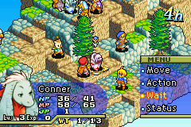

Final Fantasy Tactics offers turn based strategy combat where a player controls at most 6 characters. There are various missions where a player only controls one character. The thought of expanding upon those missions and making individual characters more intricate (by introducing a deck associated to the character) was partially an inspiration for this game.

(Screenshot taken from Final Fantasy Tactics Advance for Nintendo Gameboy Advance)

## Fire Emblem (Series)

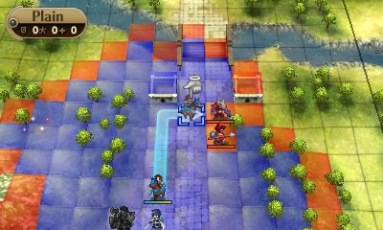

Fire Emblem, similar to Final Fantasy Tactics, offers turn based strategy combat where a player controls a large amount of characters, sometimes over 10. Features this game inspires include the choice to have a more normal view for the board, rather than the isometric view that Final Fantasy Tactics uses, having a visible grid at all times instead of only when attacking or moving, and the choice to highlight availble movement squares blue or squares you can attack red.

(Screenshot taken from Fire Emblem Awakening for Nintendo 3DS)

## Hearthstone

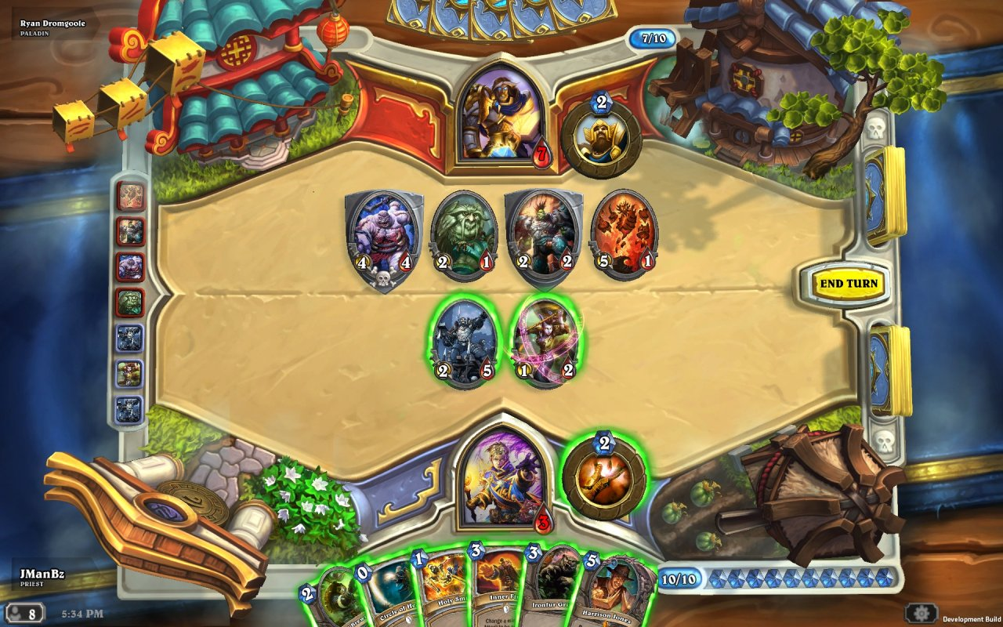

Hearthstone is a strategy game where players build decks around specific characters and battle similar decks by summoning minions and casting spells. Our game borrows heavily from Hearthstone, and its predecessors such as Magic: The Gathering, in that it uses a resource system called Psy, which similar to Hearthstone, has a limit on the total amount that can be acquired (In Magic: The Gathering, you can have as much of your resource (Mana) as you have lands that can produce it). It also borrows the concept of unique card sets being attributed to specific characters, that cannot be mixed together. This is useful for establishing and identity for each character.

(Screenshot taken from Hearthstone: Heroes of Warcraft for PC)

# Asset List

## Art

### Psychokinetic User

Character design.

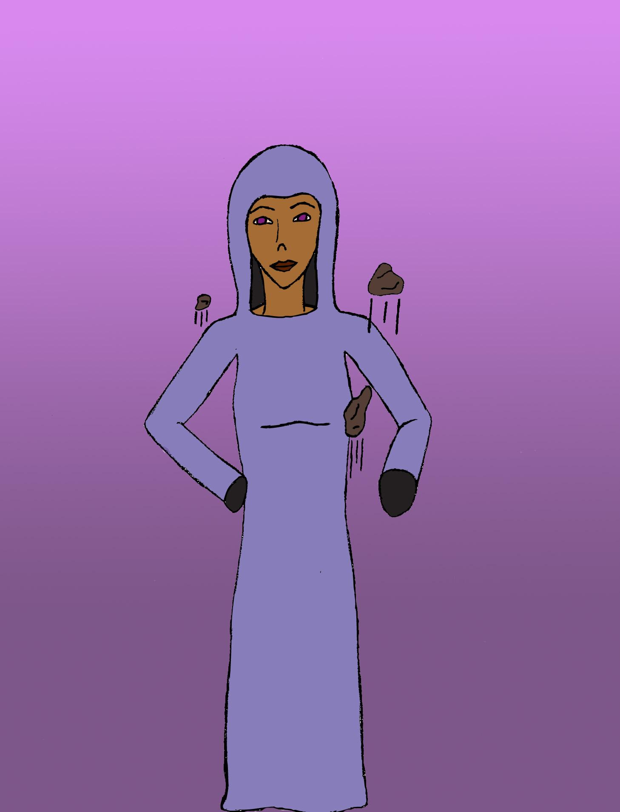

Transparent for use in information panel.

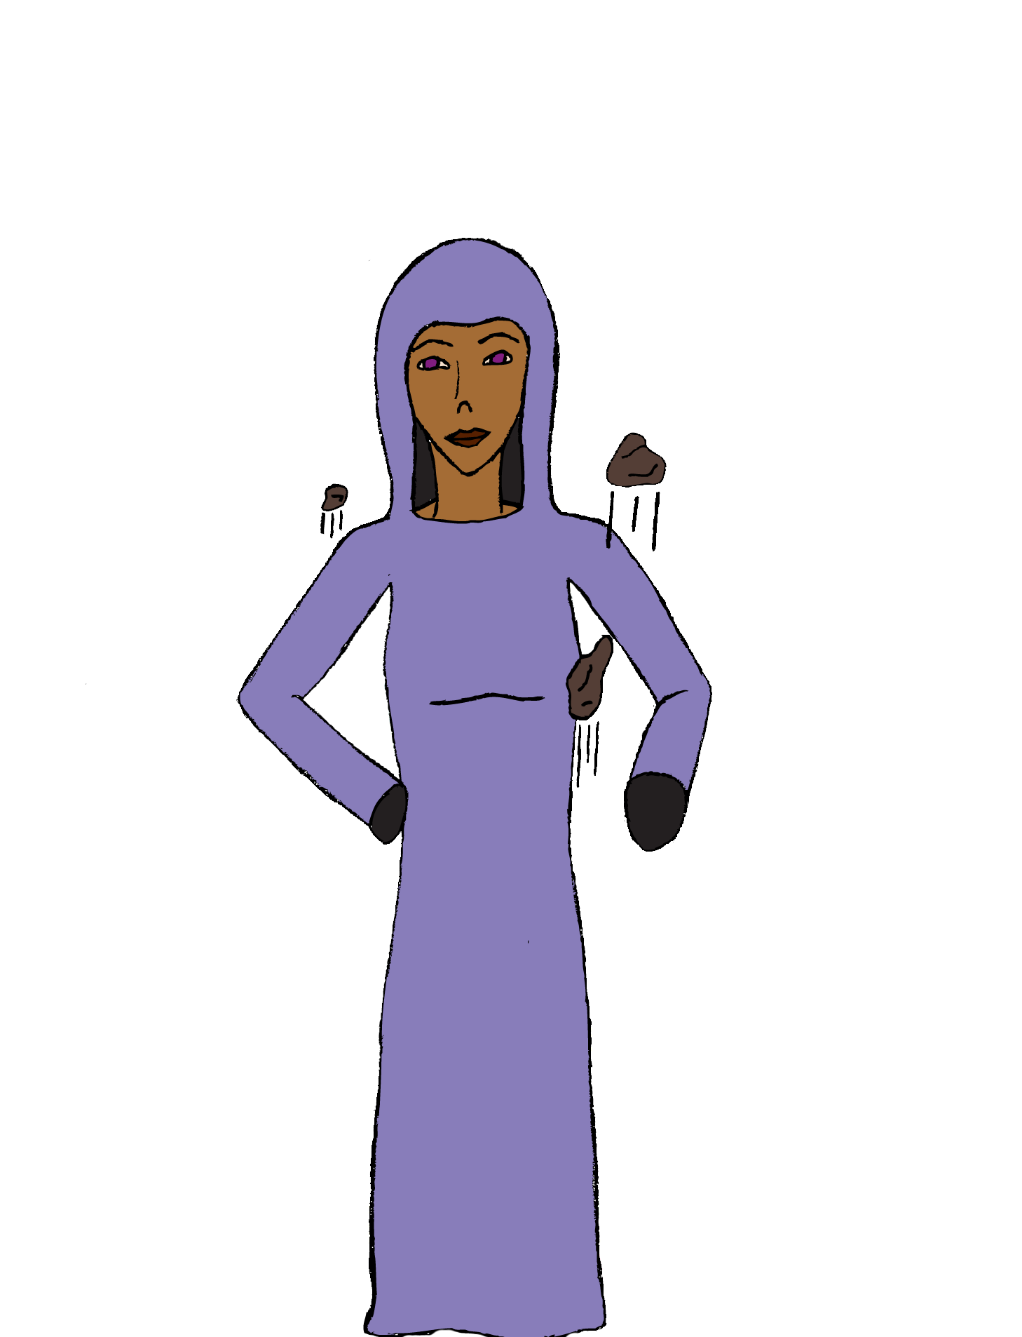

### Pyrokinetic User

Character design.

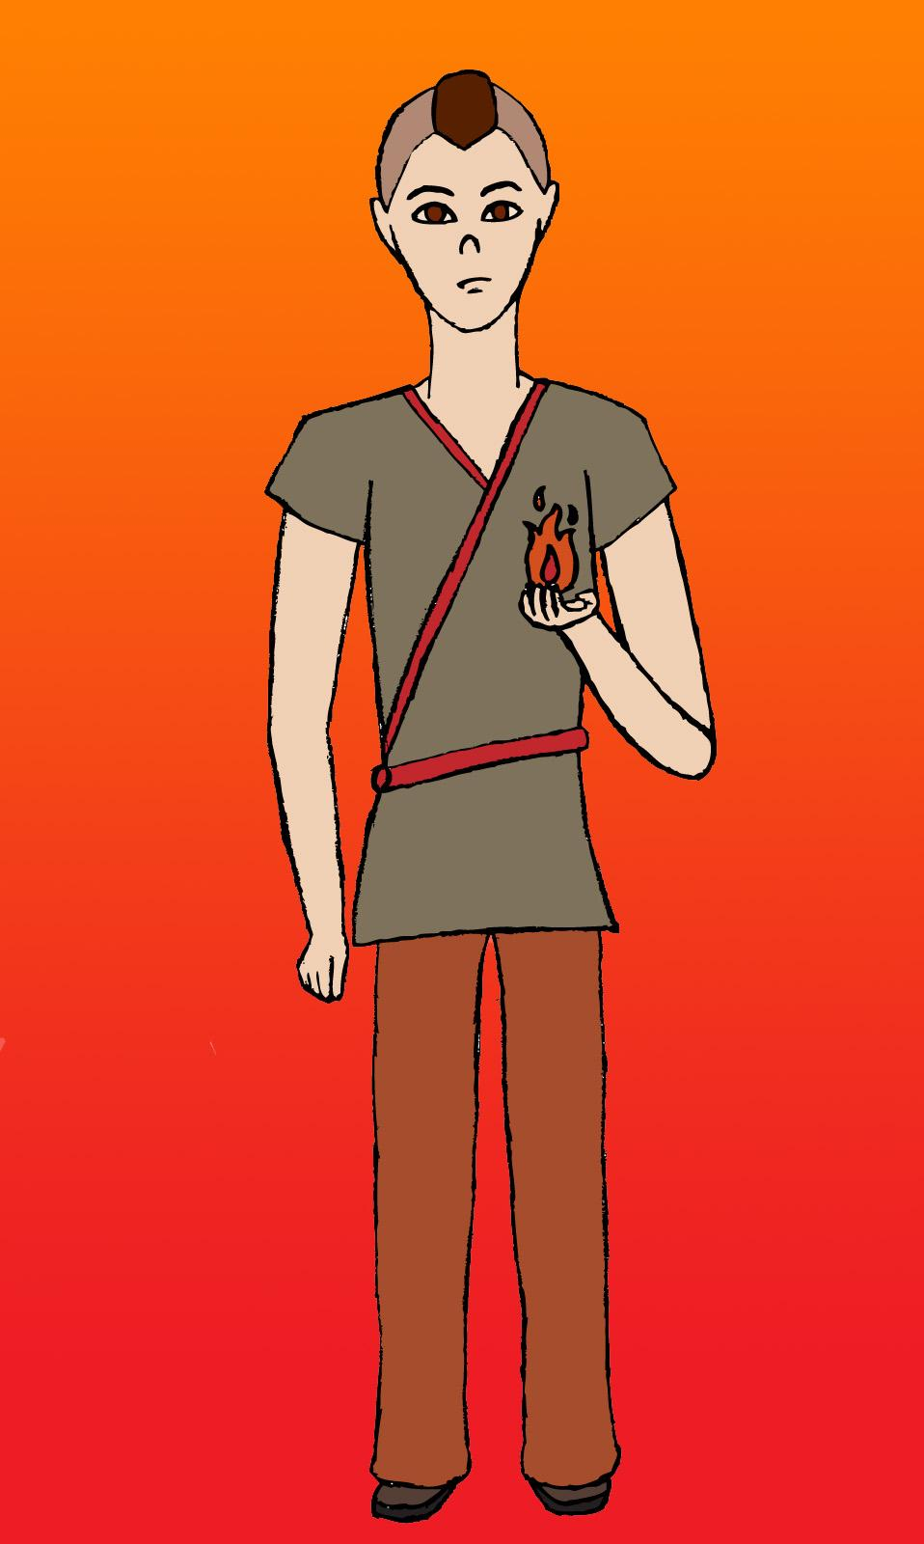

Transparent for use in information panel.

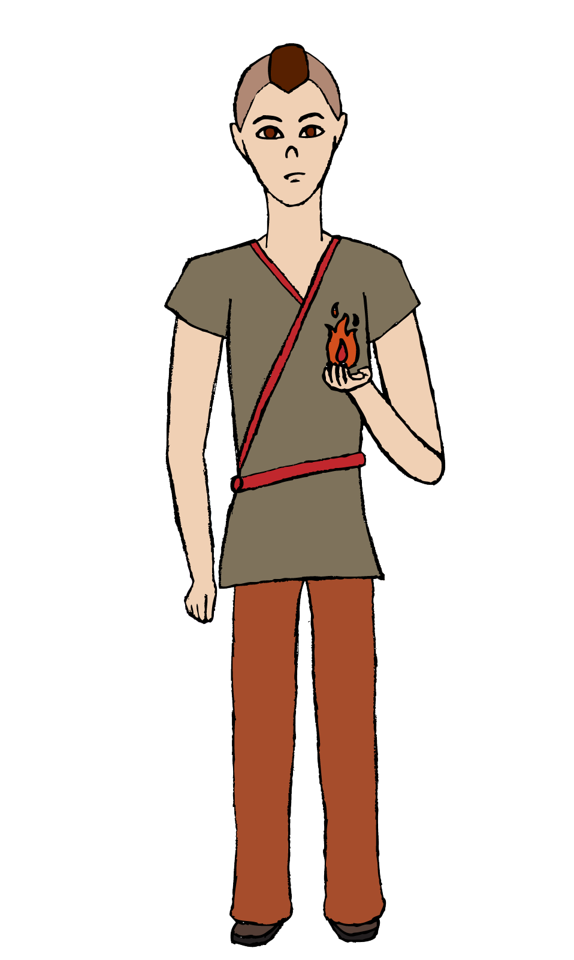

## Sound

### Punch Sound Effects

