A Wiki Paradigm for use in IT courses

Elharith Elrufaie and David A. Turner
Department of Computer Science
California State University, San Bernardino
San Bernardino, CA 92407
(Elharith.Elrufaie@cnet.com, dturner@csusb.edu)

Abstract

We present a system currently used by the department of Computer Science at the California State University, San Bernardino. The system extends the traditional wiki paradigm with features that make it useful as an instructional aid for IT courses. The most notable feature includes the use of strict XHTML for user input rather than traditional wiki markup. The use of XHTML serves three purposes: it requires IT students to learn XML syntax and concepts, it requires students to learn HTML, and it provides more flexibility to students and instructors when constructing pages. Additionally, we added other features not commonly found in wiki systems to better accommodate the needs of the classroom.

Keywords: Wiki, collaborative educational environments, learning XHTML.

Introduction

This paper describes a system that builds on a previous work [1]. In [2], wiki is defined as a social computing system that allows a group of users to initiate and evolve a hyper-linked set of web pages using a simple markup language. The Web pages that comprise a wiki allow users to freely create and edit their content by using any regular web browser in a quick and easy way. Such a system promotes an active learning environment in an educational setting, because students and instructors become co-creators of course content. However, we found that certain features not commonly found in wiki systems are useful in the context of university courses, and in particular, in the context of university IT courses [1]. These features include the following:

1. Instructors should be able to restrict modifiability of certain pages, such as a course syllabus or statement of assignments.
2. Students should be able to make pages private during a period of time that they construct them. In particular, if homework assignments are collected as wiki pages, students can develop their page submissions over a period of time and make them visible to others after their due date.
3. Although pages of a particular class are visible to the outside world, the instructor may wish to limit the ability to edit content to students in the class.
4. Each class should have its own distinct set of wiki pages, and the administration of the collection of all class wiki's should be convenient for the instructors and system administrator.
5. Students of IT can gain additional experience with XML and HTML by entering page content using the strict XHTML markup language.

The following section describes a system we implemented with these features.

System Operation

The main purpose of this system is to implement a teaching and a learning tool that works as an easy and quick communication interface between each instructor and his students. By teaching tool, we mean that both instructor and students can post coursework, and share information and knowledge in the course web page. By learning, we mean that users will be required to use XHTML for input; all input is parsed to determine if it is valid XHTML text, and will not be accepted otherwise. This system extends the traditional wiki by providing authorization functionality, that is, only authorized users (per class) are eligible to make changes in course pages.

Using this system, pages are created and modified quickly and easily. An instructor will be able to publish course materials, post announcements, presentations timetable, and other information on the web. If the student is enrolled in the course, she will be able to edit these pages and can add, for example, her presentation title to the presentations timetable, or her paper abstract to a term paper page.

This extensible paradigm, defines four types of users: guest, student, instructor and administrator. The guest user will just be able to surf the wiki pages, with no privilege to edit any of these pages. The other user roles are described in the following paragraphs.

Students need to obtain a login name and password through the system registration page. Once a student logs in, she can see listed classes, and can apply for membership in one or more listed classes. If she requests to add class X, she must wait until the instructor admits her into the class. The instructor accepts the student applicant into the course by locating her name in the class roster. As soon as the student is admitted, her status is changed from pending to active, and afterwards the student can edit and create pages in the course wiki. Otherwise, the student status is set to rejected. In either case, the student is informed by email of any change in her status.

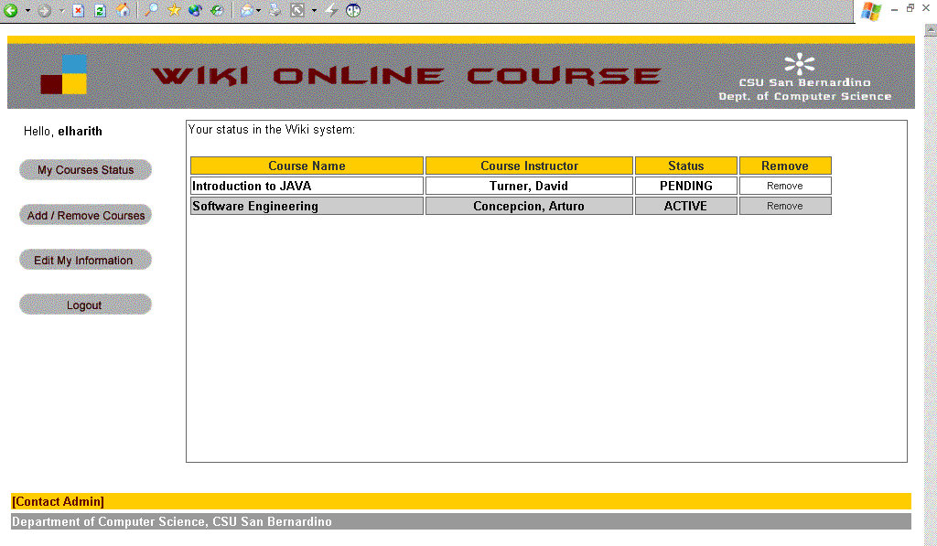
Figure 1: Student home page with a list of her status per class.

Similar to students, instructors also initially register through a registration page, and must wait for approval by the system administrator before acquiring the functionalities available to an instructor. After the system administrator activates the instructor’s account, the instructor can create course wikis, and begin admitting (or rejecting) student applications to join these courses.

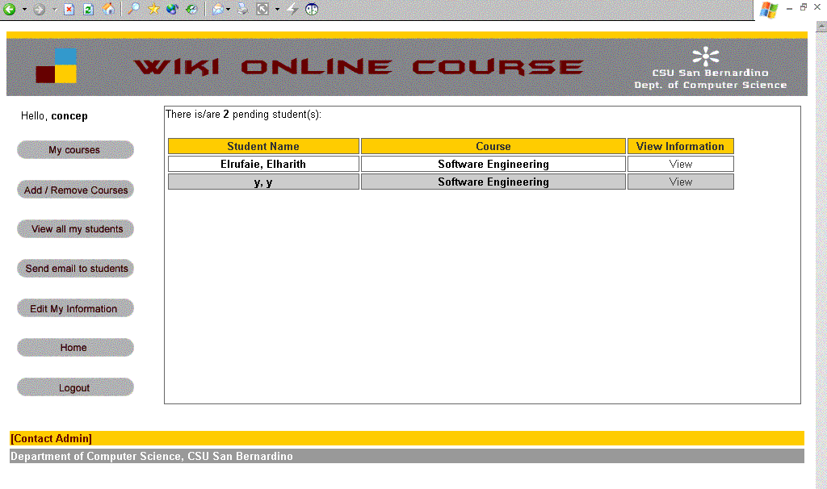
Figure 2: Instructor homepage with a list of pending students.

The system administrator user is a build-in user (who can set his or her password), which verifies the instructor information, and has super user privileges to view and modify all the pages in the system. The system administrator is also an instructor, meaning that he inherits all the functionality of an instructor to create new course pages and process student membership applications.

Learning Environment

One of the main goals of the system is to deliver learning value. Thus, we decided to use the strict version of XHTML as markup language for page content. Thus, users are required to format page content by embedding it within appropriate XHTML markup tags. When a user submits new page content, the system verifies that it is valid XML that conforms to the DTD that defines strict XHTML. If the markup is in error, the submitted content is returned to the user for corrections. In this manner, users develop an active working knowledge of XHTML through an iterative hands-on experience.

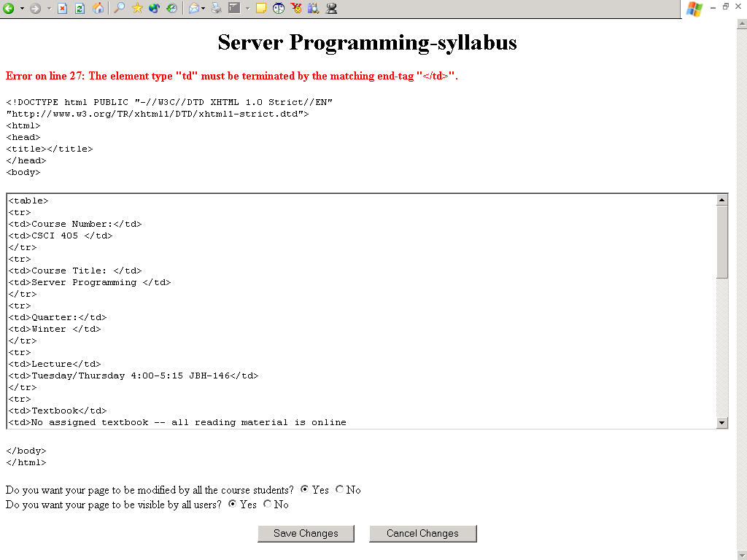
Figure 3: XHML error.

Wiki Page Characteristics

In this system, every page has an owner (the page creator), and has two other characteristics: modifiability and visibility. Because all students are given write privileges for any class wiki they are member of, it is not acceptable to allow students to edit the course syllabus or assignment sheet. Thus, the creator of the page (instructor in this example) can disable the write option for these specific types of pages. As a result, the instructor will be the only user who can edit these pages. Another scenario is when a student submits homework as a page in the class wiki. In this case, he can disable the access option, meaning that only the student, instructor and the administrator will be able to view this page. If any user (student or guest) tries to access this page, he'll get an error page. To avoid any extensive hacking attacks, the same error page is given for guests as if he requested a page which does not exist.

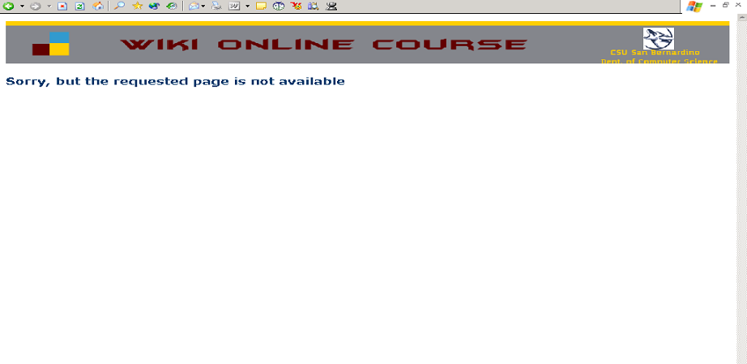

Figure 4: Error page when page is not available or the page is hidden.

The system is flexible enough to change these options anytime by the page owner. Let us say the student gave excellent answers and the instructor wants to refer to his answer as a model. In this case, the student can easily allow the visibility options, but disable the write option, so that others can view the page but modify it.

Users Functionalities

An accepted student in class X will be able to:

1. Create pages.
2. Delete pages that she created.
3. Set the visibility and modifiability attributes of any page she owns.
4. Modify pages in class X, unless the page is read-only and she does not own the page.
5. Edit personal information (change password, etc.).

An instructor of class X will be able to:

1. Start a new class wiki in the system.
2. Approve and reject applications to become students of the classes.
3. View and edit any page in class X, even if the page is hidden or set to read-only.
4. View his students’ information.
5. Edit personal information.

In addition of having all the instructor privileges, the system administrator can do the following:

1. Approve and reject applications to become instructor-level users.
2. Delete a user.
3. View and edit any page in the system, even if the page is hidden or set to read-only.
4. Edit user’s information.

Implementation Environment

The system is written in Java, and was designed according to the Model-View-Controller (MVC) architectural pattern for Java web applications. Hibernate persistence framework [3] was used to create a layer of abstraction that isolates the code from details of saving the state of objects in the database. Deployment was done using the tomcat web application container and PostgreSQL database server.

Conclusion and Future Work

Although enabling a user to enter valid XHTML text is a good learning benefit, it has some security threats. Such as, a user can add malicious codes and java scripts functions to the page that can harm all the page users and visitors. To avoid this, logging can be added to the system, so that the instructor or the administrator knows who did what in any page. Another future idea is to enable each user to have a file repository, which can allow him to upload, remove and browse different types of files in his pages. One last future idea is to enable the instructor of choosing which XHTML version he wants to use per class, rather than enforcing all students in all classes (with different levels) to use the strict version. Foe example, an instructor may want to use the simple XHTML version for freshmen classes for example

The implementation of this project was done to fulfill the requirements for a master’s degree at California State University, San Bernardino [4]. This paper shows a successful implementation of extending the wiki paradigm to serve a whole department of instructors involved in teaching information technology. The system has been designed and implemented with highly effective contemporary tools and technologies, which makes it flexible for more enhancements and improvements. The system is capable of handling sets of courses offered by set of instructors, where students can be enrolled in more than one class. Moreover, the wiki part works with XHTML validation, which provides an excellent learning environment for IT students.

References

[1] C. Wang and D. Turner. Extending the Wiki Paradigm or use in Classroom. In proceedings of the International Conference on Information Technology (ITCC 2004), 2004.

[2] B Leuf and W. Cunningham. The Wiki way: Quick collaboration of the web. Addison-Wesley, 2001.

[3] Hibernate Persistent Framework. http://www.hibernate.org
[4]. E. Elrufaie. A Wiki Paradigm to Manage Online Course Content. A Project In Partial Fulfillment of the Requirements for the Degree Master of Science in Computer Science. Technical Report, CSU San Bernardino- Department of Computer Science, 2004.

