Optimal Streaming of Stored Scalable Multimedia

David A. Turner
California State University San Bernardino
turner@csci.csusb.edu

Abstract

This paper demonstrates several methods of determining refined max-min optimal transmission policies for stored scalable multimedia. Coarse-grained and fine-grained scalability is considered, along with the cases of an infinite and finite client pre-fetch buffer. A lexicographic criterion called the refined max-min quality criterion is used to determine an optimal transmission policy from the set of feasible policies, where a feasible policy is one in which the stream’s component media units arrive on time at the client and do not overflow the client pre-fetch buffer. An Ogg Vorbis audio stream is used to demonstrate the practical application of the approach.

Introduction

Scalable data representations provide three benefits to distributed asynchronous multimedia systems. First, applications can scale down multimedia data so that play-out commences at the client after a short delay, and continues without interruption until the end of play-out. Second, applications can employ scaling to avoid overflowing client memory by reducing the size of the data representation. This is particularly relevant in the case of wireless client devices with limited memory. Third, scalability allows applications to maintain continuous play-out in best-effort environments by down scaling during low bandwidth periods, and up scaling during high bandwidth periods. This type of application requires fast algorithms, because they may need to run frequently in dynamic environments.

We use the term transmission policy when referring to the amount of scaling to apply to the data units comprising a multimedia presentation, and the rate at which the resulting data stream is to be transmitted to the client. An example of a media unit includes: a packet of compressed audio samples, a single video frame, or a group of video frames. In this paper, we consider the quality of an individual media unit to be the percentage of its total bits used in its rendering, which we will call resolution. We compare overall quality of transmissions policies with the refined max-min quality criterion, which is known as lexicographic optimality in operations research [Iberaki], and max-min fairness in ABR networks [Cao].

We call a transmission policy feasible if it results in delivery of each unit before its deadline, and the client buffer capacity is not exceeded. We call a feasible transmission policy optimal if no other feasible policy exists with greater play-out quality.

Scalability of layer-encoded media takes two forms: coarse-grained scalability (CGS), and fine-grained scalability (FGS). In the case of CGS, the component media units have a finite number of possible resolutions. In the case of FGS, the component media units are modeled as being continuously scalable, which means they can be rendered at any possible resolution. Under CGS, a transmission policy specifies how many layers of each media unit to deliver to the client. Under FGS, a transmission policy specifies the percentage of bits to deliver to the client. A pure FGS solution is not realistic, since a minimum quality play-out requires a minimum percentage of bits. Thus, applications using FGS need to define a fixed-size base layer that must be rendered in order to attain minimum acceptable quality. If any additional bits of enhancement data can also be delivered on time, then play-out quality is correspondingly improved.

We describe four different algorithms that determine optimal transmission policies for both coarse- and fine-grained scalable media for the cases of a finite and an infinite client pre-fetch buffer. We examine the use of these algorithms for streaming Ogg Vorbis audio streams [Vorbis], which is a non-proprietary, high-fidelity audio encoding.

Transmission Policy

We obtained a music file (older.ogg) from the Ogg Vorbis Web site; and from the published specification of their data format, we wrote a simple parser to analyze its contents. Fig. 1 shows the number of bits contained in the N = 96 media units (Ogg packets in this case) comprising the stream. The Ogg packets do not represent fixed play-out intervals, but range between 0.5 to 3.5 seconds. We use x_{n} to represent the number of bits comprising a full rendering of the n^{th} unit, and we let y_{n} represent the number of bits of the scaled down version of the unit.

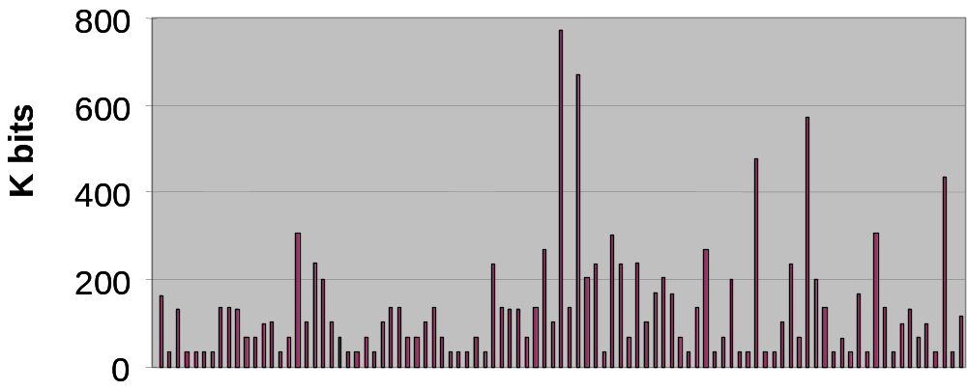
Fig. 1 Media units of an Ogg Vorbis music stream

The client needs to have the data comprising the n^{th} media unit before the start of its rendering interval, so that the application can decode it. Thus, the start time of the rendering interval t_{n} also represents the delivery deadline of the n^{th} unit. We furthermore assume that the application removes the n^{th} unit from the pre-fetch buffer at its play-out deadline t_{n}. In reality, the application will need to remove the data earlier than t_{n}, because it needs time to decode the unit before play-out, and so our assumption is conservative. This assumption means additional free space in the buffer is created only at the deadlines. If the number of bits transportable between deadlines is greater than the free space, then buffer overflow will occur unless the application transmits fewer bits over the interval than the transmission channel allows. We let z_{n} represent the number of bits the application transmits over [t_{n-1}, t_{n}].

In the case of an infinite client pre-fetch buffer, the application can send data at a rate equal to the capacity of the transmission channel. In this case, the vector Y = (y₁ ,…, y_{n}) suffices to represent the transmission policy. Otherwise, the pair (Y, Z) represents the transmission policy.

Feasibility

From either a known bandwidth provided by the network, or from a bandwidth estimator used by the application, we can compute the maximum number of bits transportable over the intervals separating the deadlines. To this effect, let b_{n} be the number of bits that can be delivered over [t_{n-1}, t_{n}]. Therefore, for our first condition of feasibility, we must have that

z_{n} ≤ b_{n} for n = 1, …,N. (1)

Let m_{n} represent the amount of free space in the buffer just after removal of the n^{th} unit at t_{n}. Let m₀ = M, the size of the pre-fetch buffer, which is empty at time t₀. Because the application can not transfer more bits to the client than it can store in the buffer, we must have

z_{n} ≤ m_{n-1} for n = 1, …,N. (2)

In order for the selected bits of the first unit y₁ to arrive on time at the client (before t₁), we must have that y₁ ≤ z₁. Likewise, the y₂ bits of unit 2, which are sent directly after the y₁ bits of unit 1, must arrive at the client before t₂, and thus y₁ + y₂ ≤ z₁ + z₂. Continuing this logic results in the following system of inequalities:

y₁ ≤ z₁
y₁ + y₂ ≤ z₁ + z₂
(3)
…
y₁ + … + y_{N} ≤ z₁ + … + z_{N}

When a transmission policy (Y, Z) satisfies constraints (1), (2), and (3), we call the policy feasible, because the application transmits data at a rate less than or equal to the channel capacity (1), the client pre-fetch buffer is not exceeded (2), and all bits sent arrive on-time (3).

Optimality

We use the refined max-min quality criterion defined in [Turner] to compare the play-out qualities between feasible transmission policies. We call a feasible transmission policy optimal if no other feasible policy exists with greater quality. We describe the refined max-min quality criterion by way of an example. Suppose an audio stream is comprised of three units, and that under transmission policy P₁ the resulting unit resolutions are (0.4, 0.3, 0.9), and under P₂ the resulting resolutions are (0.3, 0.6, 0.5). The sorted resolution vectors are (0.3, 0.4, 0.9) and (0.3, 0.5, 0.6), respectively. The two vectors tie in their first component, but the second vector has higher resolution in the second component, so we have Q(P₂) > Q(P₁).

boolean feasible(Y) {
y = 0, z = 0, m₀ = M
for k = 1 ,…, N
z_{k} = min(b_{k}, m_{k-1})
m_{k} = m_{k-1} - z_{k} + y_{k}
z = z + z_{k}, y = y + y_{k}
if y > z return false
return true
}

Fig. 3 Feasibility check

Algorithms

For any given assignment to Y, we can determine whether there exists an assignment to Z that results in a feasible policy. A function that performs this determination is shown in Fig. 3.
When the media is coarsely grained, a greedy algorithm will find an optimal policy in O(LN²), where L is the maximum number of layers. The algorithm starts with zero layers for each unit, and adds one layer to the unit that improves overall quality the most. When the number of layers of a unit can not be feasibly increased, then it is removed from further consideration. The algorithm terminates when no more units remain to be considered for a layer increase. If we partition the media units of the Ogg Vorbis audio stream given in Fig. 1 into 10 uniformly sized layers, and we assume a client buffer of 300 KB, and a bandwidth of 56 kbps, then the greedy algorithm produces a transmission policy with the resolutions shown in Fig. 4. Because some of the media units in the center of the stream are relatively large compared to the size of the client buffer, the application is forced to dramatically scale down two of the units to avoid buffer overflow.

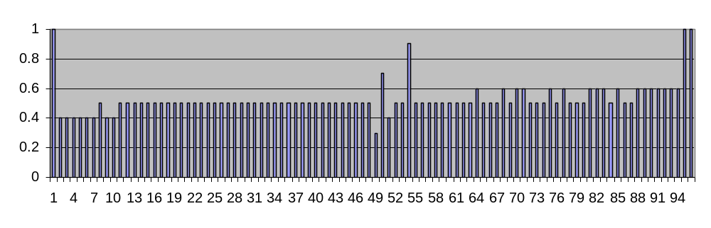
Fig. 4 Media unit resolutions of an optimal policy (300 KB buffer)

If we increase the size of the pre-fetch buffer to 1000 KB, the resulting resolutions form a non-decreasing sequence, as shown in Fig. 5. It was shown in [Turner] that resolutions of an optimal policy are non-decreasing for continuously scalable media and an infinite client buffer. The use of 10 layers approximates a continuously scalable codec, and in this example choosing a 1000 KB buffer is adequate to store as much pre-fetched data as needed to attain highest quality for the given bandwidth.
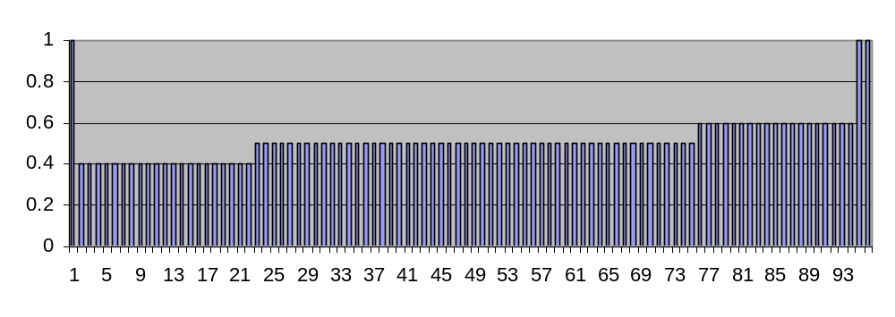
Fig. 5 Media unit resolutions of an optimal policy (1000 KB buffer)

When the layers of a layer-encoded media stream are small in size and numerous, it is possible to model the data with continuous variables. In this case, the application determines the percentage of bits to transport and render of each media unit r₁,…,r_{N}. The redistribution algorithm given in Fig. 6 produces an optimal policy when the client pre-fetch buffer is large enough to hold any amount of pre-fetched data. When applied to the example Ogg Vorbis stream, the resulting policy resembles Fig. 5.

The redistribution algorithm passes through the N media units. In pass n, the resolution of unit n is set to the maximum percentage of bits that can be sent over the n^{th} interval. This is compared with the resolution of the preceding media unit. If the resolution of unit n is less than the resolution of unit n-1, then bandwidth in interval n-1 is redistributed so that the two units have equal resolution. This process continues until the resolution scores form a non-decreasing sequence.
for n = 1 to N
b = b_{n}, x = x_{n}, r = b/x, k = n
while (k ≥ 2) and (r_{k-1} > r)
k = k – 1
b = b + b_{k}
x = x + x_{k}
r = b / x
for i = n to k
r_{i} = r

Fig. 6 Redistribution algorithm

When the client pre-fetch buffer is limited, the redistribution algorithm can no longer be applied.
However, the feasibility constraints given in (1), (2) and (3) can be rewritten as linear constraints in R and Z. Thus, the problem is an instance of a general minimax linear programming problem with a lexicographic objective, and a solution to this problem is given in [Luss].

Conclusion

Scalable media representations are becoming more widely studied as a means to create distributed multimedia applications that can provide highest possible quality of service to end users by adapting to best-effort networks and heterogeneous client devices. This paper advocates the use of the refined max-min quality criterion as a means to determine optimal streaming policies. In the case of coarsely-grained scalable media, we provide an efficient greedy algorithm that determines optimal transmission policies. In the case of finely-grained scalable media, we provide the Redistribution Algorithm to efficiently determine optimal policies for infinite client buffers. For finite client buffers, we describe how optimal policies can be determined through minimax linear programming.

References

[Vorbis] Xiphophorus. Ogg Vorbis audio codec under the LGPL. (www.vorbis.org)

[Turner] D. Turner. Asynchronous Multimedia Messaging. Ph.D. Thesis, Eurecom Institute, Jun 2001.

[Turner2] D. Turner and K. Ross. Optimal Streaming of Layer-Encoded Multimedia Presentations. In Proceedings of the IEEE International Conference on Multimedia and Expo, New York, New York, Jul/Aug 2000.

[Zhao] W. Zhao, M. Willebeek-LeMair and P. Tiwari. Efficient Adaptive Media Scaling and Streaming of Layered Multimedia in Heterogeneous Environments. Proc. of the IEEE International Conference on Multimedia Computing and Systems, Jun 1999.

[Cao] Z. Cao and E. Zegura. Utility max-min: an application-oriented bandwidth allocation scheme. Proceedings of IEEE INFOCOM 99, New York, NY, March, 1999.

[Ibaraki] T Ibaraki and N. Katoh. Resource Allocation Problems: Algorithmic Approaches. MIT Press, 1988.

[Luss] H. Luss and D.R. Smith. Resource allocation among competing activities: a lexicographic minimax approach, Operations Research Letters, 5(1986), 227-231.

