Extending the Wiki Paradigm for Use in the Classroom

Chien-min Wang
Department of Computer Science
California State University
San Bernardino
yjimmy.wang@msa.hinet.net

David Turner
Department of Computer Science
California State University
San Bernardino
dturner@csusb.edu

Abstract

The term "wiki" refers to a social computing system that allows a group of users to initiate and evolve a hyper-linked set of web pages using a simple markup language. Wiki collaboration systems encourage student-centered learning environments, because they encourage students to be co-creators of course content. However, there are several problems with the traditional wiki paradigm for use in the classroom. This paper identifies these problems, and describes a system we implemented to solve them.

Keywords: social computing applications wiki, collaborative educational environments, social user interfaces

1. Introduction

The phrase "wiki wiki" means quickly in the Hawaiian language, and it appropriately describes the efficiency by which a group of users can create and develop a wiki web site. Wikis accomplish this by providing users with a simple markup language and a simple mechanism to create new pages and link them into the evolving body of content. There are four properties of traditional wiki systems that are not desirable in the context of the classroom: all content is modifiable by any user, all content is public, simultaneous edits are allowed but not successful, and the wiki is forever evolving. In the context of the classroom, these properties are not always desirable. First, the instructor may want to restrict modifiability of certain pages, such as a course syllabus or statement of assignments. Second, an instructor or student may want to keep a newly created page private (not visible to others) until a certain point in its development. Third, in the context of a class, many students may wish to edit the contents of a given page simultaneously, so that some page locking mechanism needs to be employed so that students do not overwrite each other's submissions. Fourth, when the class ends, the instructor may wish to freeze the state of the wiki into an historical artifact rather than letting it evolve without end. To satisfy these needs, we extended the traditional wiki model by implementing a system that provides a flexible access control mechanism that adds little complexity to the user interface. Additionally, our system allows the instructor to conveniently terminate the wiki's evolution at the end of a course, and freeze the content into a set of static HTML pages. This paper is organized as follows. Section 2 provides an overview of the traditional wiki paradigm. Section 3 describes our extensions in detail. Section 4 describes the architecture of our implementation. Section 5 describes related work. Section 6 describes ongoing work, which includes the application of our system in an educational setting. Section 7 concludes the paper.

2. Wiki Paradigm

According to Ward Cunningham, originator of the wiki paradigm, a wiki is "the simplest online database that could possibly work." [1] This statement expresses one of the goals of the wiki paradigm, which is to provide user interface functionality in the simplest way possible. The benefit of simplicity in our case is that users can master system functionality quickly, and focus their energies on the collaborative development of content. Our goal was to extend the wiki paradigm with a minimum of additional complexity to make it suitable for the development of online course content as a collaboration among instructor and students.
In the traditional sense, a wiki system is a web site that allows anyone to modify its content, including changing the content of pages and creating new pages. It is thus a collaborative tool that communities can use to build site content. From the user perspective, a wiki is a collection of modifiable, hyper-linked web pages. In each of these pages, there is a menu of operations that visitors can perform, the most important being the edit operation. After invoking the edit operation of a page, the user is presented with an editable text area containing the page contents. The user can then modify the page contents and save changes to be immediately visible to others.
Wiki pages rely on a simple mark up language, so that users can italicize words, insert links, make section titles, etc. The markup system is kept simple, so that contributors can focus on writing rather than writing complicated formatting instructions. Additionally, by providing a restricted set of formatting options available to user, the wiki pages achieve a uniform appearance, and are thus easier to read.
Users create new pages by adding a wiki link to an existing page. In our system, wiki links are designated by a backslash followed by a page title. The page title is a string of alphanumeric characters terminated by white space. When a user adds a wiki link to the content of an existing page, the page displays the page title in the link as a linkable resource. Now, the user may click on the new link to go to a page with the given page title, but that is otherwise blank. At this point, the user now clicks the edit button and adds content to the new page.
Although similar, wikis and bulletin boards have important differences. Perhaps the key difference is that wiki content is fully changeable, while bulletin boards only allow users to change the state of the board by submitting new messages. Thus, the state of the bulletin board changes through the addition of new messages, but the messages themselves can not be modified after submitting. Contrastingly, all content in a wiki is modifiable. Bulletin boards thus allow users to study the history of messages. The aspect of bulletin boards that render them less beneficial to the classroom is that students must wade through old information that may be inaccurate or poorly written. The wiki overcomes this problem by allowing contributors to correct false information and to progressively refine the presentation of concepts and information. The result is a more concise record of course content that is easier to comprehend.
Wiki collaboration systems encourage student-centered learning environments, because they encourage students to be co-creators of course content. The class wiki becomes a central repository of knowledge acquired and expressed by students in the class. As a result, the class develops a sense of community ownership of course content, and students become active contributors to each other's learning.

3. Extensions for the Classroom

While basic wikis are usable in classroom environments, they can be enhanced with certain features that address the special needs of the classroom. In this section, we discuss the extensions we built into our wiki in order to make the system more useable as a tool to enhance learning.
In a basic wiki, there are no access controls, so that if two or more users try to update a page simultaneously, only one of the updates will succeed. In a classroom setting, student schedules are highly correlated, so that it is likely that more than one student will frequently attempt to modify a given page at the same time. Once a student initiates an edit operation, she may spend a long time performing her edits prior to submitting her changes; the longer the period of editing, the greater the likelihood of data loss. In order to avoid student frustration and the cultivation of an atmosphere of disorder, we designed a page locking mechanism that allows only a single student to obtain an edit screen for a given page.
Because many students may want to modify a given page at the same time, it is unacceptable to allow a single student to obtain the page lock for a long time. To solve this problem, we implemented a system that uses the following policy. If no other user attempts to edit a given page, then a single user may work in the edit window of the page indefinitely. However, if another user tries to access the edit page while another user is currently editing it, then a timer is set for the current page editor. The user currently editing the page sees the timer, and is warned that changes must be saved before the edit deadline. The waiting user is informed that the page is currently locked, but that it will be freed before the deadline.
In a classroom setting, some of the pages in the wiki ought to be modifiable only by the instructor. For example, the course syllabus ought to be posted at the beginning of the course, and students should not be able to edit the syllabus. Also, in some cases, students may need to create pages that other students can not modify. To accommodate these needs, each wiki page has an owner and a modifiable attribute (the owner of a page is the person who created the page). When the modifiable attribute is set to false, only the owner of the page (and the instructor) can modify the page.
Another need is for contributors to be able to add pages that are temporarily not visible to other users. For example, suppose the instructor is developing a page that describes an assignment for the students to complete, but she doesn't want to make the assignment public until a later time. Also, suppose a student is creating a page that responds to an assignment that needs to be kept confidential until the teacher evaluates the submission. To accommodate these needs, each page has a visible attribute that when set to false allows only the page owner and the instructor to see the page.
Another need of classrooms is for the instructor to "take a snapshot" of the wiki at the end of the course for archival purposes. The instructor can provide a link to the archive, and also keep the wiki in operation as a base for the next course.

4. System Design

The pages in our system all have the same basic layout. As an example, Figure 1 shows the home page in our system. There are three major parts to this page, and all other pages: menu, page title and body. The menu area contains three pieces of information: the name of the user logged in, the name of the owner of the current page, and a list of operations that the user may invoke. The operations appearing in the menu depend on the role of the user, because our system uses a user-level security check. The page title is shown at the middle of the line below the menu area. There are two possible outcomes when the user clicks on the page title. If the page is referenced by only one other page in the system, then the browser is redirected directly to this referencing page; if the page is referenced by more than one other page in the system, the browser is redirected to a list of linkable titles to each of the referencing pages. All text below the title is part of the body of the page. The format of the body content results from the wiki markup that was used when creating or editing the page.

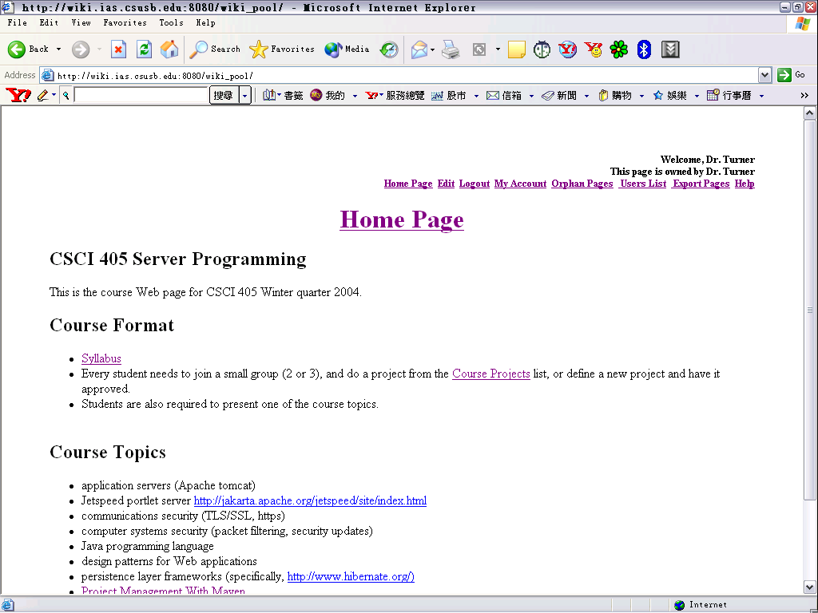
Figure 1. System user interface

There are 11 vocabularies in the markup language of our system, which allow content authors to incorporate special formatting in their pages. The HTML objects corresponding to these wiki markup functions include hyperlink, table, level-2 title, image, bulleted item, and code section. The vocabularies can be entered through the edit page in order to achieve the author's desired format. Table 1 contains a list showing the elements of our wiki markup vocabulary:

Table 1. Wiki Markup
Style | Markup vocabulary
Internal_link | \Internal_link
External_link | http://<URL>|External_link
URL | http://<URL>
Add image | img://<URL>
- Bullet Item | *Bullet Item
Insert a horizontal rule | ----
Display an asterisk | \*
Display a slash | \\
Insert a table | || column || column ||
Start a code area | *start-code
End a code area | *end-code

When the user wishes to edit a page, she clicks on the edit link in the menu. This brings the user to the edit screen for this page. (See Figure 2.) As an aid to the user, we provide a vertical list of buttons for inserting elements of our wiki vocabulary into the textarea. In addition to the wiki markup insertion buttons and the editable textarea, there are two checkboxes for changing the modifiability and visibility attributes for the page. These attribute settings are only displayed to the owner of the page, and to the instructor.

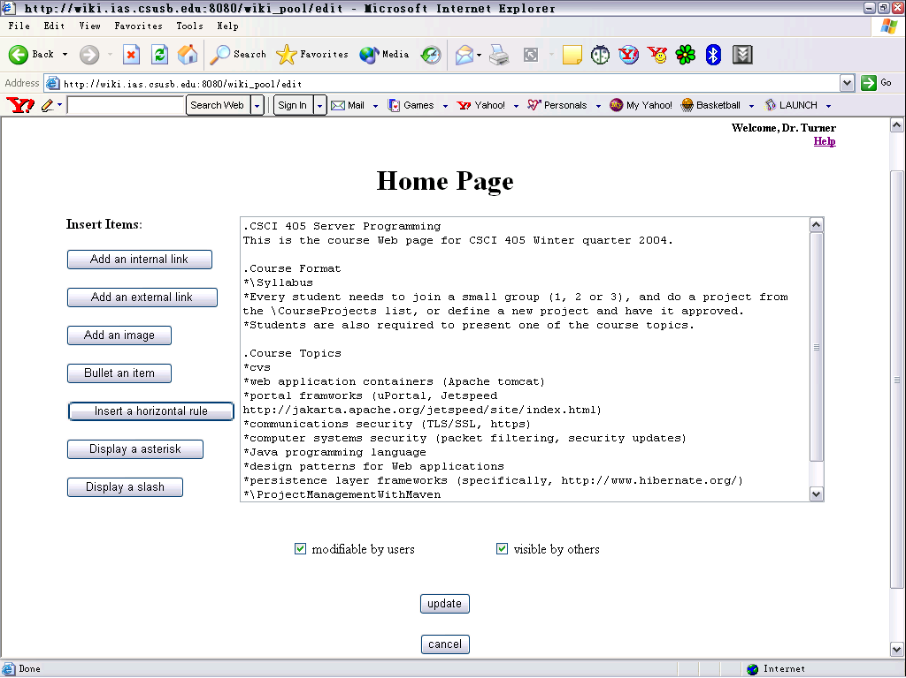
Figure 2. Edit user interface

If a user tries to edit a page that another user is currently editing, then he will receive a popup window that indicates the page is currently being edited. At the same time, the user editing the page will see a timer appear in the upper left corner of the edit screen. The user needs to complete editing before the timer goes to zero; if she fails to save prior to that moment, the page will be saved automatically. After the page is saved, other users may now invoke the edit operation on the page.

5. Related Work

Researchers in the Information Environments Program, School of Information Technology and Electrical Engineering, University of Queensland, Australia implemented and tested a wiki-based system to share ideas and provide a communication environment for classrooms [7]. Their system differs from ours in that it does not use a page locking mechanism to disallow concurrent page edits, and they do not provide the page attributes of modifiability and visibility present in our system. However, they provide on each page the ability to append a comment to a list of comments that appears at the bottom of the page, thus combining wiki and bulletin board functionality together.

6. Ongoing Work

We are currently using our classroom wiki to collaboratively develop online materials for a course in Server Programming to be taught in Winter Quarter of 2003 at California State University San Bernardino. (See CSCI 405 at http://drturner.net/) After the course begins, students will be given login identities, and will from that point onwards contribute to the classroom wiki for this course. The class itself will be charged with the problem of producing Version Two of the system. One of the planned enhancements to the system is to experiment with improving the page locking mechanism by eliminating the polling mechanism used in java script with a java applet that listens for events sent from the server. A second planned enhancement is to show in each page of the wiki a list of users who are currently viewing the page, and to allow them to chat, so that each page provides its own chat room. A third planned enhancement is to provide page templates, so that in addition to generic pages, users can create special purpose pages, such as syllabus or announcement pages. We also plan to experiment with various alternatives to the use of wiki markup, namely regular HTML, BBcode and XML.
One question that we hope to answer in the future is how willing students are to make anonymous contributions to a classroom wiki. Because students are being evaluated for a grade in the course, they may wish to have their contributions recognized by the instructor. We provide a partial solution to this problem by displaying the name of the creator of each page at the top of the page itself. Our future research will be to determine the importance of this issue, and to provide alternative methods of recognizing contributions.

7. Conclusion

In this paper, we presented the design of a collaborative teaching tool based on the wiki paradigm. To better meet the needs of the classroom, we extended the basic wiki paradigm in several ways. We explained the design of these extensions, and why they better server the specific needs of the classroom. We also explained how we are currently using the system to collaboratively create content for a new course, in which students will becomes co-creators of course content.

8. References

[1] www.wiki.org.

[2] V. Adamchik and A. Gunawardena. A Learning Objects Approach to Teaching Programming, International Conference on Information Technology: Computers and Communications, Las Vegas, April 2003.

[3] T. Mles-Board, L. Carr, S. Kampa and W. Hall. Writing the web: Supporting management reporting: a writable web case study, Proceedings of the
The Twelfth International World Wide Web Conference (WWW2003), May, 2003.

[4] E. Panagos and A. Biliris. Synchronization and recovery in a client-server storage system, The VLDB Journal, Springer-Verlag, Aug, 1997.

[5] J. Bergin, Teaching on the wiki web. Proceedings of the seventh annual conference on innovation and technology in computer science education, 2002.

[6] A. Deursen and E. Visser. The Reengineering Wiki, In Proceedings of the 6th European Conference on Software Maintenance and Reengineering (CSMR), 2002.

[7] M. Brereton, J. Donovan and S. Viller. Talking about watching: Using the Video Card Game and wiki-web technology to engage IT students in developing observational skills, Proceedings of the fifth Australasian conference on Computing education, 2003.

[8] B. Leuf and W. Cunningham, The Wiki Way: Quick collaboration on the Web, Addison-Wesley Longman Publishing Co., Inc, 2001.

[9] E. Bier and K. Pier. Sparrow web: group-writable information on structured web pages, Conference on Human Factors and Computing Systems, 2003.

[10] F. Bagnoli, F. Franci and A. Sterbini. WebTeach: an integrated web-based cooperative environment for distance teaching. SEKE 2002, Capri, Italy, 2002.

[11] M. Miettinen, P. Nokelainen, P. Floréen, H. Tirri and J. Kurhila. EDUCOSM-Personalized Writable Web for Learning Communities, International Conference on Information Technology: Computers and Communications, Las Vegas, April, 2003

