官方地址：

<https://zookeeper.apache.org/>

<https://archive.apache.org/dist/zookeeper/zookeeper-3.4.9/>

# Zookeeper分布式部署

节点规划：每个节点时leader还是follower，根据选举结果自动确定。

|  |  |  |
| --- | --- | --- |
| **主机名** | **IP地址** | **Zookeeper** |
| hadoop-1 | 192.168.198.224 | leader or follower |
| hadoop-2 | 192.168.198.225 | leader or follower |
| hadoop-3 | 192.168.198.226 | leader or follower |

## 安装步骤

注意：以下步骤需要在每个节点配置执行

# wget <https://archive.apache.org/dist/zookeeper/zookeeper-3.4.9/zookeeper-3.4.9.tar.gz>

# tar -zxvf zookeeper-3.4.9.tar.gz -C /usr/local

#

# dataDir用于配置存储快照文件的目录。

# 如果没有配置dataLogDir，那么事务日志也会存储在此目录

# mkdir /usr/local/zookeeper-3.4.9/data

# mkdir /usr/local/zookeeper-3.4.9/logs

#

# 修改配置文件

# cd /usr/local/zookeeper-3.4.9/conf

# cp zoo_sample.cfg zoo.cfg

# vim zoo.cfg

dataDir=/usr/local/zookeeper-3.4.9/data

dataLogDir=/usr/local/zookeeper-3.4.9/logs

server.1=hadoop-1:2888:3888

server.2=hadoop-2:2889:3889

server.3=hadoop-3:2890:3890

# 每个节点设置id=（1,2,3）

# echo '1' > /usr/local/zookeeper-3.4.9/data/myid

# vim /etc/profile

export ZOOKEEPER_HOME=/usr/local/zookeeper-3.4.9/

export PATH=$ZOOKEEPER_HOME/bin:$PATH

## 启动zookeeper

**# 每个节点执行start命令，启动zookeeper**

# zkServer.sh start

**# 在每个节点执行status命令，查看leader或者follower状态**

[root@hadoop-1 ~]# zkServer.sh status

ZooKeeper JMX enabled by default

Using config: /usr/local/zookeeper-3.4.9/bin/../conf/zoo.cfg

Mode: follower

[root@hadoop-1 ~]#

[root@hadoop-2 ~]# zkServer.sh status

ZooKeeper JMX enabled by default

Using config: /usr/local/zookeeper-3.4.9/bin/../conf/zoo.cfg

Mode: leader

[root@hadoop-2 ~]#

[root@hadoop-3 ~]# zkServer.sh status

ZooKeeper JMX enabled by default

Using config: /usr/local/zookeeper-3.4.9/bin/../conf/zoo.cfg

Mode: follower

[root@hadoop-3 ~]#

## 停止和重启zookeeper服务

# zkServer.sh stop

# zkServer.sh restart

# 基于Python接口的Zookeeper二次开发

## zkpython客户端安装

1）安装基础依赖包：

# yum install gcc

# yum install python-devel

2）python中有一个zkpython包，基于zookeeper的c-client开发，需要先安装zookeeper的c客户端：

# cd /usr/local/zookeeper-3.4.9/src/c

# ./configure

# make

# make install

安装c客户端成功后，相关的lib默认放置到了/usr/local/lib目录。

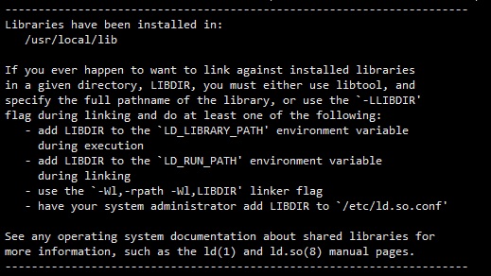

3）安装zkpython软件包；安装后执行“import zookeeper”进行验证，报错lib链接错误。

# pip install zkpython

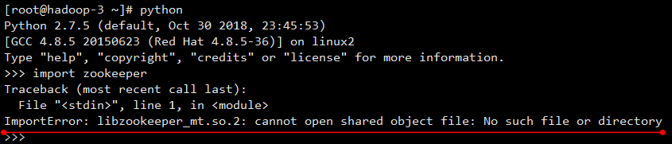

或者也可以通过下载zkpython-0.4源码包进行编译安装：

# tar -xzvf zkpython-0.4.2.tar.gz

# cd zkpython-0.4.2

# python setup.py install

4）新增lib路径到PATH

# vim /etc/profile

export LD_LIBRARY_PATH=$LD_LIBRARY_PATH:/usr/local/lib

5）测试zkpython功能可用

