
Data Dictionary



This file contains an explanation of the tables and items published daily by the U.S. Financial Management Service, as made available by the Treasury.IO API:

http://www.treasury.io/

(Version II, current as of 1 July, 2013)

Table of Contents

General Concept and Purpose 2
Source Data 2
Data Coverage 2
Data Format 3
Data Units 3
Data Structure 4
Table I (T1) 4
Table II (T2) 6
Table III 9
Table III A (T3A) 12
Table III A (T3B) 14
Table III A (T3C) 16
Table IV (T4) 17
Table V (T5) 20
Table VI (T6) 20
Contact 22
Credits 23
Appendixes 24
Appendix A (Table I definitions) TK
Appendix B (Table II definitions) TK
Appendix C (Table III definitions) TK
Appendix D (Table IV definitions) TK

General Concept and Purpose

The Financial Management Service (FMS) is the cash management arm of the U.S. Treasury. It provides central payment services for federal government agencies, manages the government’s debt collections and deposits and does the accounting and reporting of its daily operations.

Because the reporting is not provided in a machine-readable format, we’ve created the Treasury.IO API to go through the FMS’s statements and make them available to the public in a format that can be easily searched, aggregated and analyzed by the public.

Source Data

Treasury.IO downloads and parses the “Daily Treasury Statement” published by the FMS at 4pm each day the U.S. government is open for business.

The Daily Treasury Statement contains the daily cash operations of the United States Treasury: spending, taxing, borrowing, day-by-day, program-by-program. The source files are available for viewing here:

https://fms.treas.gov/fmsweb/DTSFilesArchiveAction.do

Data Coverage

Text versions of Daily Treasury Statements are available to June 2005; prior years going back to January 1998 are available in PDF format.

Currently, Treasury.IO contains all the text files, going back to 2005; the PDF files are not included in the API output.

Data Format

Data parsed from the Daily Treasury Statements is stored as a SQLite Version 3 database using the following formats, per SQLite:
- INTEGER. The value is a signed integer, stored in 1, 2, 3, 4, 6, or 8 bytes depending on the magnitude of the value.
- REAL. The value is a floating point value, stored as an 8-byte IEEE floating point number.
- TEXT. The value is a text string, stored using the database encoding (UTF-8, UTF-16BE or UTF-16LE).
For more on the SQLite data formats referenced above, see the SQLite documentation: http://www.sqlite.org/datatype3.html

Data Units

All money amounts presented in the data are in millions of U.S. dollars, rounded to the nearest million. The dollar amounts are not adjusted for inflation.

Data Structure

Each Daily Treasury Statement contains six tables, which provide the following data:

Table I
T1

Table I summarizes the operating cash balance of the U.S. Treasury. Think of it as Uncle Sam’s checkbook balance. This table answers the question, “how much money does Uncle Sam have in his checking account on any given day?”

Below is a screenshot of what Table I looks like in the Daily Treasury Statement:

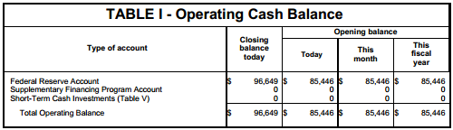

The table sums the different accounts in which the federal government keeps money and sums them into a total cash balance by day, month and fiscal year.

Table I can be accessed in the Treasury.IO API by querying table “T1” – short for Table I. Below are the fields and definitions for the table. Fields marked in italics were added to the table by the API; all others are aboriginal to the data:
Table I
Field | Datatype | Definition
table | text | The name of the table containing the data, in this case Table I
date | text | Date for balance data contained in the table, in YYYY-MM-DD format
year_month | text | Year and month for balance data contained in the table, in YYYY-MM format
year | integer | Year for balance data contained in the table, in YYYY format
month | integer | Month for balance data contained in the table, in ascending order from 1 (January) to 12 (December)
day | integer | Day of the month for the balance data
weekday | text | Day of the week for balance data (Monday thru Friday)
account | text | Name of the account containing the cash balance data, standardized across time for variances in spelling and name.  See Appendix A for account name definitions.
account_raw | text | Name of the account containing the cash balance data, in raw, unstandardized format
is_total | integer | Binary flag field indicating whether the account balance represents a total figure (1) or sub-component that adds up to the total (0). Exclude rows marked (1) from sum queries to prevent double-counting.
close_today | integer | Closing account balance as of the date marked in the date field
open_today | integer | Opening account balance as of the date marked in the date field
open_mo | integer | Opening account balance for the month marked in the month field
open_fy | integer | Opening account balance as of the start of the federal government’s fiscal year, which begins October 1 each year
footnote | real | Contains any footnotes provided in the data

Table II
T2

Table II contains the daily deposits and withdrawals of cash to/from the Treasury’s cash account at the Federal Reserve – the Federal Reserve Account.

Think of this table as a checking account statement for the federal government. It answers the question, “what did Uncle Sam spend money on today, and how much?”

Below is a screenshot of what Table II looks like in the Daily Treasury Statement:

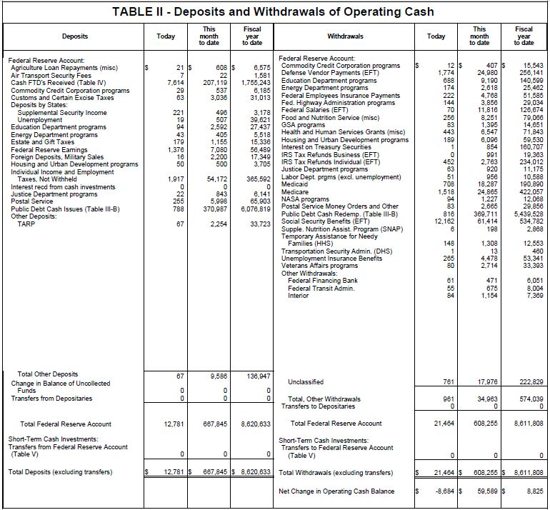

The table sums the deposits and withdrawals to/from the Federal Reserve Account and uses the net difference to calculate the net change in the government’s cash-on-hand detailed in Table I. A related account for short-term investments is summed below the Federal Reserve account in similar format, but is no longer used by the U.S. Treasury (see Table V below).
Table II is broken into two ledgers: deposits and withdrawals:

- Deposits represent money taken in by the federal government through its various agencies and programs.
- Withdrawals represent money spent by the federal government through each of various agencies and programs.

Both ledgers can be accessed in Treasury.IO by querying table “T2” - short for Table II. Below are the fields and definitions for the table. Fields marked in italics were added to the table by the API; all others are aboriginal to the data:
Table II
Field | Datatype | Definition
table | text | The name of the table containing the data, in this case Table II
date | text | Date for deposits and withdrawals data in the table, in YYYY-MM-DD format
year_month | text | Year and month for deposits and withdrawals contained in the table, in YYYY-MM format
year | integer | Year for the deposits and withdrawals contained in the table, in YYYY format
month | integer | Month for the deposits and withdrawals contained in the table, in ascending order from 1 (January) to 12 (December)
day | integer | Day of the month for the deposits and withdrawals contained in the table
weekday | text | Day of the week on which the deposits or withdrawals took place (Monday thru Friday)
account  SEE ISSUE #109 ON GITHUB | text | Name of the account impacted by the deposit or withdrawal, standardized across time for variances in spelling and name.  See Appendix A for account name definitions.
account_raw | real | Account name in raw, unstandardized format
type | text | Indicates type of transaction:  - “Deposit” for cash coming into the account through the agency or program named in the item field  - “Withdrawal” for cash coming out of the account through the agency or program named in the item field
subtype  SEE ISSUE #84 ON GITHUB | text | Indicates parent classifications that apply to certain items:  - “Deposits by States” for the items “Supplemental Security Income” and “Unemployment”  - “Other Deposits” for irregularly occurring items such as “Veterans Asset Sales”
item | text | Indicates the government agency or program responsible for the deposit or withdrawal, standardized across time for variances in spelling and name.  See Appendix B for item name definitions
item_raw | text | Item name in raw, undstandardized format
is_total | integer | Binary flag field indicating whether the deposit or withdrawal represents a total figure (1) or sub-component that adds up to the total (0). Exclude rows marked (1) from sum queries to prevent double-counting.
today | real | Deposits or withdrawals made by the agency or program on the date marked in the date field
mtd | real | Deposit or withdrawal made by the agency or program since the beginning of the month
fytd | real | Deposit or withdrawal made by the agency or program since the start of the federal government’s fiscal year, which begins October 1 each year
footnote | text | Contains any footnotes provided in the data

Table III
T3A | T3B | T3C

Table III summarizes the debt operations of the U.S. Treasury. Think of it as a credit card statement for Uncle Sam; it answers the question, “how much did Uncle Sam borrow today, and how close is he to his credit card limit?”

The table is divided into three sub-tables summarizing the government’s daily debt operations. Below are descriptions of the three tables, with screenshots of what they look like in the Daily Treasury Statement:

- Table III A (Public Debt Transactions): This table summarizes sales and repayments of U.S. government debt:

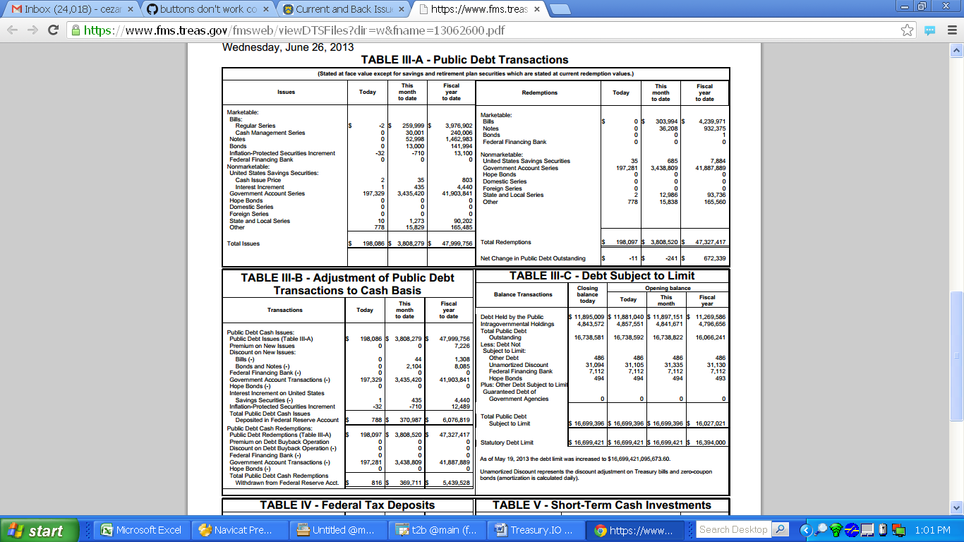

The table is broken into two ledgers – issues and redemptions. The issues represent sales of U.S. debt, while redemptions detail repayments. Redemptions minus issues equal the net change in the U.S. public debt each day, month and fiscal year to date. If redemptions are greater than issues, then the public debt shrinks; when issues outpace redemptions, the public debt grows.

The data can be accessed in Treasury.IO by querying table “T3A” – short for Table III A.

- Table III B (Adjustment of Public Debt Transactions to Cash Basis): This table converts sales and repayments of debt into a cash line item showing their impact on the Treasury’s Federal Reserve Account in Table II:

[Need to talk to FMS to write-up a quick graf here explaining how the math flows through this table.]

The data can be accessed in Treasury.IO by querying table “T3B:” – short for Table III B.

- Table III C (Debt Subject to Debt Limit): This table summarizes the amount of U.S. debt outstanding that it subject to the debt limit set by Congress and provides the prevailing debt limit.

Not all debt issued by the U.S. government is subject to the Congressionally-mandated “debt limit.” By law, certain types of debt are exempt from the limit, like debt held by a Treasury subsidiary, the Federal Financing Bank.

Table III C takes the total public debt outstanding – the sum of debt held by investors and internal governmental I.O.U.s – and adjusts it by subtracting exempt debt types like the Federal Financing Bank. The total public debt is calculated in the first two line items, by adding up debt held by the public and intragovernmental holdings. This total is then decreased by exempt holdings listed below, such as the Federal Financing Bank, to arrive at the total debt subject to the debt limit in the bottom of the table. The prevailing debt limit is listed below that total, showing how close the government is to breaching the limit.

The data can be accessed in Treasury.IO by querying table “T3C” – short for Table III C.

Fields and definitions for Table III sub-tables:

Table III A | T3A

Below are the fields and definitions for T3A (Public Debt Transactions). Fields marked in italics were added to the table by the API; all others are aboriginal to the data:
Table III A
T3A
Field | Datatype | Definition
table | text | The name of the table containing the data, in this case Table III A
date | text | Date for debt transaction data contained in the table, in YYYY-MM-DD format
year_month | text | Year and month for debt transaction data contained in the table, in YYYY-MM format
year | integer | Year for debt transaction data contained in the table, in YYYY format
month | integer | Month for debt transaction data contained in the table, in ascending order from 1 (January) to 12 (December)
day | integer | Day of the month on which the debt transaction data took place
weekday | text | Day of the week on which the debt transaction took place (Monday thru Friday)
Surtype  SEE ISSUE #114 ON GITHUB | text | Indicates whether the transaction is a sale of U.S. government debt (“issue”) or a repayment (“redemption”)
type | text | The type of debt being issued: “marketable” or “nonmarketable.” Marketable debt is sold to the public; nonmarketable debt is an I.O.U. between federal agencies and the U.S. Treasury
subtype  SEE ISSUE #114 ON GITHUB | text | Indicates parent classifications that apply to certain items:  - “Bills” for the items “Regular Series” and “Cash Management Series”  - “United States Savings Securities” for the items “Cash Issue Price” and “Interest Increment”
item | text | Indicates the debt being sold or repaid, standardized across time for variances in spelling and name.  See Appendix C for definitions of these items
item_raw | text | Item name in raw, unstandardized format
is_total | integer | Binary flag field indicating whether the debt transaction amount represents a total figure (1) or sub-component that adds up to the total (0). Exclude rows marked (1) from sum queries to prevent double-counting.
today | real | Amount of the debt sold or repaid on the date marked in the date field
mtd | real | Amount of the debt sold or repaid since the beginning of the month
fytd | real | Amount of the debt sold or repaid since the start of the federal government’s fiscal year, which begins October 1 each year
footnote | real | Contains any footnotes provided in the data

Table III B | T3B

Below are the fields and definitions for T3B (Adjustment of Public Debt Transactions to Cash Basis). Fields marked in italics were added to the table by the API; all others are aboriginal to the data:
Table III B
T3B
Field | Datatype | Definition
table | text | The name of the table containing the data, in this case Table III B
date | text | Date for debt transaction data contained in the table, in YYYY-MM-DD format
year_month | text | Year and month for debt transaction data contained in the table, in YYYY-MM format
year | integer | Year for debt transaction data contained in the table, in YYYY format
month | integer | Month for debt transaction data contained in the table, in ascending order from 1 (January) to 12 (December)
day | integer | Day of the month on which the debt transaction data took place
weekday | text | Day of the week on which the debt transaction took place (Monday thru Friday)
surtype | real | SEE ISSUE #114 ON GITHUB
type | text | Indicates whether the transactions being reconciled to a cash basis are debt sales (“Public Debt Cash Issues”) or repayments (“Public Debt Cash Redemptions”)
subtype  SEE ISSUE #114 ON GITHUB | text | Indicates parent classifications that apply to certain items:  - “Discount on New Issues” for the items “Bills” and “Bonds and Notes”
item | text | Indicates the debt sale or repayment transaction being adjusted to cash basis, standardized across time for variances in spelling and name.  See Appendix C for definitions of these items
item_raw | text | Item name in raw, unstandardized format
is_total | integer | Binary flag field indicating whether the debt transaction amount represents a total figure (1) or sub-component that adds up to the total (0). Exclude rows marked (1) from sum queries to prevent double-counting.
today | integer | Amount of debt sold or repaid on the date marked in the date field
mtd | integer | Amount of debt sold or repaid since the beginning of the month
fytd | integer | Amount of debt sold or repaid since the start of the federal government’s fiscal year, which begins October 1 each year
footnote | text | Contains any footnotes provided in the data

Table III C | T3C

Below are the fields and definitions for T3C (Debt Subject to Limit). Fields marked in italics were added to the table by the API; all others are aboriginal to the data:
Table III C
T3C
Field | Datatype | Definition
table | text | The name of the table containing the data, in this case Table III C
date | text | Date on which the debt balance data contained in the table was recorded, in YYYY-MM-DD format
year_month | text | Year and month in which the debt balance data was recorded, in YYYY-MM format
year | integer | Year in which the debt balance data was recorded, in YYYY format
month | integer | Month in which debt balance data was recorded, in ascending order from 1 (January) to 12 (December)
day | integer | Day of the month on which the debt balance data was recorded
weekday | text | Day of the week on which the debt balance data was recorded (Monday thru Friday)
type | real | SEE ISSUE #114 ON GITHUB
item  SEE ISSUE #114 ON GITHUB | text | Names of different types of debt held by the U.S. government, standardized across time for variances in spelling and name.  See Appendix C for definitions of these items
item_raw | text | Item name in raw, unstandardized format
is_total | integer | Binary flag field indicating whether the debt balance represents a total figure (1) or sub-component that adds up to the total (0). Exclude rows marked (1) from sum queries to prevent double-counting.
close_today | real | The ending balance for each type of debt named in the item column as of the date indicated in the date column
open_today | real | The opening balance for each type of debt named in the item column as of the date indicated in the date column
open_mo | real | The opening balance for each type of debt named in the item column as of the month indicated in the month column
open_fy | real | The opening balance for each type of debt named in the item column at the start of the federal government’s fiscal year, which begins October 1 each year
footnote | text | Contains any footnotes provided in the data
Table IV
T4

Table IV details the sources and uses of the federal government’s tax collections.

Tax receipts are aggregated into one deposit line item in Table II – “FTD’s Received,” short for “Federal Tax Deposits Received.” In Table IV, you can get a break-down of these taxes and find out how much came from individuals or corporations, for instance.

It's like your paycheck, which details how much you got paid and where the money went to - checking account, 401(k), health plan, etc. The table answers the question, “where is Uncle Sam getting his tax dollars from, and where is he putting them?”

Below is a screenshot of what Table IV looks like in the Daily Treasury Statement:

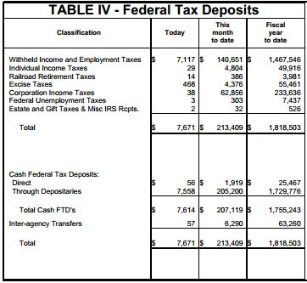

The table sums up the various sources of the federal government’s tax collections and then details the accounts into which the taxes were deposited. The sum total of the taxes collected each day, month and fiscal year to date equals the sum total of the deposits over the same periods.

Table IV can be accessed in the Treasury.IO API by querying table “T4” – short for Table IV. Below are the fields and definitions for the table. Fields marked in italics were added to the table by the API; all others are aboriginal to the data:
Table IV
T4
Field | Datatype | Definition
table | text | The name of the table containing the data, in this case Table IV
date | text | Date for the tax collections contained in the table, in YYYY-MM-DD format
year_month | text | Year and month for the tax collections contained in the table, in YYYY-MM format
year | integer | Year for the tax collections contained in the table, in YYYY format
month | integer | Month for the tax collections contained in the table, in ascending order from 1 (January) to 12 (December)
day | integer | Day of the month on which the tax collections data took place
weekday | text | Day of the week on which the tax collections took place (Monday thru Friday)
type | text | SEE ISSUE #20 ON GITHUB
classification  SEE ISSUE #20 ON GITHUB | text | For rows where the type column equals “source,” the classification gives the type of tax collected by the federal government. For rows where the type column equals “deposit,” the classification gives the name of the account into which tax receipts were deposited. The classifications are standardized across time for variances in spelling and name.  See Appendix D for definitions of these classifications
classification_raw | text | Classification name in raw, unstandardized format
is_total | integer | Binary flag field indicating whether the tax amounts represent a total figure (1) or sub-component that adds up to the total (0). Exclude rows marked (1) from sum queries to prevent double-counting.
today | real | Amount of taxes collected or deposited on the date marked in the date field
mtd | real | Amount of taxes collected or deposited since the beginning of the month
fytd | real | Amount of taxes collected or deposited since the start of the federal government’s fiscal year, which begins October 1 each year
footnote | text | Contains any footnotes provided in the data

Table V
T5

Table V details cash operations for a short-term investment account that is no longer used by the U.S. Treasury as of 30 March, 2012. The table, labeled “T5” in Treasury.IO, has been deprecated and is no longer tracked by the API.

Table VI
T6

Table VI details how much tax money was refunded by the federal government according to two major breakdowns: tax refunds to individuals and businesses.

It’s like a refund on your credit card statement detailing a reversed charge or overpayment that’s been credited back. It answers the question, “how much tax money did Uncle Sam return, and to whom?”

Below is a screenshot of what Table VI looks like in the Daily Treasury Statement:

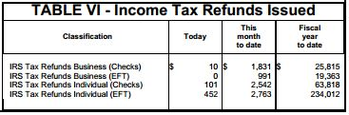

The table lists the tax refunds given to individuals and businesses each day, month and fiscal year to date. The refunds are labeled by mode of transfer – check or electronic funds transfer (“EFT”). The tax refunds tagged as EFT flow to the withdrawals ledger in Table II.

Table VI can be accessed by querying “T6” – short for Table VI. Below are the fields and definitions for the table. Fields marked in italics were added to the table by the API; all others are aboriginal to the data:
Table VI
T6
Field | Datatype | Definition
table | text | The name of the table containing the data, in this case Table VI
date | text | Date for the tax refunds contained in the table, in YYYY-MM-DD format
year_month | text | Year and month for the tax refunds contained in the table, in YYYY-MM format
year | integer | Year for the tax refunds contained in the table, in YYYY format
month | integer | Month for the tax refunds contained in the table, in ascending order from 1 (January) to 12 (December)
day | integer | Day of the month on which the tax refunds were processed
weekday | text | Day of the week on which the tax refunds were processed (Monday thru Friday)
type | real | Indicates whether the refund was processed as a check payment (“check”) or electronic funds transfer (“EFT”)  SEE ISSUE #116 ON GITHUB
classification  SEE ISSUE #116 ON GITHUB | text | Gives the type of tax refund processed by the Treasury, standardized across time for variances in spelling and name.  - Business tax refunds are classified as “IRS Tax Refunds Business”  - Individual tax refunds are classified as “IRS Tax Refunds Individual”
classification_raw | text | Classification name in raw, unstandardized format
is_total | integer | SEE ISSUE #116 ON GITHUB
today | real | Amount of tax refunds processed on the date marked in the date field
mtd | real | Amount of tax refunds processed since the beginning of the month
fytd | real | Amount of tax refunds processed since the start of the federal government’s fiscal year, which begins October 1 each year
footnote | text | Contains any footnotes provided in the data

Contact

For questions about using the API, email the support listserv and a member of the developer team will respond to your query:

federal-treasury-api@googlegroups.com

Credits:

The API was developed by CSV Soundsystem with the support of a Code Sprint Grant from the Knight-Mozilla OpenNews program. [Do we want to say more about CSV Soundsystem and list our names here?]

Find out more about CSV Soundsystem here:
http://csvsoundsystem.com/

Find out more about OpenNews here:
http://www.mozillaopennews.org/

Appendixes
Appendix A
Table I Definitions

Below are definitions for the accounts contained in Table I:

Federal Reserve Account: This is a cash account the U.S. Treasury keeps with the Federal Reserve. It is the main checking account through which the federal government pays most of its bills and receives deposits from various sources.

Supplementary Financing Program Account: [Ask FMS]

Short-Term Cash Investments: Short-term cash investments held by Treasury, detailed in Table V. [Ask FMS].

Appendix B
Table II Definitions

TK – will define items contained in Table II:

NEEDS TO BE CULLED FOR STRAY FOOTNOTES

Item | Definition
Commodity Credit Corporation programs | Commodity Credit Corporation
Education Department programs
Energy Department programs
Housing and Urban Development programs
Justice Department programs
Total Federal Reserve Account
FTD s Received ( Table IV )
Agriculture Loan Repayments ( misc )
Customs and Certain Excise Taxes
Estate and Gift Taxes
Federal Reserve Earnings
Foreign Deposits Military Sales
Individual Income and Employment Taxes Not Withheld
Interest recd from cash investments
Postal Service
Public Debt Cash Issues ( Table III B )
Supplemental Security Income
Total Deposits ( excluding transfers )
Total Other Deposits
Transfers from Depositaries
Transfers from Federal Reserve Account Table V
Unemployment
GSA Programs
Defense Vendor Payments ( EFT )
Fed Highway Administration programs
Federal Employees Insurance Payments
Federal Salaries ( EFT )
Food and Nutrition Service ( misc )
Health and Human Services Grants ( misc )
Interest on Treasury Securities
Labor Dept prgms ( excl unemployment )
Medicaid
Medicare
NASA programs
Net Change in Operating Cash Balance
Postal Service Money Orders and Other
Public Debt Cash Redemp ( Table III B )
Social Security Benefits ( EFT )
Temporary Assistance for Needy Families ( HHS )
Total Other Withdrawals
Total Withdrawals ( excluding transfers )
Transfers to Depositaries
Transfers to Federal Reserve Account Table V
Unclassified
Unemployment Insurance Benefits
Veterans Affairs Programs
Transportation Security Admin ( DHS )
Total Tax and Loan Note Accounts Table V
Thrift Savings Plan Transfer
Air Transport Security Fees
Change in Balance of Uncollected Funds closing balance
Food Stamps
IRS Tax Refunds Business ( EFT )
TARP
IRS Tax Refunds Individual ( EFT )
Emergency Prep Response ( DHS )
Supple Nutrition Assist Program ( SNAP )
Medicare Premiums
Change in Balance of Uncollected Funds
Interior
Federal Housing Admin: Note Sales
Federal Transit Admin
Deposit Insurance Fund ( net )
Agency for International Development
National Highway Traffic Safety Admin
GSE MBS Purchase Program Income
Federal Crop Ins Corp
State Department
Defense Finance Accounting Service
Minerals Management Svc Collections
Prepayment of Treasury Securities ( net )
Federal Aviation Administration
Pension Benefit Guaranty Corp
Agriculture
Federal Financing Bank
Military Active Duty Pay ( EFT )
Cash FTD s Received ( Table IV )
U S District Courts ( net )
Veterans Benefits ( EFT )
Centers for Disease Control
HHS: Indian Health Service
Agriculture Loan Payments ( misc )
International Monetary Fund
Supple Security Income Benefits ( EFT )
Railroad Unemployment Ins
USDA: Forest Service
Treasury Department programs
Environmental Protection Agency
Export Import Bank
Military Retirement ( EFT )
HHS Deposit Fund Transfers to States
Small Business Administration
Railroad Retirement ( EFT )
Civil Service Retirement ( EFT )
Natl Railroad Retirement Inv Trust
Federal Railroad Admin
Tennessee Valley Authority ( net )
Gas and Oil Lease Sales Proceeds
Treasury Dept: Claims Payments
Minerals Management Service
Federal Financing Bank ( net )
National Credit Union Administration
Commerce Programs
Securities and Exchange Commission
Fed Crop Ins Corp Fund Premiums
Federal Employees Insurance Receipt
Interntl Security Assistance ( DSCA )
Export Import Bank ( net )
FSA Tobacco Assessments
Federal Finance Bank
Pmt to Resolution Funding Corp ( Treas )
SEC: Stock Exchange Fees
HUD: Hurricane Relief
Corps of Engineers
Prem ESF Money Mkt Guar Facility
Interior: Office of Surface Mining
Animal Plant Health Inspection svcs
Federal Communications Commission
Minerals Mgmt Svc Pmts to States
Foreign Military Sales Program
Library of Congress
Small Business Admin Loan Sales
GSE Dividends
Interior: Bureau of Land Management
Customs and Borders Protection ( DHS )
Comptroller of the Currency Assessment
Maritime Administration
Overseas Private Investment Co ( net )
Pmt to Internat l Development Assn
African Development Fund
GSE Investment
Ofc of Thrift Supervision ( Assessments )
Pmt to Corp for Pub Broadcasting
Bonds
Domestic Series
FSLIC Resolution Fund ( net )
Foreign Series
Government Account Series
Hope Bonds
Notes
Other
Pmt to Int l Bk for Reconstruction
State and Local Series
Farm Credit System Ins Corp
Puerto Rico Refund of IRS Collections
Bills
Cash Issue Price
Cash Management Series
District of Columbia
FSLIC Resolution Fund
Inflation Protected Securities Increment
Interest Increment
Interior: Office of Territories
Net Change in Public Debt Outstanding
Regular Series
Total Issues
Total Redemptions
United States Savings Securities
Veterans Assets Sales
Asian Development Bank Payment
Commodity Futures Trading Commission
Farm Credit Insurance Corp
Inter American Development Bank
Lend Lease Receipts
Defense Energy Supply Center
Asset Sale: U S Enrichment Corp
Bank Insurance Fund ( net )
Capital Purchase Program ( TARP )
Federal Trade Commission
GSE Obligations HFA Initiative
Interior: Bureau of Reclamation
FHA Debentures
FSLIC Resolution Funds ( RTC net )
Includes a million adjustment previously reported on September
Includes a reclassification of million for the month of October and
Pmt to Resolution Funding Corp ( RTC )
Presidential Election Campaign Fund
Represents a return of million previously reported on September
U S Enrichment Corp
Appendix C
Table III Definitions

TK – will define items contained in Table III:

NEEDS TO BE CULLED FOR STRAY FOOTNOTES

Item | Definition
Act of operated to permanently increase the statutory debt
Act of operated to permanently increase the statutory debt limit to
Bills
Bills (-)
Bonds
Bonds and Notes (-)
Cash Issue Price
Cash Management Series
Debt Held by the Public
Discount on Debt Buyback Operation (-)
Domestic Series
Federal Financing Bank
Federal Financing Bank ( net )
Federal Financing Bank (-)
Foreign Series
Government Account Series
Government Account Transactions (-)
Guaranteed Debt of Government Agencies
Hope Bonds
Hope Bonds (-)
Inflation Protected Securities Increment
Interest Increment
Interest Increment on United States Savings Securities
Intragovenmental Holdings increased by million
Intragovernmental Holdings
Net Change in Public Debt Outstanding
Notes
Other
Other Debt
Premium on Debt Buyback Operation
Premium on New Issues
Public Debt Issues ( Table III A )
Public Debt Redemptions ( Table III A )
Regular Series
Repurchase Agreements
State and Local Series
Statutory Debt Limit
Subject to Limit
Total Issues
Total Public Debt Cash Issues Deposited in Federal Reserve Account
Total Public Debt Cash Redemptions Withdrawn from Federal Reserve Acct
Total Public Debt Outstanding
Total Redemptions
Unamortized Discount
United States Savings Securities
adjustment on Treasury bills and zero coupon bonds ( amortization is calculated daily ) The Closing Balance Today for Debt Held by the Public decreased by million and the
billion after
bonds ( amortization is calculated daily ) DAILY TREASURY STATEMENT PAGE:
ery Act of Public Law ( ) These long term nonmarketable
limit to billion after
limit to billion after Unamortized Discount represents the discount
securities which are stated at current redemption value ) Hope Bond was issued on pursuant to the Housing and Economic Reco
securities which are stated at current redemption value ) Hope bond was issued on pursuant to the Housing and Economic Recov
securities which are stated at current redemption value ) Includes an adjustment of million due to an understatement of the Issues on May
very Act of Public Law ( ) These long term nonmarketable

Appendix D
Table IV Definitions

TK – will define classifications contained in Table IV:

Classification | Definition
Total
Corporation Income Taxes
Direct
Estate and Gift Taxes Misc IRS Rcpts
Excise Taxes
Federal Unemployment Taxes
Individual Income Taxes
Inter agency Transfers
Railroad Retirement Taxes
Withheld Income and Employment Taxes
Change in Balance of Unclassified Taxes
Collector Depositaries
Tax and Loan Accounts
Through Depositaries
Total Cash FTD s

