MNIST Sigmoid:

Not normalized (images in 1-255):

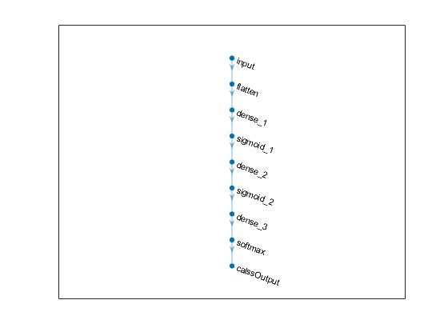

Validation accuracy: 86.00%

Test accuracy = 0.8517

MNIST Sigmoid:

Normalized (images in 0-1):



Validation accuracy: 77.28%

Test accuracy = 0.7632

