MNIST Sigmoid:

Not normalized (images in 0-255):

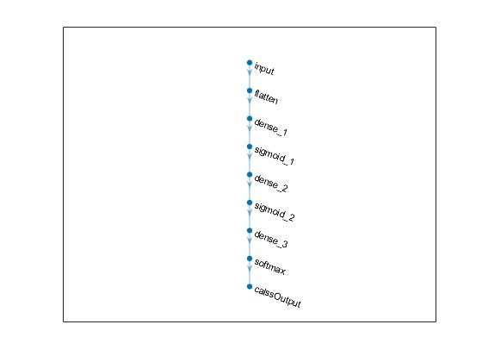

Validation accuracy: 96.22%

Test accuracy = 0.9573

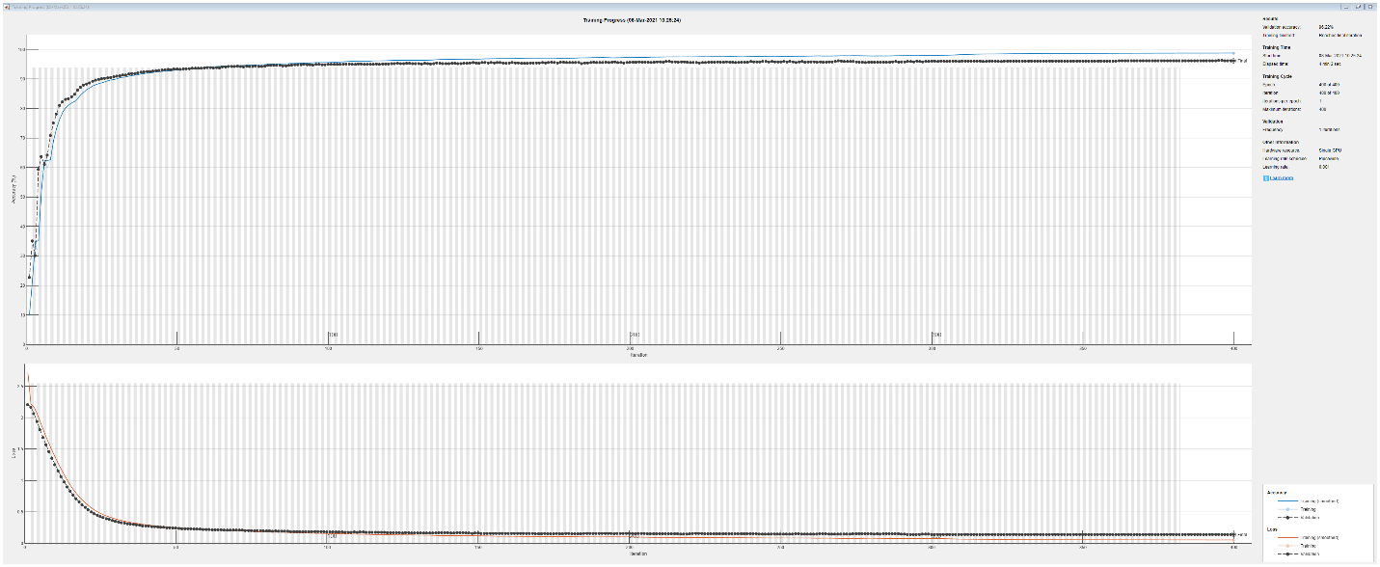

MNIST Sigmoid:

Normalized (images in 0-1):



Validation accuracy:

Test accuracy =

