Tanh MNIST 600 500 (not normalized) [0-255]

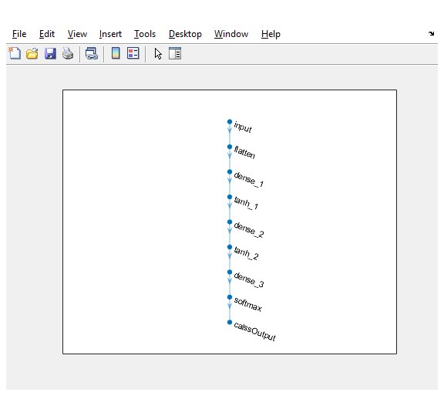

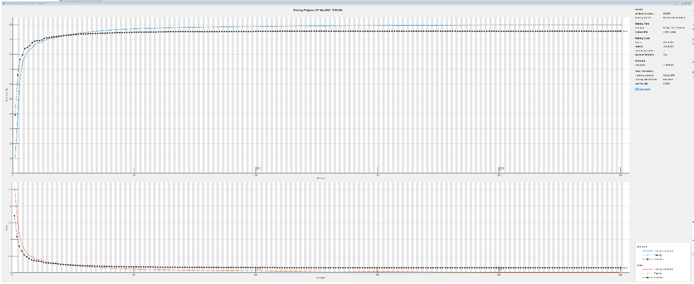

Validation accuracy: 95.60%

Test accuracy: 95.44 %

